**Team Name**: BreadBusters

**Team Members**

1. Alexander Semaan
2. Clara Mae Wells
3. Erin Tynan

**Table Row Counts**:

* Licenses: 8178
* LicenseCategories: 31
* LiquorLicenses: 1109
* FoodLicenses: 7069
* Establishments: 8178
* Addresses: 8178
* LiquorEstablishments: 1109
* FoodEstablishments: 7069
* InspectionHistory: 126139
* ViolationHistory: 477040
* Weather: 3749

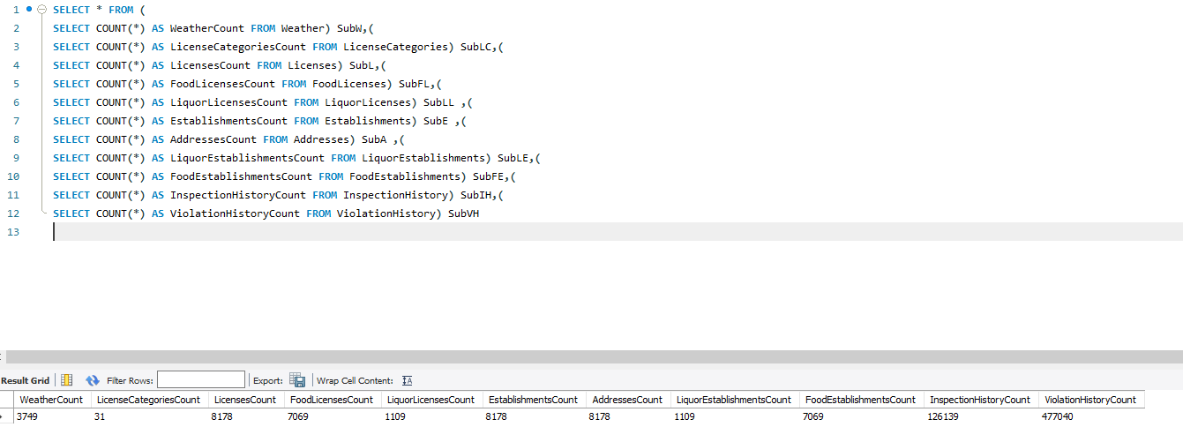

**Presentation Topics & Presenters**

[UML](https://youtu.be/N1S4b4-nBhk): Clara

[CREATE table statements](https://vimeo.com/366897376): Erin

[Load data & row counts](https://www.youtube.com/watch?v=Apesixr-I7I&feature=youtu.be): Alex