**Excercise 1: Methane Annual Increase**

Go to this link from the Global Monitoring Laboratory: <https://gml.noaa.gov/ccgg/trends_ch4/>

At the bottom of the page, click on the CSV file "Global averaged marine surface annual mean growth rates (CSV)" shown in the figure below:

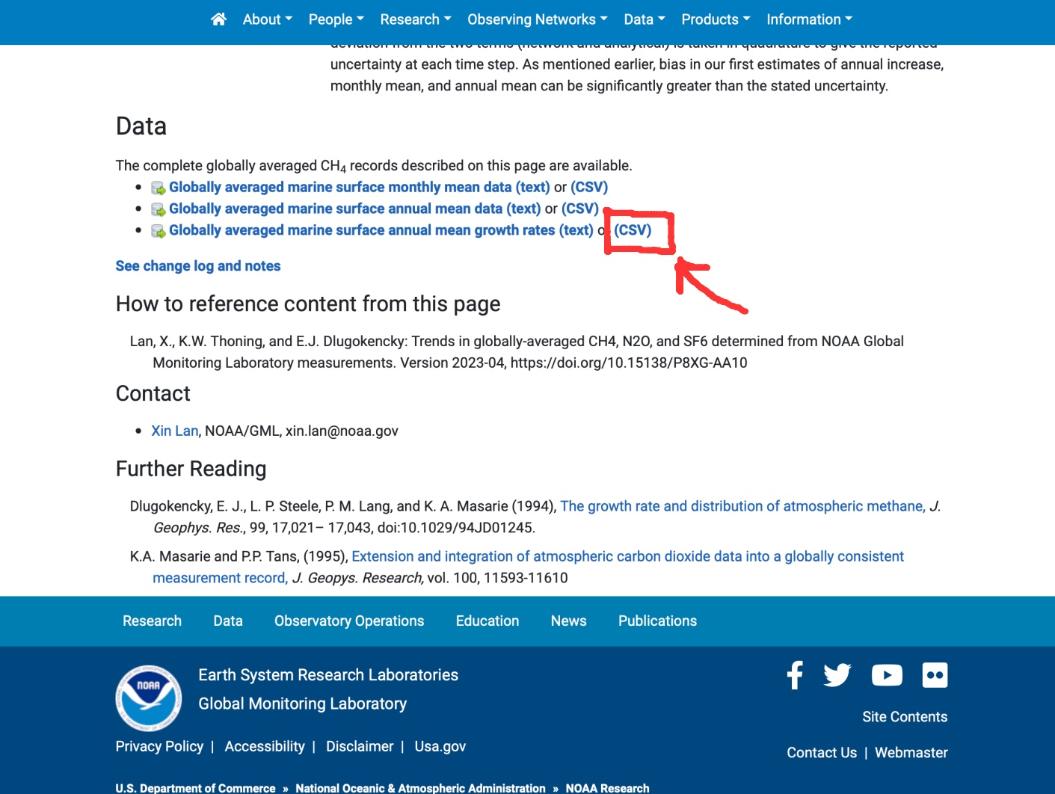

This file contains data on the annual increase in globally averaged atmospheric methane. Look at the file and count how many lines you have to skip when importing the document.

Import the document directly from the website and graph the data with its uncertainties.

**Exercise 2: Is the Stefan-Boltzmann law applicable to a light bulb?**

A light bulb is connected to a voltage source. Two students (1 and 2) measure the voltage U across the bulb and the current I through the bulb. The electrical power P is the product of U times I. The temperature T of the bulb can be estimated from the measured resistance. In the file 'lightbulb_power.xlsx' are the values of temperature T and power P measured by the two students.

Import the data and plot them on the same graph.

In such an experiment, one could assume that the electrical power P supplied to the light bulb is completely converted into radiated electromagnetic energy (light, heat). Thus, one can test the Stefan-Boltzmann law. It says that the radiated power of an ideal black body with temperature T is proportional to T^4.

To test the model, plot the electric power P as a function of T^4 for the two students' data.

Then perform a linear regression and calculate r^2.