1. Introduction

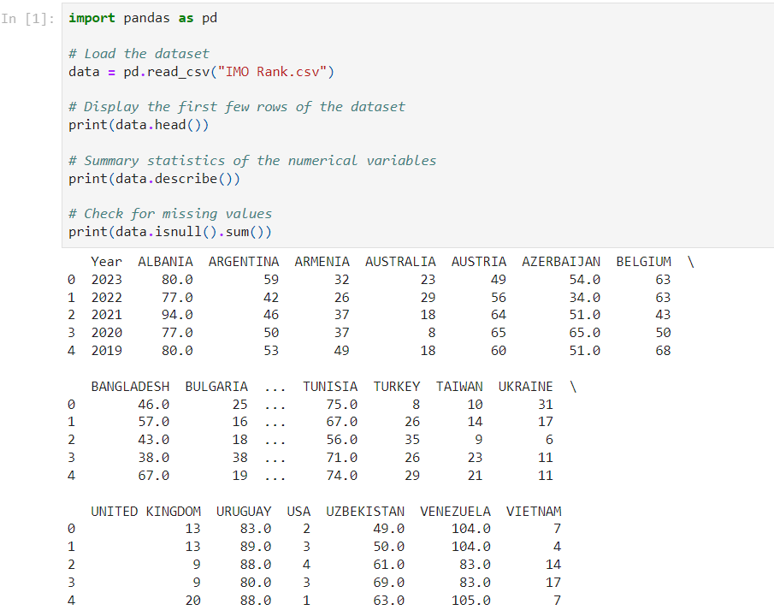In this exploratory data analysis report, we will analyze the dataset containing International Mathematical Olympiad (IMO) ranks by country. The dataset provides information about the ranks achieved by different countries in the IMO competition over the years.

2. Data Exploration

Data exploration refers to the process of examining and analyzing a dataset to understand its structure, characteristics, and patterns. The main goals of data exploration are:

Understanding the Data: Exploring the dataset helps in gaining insights into the variables (columns) and observations (rows) it contains. This includes understanding the data types, variable names, and the overall structure of the dataset.

Identifying Patterns and Trends: Data exploration involves visualizing the data to identify any patterns, trends, or relationships between variables. This can help in uncovering interesting insights or correlations that may not be immediately apparent.

Detecting Anomalies or Outliers: By exploring the data, we can identify any unusual or unexpected observations that deviate from the norm. These anomalies, also known as outliers, may need further investigation as they can have a significant impact on the analysis or modeling process.

Preparing Data for Analysis: Data exploration also involves data preprocessing tasks such as handling missing values, encoding categorical variables, and scaling numerical features. By exploring the data, we can determine the appropriate preprocessing steps needed to clean and prepare the data for analysis or modeling.

2.2Histogram of Ranks

2.2 **Scatter plot**

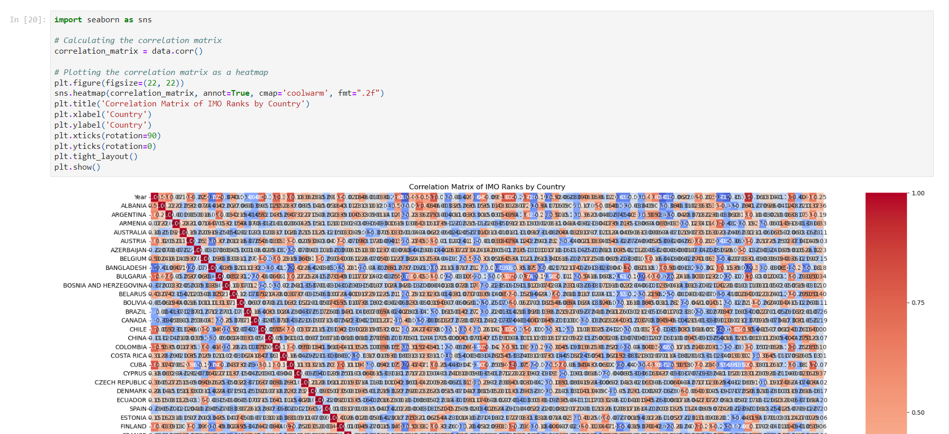3.4 Correlation Matrix

Lastly, we'll calculate the correlation matrix to explore the relationships between ranks of different countries over the years. We'll visualize the correlation matrix using a heatmap.

4. Conclusion

Through this exploratory analysis, we gained insights into the distribution of ranks achieved by countries in the IMO competition over the years. We also explored how the ranks of a specific country changed over time and investigated the relationships between ranks of different countries using correlation analysis.

Further analysis could involve examining trends in ranks for multiple countries simultaneously and identifying factors that may influence a country's performance in the IMO competition.