ImputeFinder: auditable condition-specific routing of missing proteomics intensities
Emir Turkes

Abstract
Background. Missing proteomics intensities often require condition-specific treatment, but observed patterns alone do not identify their underlying mechanisms. Existing workflows already support mixed imputation and condition-aware handling. The remaining practical problem is making routing, filtering, uncertainty, and artificial observations explicit and reproducible.
Methods. ImputeFinder records feature-condition states, intensity cutoffs, original observation counts, retention decisions, and optional minimum-value rescue. We evaluated eight generative missingness scenarios, three replication levels, and 30 independent datasets per setting. We compared ten operational routes and eight downstream pipelines, including observed-only limma and dropout-aware proDA. We also analysed the full filtered PXD020717 BA46 soluble protein-group table and masked measured values in its complete-feature subset. An external iPRG2015 experiment provided six known spike effects in a constant yeast background.
Results. Automatic selection was strongly scenario-dependent and did not establish missingness mechanisms. At six samples per condition, the no-rescue detector accepted 100.0% of observed-covariate MAR datasets. Its MAR recall was only 22.0% in that setting. It declined all MCAR-background and high-tail MNAR datasets at this replication level. In mixed-missingness simulations, no-rescue routing followed by mixed imputation produced mean FDP 7.6% and power 69.8%. Observed-only limma produced corresponding values of 2.9% and 70.0%. The public table contained 2645 retained protein groups and 17 donors. Every full-table and feature-bootstrap condition profile contained multiple candidate transitions.
Conclusions. ImputeFinder provides auditable operational routing, not mechanism identification or a generally superior inference pipeline. Its abstention, rescue, filtering, and cutoff sensitivity must remain visible when interpreting downstream results.

Introduction
Missing values in label-free proteomics can arise through several acquisition and processing processes. An association between observed intensity and missingness does not establish a unique cause. MAR and MNAR describe conditional missing-data models, not directly observable labels for individual blank cells [1,2]. Gradual intensity-dependent detection also challenges a simple division between random loss and hard left censoring [3].
Condition-aware mixed treatment is established prior art. DEP demonstrates mixed MAR/MNAR imputation using complete condition absence and separate condition subsets [4,5]. DAPAR/ProStaR distinguishes partially observed values from values missing throughout a condition [6]. msImpute uses group-aware information to combine MAR and MNAR reconstructions [7]. Intensity and missingness-rate sector routing provides another direct precedent [8]. These contributions preclude claiming that condition-wise or intensity-based mixed imputation is itself new.
An earlier hybrid strategy was used in Fowler and colleagues’ extracellular-vesicle study and described in Turkes’ thesis [9,10]. That application used manually selected cutoffs and evaluated a particular simulation. The current software formalises the operational states, adds automatic transition diagnostics, preserves original evidence, and exposes rescue and abstention policies. We do not reuse historical recovery percentages as independent evidence for this implementation.
The scientific question is therefore narrower than finding the best imputer. Can an explicit routing interface preserve decisions and expose situations where its assumptions fail? We assess implementation behaviour, routing coverage, downstream consequences, and real-data cutoff stability. We report unfavourable findings because reconstruction accuracy and differential-analysis performance need not agree [11].

Methods

Input, states, and retention
ImputeFinder accepts ordinary numeric matrices or SummarizedExperiment assays containing unnormalised log2 intensities. Rows identify features; columns identify samples; an aligned vector defines experimental conditions. Missing cells use NA; zero remains observed. Input validation checks structure and finiteness, but cannot verify the claimed preprocessing history.
For each feature-condition block, the software counts observations and calculates the arithmetic mean of observed log2 intensities. This mean corresponds to a geometric mean on the original intensity scale. Complete blocks remain complete, regardless of their intensity. The following rules apply after the selected rescue policy.
State | Operational rule
complete | Every sample is observed.
MNAR | Some values are missing and the observed mean is below the condition cutoff.
MAR | Some values are missing, the mean reaches the cutoff, and strictly more than half the samples are observed.
insufficient | The mean reaches the cutoff, but no strict observed majority exists.
absent | No value was observed and rescue is disabled.
The MAR and MNAR names are compatibility labels for operational routes. They are neither posterior mechanism probabilities nor validated diagnoses of blank cells. Equality belongs to the MAR side of the cutoff. A feature is retained only when no condition is insufficient and at least one condition is MAR or complete. Globally missing features and features that are MNAR or absent everywhere are dropped. Thus, good diagnostic classification does not imply that a missing cell remains actionable after filtering.

Rescue and provenance
The default minimum-rescue policy inserts one condition-minimum value into each surviving fully missing block. The minimum uses finite intensities before any insertions. The selected sample follows a reproducible random draw over sorted identifiers. Globally absent features receive no rescue. No-rescue mode preserves fully missing blocks as absent and excludes them from intensity fitting.
Every insertion records the feature, condition, sample, value, and seed. Original observation counts and means remain available separately from processed statistics. The result also preserves dropped-feature reasons and the selected assay metadata. Rescue changes the returned data; it is not merely a plotting device. In one-sample conditions, rescue creates synthetic completeness, so meaningful within-condition assessment requires replication.

Automatic transition selection
For a condition, let nI and nC denote incomplete and complete feature counts. Let fI(z) and fC(z) denote their kernel density estimates over observed mean intensity z. The displayed curve is:
q(z) = nI fI(z) / [nI fI(z) + nC fC(z)]
This curve estimates an intensity-indexed incomplete-feature proportion. It does not estimate the fraction of missing cells or their causal mechanisms. Both densities use Gaussian kernels, a shared pooled bw.nrd0 bandwidth, and a 512-point grid.
Method version 3 requires at least 80 observed feature means and 12 features in each completeness class. It retains the density-supported interval around the dominant density peak, using a relative-density floor of 0.1. A logistic incomplete-feature trend must decrease with intensity and pass a likelihood-ratio screen at 0.001. This screen is an algorithmic criterion, not a calibrated biological hypothesis test. Feature dependence can affect its calibration.
A degree-three local polynomial estimates the derivative over a half-window of approximately half a bandwidth. Candidate downward transitions require a proportion drop of at least 0.05 and a derivative peak-to-noise ratio of at least 1.5. The algorithm selects the lowest-intensity credible transition. If r denotes its right half-depth crossing, p its derivative minimum, and h the bandwidth, the cutoff is min(r − h, p + 0.5h). These fixed heuristics are not estimated confidence bounds or a physical detection limit. The source and stored diagnostics define all numerical safeguards.
Unsupported profiles raise structured errors that retain the profile and failure reason. Multiple transitions warn by default; strict mode raises an ambiguity error. Our benchmarks explicitly accept the lowest transition and retain ambiguity records. Consequently, reported availability is permissive detector availability, not availability under the strict policy.

Independent simulations and routing comparators
We generated 720 datasets: eight scenarios, three replication levels, and 30 seeds per setting. Each dataset contained 600 features and two conditions with 3, 6, or 10 samples each. Baseline feature means followed Normal(14, 2.5²). Twenty percent initially received a condition effect of either −1.5 or +1.5 log2 units. Ordinary measurement noise had standard deviation 0.4. Five percent were forced on/off features, with condition means 9 and 16. This overwrite can increase the final number of changed features; power uses the final recorded effects. Their absent blocks were recorded separately from simulated MAR and MNAR causes. Thus, the MCAR setting has an MCAR background plus explicitly scored on/off features, not exclusively MCAR missingness.
The generator records cell causes before calling the package. It does not construct truth by reproducing ImputeFinder’s cutoff or retention rules. Random loss is applied first; any additional intensity-dependent loss receives an MNAR cause. The cell labels identify simulated loss components, not individually identifiable mechanisms in observational data.
Scenario | Missingness beyond forced on/off blocks
MCAR | Independent loss probability 0.25.
Observed-covariate MAR | Loss depends on a fully observed covariate correlated with feature intensity, not on unobserved intensities conditional on that covariate.
Smooth MNAR | Low-tail logistic loss, maximum 0.85, midpoint 12, width 0.8; background random loss 0.03.
Hard censoring | Loss probability 0.95 below intensity 12; background random loss 0.03.
Dual transition | Two low-tail logistic components centred at 11 and 15; background random loss 0.03.
High-tail MNAR | Increasing logistic loss centred at 15; background random loss 0.03.
Heteroscedastic/batch | Intensity-dependent noise, balanced sample shifts, random loss 0.10, and smooth low-tail loss.
Mixed | Random loss 0.12 and smooth low-tail loss.
The observed MAR covariate is intentionally unavailable to this intensity-only classifier. That scenario probes a realistic confounding limitation, not whether a covariate-aware model could succeed. The exact equations, seeds, and input matrices are reproducible from benchmark.R. Simulation conditions were not adjusted to improve the resulting scores.
We compared automatic selection with and without rescue; no-rescue manual cutoffs at 11, 12, and 13; and five simple routes. The simple routes use pooled intensity Q25, condition intensity Q25, observed majority, all-MAR assignment, or DEP-style complete-condition absence. The DEP-style rule routes a feature to MNAR if it is fully absent in any condition. Simple baselines retain every feature with an observation somewhere. Their broader retention is reported, not hidden by a common post hoc subset. Manual cutoffs are illustrative fixed boundaries, not recommendations for arbitrary instruments or input scales.

Estimands and uncertainty
Diagnostic coverage counts original MAR/MNAR-caused missing cells receiving either operational route, including subsequently dropped features. Diagnostic correctness counts cells whose route agrees with their recorded simulated cause. Actionable coverage and correctness additionally require feature retention. Fully absent structural blocks are excluded from mechanism-scoring denominators and assessed through on/off retention. Selective accuracy uses only assigned cells and must be interpreted with its coverage.
Every requested method-dataset pair appears in the output, including errors. Failed pipelines receive zero availability, unconditional coverage, correctness, retention, and discovery power. Reconstruction error, effect error, and FDP remain undefined for unexecuted analyses. Their summary tables report the number of successful finite evaluations. An executed analysis with no discoveries has FDP zero.
Uncertainty uses datasets as independent units, not cells or features. We report 95% Student-t Monte Carlo intervals across seeds and Wilson intervals for binary availability. Paired contrasts subtract outcomes within the same simulated dataset. Intervals describe variation under the specified generator, not uncertainty about a patient population. The data are not a model of peptide identification, correlated pathways, or every mass-spectrometry acquisition regime.

Downstream pipelines
We evaluated 90 paired datasets with six samples per condition from the MCAR, mixed, and heteroscedastic/batch scenarios. Uniform kNN and uniform MinProb used imputeLCMD [20], with K=10, q=0.01, and tune.sigma=1. Mixed pipelines fitted both candidates within each condition using the available retained matrix. They selected MinProb for MNAR or absent blocks and kNN elsewhere. Original finite values remained unchanged. Conditions and imputers used distinct deterministic random streams, shared consistently across compared methods.
The DEP comparator reproduces its absence-based routing rule with these shared imputers. It does not reproduce the complete DEP normalization and inference workflow. Likewise, these comparisons do not benchmark every DAPAR, msImpute, or sector-routing implementation. ImputeFinder pipelines also change retention and, under rescue, the imputer training matrix. They are therefore complete processing comparisons, not pure routing-only ablations.
We fitted the same two-condition linear model with limma to observed or completed matrices [12]. The observed-only branch kept missing values. The proDA branch fitted a dropout-aware model to those original missing values and used its Wald contrast [13]. proDA is an inference comparator, not a reconstruction or routing algorithm. Its random initialization used a separate fixed seed for each dataset or contrast. We recorded numerical convergence, iteration counts, and final parameter-change errors with a uniform 100-iteration limit and unchanged 0.001 tolerance. A numerical audit found one default fit that required 22 iterations, exceeding the package’s default limit of 20. The larger limit changes the numerical stopping allowance, not the model or tolerance. The recorded stopping iteration also identifies fits that would converge within the default limit, using the same fixed initialization. A returned fit without numerical convergence was unavailable for primary inference, even if the API returned estimates. Solver-only probes compared limits of 20 and 100 iterations with identical initial random states on one dataset from each downstream scenario. These probes did not use discovery performance to choose settings. No pipeline received additional normalization; simulated sample offsets were balanced within conditions. The balanced design isolates missingness effects but does not validate a real-data normalization choice.
For comparability, untested or filtered features received p=1 before Benjamini–Hochberg adjustment over all 600 original features [14]. This common universe differs from adjusting only retained features. Power counts discoveries among all truly changed features, including filtered features. FDP counts unchanged features among discoveries at adjusted p<0.05. Single imputation does not propagate missing-value uncertainty and does not guarantee nominal FDR control. Missing-cell reconstruction and effect errors are conditional on the returned features; retention and reconstructed fractions accompany them.

Public-data extraction and sensitivity
We used the complete proteinGroups.txt member from the PXD020717 BA46 soluble MaxQuant archive [15]. The extraction verifies archive size, member size and CRC, and a pinned SHA256 digest. It excludes reverse hits, potential contaminants, and rows identified only by site. All other protein groups and intensity columns remain eligible, without disease- or protein-based selection.
The source contains 3,002 rows and 18 runs. The filtered table contains 2,645 protein groups. Two AD04 runs share a donor identifier. We collapse them using the mean of positive linear intensities before log2 transformation, producing nine AD and eight control donors. All-zero donor blocks remain missing. This choice preserves any detection but can conceal run-level missingness; a separate 18-run sensitivity analysis records its effect. Protein-group identifiers remain groups, not asserted one-to-one gene measurements.
We ran both rescue policies, perturbed each selected cutoff by ±1 log2 unit, and performed 100 feature-bootstrap resamples per policy. These resamples describe algorithmic stability, not independent-protein or donor-level confidence intervals. Twenty rescue seeds tested classification invariance and changes in sample medians. No disease association, diagnostic performance, or missingness mechanism is inferred from this observational table.
For measured-value holdout, we used all 932 features observed in every donor. Thirty seeds applied either 20% random masking or smooth low-tail masking. The hidden measurements provide reconstruction targets, not experimental knowledge of naturally missing values. Complete-feature selection favours observable proteins and excludes the original absent blocks. This analysis is a semi-synthetic sensitivity check, not independent experimental validation of missingness mechanisms.

External controlled-mixture calibration
The iPRG2015 study added six proteins at known amounts to four mixtures containing 200 ng of the same yeast digest [16]. Each mixture had three technical runs, not independent biological replicates. We used the complete MaxQuant 1.6.17.0 raw-intensity table from its PXD028038 reprocessing [17]. Match-between-runs was enabled upstream. We did not rerun peptide identification, alignment, or protein grouping. The source checksum and original accession MSV000079843 are recorded with the extract.
Filtering retained 3,262 groups, including all six declared spikes. Known spike identifiers override generic contaminant exclusion; reverse and site-only exclusions remain. The blinded spike accessions are study labels, not current organism annotations. The source has approximately 2.4% missing cells, so this is a relatively complete-table calibration.
We analysed all six pairwise contrasts with seven pipelines, omitting the simulation-specific manual cutoff of 12. Classification used unnormalised log2 intensities. The primary inference analysis then subtracted prespecified sample offsets calculated from medians of the original observed intensities. The same offsets applied to every pipeline, including proDA. A second analysis omitted normalization to expose preprocessing sensitivity.
The added amounts imply six nonzero spike effects per contrast, with 36 nonzero effects across the six contrasts. Only 30 exceed an absolute log2 fold change of one. Our zero-null tests therefore count all 36 nonzero effects as positives, including small effects. Every denominator includes all six spikes, even when a pipeline drops or cannot test them. The background-discovery count uses all other retained source groups as the expected constant yeast background. Common-universe BH adjustment assigns untested features p=1. Effect error reports the number of estimable spikes.
These are correlated contrasts from one controlled experiment. We report realised FDP and counts without independent-contrast confidence intervals or claims of calibrated general FDR control. Added concentrations provide effect truth, not causes for individual missing cells.

Results

Availability and routing failures are informative
Figure 1 reports permissive availability and correctly routed actionable missing cells at six samples per condition. The complete supplement includes all replication levels and failure messages. The no-rescue detector accepted every smooth, mixed, dual-transition, covariate-MAR, and heteroscedastic/batch dataset at this replication level. It accepted 90.0% of hard-censoring datasets and none of the MCAR-background or high-tail datasets. Abstention under incompatible profiles prevents forced cutoff selection, but also limits automatic coverage.
The observed-covariate MAR scenario illustrates a central identification failure. Its decreasing incomplete-feature curve looked compatible with the detector despite having no MNAR-caused cells outside the separately labelled structural absence. Only 22.0% [19.9%, 24.0%] of MAR-caused missing cells received a MAR route. Automatic success therefore cannot be interpreted as evidence that MNAR mechanisms exist.
Filtering substantially reduced actionable coverage compared with diagnostic classification. In the mixed scenario, no-rescue diagnostic correctness was 63.7%, while actionable correctness was 20.8%. The denominator includes original MAR/MNAR-caused missing cells, not only retained or successfully routed cells. This difference is a consequence of the retention rule and must remain visible in evaluations.
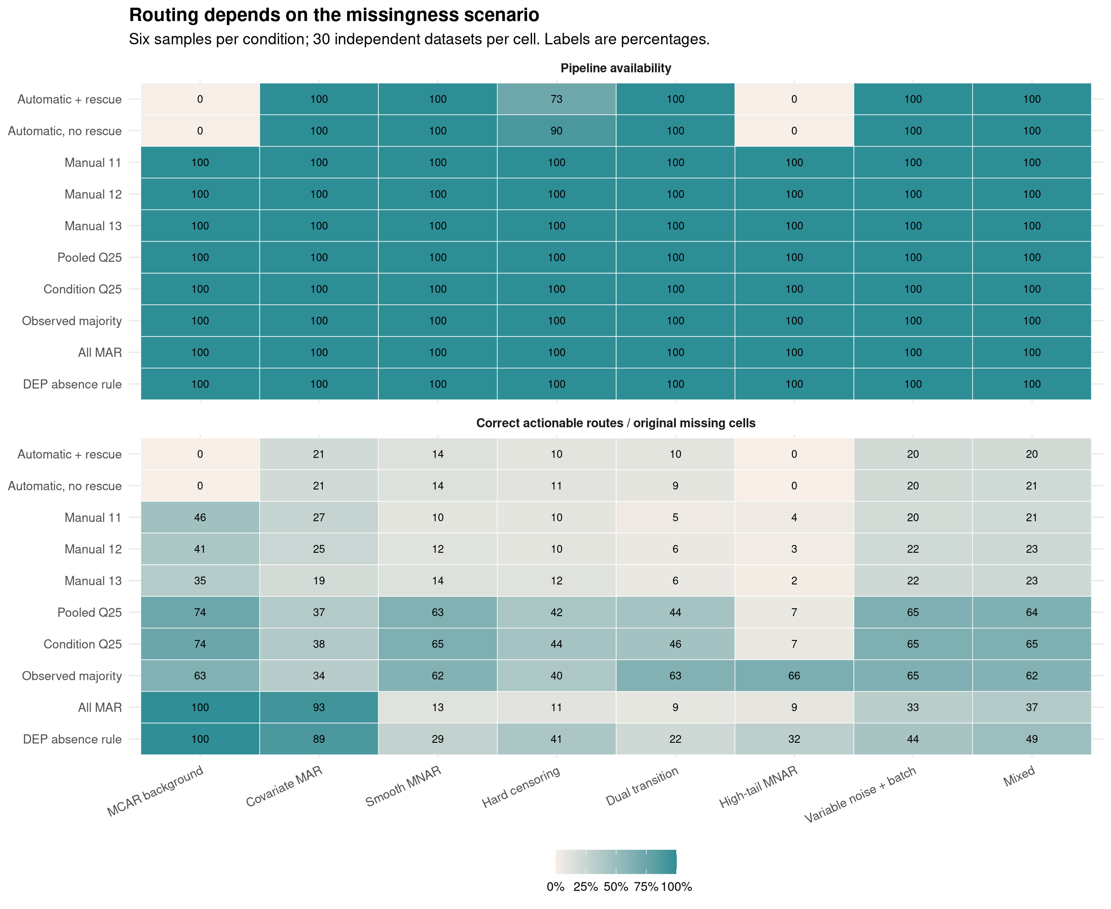
Figure 1. Scenario-specific routing. Each cell aggregates 30 independent datasets. Availability intervals and complete metrics appear in the supplement. Actionable correctness includes filtering and treats pipeline failures as unassigned.

Downstream consequences do not support universal superiority
Figure 2 and Table 1 show discovery trade-offs under the fixed processing choices. In mixed missingness, minimum rescue produced mean FDP 4.8% [3.9%, 5.7%] and power 64.5% [62.3%, 66.7%]. Disabling rescue produced mean FDP 7.6% [6.7%, 8.5%] and power 69.8% [68.2%, 71.4%]. The DEP-style route retained more features and reached power 91.5%, but its mean FDP was 17.7%. These results do not make one route universally preferable. Observed-only and dropout-aware inference address a different trade-off without requiring an imputed matrix as input. proDA satisfied the recorded convergence criterion in 90 of 90 simulated datasets. Of these, 89 stopped within the default 20 iterations.
Table 1. Mixed-missingness downstream results. Brackets show 95% Monte Carlo intervals; availability uses Wilson intervals.
Method | Availability | Retained | FDP | Power
Automatic + rescue | 100.0% [88.6%, 100.0%] | 60.2% | 4.8% [3.9%, 5.7%] | 64.5% [62.3%, 66.7%]
Automatic, no rescue | 100.0% [88.6%, 100.0%] | 61.3% | 7.6% [6.7%, 8.5%] | 69.8% [68.2%, 71.4%]
Manual 12 | 100.0% [88.6%, 100.0%] | 65.9% | 6.4% [5.7%, 7.1%] | 73.0% [71.7%, 74.3%]
DEP absence rule | 100.0% [88.6%, 100.0%] | 99.0% | 17.7% [16.5%, 18.8%] | 91.5% [90.6%, 92.3%]
Uniform kNN | 100.0% [88.6%, 100.0%] | 99.0% | 28.9% [27.5%, 30.3%] | 95.7% [94.9%, 96.4%]
Uniform MinProb | 100.0% [88.6%, 100.0%] | 99.0% | 2.2% [1.4%, 3.0%] | 34.6% [33.3%, 35.9%]
Observed-only limma | 100.0% [88.6%, 100.0%] | 99.0% | 2.9% [2.3%, 3.5%] | 70.0% [69.1%, 71.0%]
proDA | 100.0% [88.6%, 100.0%] | 99.0% | 7.1% [6.1%, 8.1%] | 88.6% [87.4%, 89.8%]
Uniform MinProb often reduced discoveries, whereas kNN could produce substantial false discoveries. The observed-only branch also failed to recover every changed feature, especially forced on/off features. Filtering, imputed variance, censoring bias, and imputer choice all contribute to these differences. We do not attribute every downstream difference solely to routing accuracy. Paired contrasts, conditional reconstruction errors, successful-run counts, and complete warning logs are supplied as CSV tables.
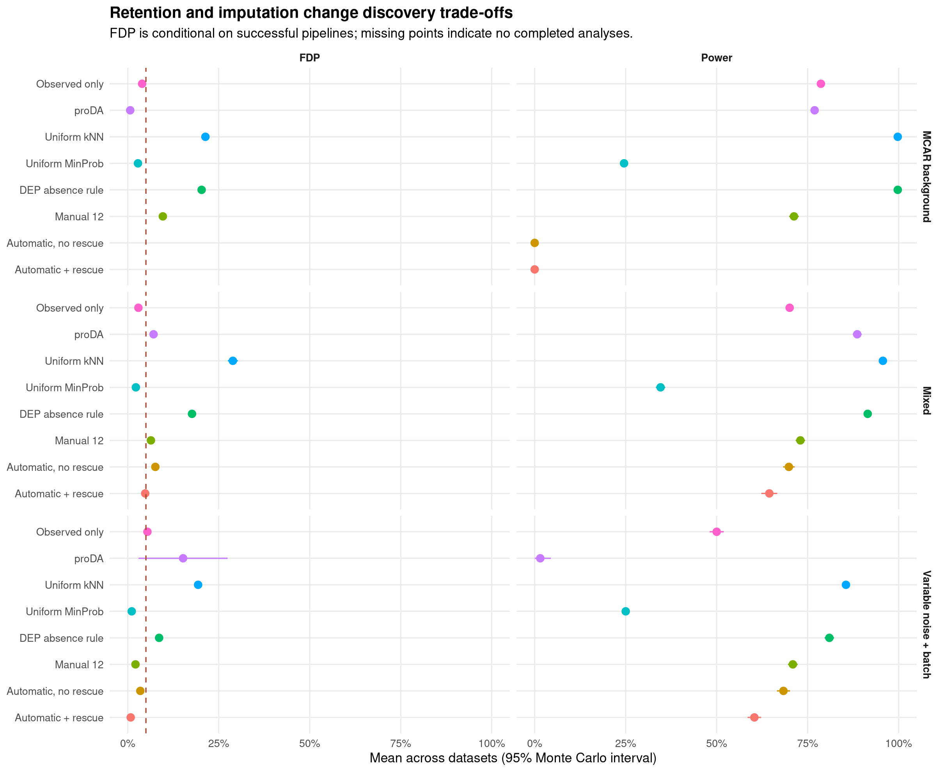
Figure 2. Downstream power and FDP. Points are dataset means with 95% Monte Carlo intervals. The dashed line marks 5% FDP, not a guarantee. Missing FDP points represent unavailable analyses; failed pipelines contribute zero unconditional power.

Public profiles have multiple plausible transitions
The donor-collapsed table had 26.7% missing cells and 51 globally absent protein groups. No-rescue automatic selection retained 1684 groups. Minimum rescue retained 1680 and inserted 71 values before final filtering. Both condition profiles contained multiple candidate transitions under both policies. Every bootstrap profile was also ambiguous. Strict ambiguity handling would therefore require manual decisions rather than accept these full-table outputs.
The full-table no-rescue cutoffs were 24.29 for AD and 22.84 for controls. The bootstrap distributions were broad and differed from these selected values (Figure 3). The no-rescue 2.5th–97.5th percentile ranges were 21.55–24.38 for AD and 22.54–25.01 for controls. These are descriptive stability ranges, not calibrated confidence intervals. Changing both no-rescue cutoffs by ±1 altered retention from 1545 to 1760 groups. These changes are not evidence of disease effects. They show that a numerically returned cutoff is not necessarily a stable scientific boundary.
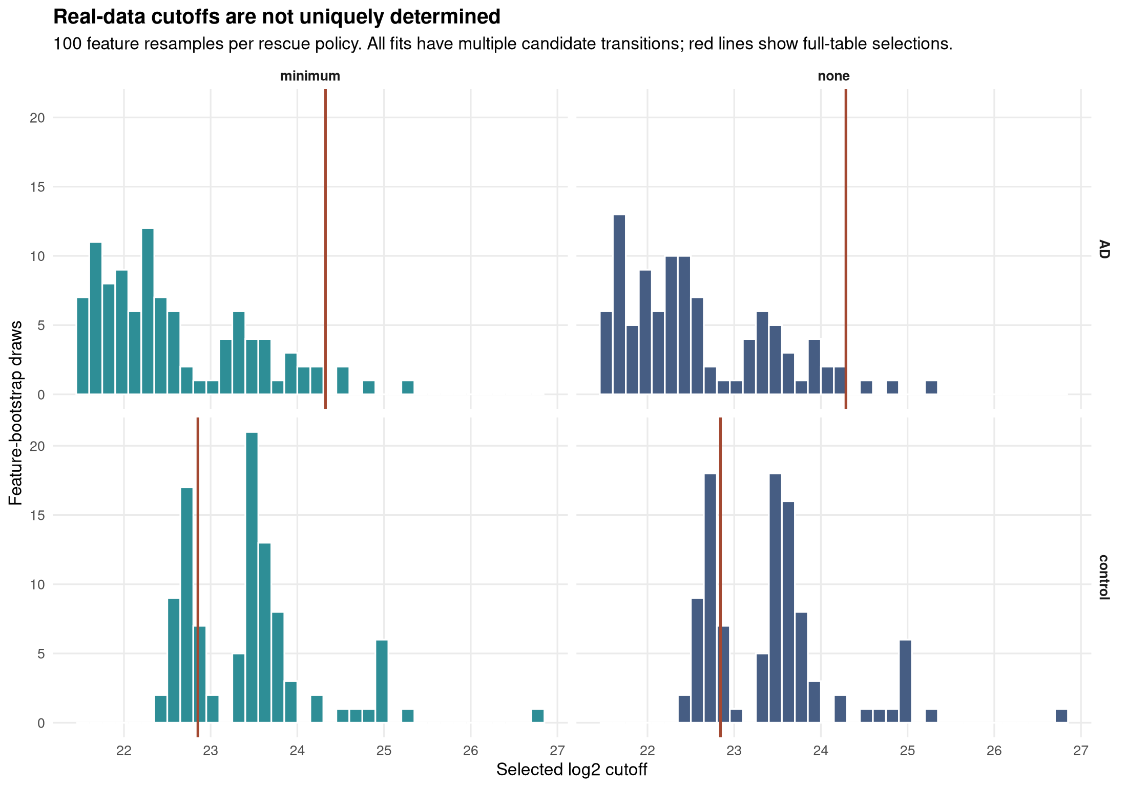
Figure 3. Feature-bootstrap cutoff stability in PXD020717. All 100 draws per rescue policy returned a cutoff but had multiple transitions. Red lines mark full-table selections. These distributions are descriptive, not donor-level confidence intervals.
The 20 rescue seeds preserved classifications, cutoffs, and retention exactly. They changed the logged sample receiving each artificial value, but all 71 rescued blocks belonged to subsequently dropped features. Consequently, no artificial values remained in this particular returned matrix, and its sample medians did not change across seeds. The largest absolute sample-median shift relative to the unrescued retained matrix was 0.00 log2 units. This null result does not establish seed invariance for datasets whose rescued features survive filtering.

Measured-value holdout does not remove selection bias
In random masking, both automatic policies declined all 30 datasets. In low-tail masking, both accepted all 30. No-rescue ImputeFinder had conditional missing-cell RMSE 1.91 log2 units. The DEP-style route had RMSE 1.62. These errors apply to returned features; the supplement reports retained and reconstructed fractions. They provide no evidence that ImputeFinder improves reconstruction generally. They also do not reveal errors for naturally absent measurements, which have no observed target in this dataset.

Controlled mixtures provide a separate downstream check
Table 2 reports the median-normalised iPRG2015 analysis. Counts sum across six correlated contrasts and must not be interpreted as six independent experiments. The supplement preserves every contrast, pipeline failure, spike estimate, and the unnormalised sensitivity analysis. Across both normalization choices, proDA satisfied its numerical criterion in 12 of 12 fits.
Table 2. External controlled-mixture results. Background calls are summed feature-contrast outcomes, not unique proteins. Missing counts indicate no completed contrasts.
Method | Completed contrasts | Spike discoveries | Background calls | Estimable spike effects
Automatic + rescue | 3/6 | 14/36 | 13 | 18/36
Automatic, no rescue | 3/6 | 14/36 | 28 | 18/36
DEP absence rule | 6/6 | 30/36 | 54 | 36/36
Uniform kNN | 6/6 | 30/36 | 170 | 36/36
Uniform MinProb | 6/6 | 30/36 | 36 | 36/36
Observed-only limma | 6/6 | 30/36 | 35 | 36/36
proDA | 6/6 | 24/36 | 8 | 36/36
One false background discovery alongside six true positives already yields FDP of at least 14.3% in a contrast. Conversely, zero observed false discoveries cannot establish general 5% FDR control. The external analysis tests performance on real instrument-derived intensities with known added concentrations. It does not remove the limits imposed by six spike proteins, technical replication, upstream matching, and relatively little missingness.

Discussion
ImputeFinder’s contribution is an explicit and inspectable routing contract. Original evidence, artificial insertions, absent blocks, rejected features, candidate cutoffs, and failures remain recoverable from the result. That contract supports sensitivity analysis and prevents a completed matrix from obscuring how its values were selected. It does not solve the general identification problem for missing-data mechanisms.
The counterexamples are consequential. Observed-covariate MAR can produce a descending intensity profile, while high-intensity MNAR violates the detector’s assumed direction. Hard censoring can leave too little observed transition evidence for automatic fitting. The full public-data table yielded multiple transitions in every condition and feature-bootstrap fit. These results argue for reviewing the stored diagnostics, reporting abstention, and retaining no-rescue analyses. They do not support choosing manual cutoffs solely to maximise a desired downstream discovery count.
Rescue should be treated as an explicit modelling intervention. The inserted minimum can affect the fitted profile, feature retention, imputer training, and normalization summaries. The absence of a value does not establish that the biological quantity was near the smallest observed intensity. Users who need that assumption must justify it for their assay or retain an absent state.
The comparison has defined limits. Simulations use simplified feature distributions and only two conditions. The downstream comparison fixes a small imputer set and does not optimise each established workflow. Deep-learning and Bayesian reconstruction methods provide additional approaches that were not evaluated here [18,19]. The observational protein table comes from one assay subset with disease-related heterogeneity and no known naturally missing values. The independent controlled-mixture experiment contains only six spike proteins and technical replication. Complete-feature masking introduces selection bias and does not recreate acquisition failures. Feature-bootstrap stability is not calibrated under correlated protein groups. Single-imputation inference can remain anticonservative even when reconstruction appears satisfactory.
Consequently, this article supports software correctness, traceability, and bounded empirical characterisation. It does not support claims of first condition-aware mixed imputation, mechanism recovery from arbitrary observations, universal superiority, or validated disease discovery. Studies requiring those stronger claims need corresponding experimental truth, appropriate competing implementations, and application-specific calibration.

Software and reproducibility
The package is distributed under GPL-3.0-or-later at https://github.com/eturkes/imputefinder. The evaluated package version is 0.99.8; the automatic detector is method version 3. The source archive is not described as an accepted Bioconductor release.
publication/reproduce.py regenerates source extraction, all analyses, figures, and this article. Its --verify mode independently reruns the analyses and compares deterministic evidence hashes. The source-data manifest pins source and output SHA256 digests. publication/check-results.R validates required dimensions, denominators, and failure handling. tools/check-package.R builds the source package and runs examples, tests, and vignettes. The supplementary files include all per-dataset outcomes, structured real-data diagnostics, sensitivity tables, and software versions. No hosted continuous-integration result, journal acceptance, or public archive deposit is inferred from these local checks.

Declarations for author confirmation
The displayed author name follows the package metadata and is provisional for journal submission. The final author list, affiliations, contributions, funding, and competing-interest statements require author confirmation. This analysis reuses public data and recruits no new participants. The corresponding ethics and data-reuse wording requires author confirmation against the selected journal’s requirements. The target journal, archival release identifier, and submission details remain editorial decisions.

References
- Rubin DB. Inference and missing data. Biometrika. 1976;63:581–592. https://doi.org/10.1093/biomet/63.3.581.
- Nabi R, Bhattacharya R. On Testability and Goodness of Fit Tests in Missing Data Models. Proceedings of UAI. 2023;216:1467–1477. https://proceedings.mlr.press/v216/nabi23a.html.
- Li M, Smyth GK. Neither random nor censored: estimating intensity-dependent probabilities for missing values in label-free proteomics. Bioinformatics. 2023;39:btad200. https://doi.org/10.1093/bioinformatics/btad200.
- Zhang X, Smits AH, van Tilburg GBA, Ovaa H, Huber W, Vermeulen M. Proteome-wide identification of ubiquitin interactions using UbIA-MS. Nature Protocols. 2018;13:530–550. https://doi.org/10.1038/nprot.2017.147.
- DEP. Missing value handling. Official package workflow. https://bioconductor.posit.co/packages/3.21/bioc/vignettes/DEP/inst/doc/MissingValues.html.
- Wieczorek S, Combes F, Lazar C, et al. DAPAR & ProStaR: software to perform statistical analyses in quantitative discovery proteomics. Bioinformatics. 2017;33:135–136. https://doi.org/10.1093/bioinformatics/btw580.
- Hediyeh-Zadeh S, Webb AI, Davis MJ. MsImpute: Estimation of Missing Peptide Intensity Data in Label-Free Quantitative Mass Spectrometry. Molecular & Cellular Proteomics. 2023;22:100558. https://doi.org/10.1016/j.mcpro.2023.100558.
- Shi Y, Zhong H, Rogalski JC, Foster LJ. Optimizing imputation strategies for mass spectrometry-based proteomics considering intensity and missing value rates. Computational and Structural Biotechnology Journal. 2025;27:1818–1826. https://doi.org/10.1016/j.csbj.2025.04.041.
- Fowler SL, Behr TS, Turkes E, et al. Tau filaments are tethered within brain extracellular vesicles in Alzheimer’s disease. Nature Neuroscience. 2025;28:40–48. https://doi.org/10.1038/s41593-024-01801-5.
- Turkes E. Development of Gene Set Enrichment and Imputation Methods for Transcriptomics and Proteomics: Application in the Study of Neurofibrillary Tangle-bearing Neurons in Alzheimer’s Disease. Doctoral thesis. University College London; 2025. https://discovery.ucl.ac.uk/id/eprint/10215006/.
- Harris L, Fondrie WE, Oh S, Noble WS. Evaluating Proteomics Imputation Methods with Improved Criteria. Journal of Proteome Research. 2023;22:3427–3438. https://doi.org/10.1021/acs.jproteome.3c00205.
- Ritchie ME, Phipson B, Wu D, et al. limma powers differential expression analyses for RNA-sequencing and microarray studies. Nucleic Acids Research. 2015;43:e47. https://doi.org/10.1093/nar/gkv007.
- Ahlmann-Eltze C, Anders S. proDA: Probabilistic Dropout Analysis for Identifying Differentially Abundant Proteins in Label-Free Mass Spectrometry. bioRxiv, preprint. 2020 revision. https://doi.org/10.1101/661496. Software: https://doi.org/10.18129/B9.bioc.proDA.
- Benjamini Y, Hochberg Y. Controlling the false discovery rate: a practical and powerful approach to multiple testing. Journal of the Royal Statistical Society B. 1995;57:289–300. https://doi.org/10.1111/j.2517-6161.1995.tb02031.x.
- Wesseling H, et al. Tau PTM Profiles Identify Patient Heterogeneity and Stages of Alzheimer’s Disease. Cell. 2020;183:1699–1713.e13. https://doi.org/10.1016/j.cell.2020.10.029.
- Choi M, Eren-Dogu ZF, Colangelo C, et al. ABRF Proteome Informatics Research Group (iPRG) 2015 Study: Detection of Differentially Abundant Proteins in Label-Free Quantitative LC-MS/MS Experiments. Journal of Proteome Research. 2017;16:945–957. https://doi.org/10.1021/acs.jproteome.6b00881. Committee spike design: https://abrf.org/wp-content/uploads/iPRG15.pdf.
- Bloom J, Triantafyllidis A, Quaglieri A, Ngov PB, Infusini G, Webb A. Mass Dynamics 1.0: A Streamlined, Web-Based Environment for Analyzing, Sharing, and Integrating Label-Free Data. Journal of Proteome Research. 2021;20:5180–5188. https://doi.org/10.1021/acs.jproteome.1c00683.
- Webel H, Niu L, Nielsen AB, et al. Imputation of label-free quantitative mass spectrometry-based proteomics data using self-supervised deep learning. Nature Communications. 2024;15:3599. https://doi.org/10.1038/s41467-024-48711-5.
- He J, et al. msBayesImpute as a versatile framework for addressing missing values in biomedical mass spectrometry proteomics data. Communications Chemistry. 2026. https://doi.org/10.1038/s42004-026-02106-3.
- Lazar C, Burger T. imputeLCMD: A Collection of Methods for Left-Censored Missing Data Imputation. R package version 2.1; 2022. https://doi.org/10.32614/CRAN.package.imputeLCMD.

