Go to <https://Make.powerapps.com> and Data -> Custom Connectors

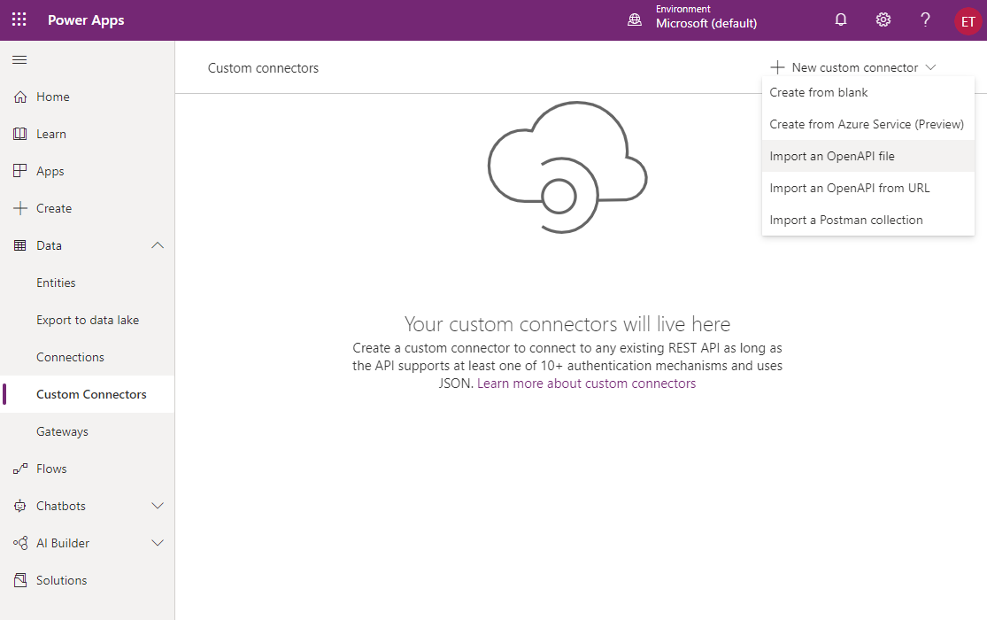

Click on new Connector, import an Open API File,

Give a name to your connector,

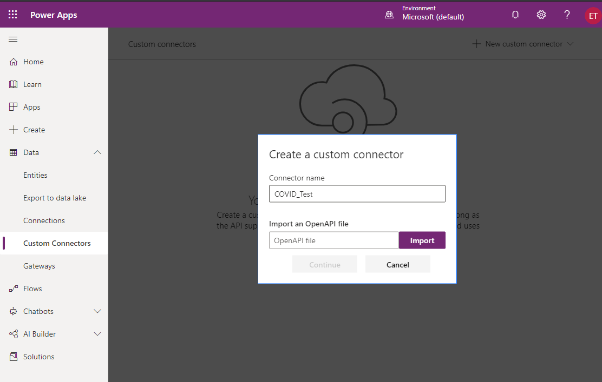

Select the Custom Control from the files you downloaded from github,

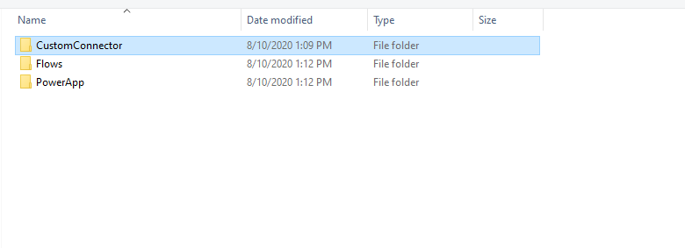

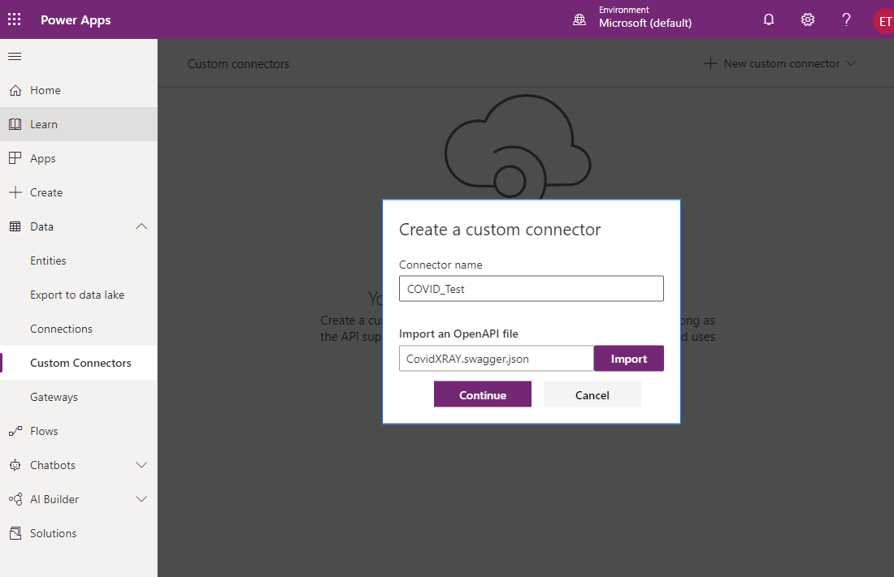

Upload some icon and click on create connector.

After the connector is created now you can test it with API KEY

“Bearer 4dSyxGWssgFLdaqc52OTXJGuMlZG9g9h”

Click on Test , New Connection,

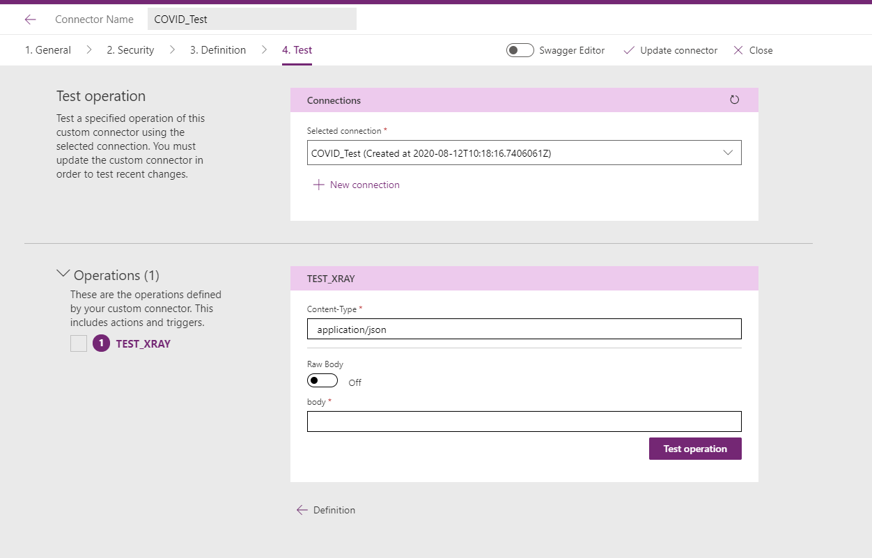

Pass sample covid xray to body of the request <https://qnacovdi19app-bot.azurewebsites.net/image/Covid.png>

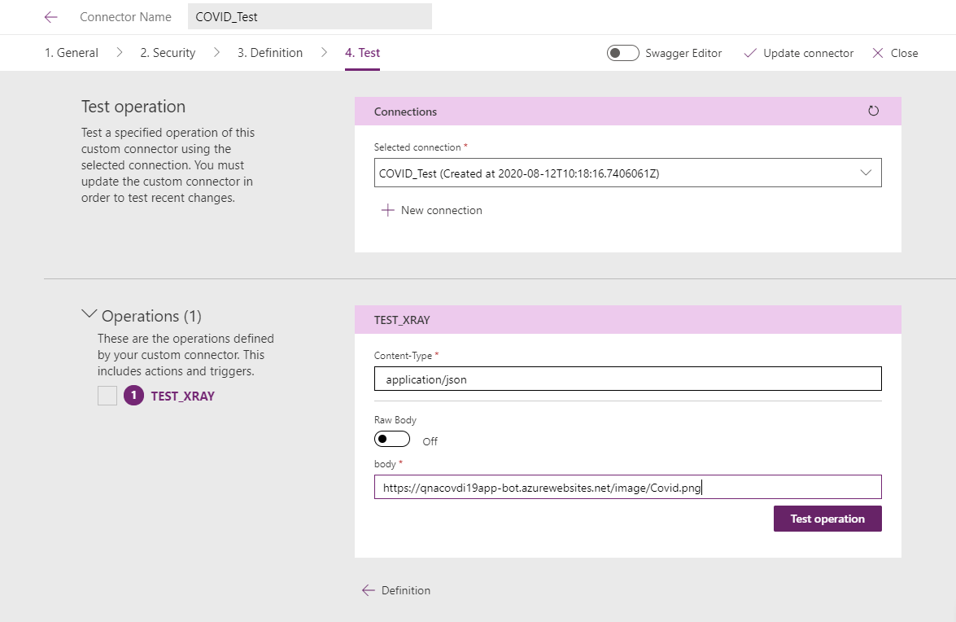

Click on Test Operation and you should see a result like below.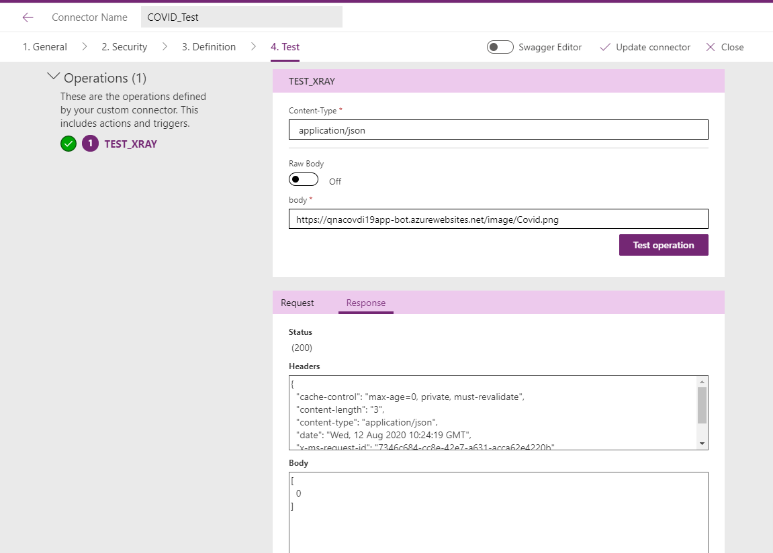

Now go to flow.microsoft.com

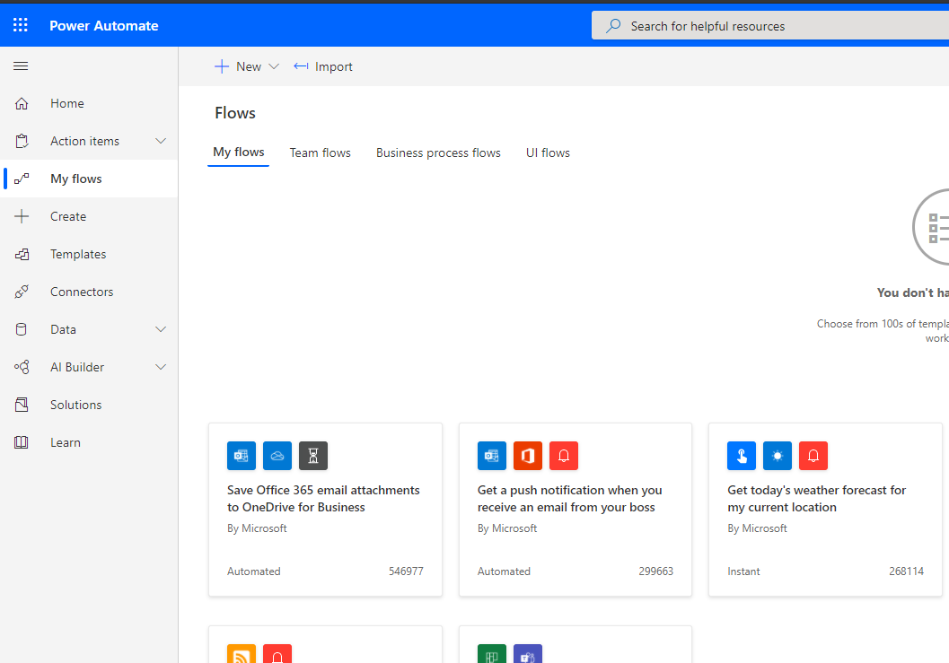

Click on Import and choose the flow files to import both of them,

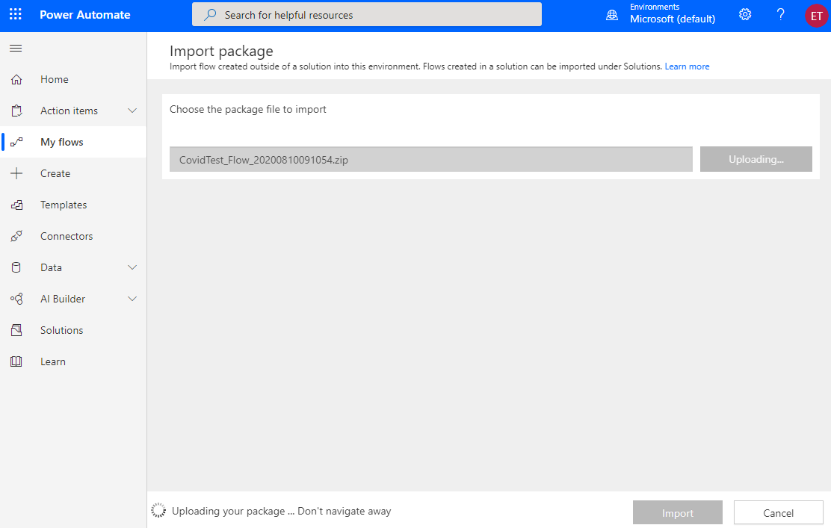

Select the connector and connections,

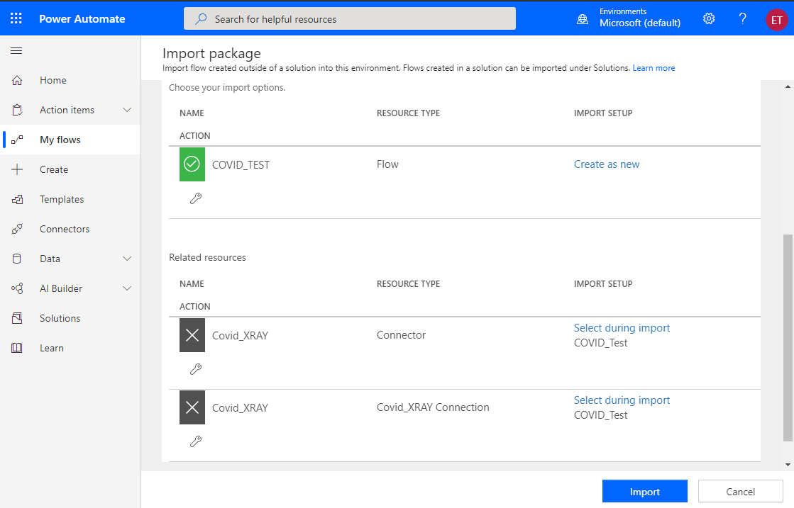

Click on Import.

On The Second Flow, make sure to create OneDrive and outlook connections, and then import.

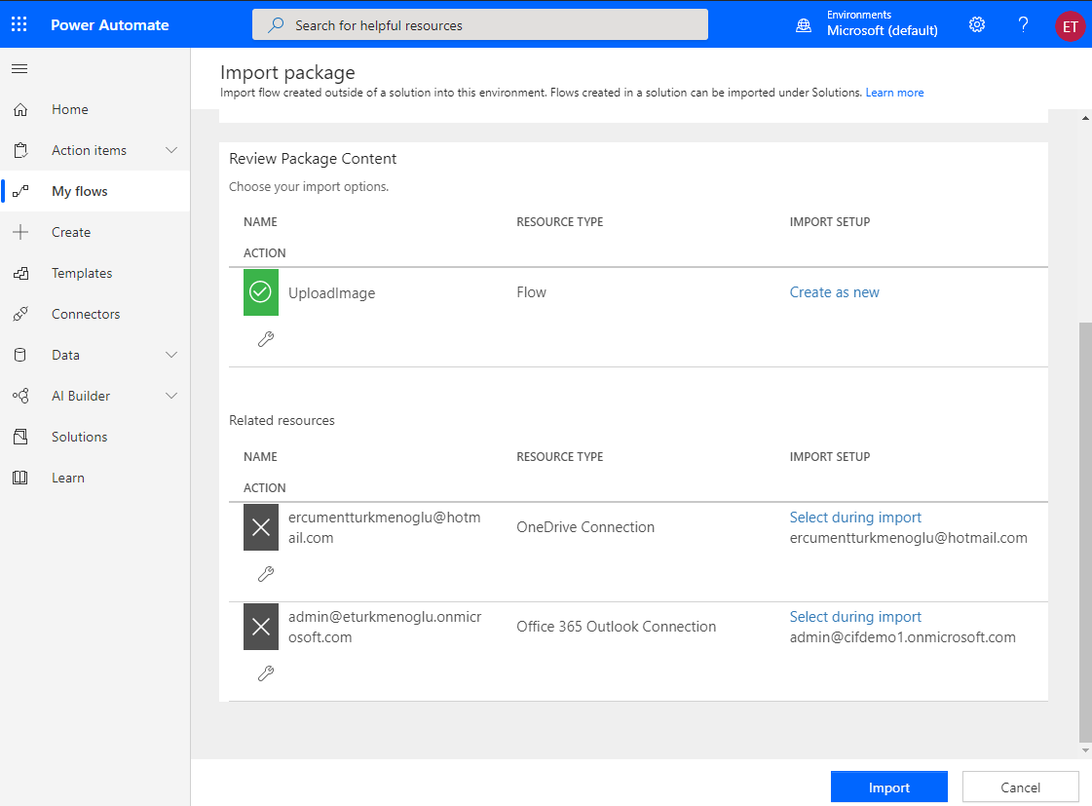

After Successful import you will see below screen,

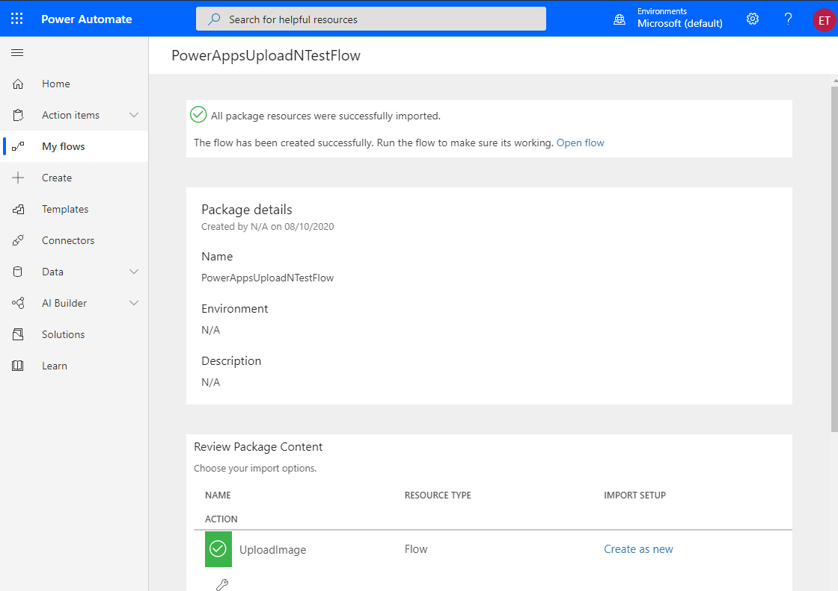

So far we have configured our connector + Microsoft Flows.

Now it is time to import our PowerApp for XRAY Test. Go to make.powerapps.com

Click on Import CanvasApp

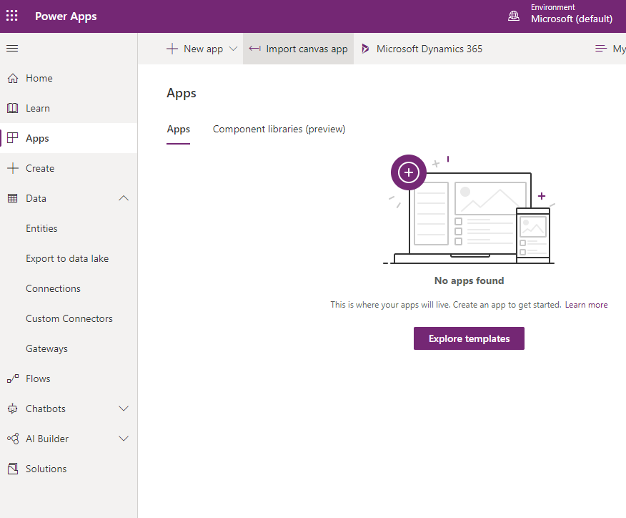

Choose the PowerApp downloaded from Github from the files,

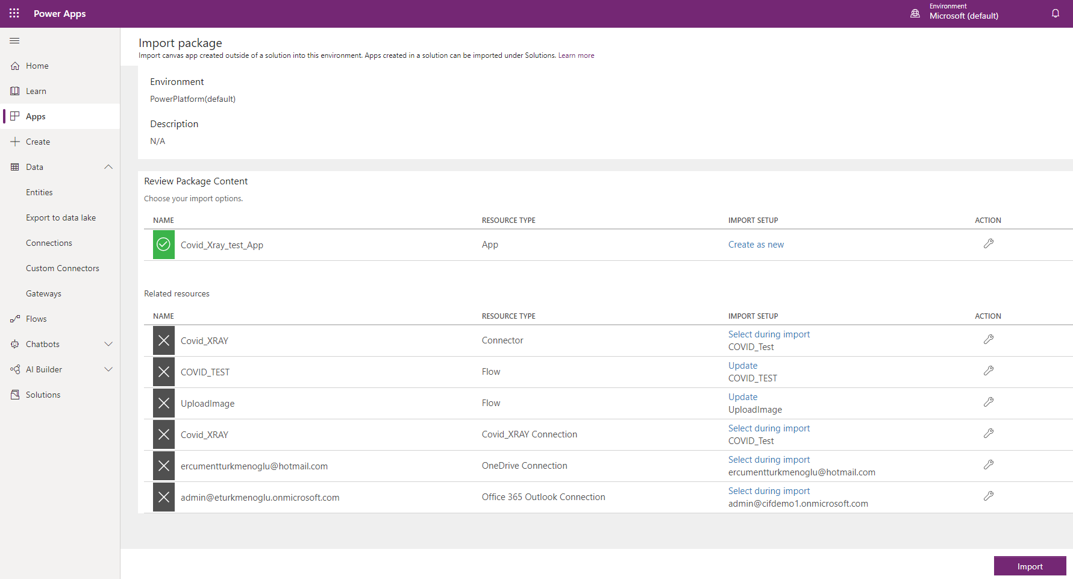

Mapp all the required components to your environment.

And click import.Once your app is successfully imported, open it up by clicking on Play as below

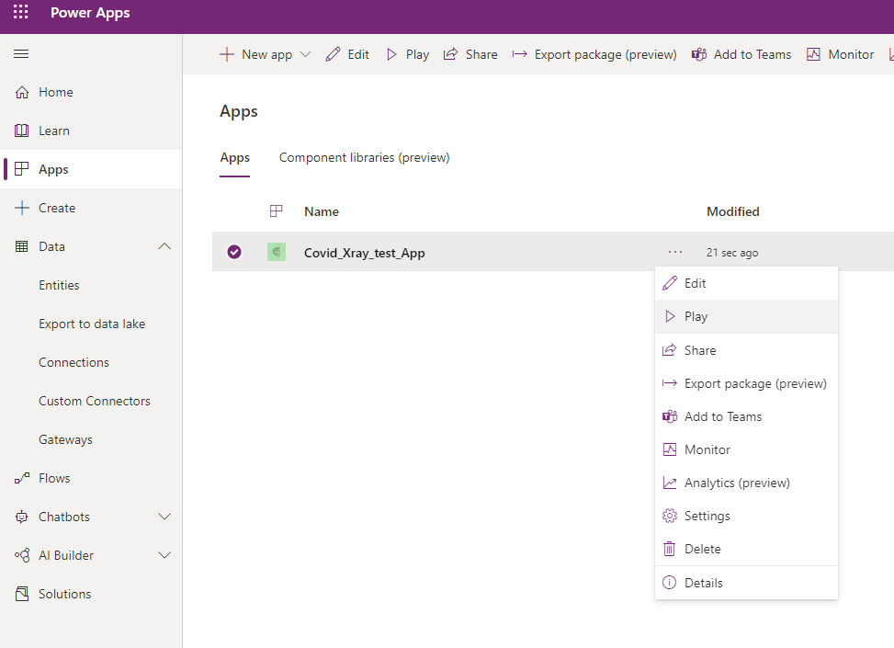

If PowerApp Prompts you that this app needs premium license for using these components, just click on next and start trial.

Application needs to use custom components, and custom connectors in Power Platform world is something premium, hence the notification.

After that click allow for all the connections,

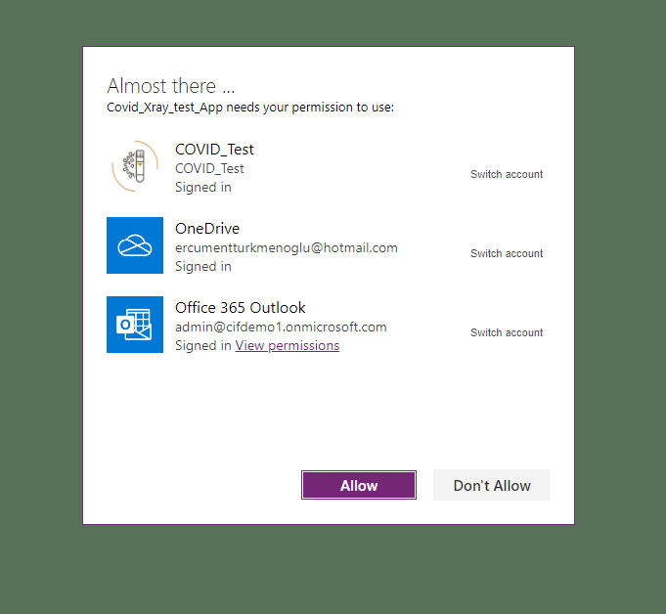

Now you have your Sample App to test Covid scenarios thru Chest XRAY Images.

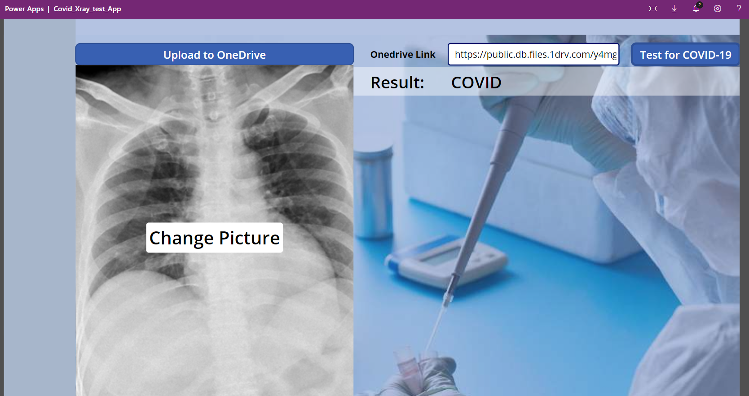

That’s it ! Feel free to edit the app and connectors 😊