



**businessONLINE**

businessONLINE –

HOW TO INITIATE A LOCAL CURRENCY PAYMENT

# HOW TO INITIATE A LOCAL CURRENCY PAYMENT

* Login to **businessONLINE**

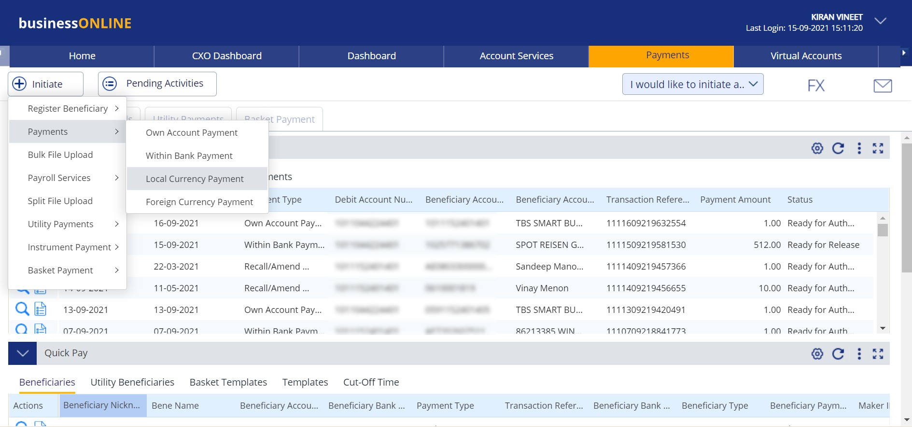

1. **Click on Payments**
2. **Click on Initiate > Payments**
3. **Click on Local Currency Payment**

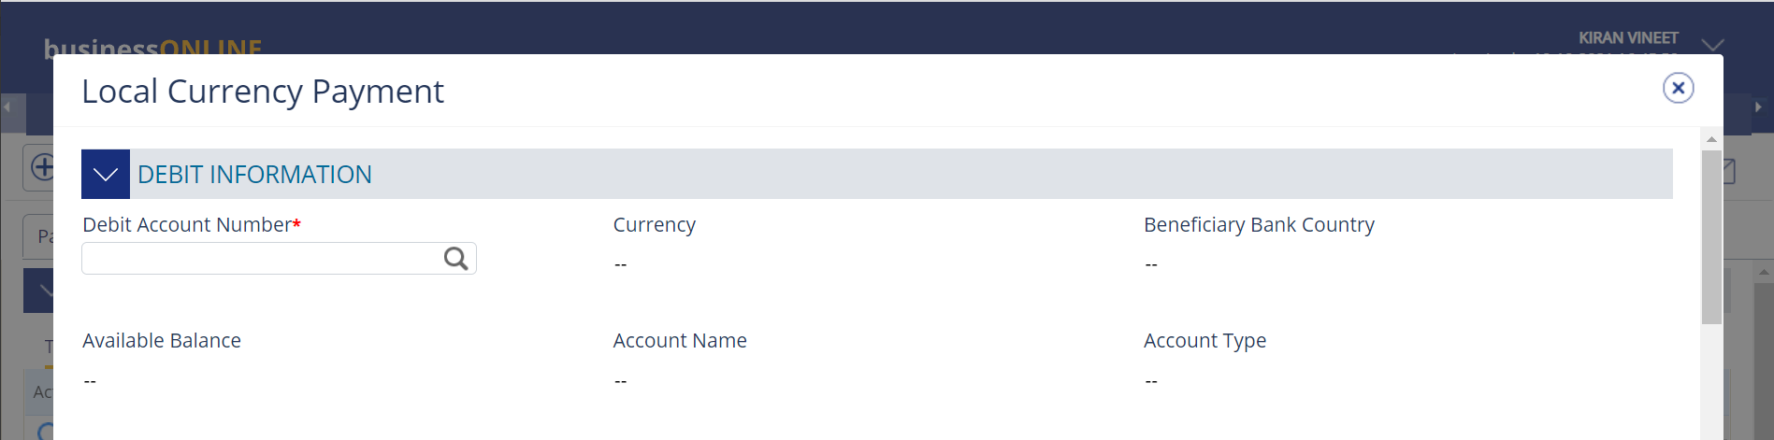

**4. Click on the search icon**

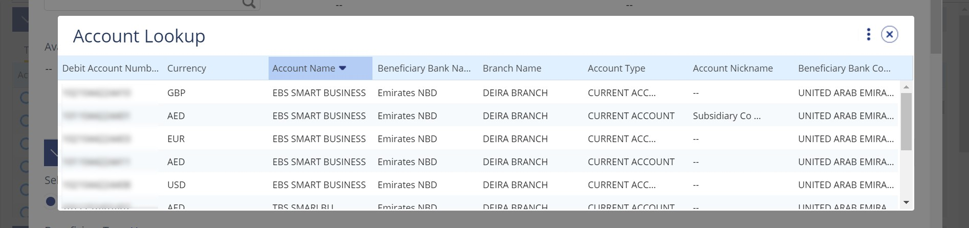

**5. Double click on the account from which you would like to initiate the payment.**

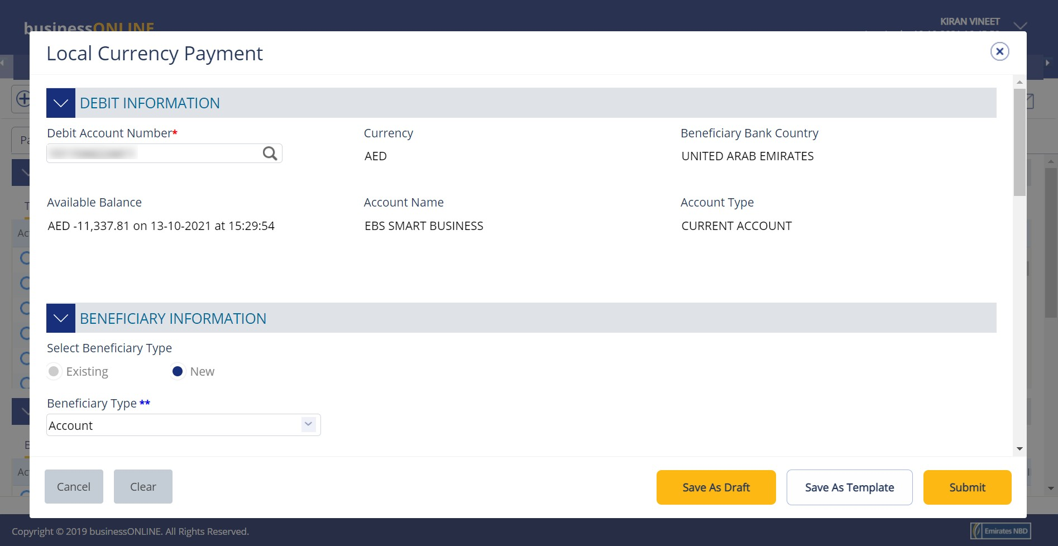

1. **Select New**
2. **Scroll down**

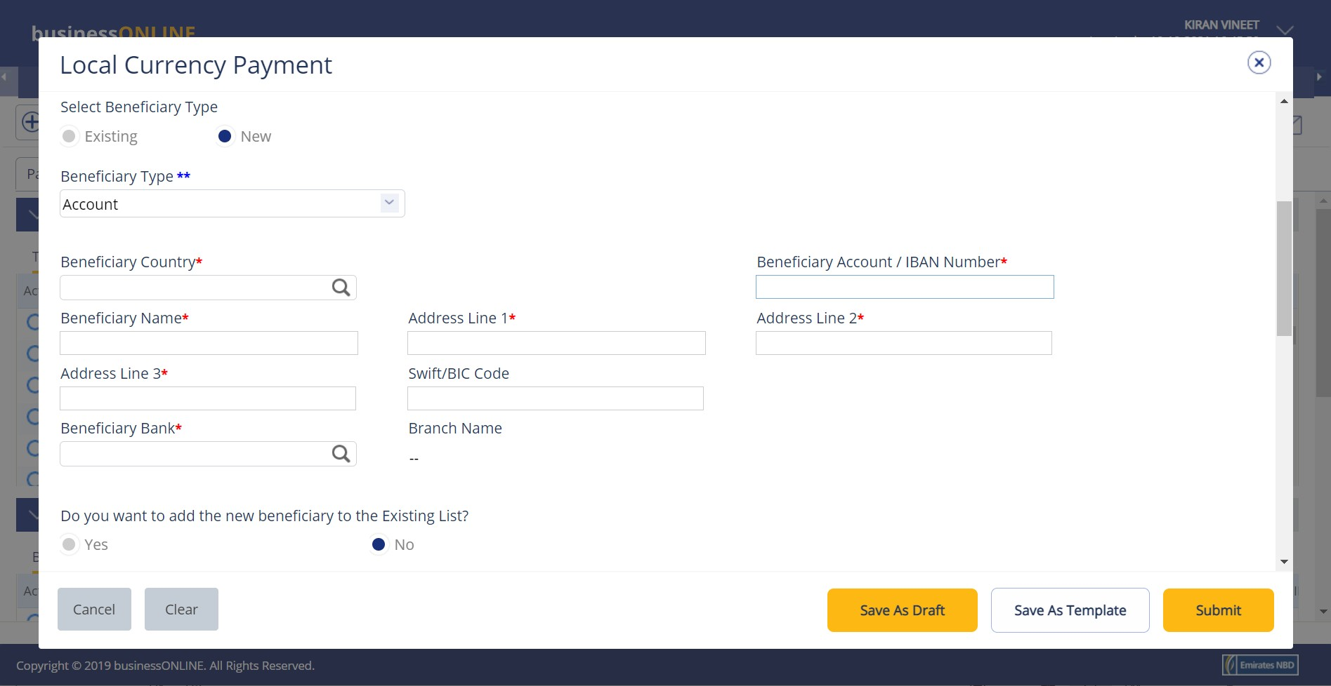

**8. Click on the search icon**

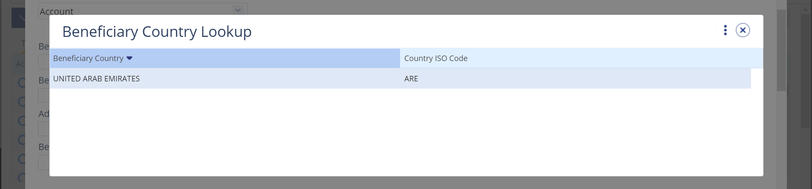

**9. Double click on United Arab Emirates**

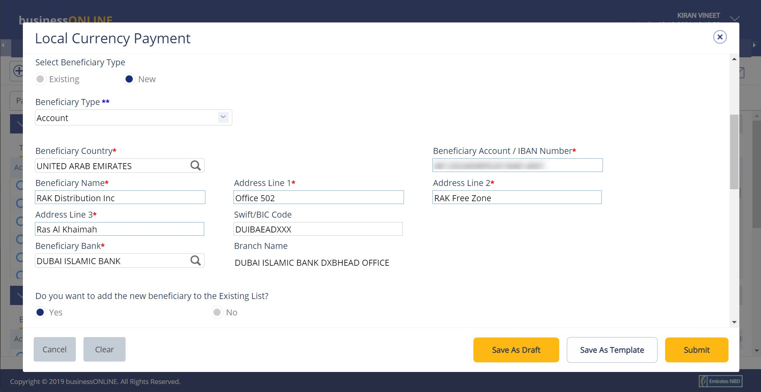

1. **Type in the beneficiary’s IBAN**
2. **Type in the beneficiary’s name, address details and bank SWIFT code**
3. **Scroll down**

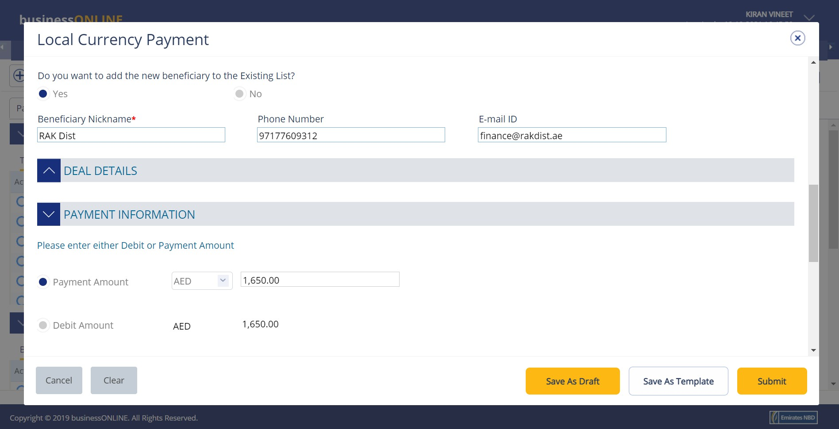

**13. If you would like to save the beneficiary’s details to**

**make payments to them in the future, select Yes.**

**14. Create a nickname for your beneficiary**

**15. Enter the beneficiary’s contact details**

**Note: The currency of the payment will be selected automatically**

1. **Type in the payment amount**
2. **Scroll down**

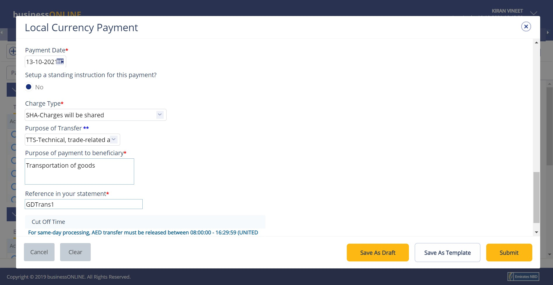

**(Optional step): To schedule this payment for a future date, click on the calendar icon and select a date.**

1. **Select who will pay the transaction charges**
2. **Select the purpose of the transfer from the dropdown list**
3. **Type in the description for this payment which you would like your beneficiary to see**
4. **Type in a reference for this payment which will appear in your bank statement**
5. **Click on Submit**

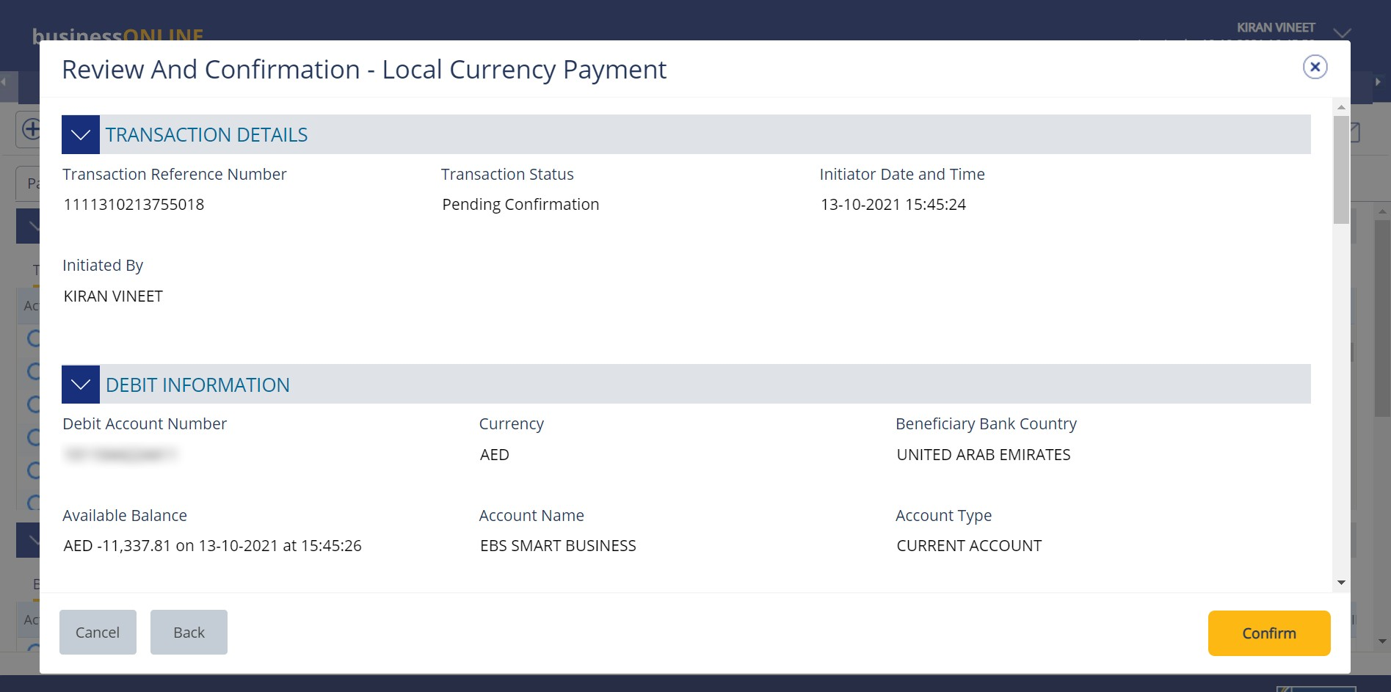

1. **Review the payment details on the screen**
2. **Click on Confirm**

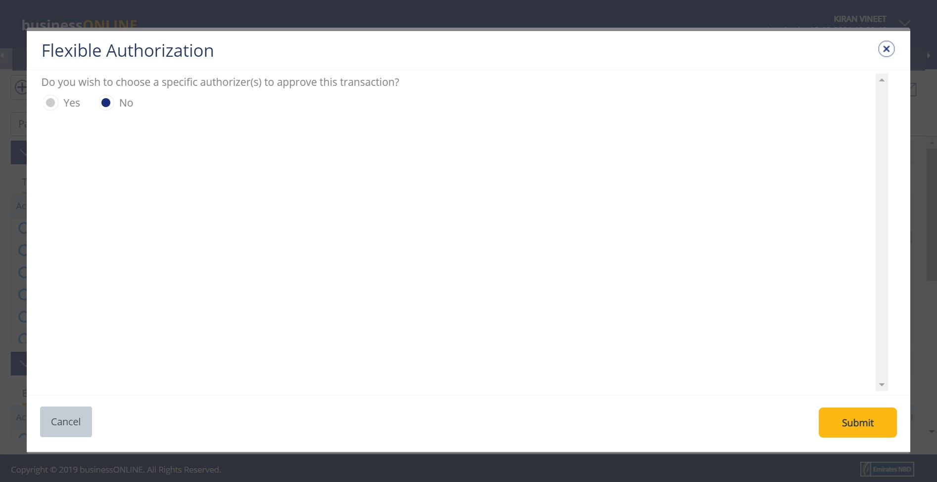

1. **Select No**
2. **Click on Submit**

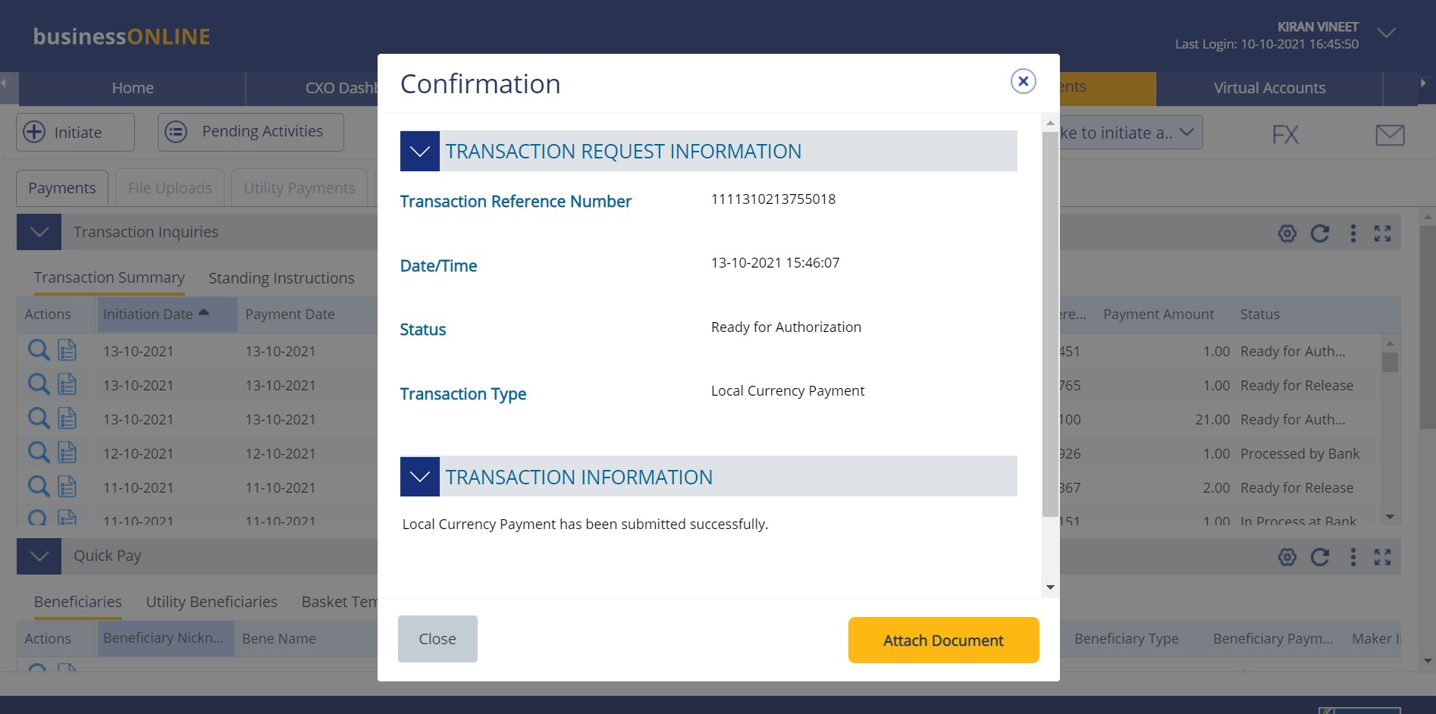

**27. Click on Close**

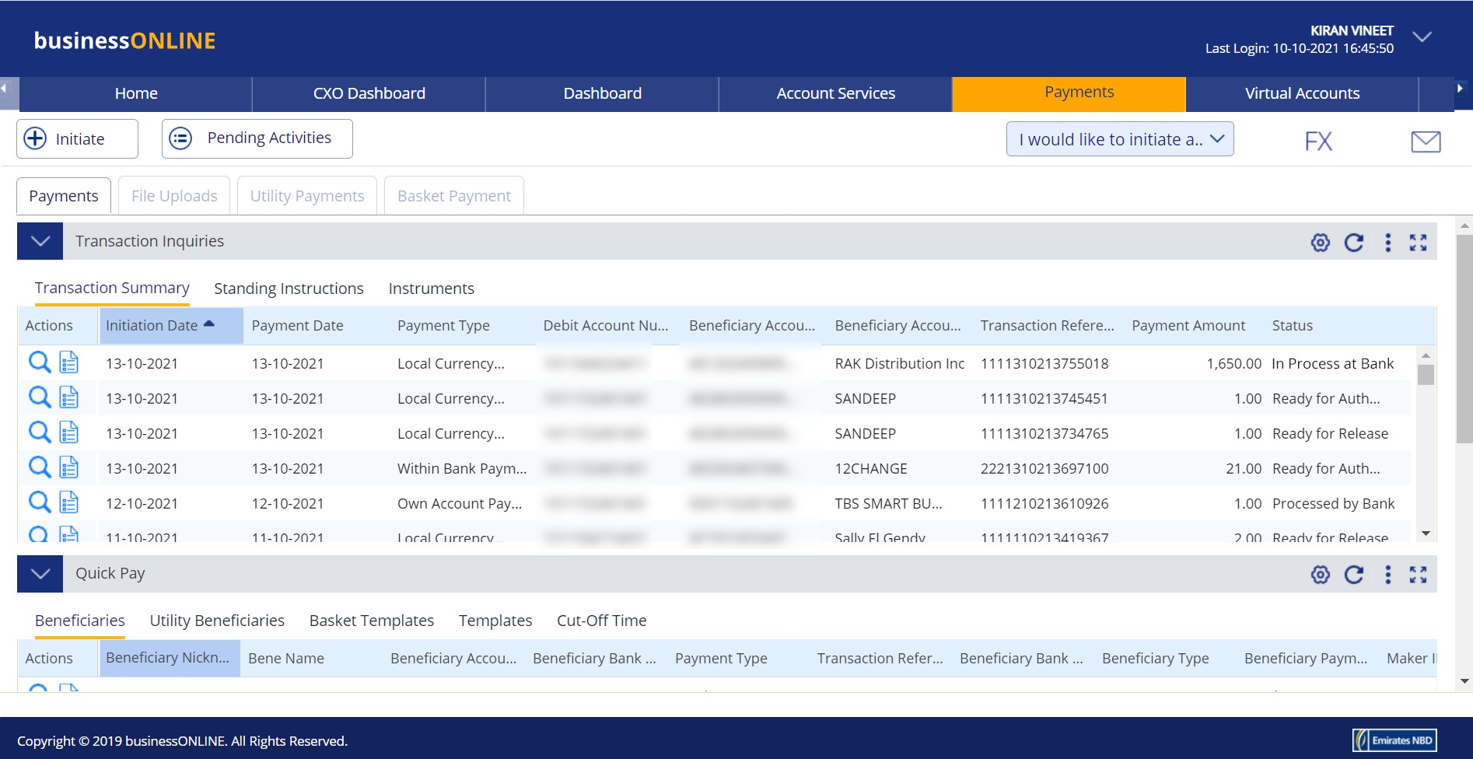

1. **Click on the Refresh icon**
2. **Your payment will appear here**
3. **The payment status will appear here (see notes below)**

## Notes: Payment Statuses and what they mean

* + **In Process at Bank** – the payment is completed and is being processed by the bank.
  + **Ready for Authorization** – the payment requires approvals from authorizers within your company. (see Page 8)
  + **Ready for Release** – the payment has been approved by the authorizers but requires to be released (see Page 12)

# HOW TO AUTHORIZE A PAYMENT

* If you have access to authorize payments, follow the steps below.
* If not, request the nominated person from your company who has authorization access to login to

**businessONLINE** and follow the steps below:



1. **Click on Payments**
2. **Click on Pending Activities**

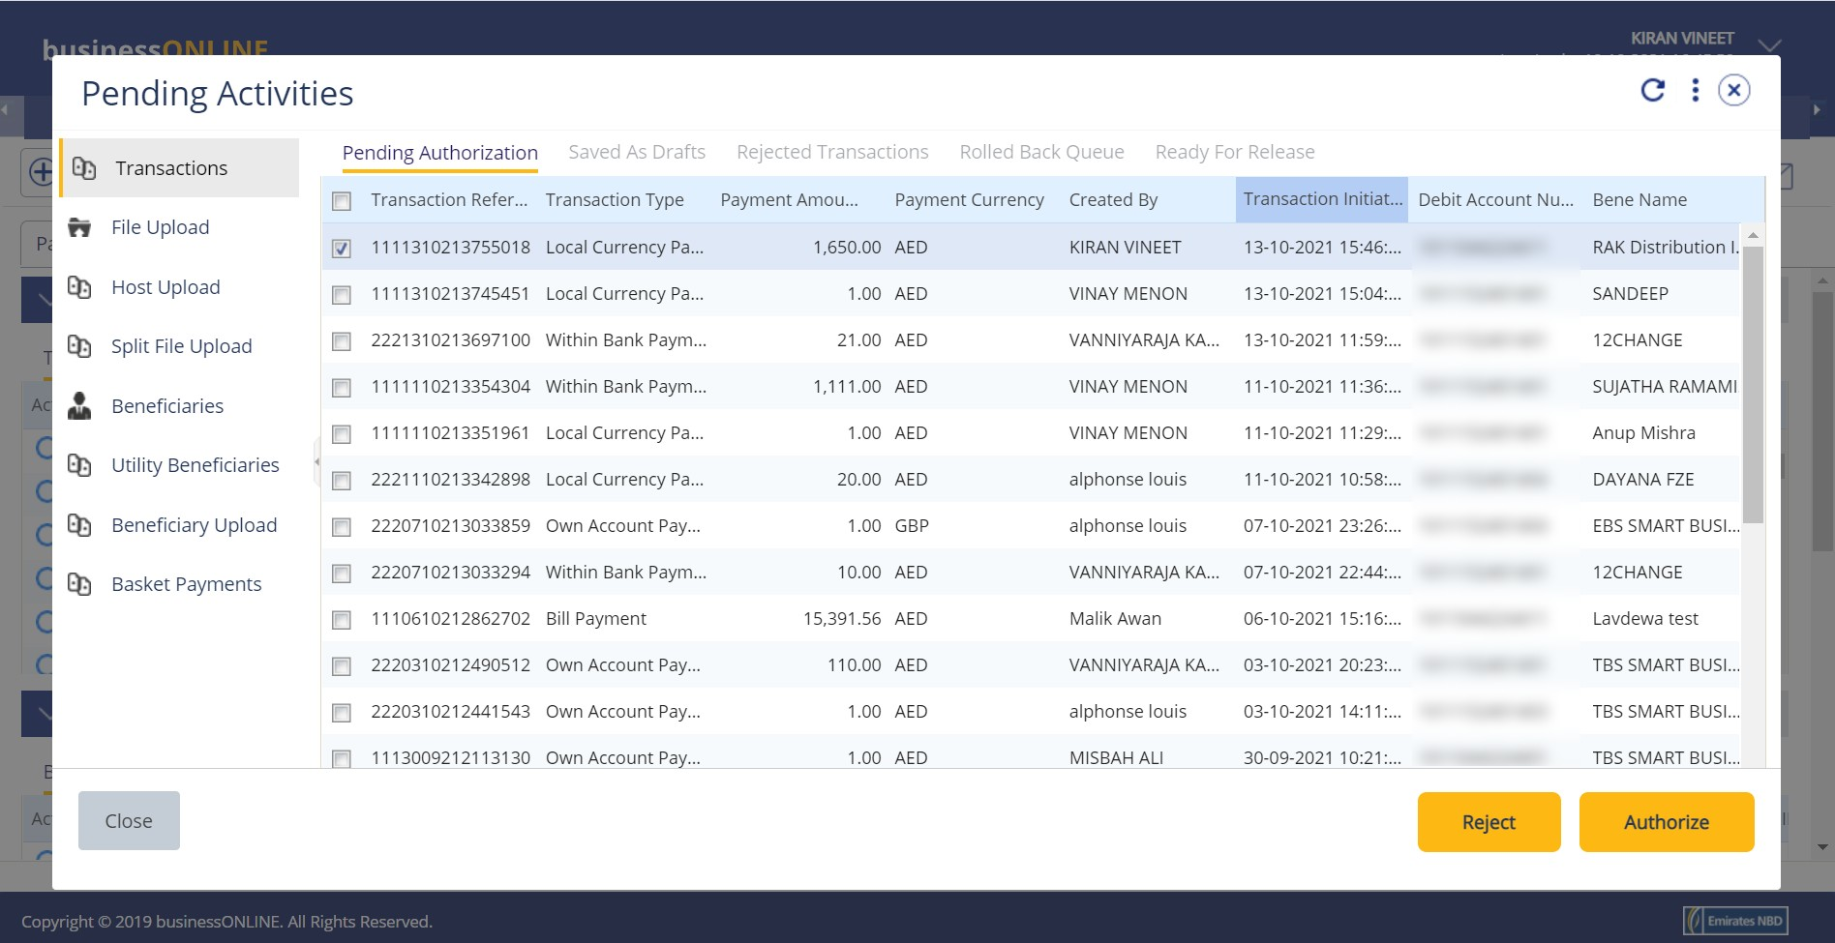

1. **Select the checkbox for the Payment you would like to authorize**
2. **Click on Authorize**

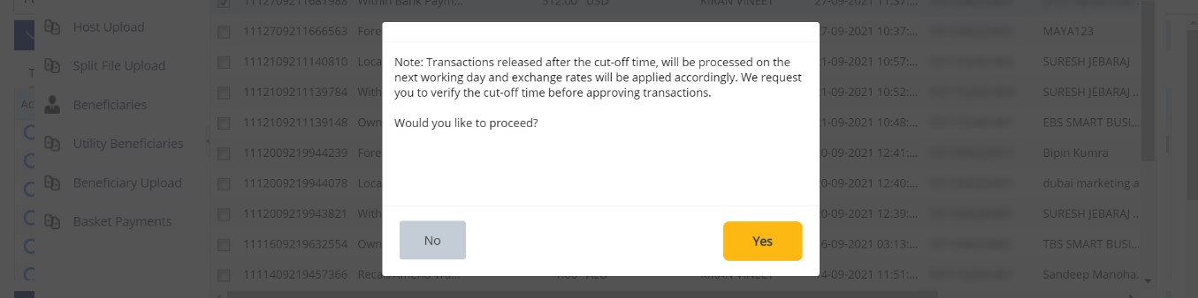

**5. Click on Yes**

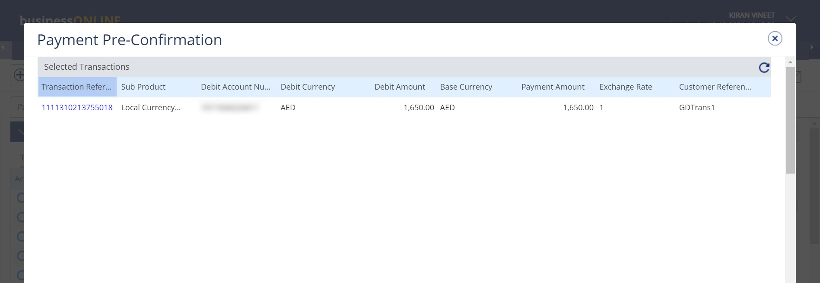

**6. Scroll down**

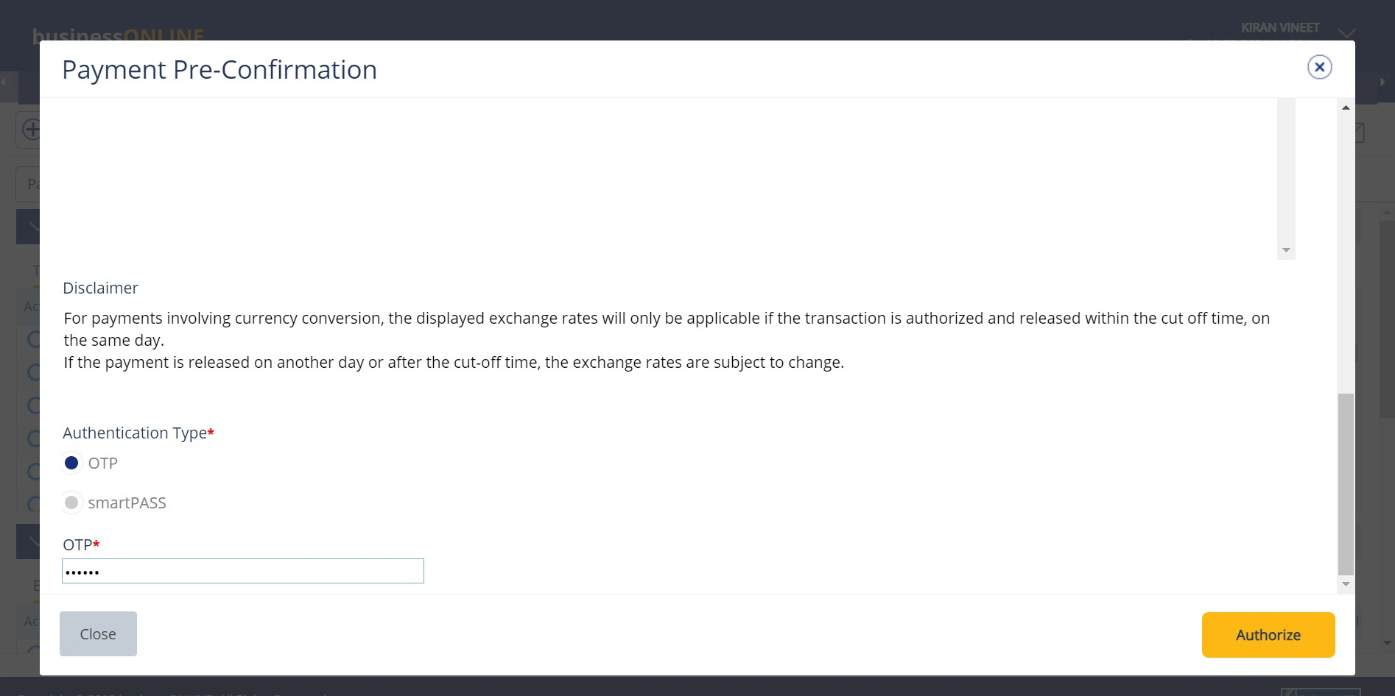

**7. Select the type of Authentication e.g. OTP**

**8. Enter the PIN received on your mobile device**

**9. Click on Authorize**

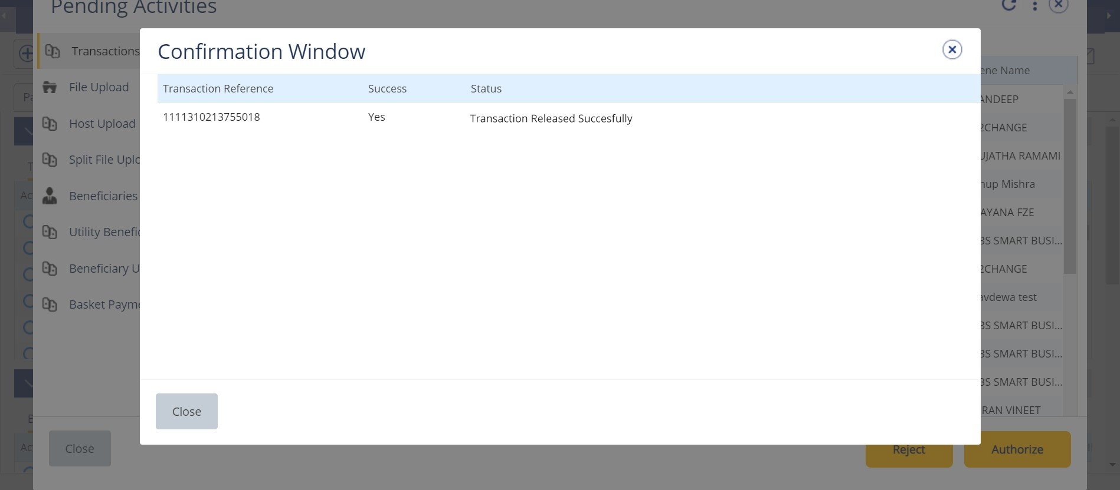

**10. Click on Close**



**11. Click on Close**

* If you online setup requires more than one approver to authorize the payment, each of them would have to authorize the payment as described in the steps, previously.
* After all the approvals are completed, the payment status will appear as **In Process at Bank**
* Follow the steps on the next page, to view the status of your payment.



1. **Click on the Refresh icon**
2. **Your payment will appear here**
3. **The Payment Status will appear here (See notes below)**

## Notes: Payment Statuses and what they mean

* + **In Process at Bank** – the payment is completed and is being processed by the bank.
  + **Ready for Release** – the payment has been approved by the authorizers but requires to be released (see Page 12)

# HOW TO RELEASE A PAYMENT

* If you have access to Release payments, follow the steps below.
* If not, request the nominated person from your company who has access to Release payments to login to **businessONLINE** and follow the steps below:

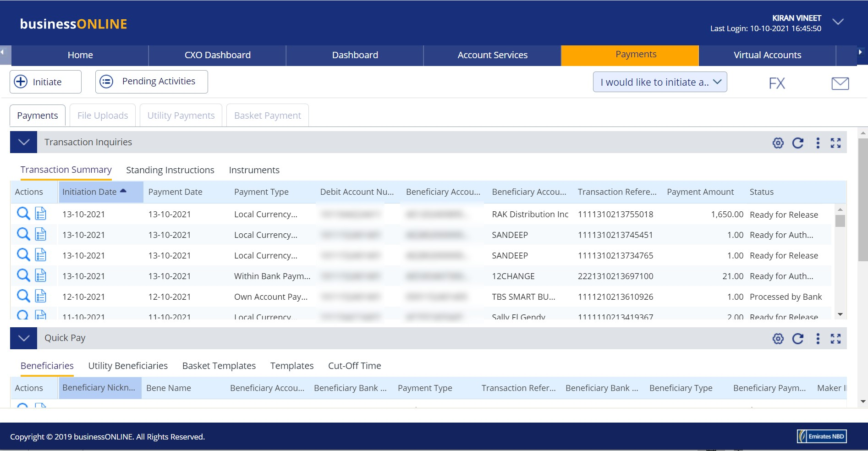

1. **Click on Payments**
2. **Click on Pending Activities**

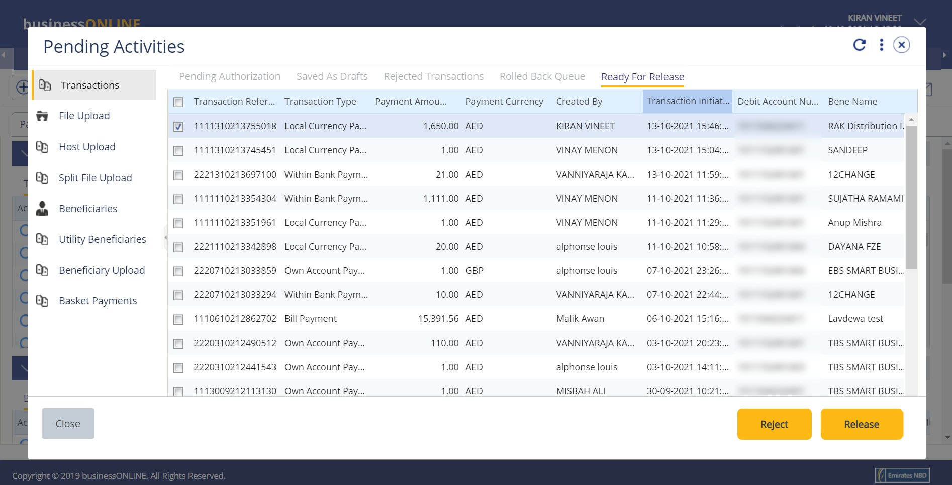

1. **Select the checkbox for the Payment you would like to Release**
2. **Click on Release**



**5. Click on Close**

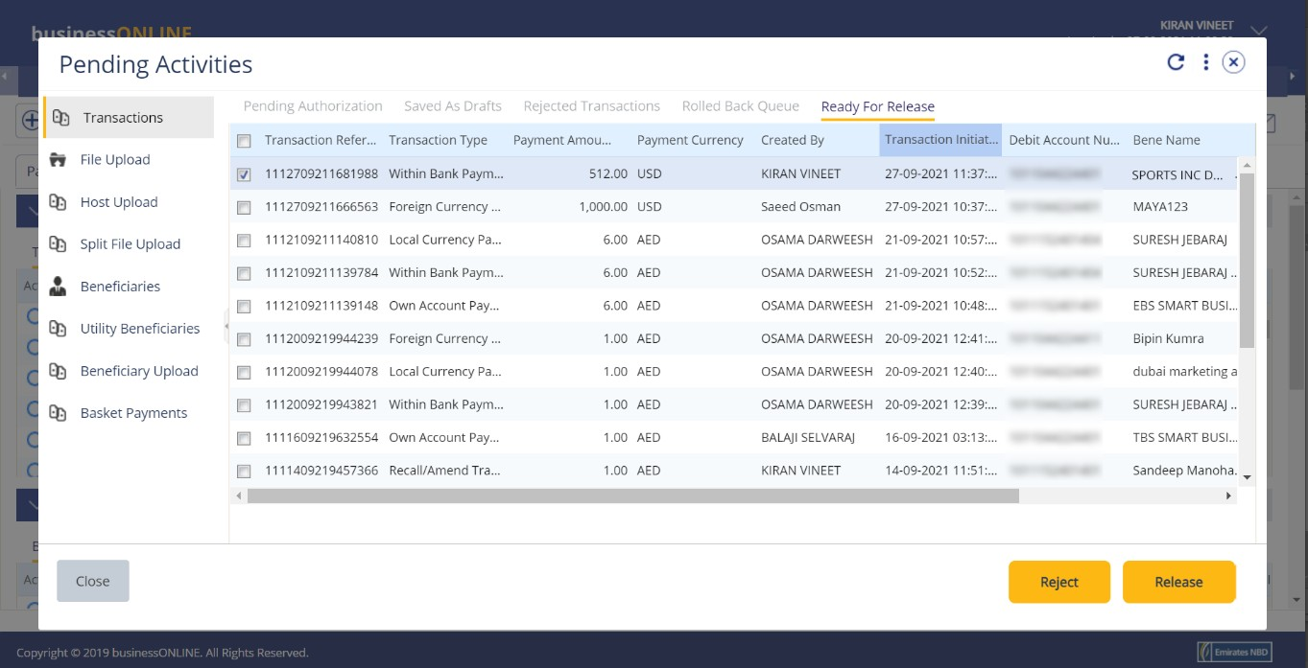

**6. Click on Close**

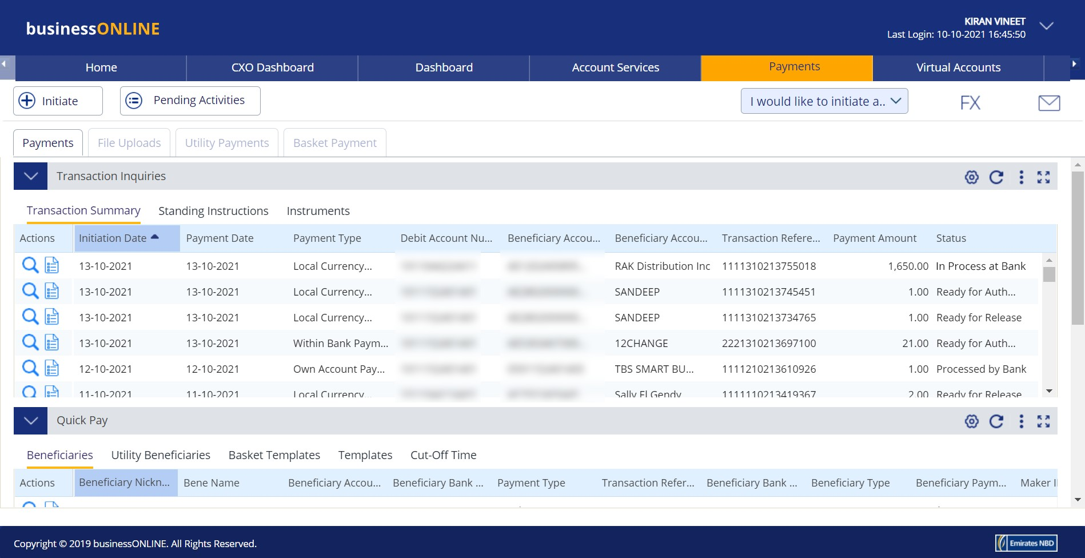

1. **Click on the Refresh icon**
2. **Your payment will appear here**
3. **The Payment Status will be - in Process at Bank**



CONTACT US:

**Business Banking:**

+971 600 54 0009

[businessONLINEhelp@EmiratesNBD.com](mailto:businessONLINEhelp@EmiratesNBD.com)

**Corporate & Institutional Banking:**

+971 4 3160214 (IVR - option 2)

[businessONLINEwb@EmiratesNBD.com](mailto:businessONLINEwb@EmiratesNBD.com)

