URBAN HEAT İSLAND

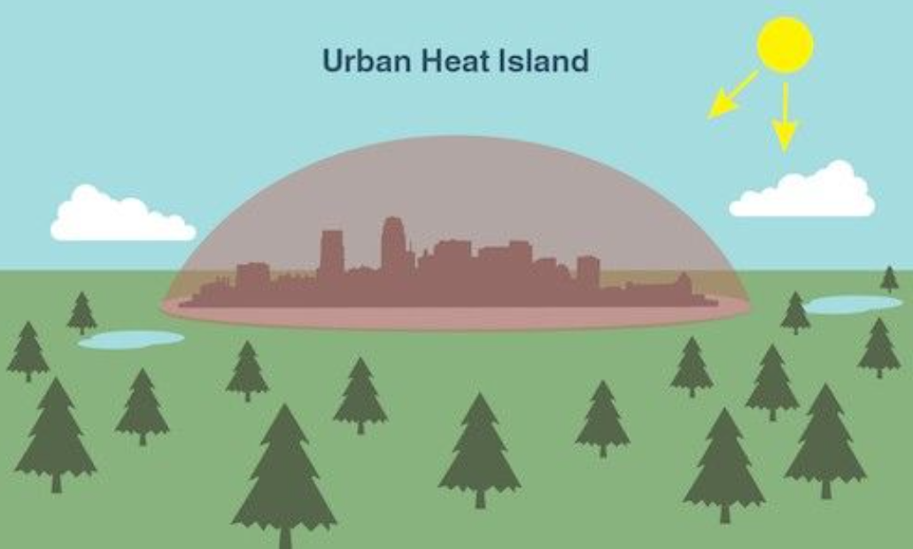

Our team : Elif,İpek,Nazlı

Paragraph 1

The Urban Heat Island effect is a serious problem because it affects people’s health and daily life in cities. Higher temperatures increase the risk of heat-related illnesses such as heat exhaustion and heat stroke, especially for elderly people, children, and people with health problems. Hot weather also makes air pollution worse by increasing ground-level ozone, which can cause breathing difficulties. In addition, people use air conditioning more often, which increases energy consumption and electricity costs. As a result, the Urban Heat Island effect lowers the quality of life and creates health risks for people living in cities.

Paragraph 2

Urban heat island became a problem slowly over the years. In the past it was not a serious issue because cities were smaller and less crowded.
There were more trees parks and natural areas, so the weather was cooler. As time passed cities grew very fast. Green areas were replaced by buildings roads and parking lots. Concrete and asphalt absorb heat from the sun and release it slowly, especially at night. Also the number of cars factories and air conditioners increased, which made cities even warmer. Because of all these reasons urban heat island was not always a big problem, but it became much worse with urban development.

Paragraph 3

Istanbul is taking several steps to reduce the Urban Heat Island effect. The city increases green areas by planting trees, creating new parks, and protecting existing green spaces. Projects such as urban parks and green corridors help cool the city and improve air quality. Some buildings use green roofs, and light-colored materials are used on roads and buildings to reduce heat absorption. In addition, Istanbul invests in public transportation, such as metro and metrobus lines, and encourages walking and cycling to reduce traffic, air pollution, and heat in the city.

Paragraph 4

Our city can develop many different actions to reduce the Urban Heat Island effect. Increasing green spaces in crowded areas where temperatures are higher could be a good starting point. Using light-colored or heat-resistant materials on roads and buildings may help reduce heat absorption. In addition, planting more trees along streets and expanding green roof projects on buildings would contribute to cooling the environment. Improving public transportation and focusing more on environmentally friendly projects could also be effective in reducing energy use and emissions.

