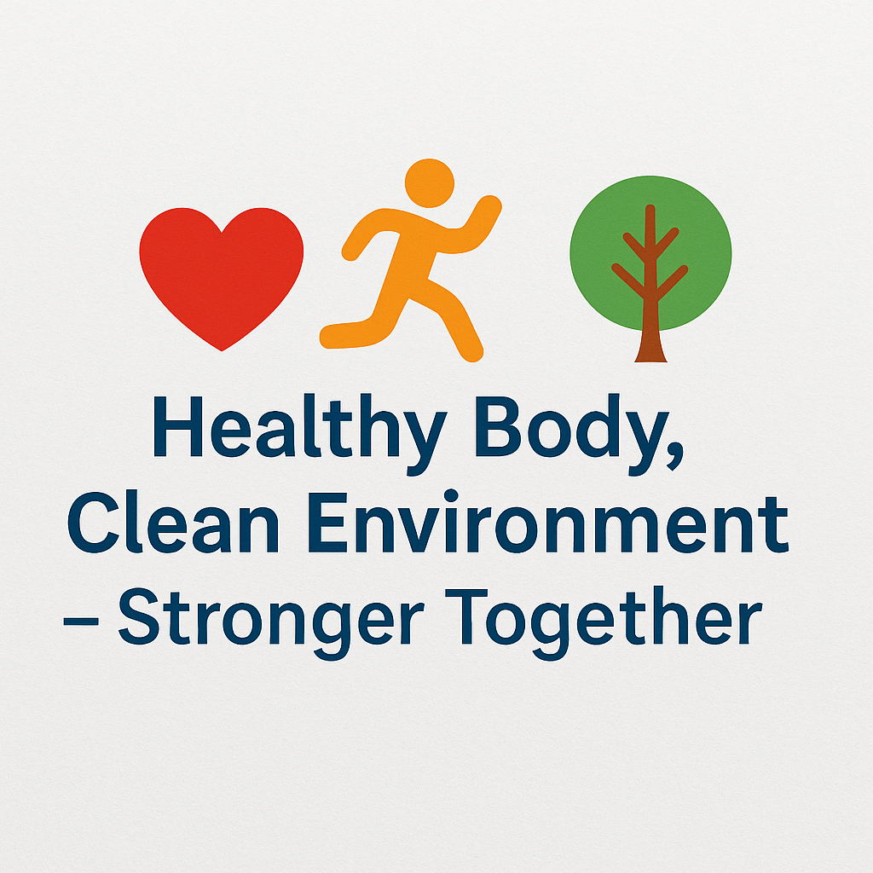

HEALTHY BODY AND CLEAN ENVIRONMENT
Monthly Project Plan (2025–2026)
Coordinator: Mediha Tabak – Haydarpaşa High School

October 2025
- • First teachers’ online meeting.
- • School introduction videos created and shared.
- • Upload school logos, student lists, and parent permission forms.
- • Create and activate social media pages.
- • Open a Padlet wall for students’ ideas and suggestions.
- • Launch logo and poster contest.

November 2025
- • Voting for final logo and poster.
- • E-Safety workshop and presentation.
- • Add ‘About Us’ bilingual page (Turkish–English).

December 2025
- • Month theme: Healthy lifestyle and physical activity.
- • Design ‘Daily Activity Tracker’.
- • Record and share 10-minute morning exercise video.

January 2026
- • Month theme: Environmental awareness.
- • Prepare recycling posters and campaigns.
- • Organize ‘Green Day’ at each school.

February 2026
- • Healthy nutrition and cultural exchange activities.
- • Share traditional healthy recipes.
- • Create a joint e-book.

March 2026
- • Student-led workshops.
- • International student teams’ presentations.

April 2026
- • Digital outputs and Earth Day campaign.
- • Students prepare summary videos of what they learned.

May 2026
- • Final evaluation and closing ceremony.
- • Upload all project outputs and give certificates.

June 2026
- • Share results with schools and communities.
- • Apply for National and European Quality Label.

