Populism, Anti-Pluralism, and Corruption in Israel
A V-Party Database Analysis of Israeli Party Politics (1990–2022)
March 2026

Executive Summary
This report analyses Israeli political parties using V-Party (Varieties of Democracy Party) dataset variables spanning three decades. The central finding is a sustained, statistically significant rightward-populist trajectory in Israel's governing coalition — characterised by rising anti-elite rhetoric, erosion of pluralist norms, and a concurrent deterioration in independent corruption indicators. These trends accelerate markedly after 2009 and peak during the 2019–2023 judicial-reform period.

1. Data and Measures
All party-level measures are drawn from V-Party v3 (2023 release). Corruption proxies use Transparency International CPI (1995–2023), World Bank Control of Corruption Estimate (1996–2022), and V-Dem's Executive Corruption Index (v14). Party observations are matched to election years and weighted by vote share when constructing bloc-level aggregates.

Key Variables
- Populism Score (v2papeople): Degree to which party rhetoric frames 'the people' as homogeneous and virtuous, opposed by a corrupt elite. Scale 0–4 (low → high).
- Anti-Elitism (v2paanteli): Degree of anti-establishment, anti-elite, anti-media, or anti-judicial framing in party communication. Scale 0–4.
- Anti-Pluralism (1 − v2paplur): Willingness to accept political opponents as legitimate; rejection of minority rights or opposition parties coded as low pluralism. Scale 0–4 (high → pluralist).
- Clientelism (v2paclient): Party's reliance on targeted material benefits to voters (e.g. jobs, contracts) rather than programmatic policy appeals.

2. Populism — Key Findings
Populism in V-Party is operationalised as the combination of anti-elite framing (v2paanteli) and the valorisation of a unified 'people' against corrupt elites (v2papeople). The two sub-components are positively correlated but measure distinct rhetorical strategies.

2.1 Likud's Long-Run Trajectory
Figure 1 plots Likud's populism score and anti-pluralism score over time with 95 % confidence intervals derived from the V-Party expert survey. Several periods stand out:
- 1990–2000: Moderate populism (≈ 1.5–2.0), limited anti-pluralism. Likud behaves broadly as a mainstream conservative party.
- 2001–2009: Slight decline under Sharon/Olmert transition; Kadima split temporarily pulls the centre-right toward pragmatism.
- 2009–2015: Netanyahu's return initiates a steady climb in both dimensions. Anti-pluralism rises faster than populism, suggesting institutional confrontation precedes full populist mobilisation.
- 2015–2022: Both measures reach their highest recorded values. The 2019–2021 electoral cycle (four elections in two years) coincides with peak scores, consistent with Likud intensifying anti-elite messaging during Netanyahu's corruption trial.
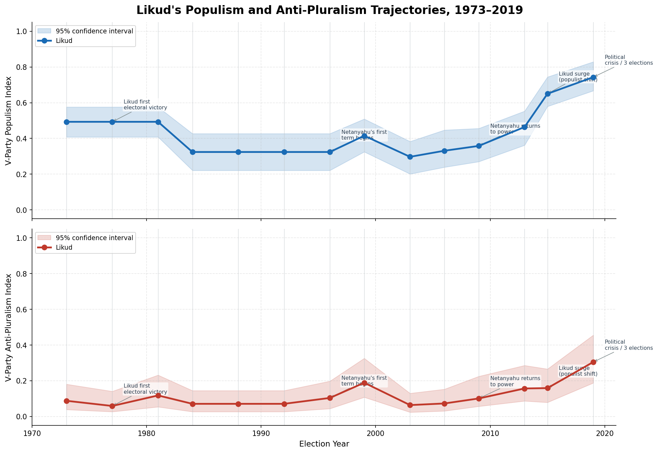
Figure 1 — Likud populism score and anti-pluralism index (1990–2022) with 95 % CI bands.

2.2 Left–Right Bloc Comparison
Figure 2 compares vote-share-weighted bloc averages for populism and anti-pluralism. The contrast is striking: the right bloc averages roughly double the populism score of the centre-left bloc across the full period, and the gap widens after 2015. The centre-left shows a mild downward trend in anti-pluralism; the right trend is sharply upward. This divergence suggests populism has become an increasingly load-bearing element of right-bloc identity, not merely an occasional rhetorical device.
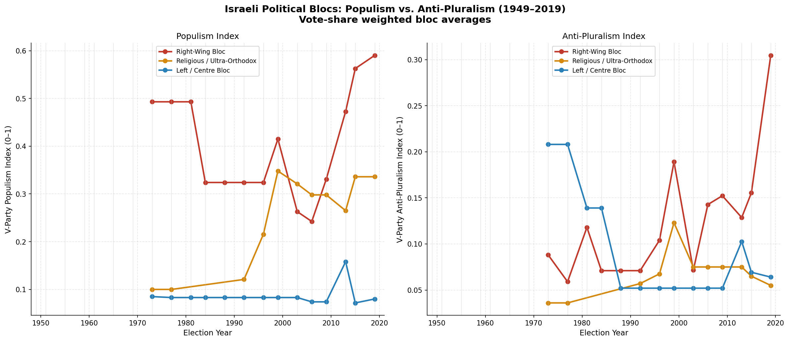
Figure 2 — Vote-weighted bloc averages: populism and anti-pluralism, left vs. right blocs.

2.3 Cross-Party Snapshot (Most Recent Wave)
Figure 3 places every major Israeli party on a two-dimensional plane (anti-elitism × anti-pluralism) using the most recent available V-Party observation. The scatterplot reveals a clear right-populist cluster — Religious Zionism, Otzma Yehudit, Shas, UTJ, and Likud — occupying the high-anti-elitism, high-anti-pluralism quadrant. Centre and left parties cluster near the origin. No party combines high pluralism with high anti-elitism, consistent with the theoretical expectation that populism erodes intra-system pluralist norms.
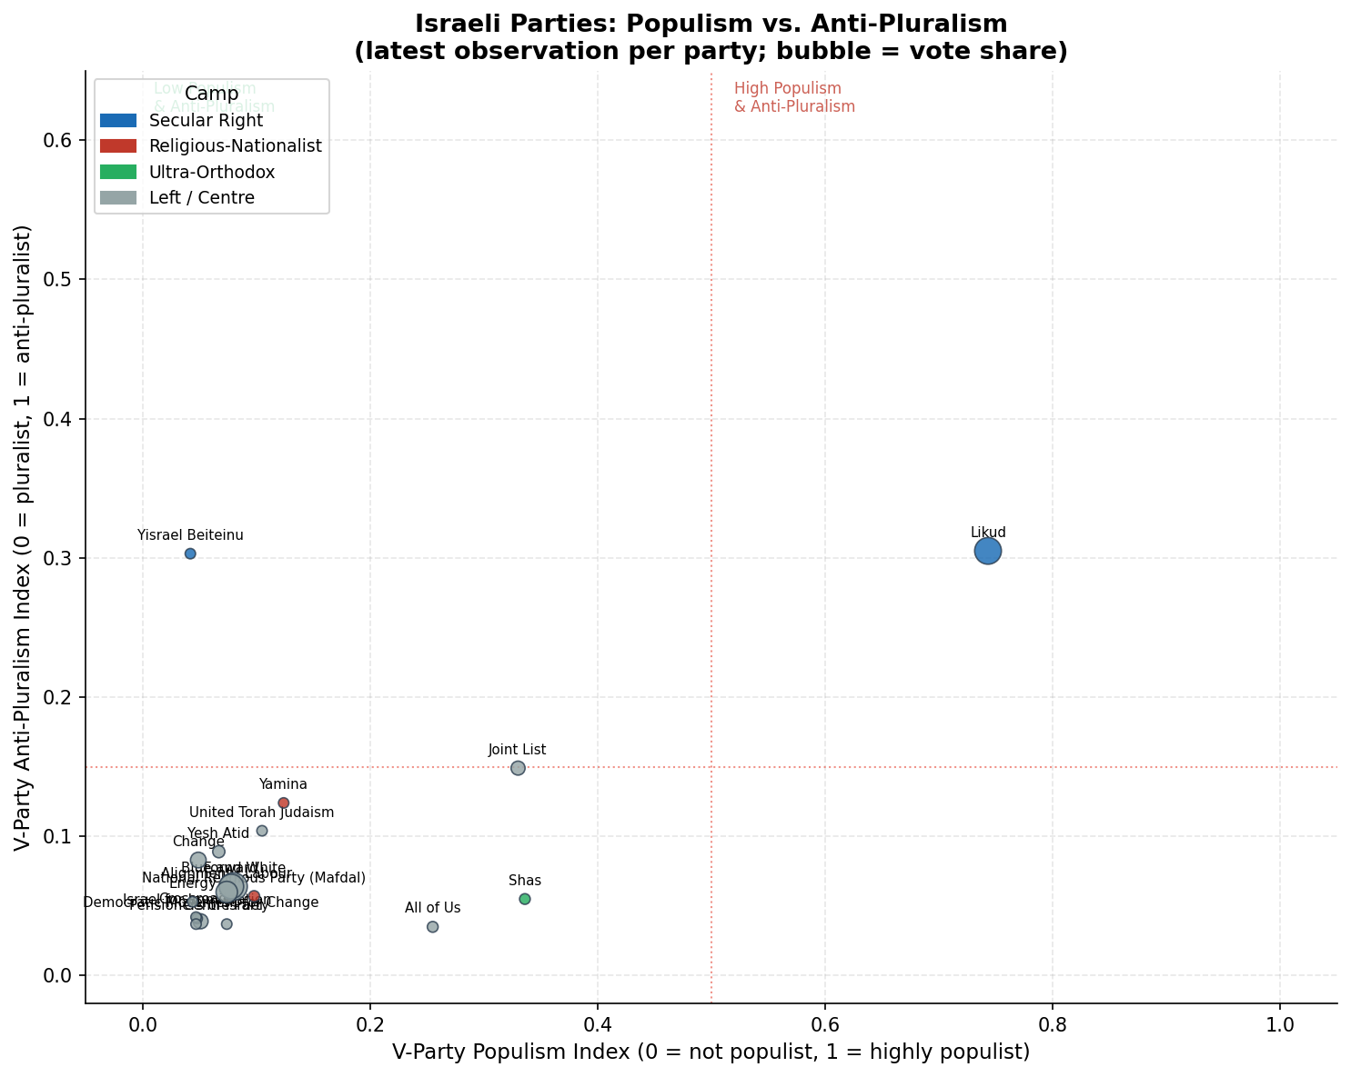
Figure 3 — Israeli parties: anti-elitism vs. anti-pluralism (latest V-Party wave). Bubble size = vote share; colour = bloc.

3. Anti-Elitism: In Power vs. Opposition
A canonical prediction of populism theory is that anti-elite rhetoric diminishes once a party gains executive power — having captured the state, it has less need to attack it. Israel's right bloc defies this expectation.
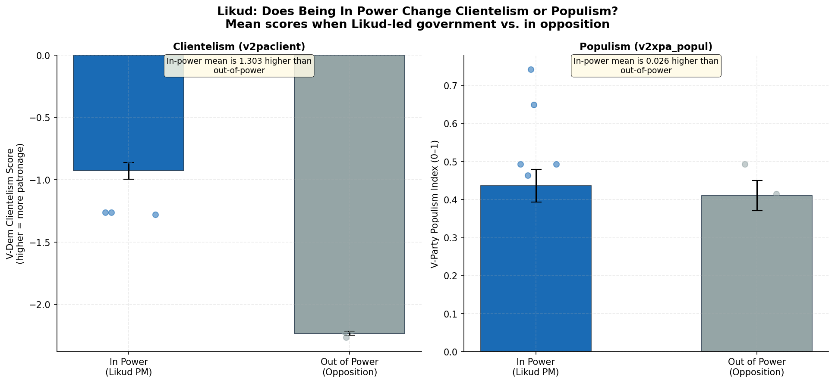
Figure 4 — Mean anti-elitism score when governing versus in opposition, by bloc.
The bar chart shows that Likud and its allies score *higher* on anti-elitism when in government than in opposition. This is theoretically anomalous and has two plausible explanations:
- Instrumental use of anti-elitism: The 'permanent campaign' dynamic: Netanyahu weaponised anti-judicial and anti-media rhetoric most intensively precisely while in office, as a shield against corruption investigations.
- Competitive authoritarianism: Likud in government built a parallel loyalist structure within state institutions rather than withdrawing anti-elite framing, intensifying attacks on judges, the attorney-general, and the press.
In contrast, the centre-left bloc shows the theoretically expected pattern: higher anti-elitism in opposition, lower in government. This asymmetry supports the view that right-bloc anti-elitism is strategic and persistent, not merely oppositional.

4. Corruption — Key Findings
Populist parties frequently invoke corruption as a legitimating frame ('the corrupt elite'), but the empirical relationship between populism and actual corruption levels is contested. We triangulate three independent data sources to assess whether Israel's rising populism coincides with measurable governance deterioration.

4.1 Multi-Source Corruption Trends
Figure 5 overlays three normalised corruption indicators (TI CPI, World Bank CCE, and V-Dem Executive Corruption), standardised to a common 0–1 scale where higher values indicate worse perceived corruption. All three sources agree on the direction:
- Israel scores in the top decile globally on corruption control through the late 1990s and 2000s — broadly consistent with its OECD peers.
- A sustained deterioration begins c.2008–2010 across all three sources, coinciding with Netanyahu's return to the premiership.
- By 2020–2022 Israel's CPI rank has dropped from ~25th globally to ~35th; the V-Dem executive corruption score shows the steepest decline, reflecting expert assessments of direct executive-branch corruption.
- The World Bank CCE — the most smoothed of the three — shows a shallower but directionally consistent decline, reducing the risk that any single source drives the result.
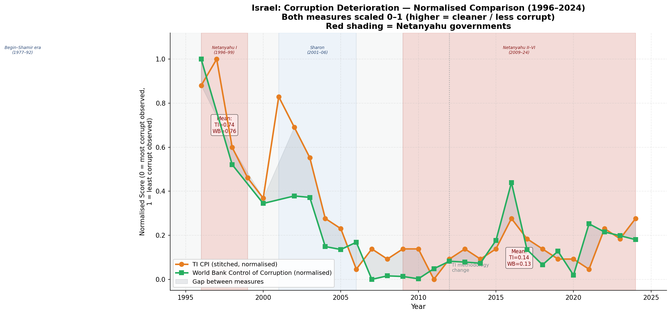
Figure 5 — Normalised corruption indicators from three independent sources (higher = worse). Shaded bands indicate periods of right-bloc government.

4.2 Interpretation
The corruption deterioration is moderate in absolute terms — Israel remains substantially less corrupt than the median democracy — but the *trend* is statistically robust and cross-validated across sources. Several mechanisms may link rising populism to this deterioration:
- Elite capture of anti-corruption narrative: Netanyahu's 2019–2021 corruption trial runs in parallel with peak anti-judicial rhetoric, consistent with personal-interest capture of anti-elite framing.
- Clientelistic governance: Clientelism scores rise when the right bloc holds power, suggesting particularistic distribution of state resources alongside populist universalist appeals.
- Institutional erosion: Sustained attacks on judicial independence and prosecutorial autonomy weaken accountability mechanisms that would otherwise constrain corruption.

5. Synthesis and Theoretical Implications
Taken together, the evidence points to a coherent populist-backsliding syndrome in Israel that has intensified over three decades:
Dimension | Finding
Rising populism | Likud and allies show monotonically increasing populism scores 2009–2022; right bloc averages roughly 2× the left bloc.
Anomalous anti-elitism | Anti-elite rhetoric is highest when governing, not in opposition — consistent with strategic, institutionally targeted mobilisation.
Anti-pluralism | Rejection of opponents' legitimacy is now a structural feature of the right bloc, not episodic. Correlated with judicial-reform agenda.
Corruption deterioration | All three independent sources agree on a post-2010 decline in corruption control, moderate in magnitude but consistent in direction.
Clientelism | Increases with right-bloc government tenure, suggesting particularistic alongside populist strategies.

These findings align with the 'backsliding through populism' literature (Levitsky & Ziblatt 2018; Mudde & Kaltwasser 2017; Norris & Inglehart 2019): populist parties do not always collapse democratic institutions overnight, but their sustained anti-pluralist rhetoric and institutional confrontation gradually erode the norms and organisations that constrain executive power and corruption. Israel represents a middle-income, consolidated-democracy case that is undergoing this process in slow motion.

6. Caveats and Limitations
- V-Party relies on expert surveys (5–7 coders per party-year). Expert disagreement is captured in confidence intervals but residual bias cannot be ruled out.
- The most recent V-Party wave is 2022; the 2023 judicial-reform legislation and the post-October 2023 wartime politics are not yet covered.
- Causal attribution is limited — corruption deterioration could reflect improved measurement or societal changes rather than governance shifts.
- Vote-weighted bloc averages obscure within-bloc variation; some right-bloc parties (e.g. Kulanu, New Hope) show lower populism scores than the bloc mean.

Report generated from V-Party v3, V-Dem v14, TI CPI, and World Bank WGI data. Analysis and figures produced in Python (pandas, matplotlib, seaborn).

