Emily Zeng

CIS 310-01

Professor Guan

4/12/17

Assignment 10

Part 0

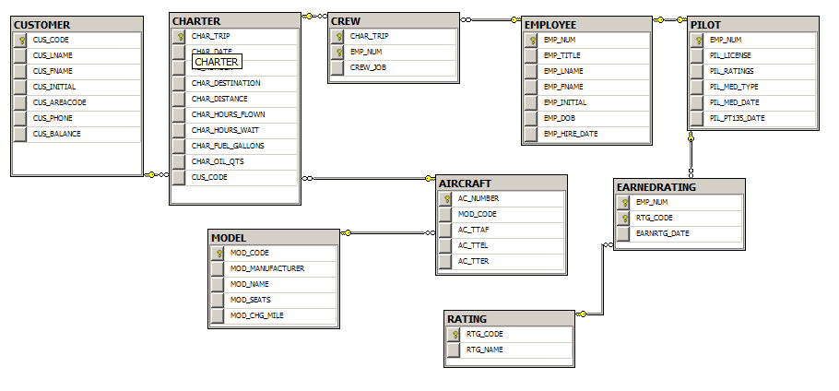

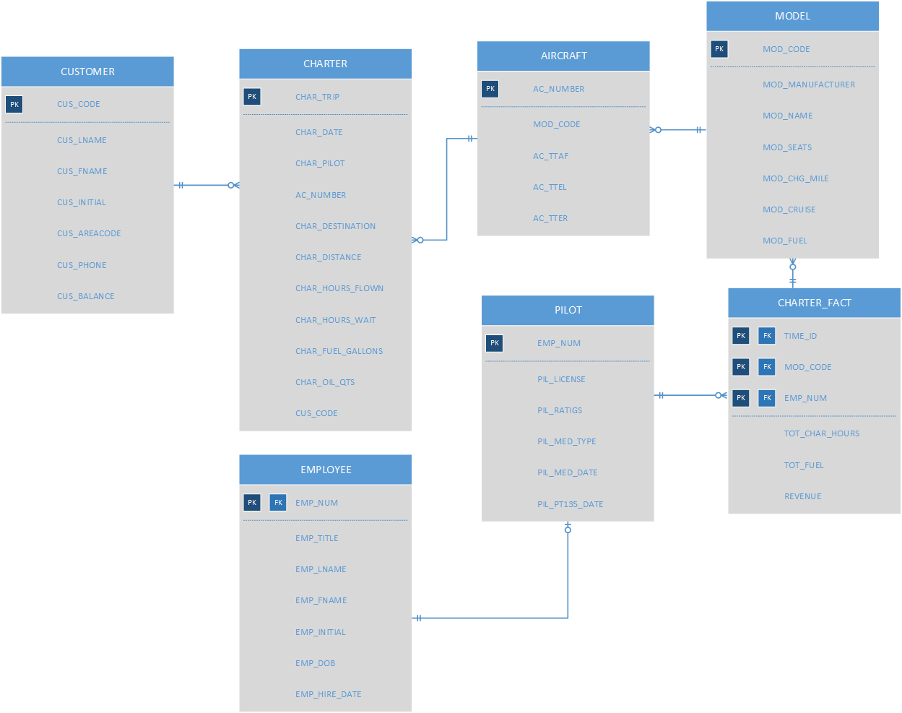Part 1

Part 2

/* A10 Script */

CREATE TABLE CUSTOMERDIM (

CUS_CODE int NOT NULL IDENTITY,

CUS_LNAME varchar(15),

CUS_FNAME varchar(15),

CUS_INITIAL varchar(1),

CUS_AREACODE varchar(3),

CUS_PHONE varchar(8),

CUS_BALANCE float(8)

);

ALTER TABLE CUSTOMERDIM

ADD CONSTRAINT PK_CUSTOMERDIM PRIMARY KEY (CUS_CODE)

ALTER TABLE CUSTOMERDIM

ADD CONSTRAINT FK_CUS_CODE FOREIGN KEY (CUS_CODE) REFERENCES CHARTER

CREATE TABLE CHARTERDIM (

CHAR_TRIP int NOT NULL IDENTITY,

CHAR_DATE datetime,

AC_NUMBER varchar(5),

CHAR_DESTINATION varchar(3),

CHAR_DISTANCE float(8),

CHAR_HOURS_FLOWN float(8),

CHAR_HOURS_WAIT float(8),

CHAR_FUEL_GALLONS float(8),

CHAR_OIL_QTS integer,

CUS_CODE int

);

ALTER TABLE CHARTERDIM

ADD CONSTRAINT PK_CHARTERDIM PRIMARY KEY (CHAR_TRIP)

ALTER TABLE CHARTERDIM

ADD CONSTRAINT FK_AC_NUMBER FOREIGN KEY (AC_NUMBER) REFERENCES AIRCRAFT

CREATE TABLE EMPLOYEEDIM (

EMP_NUM int NOT NULL IDENTITY,

EMP_TITLE varchar(4),

EMP_LNAME varchar(15),

EMP_FNAME varchar(15),

EMP_INITIAL varchar(1),

EMP_DOB datetime,

EMP_HIRE_DATE datetime

);

ALTER TABLE EMPLOYEEDIM

ADD CONSTRAINT PK_EMPLOYEEDIM PRIMARY KEY (EMP_NUM)

ALTER TABLE EMPLOYEEDIM

ADD CONSTRAINT FK_EMP_NUM FOREIGN KEY (EMP_NUM) REFERENCES PILOT

CREATE TABLE AIRCRAFTDIM (

AC_NUMBER varchar(5) NOT NULL,

MOD_CODE varchar(10) NOT NULL,

AC_TTAF float(8),

AC_TTEL float(8),

AC_TTER float(8)

);

ALTER TABLE AIRCRAFTDIM

ADD CONSTRAINT PK_AIRCRAFTDIM PRIMARY KEY (AC_NUMBER)

ALTER TABLE AIRCRAFTDIM

ADD CONSTRAINT FK_MOD_CODE FOREIGN KEY (MOD_CODE) REFERENCES MODEL

CREATE TABLE PILOTDIM (

EMP_NUM int NOT NULL IDENTITY,

PIL_LICENSE varchar(25),

PIL_RATINGS varchar(25),

PIL_MED_TYPE varchar(1),

PIL_MED_DATE datetime,

PIL_PT135_DATE datetime

);

ALTER TABLE PILOTDIM

ADD CONSTRAINT PK_PILOTDIM PRIMARY KEY (EMP_NUM)

ALTER TABLE PILOTDIM

ADD CONSTRAINT FK_EMP_NUM FOREIGN KEY (EMP_NUM) REFERENCES CHARTER_FACT

CREATE TABLE MODELDIM (

MOD_CODE varchar(10) NOT NULL,

MOD_MANUFACTURER varchar(15),

MOD_NAME varchar(20),

MOD_SEATS float(8),

MOD_CHG_MILE float(8)

);

ALTER TABLE MODELDIM

ADD CONSTRAINT PK_MODELDIM PRIMARY KEY (MOD_CODE)

ALTER TABLE MODELDIM

ADD CONSTRAINT FK_MOD_CODE FOREIGN KEY (MOD_CODE) REFERENCES CHARTER_FACT

CREATE TABLE CHARTER_FACT (

TIME_ID int NOT NULL IDENTITY,

MOD_CODE int NOT NULL,

EMP_NUM int NOT NULL,

TOTAL_CHAR_HOURS int,

TOT_FUEL float(8),

REVENUE MONEY

);

ALTER TABLE CHARTER_FACT

ADD CONSTRAINT PK_CHARTER_FACT PRIMARY KEY (TIME_ID)

ALTER TABLE CHARTER_FACT

ADD CONSTRAINT PK_EMP_NUM FOREIGN KEY (EMP_NUM) REFERENCES EMPLOYEE

CREATE TABLE STAGING (

TIME_ID INT,

MOD_CODE INT,

EMP_NUM INT,

CUS_CODE INT,

TOTAL_CHAR_HOURS INT,

AC_NUMBER INT,

CHAR_TRIP INT,

TOT_FUEL FLOAT(8),

REVENUE MONEY)

**Part 3**

--Create A10 procedure

CREATE PROCEDURE A10

AS

BEGIN

--DROP PK AND FK FOR ALL TABLES

ALTER TABLE CUSTOMERDIM

DROP CONSTRAINT PK_CUS_CODE

ALTER TABLE CUSTOMERDIM

DROP CONSTRAINT FK_CUS_CODE

ALTER TABLE CHARTERDIM

DROP CONSTRAINT PK_CHARTERDIM

ALTER TABLE CHARTERDIM

DROP CONSTRAINT FK_AC_NUMBER

ALTER TABLE EMPLOYEEDIM

DROP CONSTRAINT PK_EMPLOYEEDIM

ALTER TABLE EMPLOYEEDIM

DROP CONSTRAINT FK_EMP_NUM

ALTER TABLE AIRCRAFTDIM

DROP CONSTRAINT PK_AIRCRAFTDIM

ALTER TABLE AIRCRAFTDIM

DROP CONSTRAINT FK_MOD_CODE

ALTER TABLE PILOTDIM

DROP CONSTRAINT PK_PILOTDIM

ALTER TABLE PILOTDIM

DROP CONSTRAINT FK_EMP_NUM

ALTER TABLE MODELDIM

DROP CONSTRAINT PK_MODELDIM

ALTER TABLE MODELDIM

DROP CONSTRAINT FK_MOD_CODE

ALTER TABLE CHARTER_FACT

DROP CONSTRAINT PK_CHARTER_FACT

ALTER TABLE CHARTER_FACT

DROP CONSTRAINT PK_EMP_NUM

--TRUNCATE TABLES

TRUNCATE TABLE CUSTOMERDIM

TRUNCATE TABLE CHARTERDIM

TRUNCATE TABLE AIRCRAFTDIM

TRUNCATE TABLE EMPLOYEEDIM

TRUNCATE TABLE PILOTDIM

TRUNCATE TABLE CHARTER_FACT

TRUNCATE TABLE MODELDIM

TRUNCATE TABLE STAGING

--RE-ADD CONSTRAINTS

ALTER TABLE CUSTOMERDIM

ADD CONSTRAINT PK_CUSTOMERDIM PRIMARY KEY (CUS_CODE)

ALTER TABLE CUSTOMERDIM

ADD CONSTRAINT FK_CUS_CODE FOREIGN KEY (CUS_CODE) REFERENCES CHARTER

ALTER TABLE CHARTERDIM

ADD CONSTRAINT PK_CHARTERDIM PRIMARY KEY (CHAR_TRIP)

ALTER TABLE CHARTERDIM

ADD CONSTRAINT FK_AC_NUMBER FOREIGN KEY (AC_NUMBER) REFERENCES AIRCRAFT

ALTER TABLE EMPLOYEEDIM

ADD CONSTRAINT PK_EMPLOYEEDIM PRIMARY KEY (EMP_NUM)

ALTER TABLE EMPLOYEEDIM

ADD CONSTRAINT FK_EMP_NUM FOREIGN KEY (EMP_NUM) REFERENCES PILOT

ALTER TABLE AIRCRAFTDIM

ADD CONSTRAINT PK_AIRCRAFTDIM PRIMARY KEY (AC_NUMBER)

ALTER TABLE AIRCRAFTDIM

ADD CONSTRAINT FK_MOD_CODE FOREIGN KEY (MOD_CODE) REFERENCES MODEL

ALTER TABLE PILOTDIM

ADD CONSTRAINT PK_PILOTDIM PRIMARY KEY (EMP_NUM)

ALTER TABLE PILOTDIM

ADD CONSTRAINT FK_EMP_NUM FOREIGN KEY (EMP_NUM) REFERENCES CHARTER_FACT

ALTER TABLE MODELDIM

ADD CONSTRAINT PK_MODELDIM PRIMARY KEY (MOD_CODE)

ALTER TABLE MODELDIM

ADD CONSTRAINT FK_MOD_CODE FOREIGN KEY (MOD_CODE) REFERENCES CHARTER_FACT

ALTER TABLE CHARTER_FACT

ADD CONSTRAINT PK_CHARTER_FACT PRIMARY KEY (TIME_ID)

ALTER TABLE CHARTER_FACT

ADD CONSTRAINT PK_EMP_NUM FOREIGN KEY (EMP_NUM) REFERENCES EMPLOYEE

--INSERT DATA FROM ORIGINAL DATABASE

INSERT INTO CUSTOMERDIM

SELECT *

FROM CUSTOMER

INSERT INTO CHARTERDIM

SELECT *

FROM CHARTER

INSERT INTO EMPLOYEEDIM

SELECT *

FROM EMPLOYEE

INSERT INTO AIRCRAFTDIM

SELECT *

FROM AIRCRAFT

INSERT INTO PILOTDIM

SELECT *

FROM PILOT

INSERT INTO MODELDIM

SELECT *

FROM MODEL

INSERT INTO CHARTER_FACT

SELECT C.CHAR_HOURS_FLOWN, C.CHAR_FUEL_GALLONS, (C.CHAR_FUEL_GALLONS * M.MOD_CHG_MILE) AS REVENUE

FROM CHARTER C INNER JOIN AIRCRAFT A ON C.AC_NUMBER = A.AC_NUMBER INNER JOIN

MODEL M ON A.MOD_CODE = M.MOD_CODE

INSERT INTO STAGING

SELECT C.CUS_CODE, CH.CHAR_TRIP, A.AC_NUMBER, E.EMP_NUM, P.EMP_NUM, CF.TIME_ID, CF.TOT_CHAR_HOURS, CF.TOT_FUEL, CF.REVENUE, M.MOD_NUM

FROM CUSTOMER C INNER JOIN CHARTER CH ON C.CUS_CODE = CH.CUS_CODE INNER JOIN

AIRCRAFT A ON CH.AC_NUMBER = A.AC_NUMBER INNER JOIN

MODEL M ON A.MOD_CODE = M.MOD_CODE INNER JOIN

CHARTER_FACT CF ON M.MOD_CODE = CF.MOD_CODE INNER JOIN

PILOT P ON CF.EMP_NUM = P.EMP_NUM INNER JOIN

EMPLOYEE E ON E.EMP_NUM = P.EMP_NUM INNER JOIN

--UPDATE STAGING TABLE WITH DIMENSION TABLE PK INFO

UPDATE STAGING

SET CUS_CODE = D.CUS_CODE

FROM STAGING S INNER JOIN CUSTOMERDIM D

ON S.CUS_CODE = D.CUS_CODE

UPDATE STAGING

SET CHAR_TRIP = CH.CHAR_TRIP

FROM STAGING S INNER JOIN CHARTERDIM CH

ON S.CHAR_TRIP = CH.CHAR_TRIP

UPDATE STAGING

SET AC_NUMBER = A.AC_NUMBER

FROM STAGING S INNER JOIN AIRCRAFT A

ON S.AC_NUMBER = A.AC_NUMBER

UPDATE STAGING

SET EMP_NUM = E.EMP_NUM

FROM STAGING S INNER JOIN EMPLOYEE E

ON S.EMP_NUM = E.EMP_NUM

UPDATE STAGING

SET TIME_ID = CF.TIME_ID

FROM STAGING S INNER JOIN CHARTER_FACT CF

ON S.TIME_ID = CF.TIME_ID

UPDATE STAGING

SET TOTAL_CHAR_HOURS = CF.TOTAL_CHAR_HOURS

FROM STAGING S INNER JOIN CHARTER_FACT CF

ON S.TOTAL_CHAR_HOURS = CF.TOTAL_CHAR_HOURS

UPDATE STAGING

SET REVENUE = CF.REVENUE

FROM STAGING S INNER JOIN CHARTER_FACT CF

ON S.REVENUE = CF.REVENUE

UPDATE STAGING

SET MOD_CODE = M.MOD_CODE

FROM STAGING S INNER JOIN MODEL M

ON S.MOD_CODE = M.MOD_CODE

--INSERT DW KEYS AND FACTS INTO CHARTER_FACT TABLE

INSERT INTO CHARTER_FACT (TIME_ID, MOD_CODE, EMP_NUM, TOTAL_CHAR_HOURS, TOT_FUEL, REVENUE)

SELECT TIME_ID, MOD_CODE, EMP_NUM, TOTAL_CHAR_HOURS, TOT_FUEL, REVENUE

FROM STAGING

END

--RUN STORED PROCEDURE

EXEC A10

SELECT *

FROM STAGING

**Part 4**

--Q1

--List names of pilots who have flown the most miles

SELECT E.EMP_FNAME

FROM CHARTER_FACT CF

INNER JOIN EMPLOYEE E ON CF.EMP_NUM = E.EMP_NUM INNER JOIN

PILOT P ON CF.EMP_NUM = P.EMP_NUM INNER JOIN

MODEL M ON CF.MOD_CODE = M.MOD_CODE INNER JOIN

AIRCRAFT A ON M.MOD_CODE = A.MOD_CODE INNER JOIN

CHARTER C ON A.AC_NUMBER = C.AC_NUMBER

WHERE C.CHAR_DISTANCE = (SELECT MAX(CHAR_DISTANCE)

FROM CHARTER)

--Q2

--List revenue by model and month in ascending order

SELECT REVENUE

FROM CHARTER_FACT CF

INNER JOIN MODEL M ON CF.MOD_CODE = M.MOD_CODE INNER JOIN

AIRCRAFT A ON M.MOD_CODE = A.MOD_CODE INNER JOIN

CHARTER C ON A.AC_NUMBER = C.AC_NUMBER

ORDER BY M.MOD_CODE, MONTH(C.CHAR_DATE)