 |  |  | type of Document |  |  |  | N°: | technical document code
 |  |  | CLIENT: | internal client |  |  |  |  |  |  | sheet: |  | 1 of 2
 |  |  | Job: | Program, project or process
 |  |  | aREA: | ActivitY area
 |  |  | Title: | technical DOCUMENT title |  |  |  |  |  |  | department
 |  |  |  |  |  |  |  |  |  |  | confidentiality
index of revision
REV. | description and/or revised sheets
0 | original
 |  | Rev. 0 |  |  | Rev. A | Rev. B |  |  | Rev. C | Rev. D |  | Rev. E
Date
EXECUtion
check
APproval
the information contained in this document is petrobras’ property and may not be used for purposes other than those specifically indicated
herein. this form is part of petrobras’ nI-381-rev.m.

EXAMPLE OF A TITLE OUTSIDE THE TOC
Letter to Tom 74. Music by Vinícius de Moraes and Toquinho.
TOC
INTRODUCTION 2

INTRODUCTION

-X-X-X-
Note: To update the Table of Contents, open the document in Word, right-click on the TOC, and select 'Update Field'.
-X-X-X-
This report documents the Factory Acceptance Test (FAT) performed on an API 610 centrifugal pump at the manufacturer's facility. The FAT was conducted to verify compliance with the technical specifications and contractual requirements before shipment.
The primary objective of the FAT is to ensure that the pump meets the required mechanical, and performance criteria as defined in API 610 and the project specifications. The test procedures include mechanical run tests and performance verification, vibration analysis, and NPSH (Net Positive Suction Head) testing.
This report provides a detailed record of the test procedures, observed results, and compliance with the acceptance criteria. Any deviations, corrective actions, and final acceptance status are also documented to ensure transparency and traceability of the qualification process.
- Tests Development
Here we present the key details regarding the development of the tests.
  - Equipment Description
The following section presents the main characteristics of the equipment.
TAG | B-21014A/B
Service | Light Naphtha Pump
Serial Number | A1881559-03-04
Manufacturer | SUNDYNE CORPORATION
Model | LMV-311 / OH6

Design Point data:
Service | Water and Hydrocarbon
Density | 833.49 kg/m³
Capacity | 36.70 m³/h
Differential Head | 240.00 m
Npsh Available | 3.50 m
Speed Of Rotation | 3550.00 rpm
Breaking Power | 39.80 kW
  - Test Data - B-21014A
    - Performance test summary.
The computations in this section were performed in accordancy with API 610 12th issue:
8.3.3.4.3 The test data shall be fit to a spline or an appropriate polynomial (typically, not less than a third order) for head and for power using a least squares method. The resulting polynomial equation shall be stated on the head and power calculated. These values shall be corrected for speed, viscosity, and density (specific gravity).[..]
Calculated Head and Power:
Parameter | Actual | Minimum | Maximum
Head | 246.18 m | 232.80 m | 247.20 m
Breaking Power | 39.96 kW | - | 41.39 kW
Efficiency | 51.37 % | - | -
Rated Capacity | 36.70 m³/h | - | -

Here we can find the translation of the test results into data based on the specified speed of rotation (or frequency) and density.
Capacity | Head | Breaking Power | Hydraulic Power | Efficiency
14.47 m³/h | 277.21 m | 25.92 kW | 9.11 kW | 35.15 %
24.40 m³/h | 267.58 m | 32.01 kW | 14.83 kW | 46.33 %
29.45 m³/h | 257.86 m | 36.09 kW | 17.25 kW | 47.79 %
36.70 m³/h | 248.30 m | 39.51 kW | 20.70 kW | 52.39 %
40.30 m³/h | 228.52 m | 43.34 kW | 20.92 kW | 48.26 %
42.25 m³/h | 218.71 m | 44.84 kW | 20.99 kW | 46.80 %
    - Performance Curve - Water
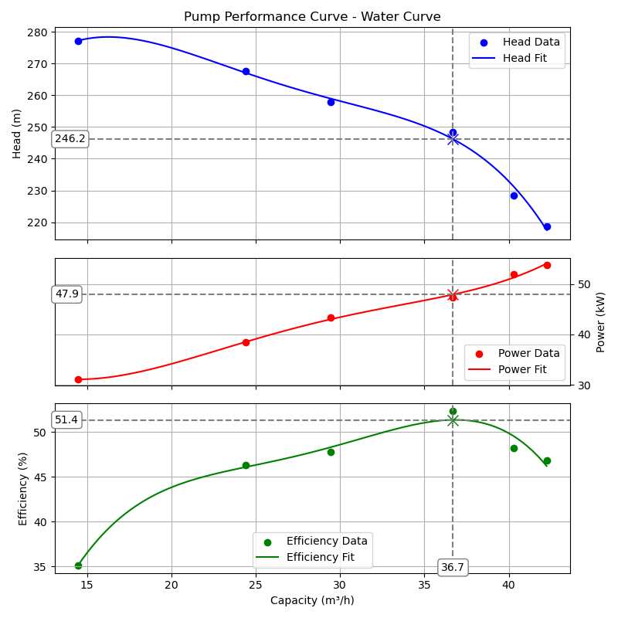
    - Performance Curve - Service Fluid
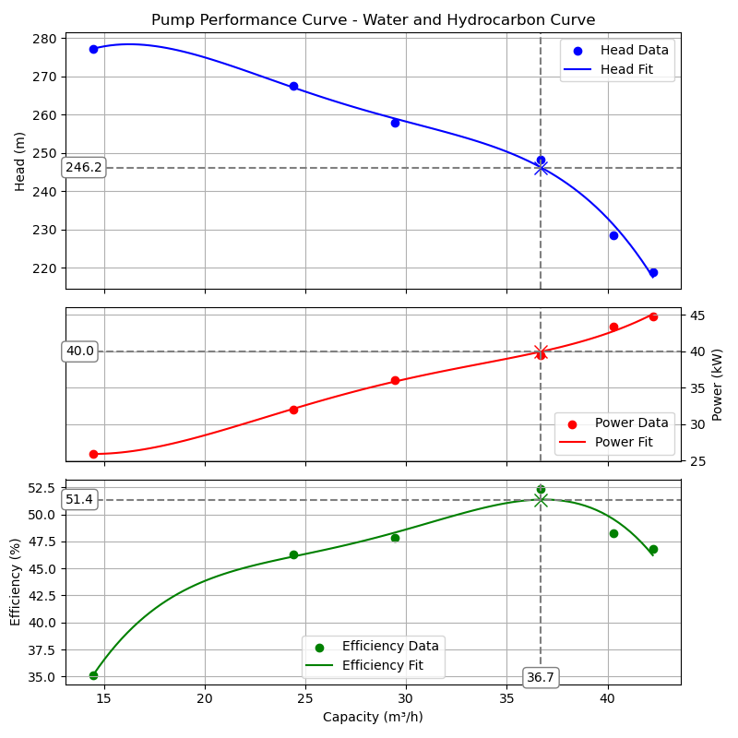
  - Test Data - B-21014B
    - Performance test summary.
The computations in this section were performed in accordancy with API 610 12th issue:
8.3.3.4.3 The test data shall be fit to a spline or an appropriate polynomial (typically, not less than a third order) for head and for power using a least squares method. The resulting polynomial equation shall be stated on the head and power calculated. These values shall be corrected for speed, viscosity, and density (specific gravity).[..]
Calculated Head and Power:
Parameter | Actual | Minimum | Maximum
Head | 241.83 m | 232.80 m | 247.20 m
Breaking Power | 39.97 kW | - | 41.39 kW
Efficiency | 50.48 % | - | -
Rated Capacity | 36.70 m³/h | - | -

Here we can find the translation of the test results into data based on the specified speed of rotation (or frequency) and density.
Capacity | Head | Breaking Power | Hydraulic Power | Efficiency
14.71 m³/h | 277.35 m | 24.59 kW | 9.27 kW | 37.69 %
25.15 m³/h | 257.81 m | 32.09 kW | 14.73 kW | 45.89 %
29.43 m³/h | 243.00 m | 34.26 kW | 16.24 kW | 47.42 %
37.37 m³/h | 243.68 m | 41.26 kW | 20.68 kW | 50.13 %
40.37 m³/h | 229.00 m | 41.51 kW | 21.00 kW | 50.59 %
42.20 m³/h | 219.12 m | 44.09 kW | 21.00 kW | 47.63 %
    - Performance Curve - Water
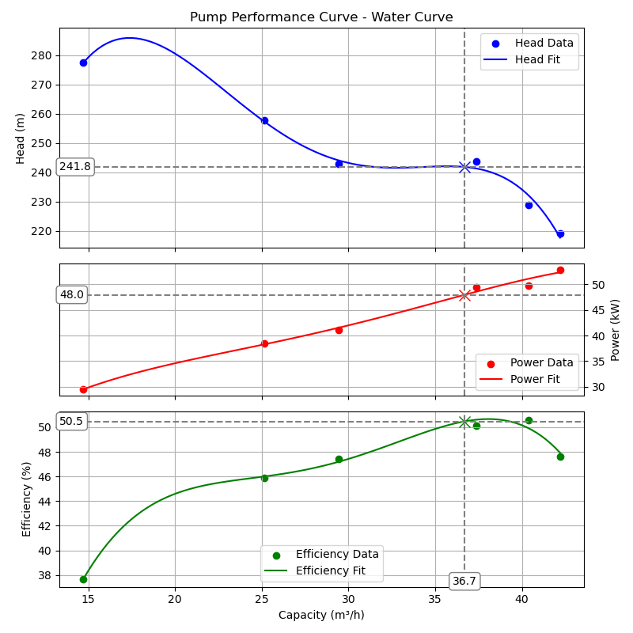
    - Performance Curve - Service Fluid
