|  |  |  |  |  |  |  |  |  |  |  |  |  |  |  |
| --- | --- | --- | --- | --- | --- | --- | --- | --- | --- | --- | --- | --- | --- | --- |
|  | | | type of Document | | | | N°: | technical document code | | | | | | |
|  | | | CLIENT: | internal client | | | | | | | sheet: | | 1 of 2 | |
|  | | | Job: | Program, project or process | | | | | | |  | | | |
|  | | | aREA: | ActivitY area | | | | | | |  | | | |
|  | | | Title: | technical DOCUMENT title | | | | | | | department | | | |
|  | | |  |  | | | | | | | confidentiality | | | |
|  | | | | | | | | | | | | | |  |
| index of revision | | | | | | | | | | | | | | |
| REV. | description and/or revised sheets | | | | | | | | | | | | | |
| 0 | original | | | | | | | | | | | | | |
|  | | Rev. 0 | | | Rev. A | Rev. B | | | Rev. C | Rev. D | | Rev. E | | |
| Date | |  | | |  |  | | |  |  | |  | | |
| EXECUtion | |  | | |  |  | | |  |  | |  | | |
| check | |  | | |  |  | | |  |  | |  | | |
| APproval | |  | | |  |  | | |  |  | |  | | |
| the information contained in this document is petrobras’ property and may not be used for purposes other than those specifically indicated | | | | | | | | | | | | | | |
| herein. this form is part of petrobras’ nI-381-rev.m. | | | | | | | | | | | | | | |

EXAMPLE OF A TITLE OUTSIDE THE TOC

Letter to Tom 74. Music by Vinícius de Moraes and Toquinho.

TOC

INTRODUCTION 2

INTRODUCTION

-X-X-X-  
Note: To update the Table of Contents, open the document in Word, right-click on the TOC, and select 'Update Field'.  
-X-X-X-

This report documents the Factory Acceptance Test (FAT) performed on an API 610 centrifugal pump at the manufacturer's facility. The FAT was conducted to verify compliance with the technical specifications and contractual requirements before shipment.

The primary objective of the FAT is to ensure that the pump meets the required mechanical, and performance criteria as defined in API 610 and the project specifications. The test procedures include mechanical run tests and performance verification, vibration analysis, and NPSH (Net Positive Suction Head) testing.

This report provides a detailed record of the test procedures, observed results, and compliance with the acceptance criteria. Any deviations, corrective actions, and final acceptance status are also documented to ensure transparency and traceability of the qualification process.

1. Tests Development

Here we present the key details regarding the development of the tests.

* 1. Equipment Description

The following section presents the main characteristics of the equipment.

|  |  |
| --- | --- |
| **TAG** | B-21014A/B |
| **Service** | Light Naphtha Pump |
| **Serial Number** | A1881559-03-04 |
| **Manufacturer** | SUNDYNE CORPORATION |
| **Model** | LMV-311 / OH6 |

Design Point data:

|  |  |
| --- | --- |
| **Service** | Water and Hydrocarbon |
| **Density** | 833.49 kg/m³ |
| **Capacity** | 36.70 m³/h |
| **Npsh Available** | 3.50 m |
| **Speed Of Rotation** | 3550.00 rpm |
| **Breaking Power** | 39.80 kW |
| **Head** | 240.00 m |

* 1. Test Data - B-21014A
     1. Performance test summary.

The computations in this section were performed in accordancy with API 610 12th issue:

8.3.3.4.3 The test data shall be fit to a spline or an appropriate polynomial (typically, not less than a third order) for head and for power using a least squares method. The resulting polynomial equation shall be stated on the head and power calculated. These values shall be corrected for speed, viscosity, and density (specific gravity).[..]

Calculated Head and Power:

|  |  |  |  |
| --- | --- | --- | --- |
| **Parameter** | **Actual** | **Minimum** | **Maximum** |
| Head | 246.18 m | 232.80 m | 247.20 m |
| Breaking Power | 39.96 kW | - | 41.39 kW |
| Efficiency | 51.37 % | - | - |
| Rated Capacity | 36.70 m³/h | - | - |

Here we can find the translation of the test results into data based on the specified speed of rotation (or frequency) and density.

|  |  |  |  |  |
| --- | --- | --- | --- | --- |
| **Capacity** | **Head** | **Breaking Power** | **Hydraulic Power** | **Efficiency** |
| 14.47 m³/h | 277.21 m | 25.92 kW | 9.11 kW | 35.15 % |
| 24.40 m³/h | 267.58 m | 32.01 kW | 14.83 kW | 46.33 % |
| 29.45 m³/h | 257.86 m | 36.09 kW | 17.25 kW | 47.79 % |
| 36.70 m³/h | 248.30 m | 39.51 kW | 20.70 kW | 52.39 % |
| 40.30 m³/h | 228.52 m | 43.34 kW | 20.92 kW | 48.26 % |
| 42.25 m³/h | 218.71 m | 44.84 kW | 20.99 kW | 46.80 % |

* + 1. Performance Curve - Water

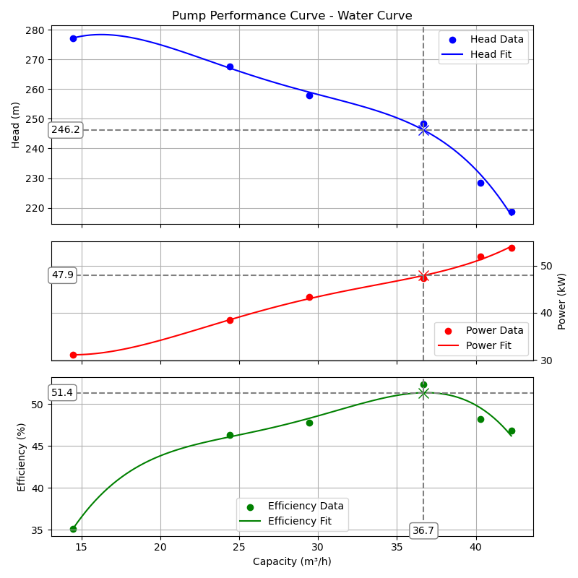

* + 1. Performance Curve - Service Fluid

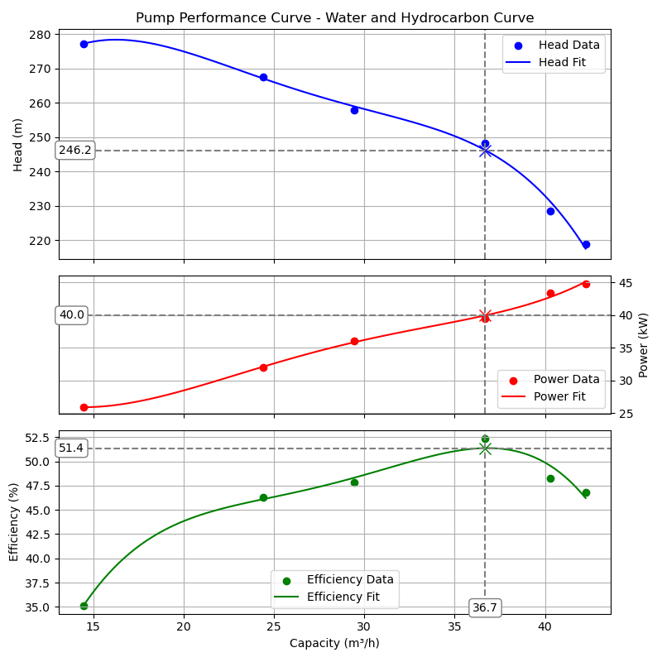

* 1. Test Data - B-21014B
     1. Performance test summary.

The computations in this section were performed in accordancy with API 610 12th issue:

8.3.3.4.3 The test data shall be fit to a spline or an appropriate polynomial (typically, not less than a third order) for head and for power using a least squares method. The resulting polynomial equation shall be stated on the head and power calculated. These values shall be corrected for speed, viscosity, and density (specific gravity).[..]

Calculated Head and Power:

|  |  |  |  |
| --- | --- | --- | --- |
| **Parameter** | **Actual** | **Minimum** | **Maximum** |
| Head | 241.83 m | 232.80 m | 247.20 m |
| Breaking Power | 39.97 kW | - | 41.39 kW |
| Efficiency | 50.48 % | - | - |
| Rated Capacity | 36.70 m³/h | - | - |

Here we can find the translation of the test results into data based on the specified speed of rotation (or frequency) and density.

|  |  |  |  |  |
| --- | --- | --- | --- | --- |
| **Capacity** | **Head** | **Breaking Power** | **Hydraulic Power** | **Efficiency** |
| 14.71 m³/h | 277.35 m | 24.59 kW | 9.27 kW | 37.69 % |
| 25.15 m³/h | 257.81 m | 32.09 kW | 14.73 kW | 45.89 % |
| 29.43 m³/h | 243.00 m | 34.26 kW | 16.24 kW | 47.42 % |
| 37.37 m³/h | 243.68 m | 41.26 kW | 20.68 kW | 50.13 % |
| 40.37 m³/h | 229.00 m | 41.51 kW | 21.00 kW | 50.59 % |
| 42.20 m³/h | 219.12 m | 44.09 kW | 21.00 kW | 47.63 % |

* + 1. Performance Curve - Water

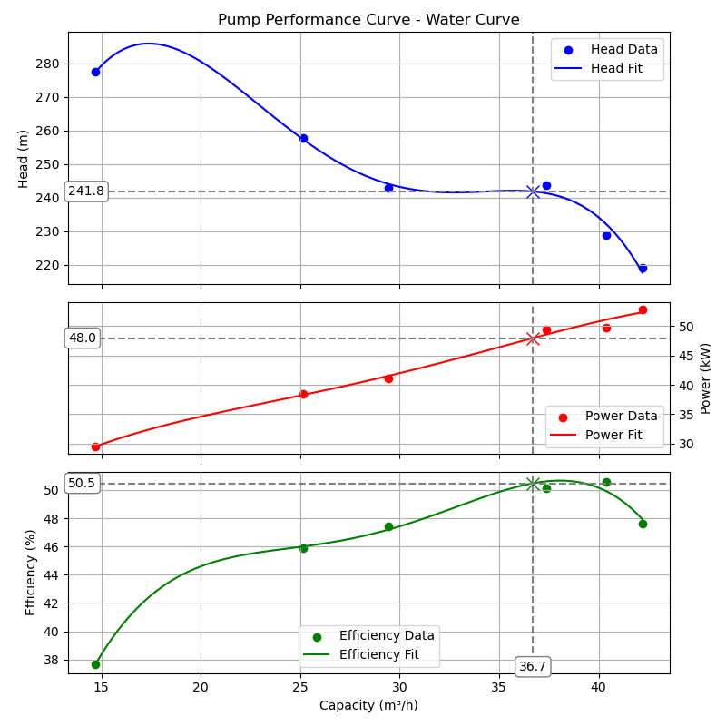

* + 1. Performance Curve - Service Fluid

