How To Select the Duration of Codes

Encoded into the QR Codes is a date which indicates for how long this code will be valid.

This date can be set on the ‘Export’ page as shown:

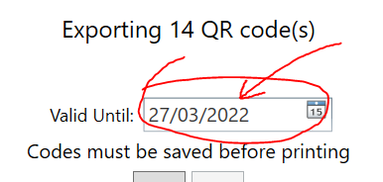

You can type a date or use the calendar to pick a date. Whatever you choose will be saved into the application data and will be remembered for next time.