How To Export a QR Code

Exporting individual rows to a printable QR code is hopefully a simple process -

1. The grid displays a like for like view of your excel sheet. Firstly select any rows that you wish to export.
2. When all the desired rows are highlighted click the ‘Export’ button which will show the following screen:

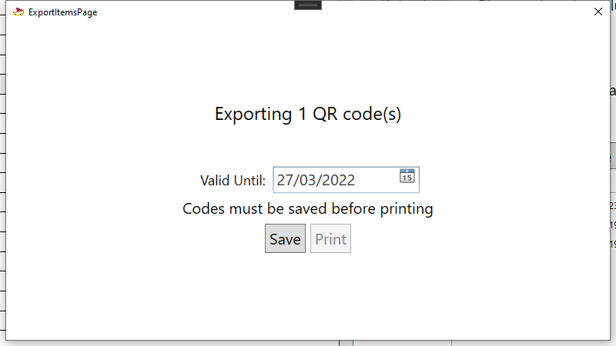

The screen gives a summary of what is being exported.

1. The date picker will allow you to choose for how long these codes will be valid for. This value is saved and will likely only be changed once a year.
2. Once read, hit the ‘Save’ button to generate and save the QR codes to an internal folder.
3. Once saved the ‘Print’ button will become available and clicking it will bring up a printer dialogue for the pages.

Note: You can use the ‘Open Codes’ button on the main page to navigate to the folder where these QR codes are saved to. This is useful if you wish to save now and print later.

Note: You can select individual rows by holding the ‘ctrl’ key and clicking. And a range of rows by holding ‘shift’ or by dragging the mouse. These actions can be combined.