How To Import a Spreadsheet

The program is only able to import excel spreadsheets if they are ‘Saved As’ a ‘.csv’ file. It is advised that the working excel data sheet is saved as a .CSV and this copy is then used as the working copy. This will remove the need for maintaining two copies of the spreadsheet.

See: <https://support.microsoft.com/en-us/office/save-a-workbook-to-text-format-txt-or-csv-3e9a9d6c-70da-4255-aa28-fcacf1f081e6>

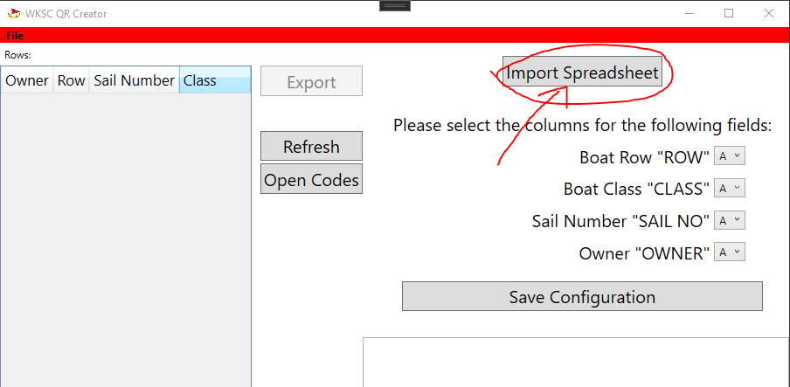

1. Once you have your spreadsheet in .csv format hit the ‘Import Spreadsheet’ button and select your file.
2. Next step is to tell the application which columns point to which bit of information. In the following example we would set **ROW as A**, **CLASS as B**, **SAIL NO as C** and **OWNER as E**. Use the drop downs to select which values.

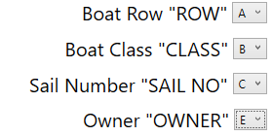

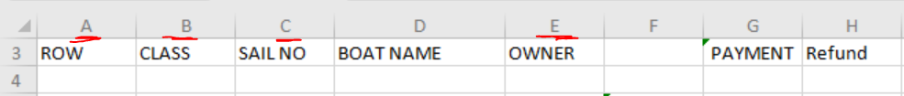

1. Next hit ‘Save Configuration’ and the application will load your spreadsheet into the view on the left. These settings are remembered.

Note: There may be some junk imported into the grid displayed as rows with missing information or perhaps as rows with information not relevant to someone’s boat. In this case just ignore these rows and be careful not to export them - they will still create QR codes and would confuse the process.