How To Export Manually

In addition to selecting rows via the user interface, there is support for exporting only particular rows that you have specified.

This is achieved by specifying a column to be used, this column is marked by the “FLAGGED” text:

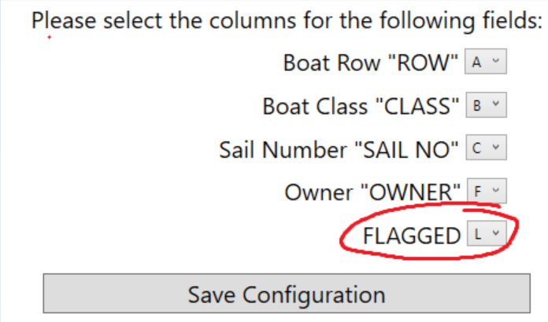

For example we have chosen column L. Next, in your original .csv file mark any rows that you wish to export with some text I.e. an ‘x’. These marks need to lie within the specified column.

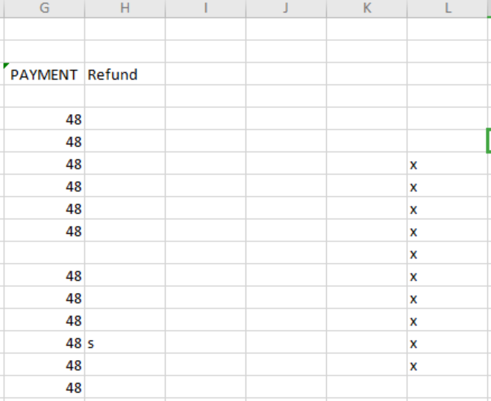

Save your file and allow a second or two for the application to detect these changes.

Click the ‘Export Flagged’ button. This will take you to the usual export screen and you will notice only the rows marked in column ‘L’ will be exported.

Note: Marked cells will not be cleared after exporting. This will have to be done manually.