12-5313 Object Oriented Analysis, Design & Implementation

Assignment 2

As indicated in the module description, the learning outcomes for this module are that the student should be able to:
- Explain Object Oriented principles (such as encapsulation, inheritance and polymorphism).
- Identify and explain the application and significance of these principles in the software systems development process.
- Identify and explain the main aspects of UML and use them to model systems.
- Identify the Object Oriented features of a suitable language such as Java and explain the relationship between these features and UML diagrams.
- Use an OO programming language to adapt and modify an OO software application.

Accordingly, for this second assignment, you are required to modify an OO system for a Car Park Simulation System. This assignment directly addresses learning outcomes 4 and 5 above.

This module is based on 100% continuous assessment (including a phase test). This assignment represents 15 of the (100) total marks available in this module.

For this assignment you should be working INDIVIDUALLY.

BACKGROUND

With this assignment, you are provided with a partial object-oriented implementation of a Car Park Simulation System. The implementation is based on Visual Basic 2010.

The following UML diagrams illustrate the static view of the system and its functionality:
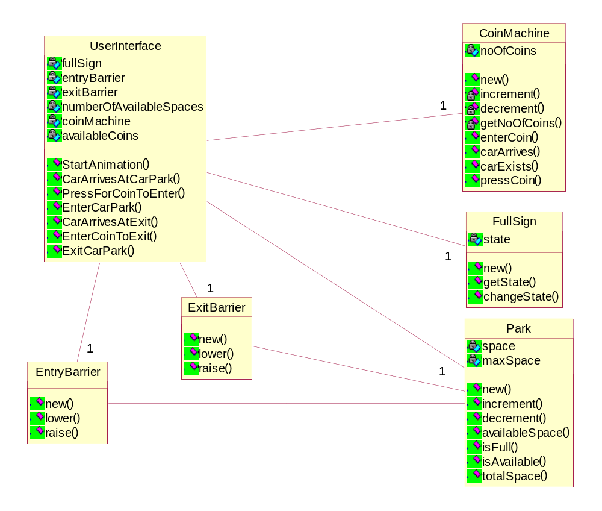
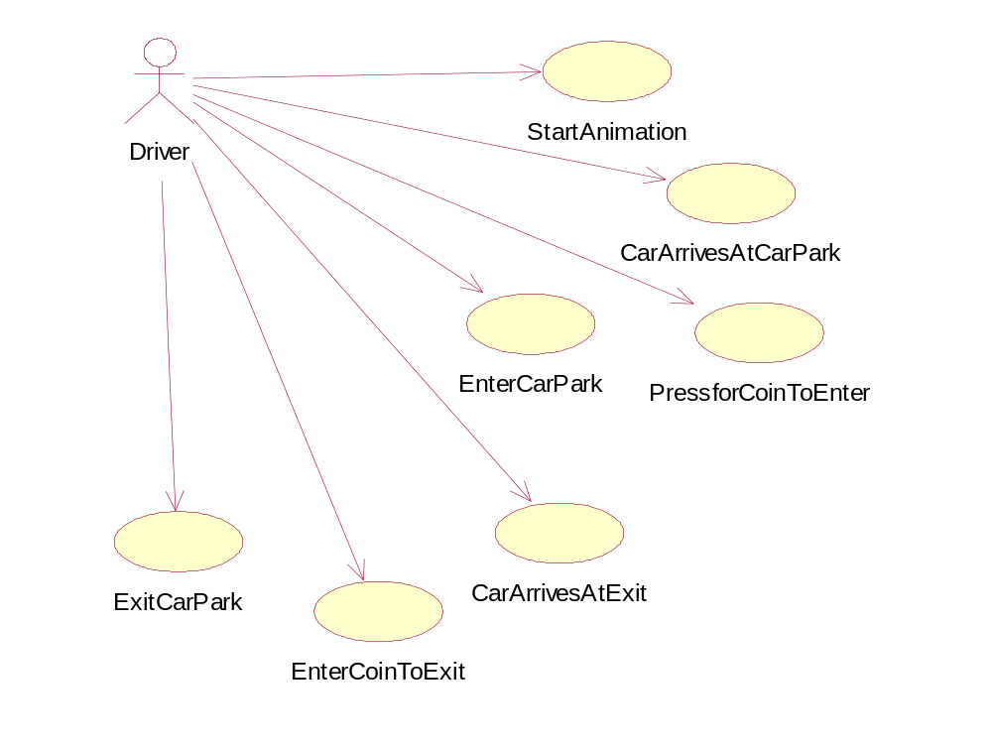

SPECIFIC TASKS

An executable version of this application is also provided to enable you to understand the execution behaviour of this program.

In this assignment, you are expected to:

- produce sequence diagrams for all the operations provided by the "User Interface" class
- implement some of the functionality as outlined below

Specifics of these tasks will now be detailed.

SEQUENCE DIAGRAMS

Produce a separate sequence diagram for each of the following operations provided by the User Interface class:

- CarArrivesAtCarPark
- PressForCoinToEnter()
- EnterCarPark()
- CarArrivesAtExit
- EnterCoinToExit()
- ExitCarPark()

(5 marks each)

(Total = 30 marks)

IMPLEMENTATION

You are expected to implement the following functionality.

User Interface Class

- PressForCoinToEnter()
- EnterCarPark()
- ExitCarPark()
(10 marks each)

Coin Machine

Implement all the methods and the constructor
(15 marks)
Park

Implement all the methods and the constructor
(15 marks)
Full Sign

Implement all the methods and the constructor
(10 marks)

(Total = 70 marks)

Consistency between sequence diagrams and implementations is of paramount importance. You are required to provide a table, showing how sequence diagrams correspond to your implementations. Marks up to 10 will be deducted if inaccuracies are found between sequence diagrams and their corresponding implementations.

SUBMISSION DETAILS

Your assignment submission should include the following:

- A set of sequence diagrams as outlined in "Specific Tasks".

- A listing of the entire program, detailing your specific contributions. (You should highlight your contributions in this listing).

- A zipped-up project folder representing your software on a CD so that I can verify your contribution. Please make sure that, once the zip file is expanded, your project will run. I will not accept any responsibility if you fail to test this aspect. Moreover, you must NOT use any archiving software that is not supported by the university. It is entirely your responsibility to test this aspect.

SUBMISSION DATE

11th March 2011 (by 4pm at the latest)

Please ensure that your work is handed in to Furnival reception on or before the deadline. Make sure that you write Mehmet B Ozcan on the assignment form before you hand in your assignment.

MB Özcan

21st February 2011

Notes:

- Is Available, some kind of validation?

