Maze 1(Easy)

The player starts on the red triangle and must reach the orange square

You have 2 minute to do so.

The player must go to the blue walls and complete the puzzles there to progress.

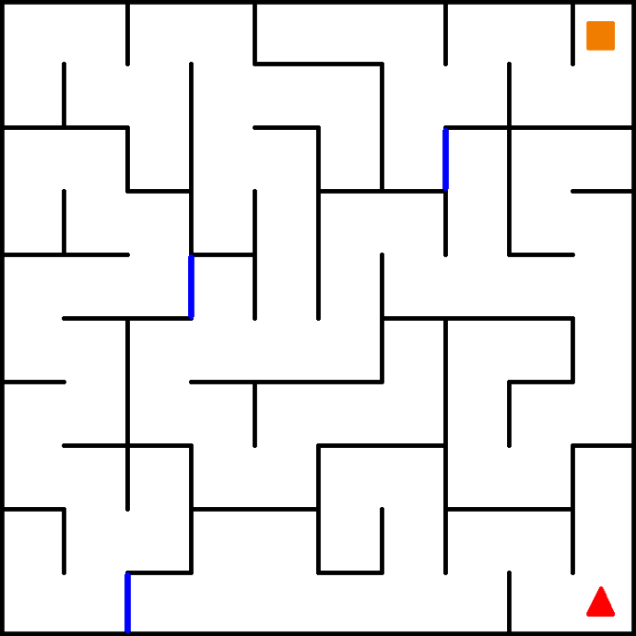

On the puzzle console, there will be a screen displaying either:

Red, blue, white, yellow or black.

1 2 3 4

|  |  |
| --- | --- |
| Yellow | Press the 1st button |
| Red or Black | Press the 2nd button |
| White | Press the 3rd button |
| Blue | Press the 4th button |

Maze 2(Medium)

The player starts on the black arrow and must reach the orange square

You have 1.45 minute to do so.

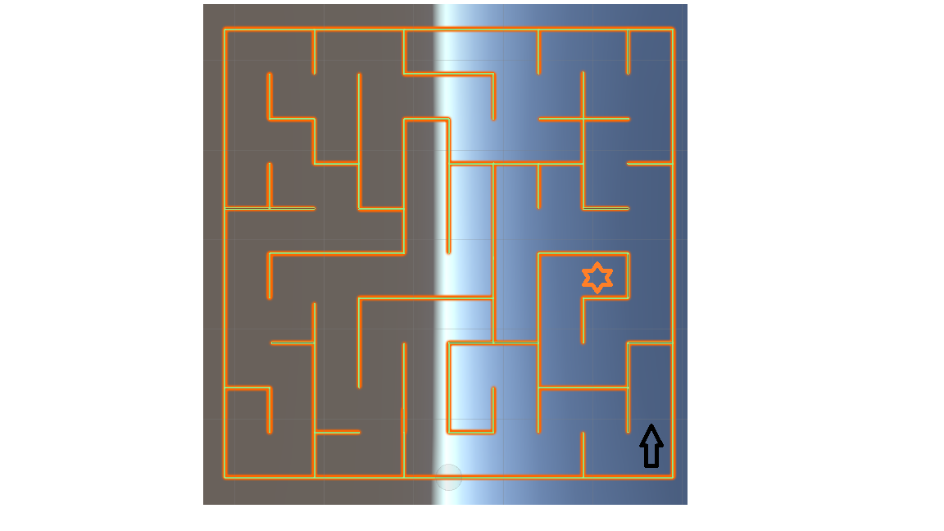

Throughout the maze you will discover puzzle doors with a console on them. On the puzzle console, there will be a screen displaying either: Red, blue, white, yellow or black.

1 2 3 4

|  |  |
| --- | --- |
| Yellow | Press the 1st button |
| Red or Black | Press the 2nd button |
| White | Press the 3rd button |
| Blue | Press the 4th button |