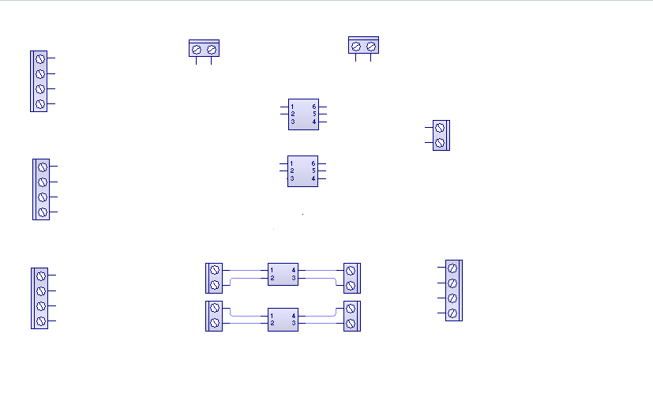

Relay C

Relay B

Sensor IN

Sensor C 🡪

Btn C 🡪

Sensor B 🡪

Btn B 🡪

Sensor power OUT

12V- C 🡨

12V + C 🡨

12V- B 🡨

12V + B 🡨

Alarm power OUT

12V- C 🡨

12V + C 🡨

12V- B 🡨

12V + B 🡨

Batery lapto 12v

USB 5v

DRAWN BY:

Sergio Giovanny Marcano Villarhermosa

SHEET:

1/1

DATE:

2020-17-10

REV:

1.0

TITLE:

Electrical board of the house sensors

Sensor OUT port parallel

🡪 Sensor C

🡪 Btn C

🡪 Sensor B

🡪 Btn B

- +

- +

Alarm comand IN

🡨 Pin 16 alarm C

🡨 Pin 14 alarm B

Outo C

Opto B