Creating Colline Clusters for Eastern DRC Using QGIS

1. After creating your 3D view, arrange your windows in such a way that it will easily facilitate editing. Whatever works best for you. An example is below:

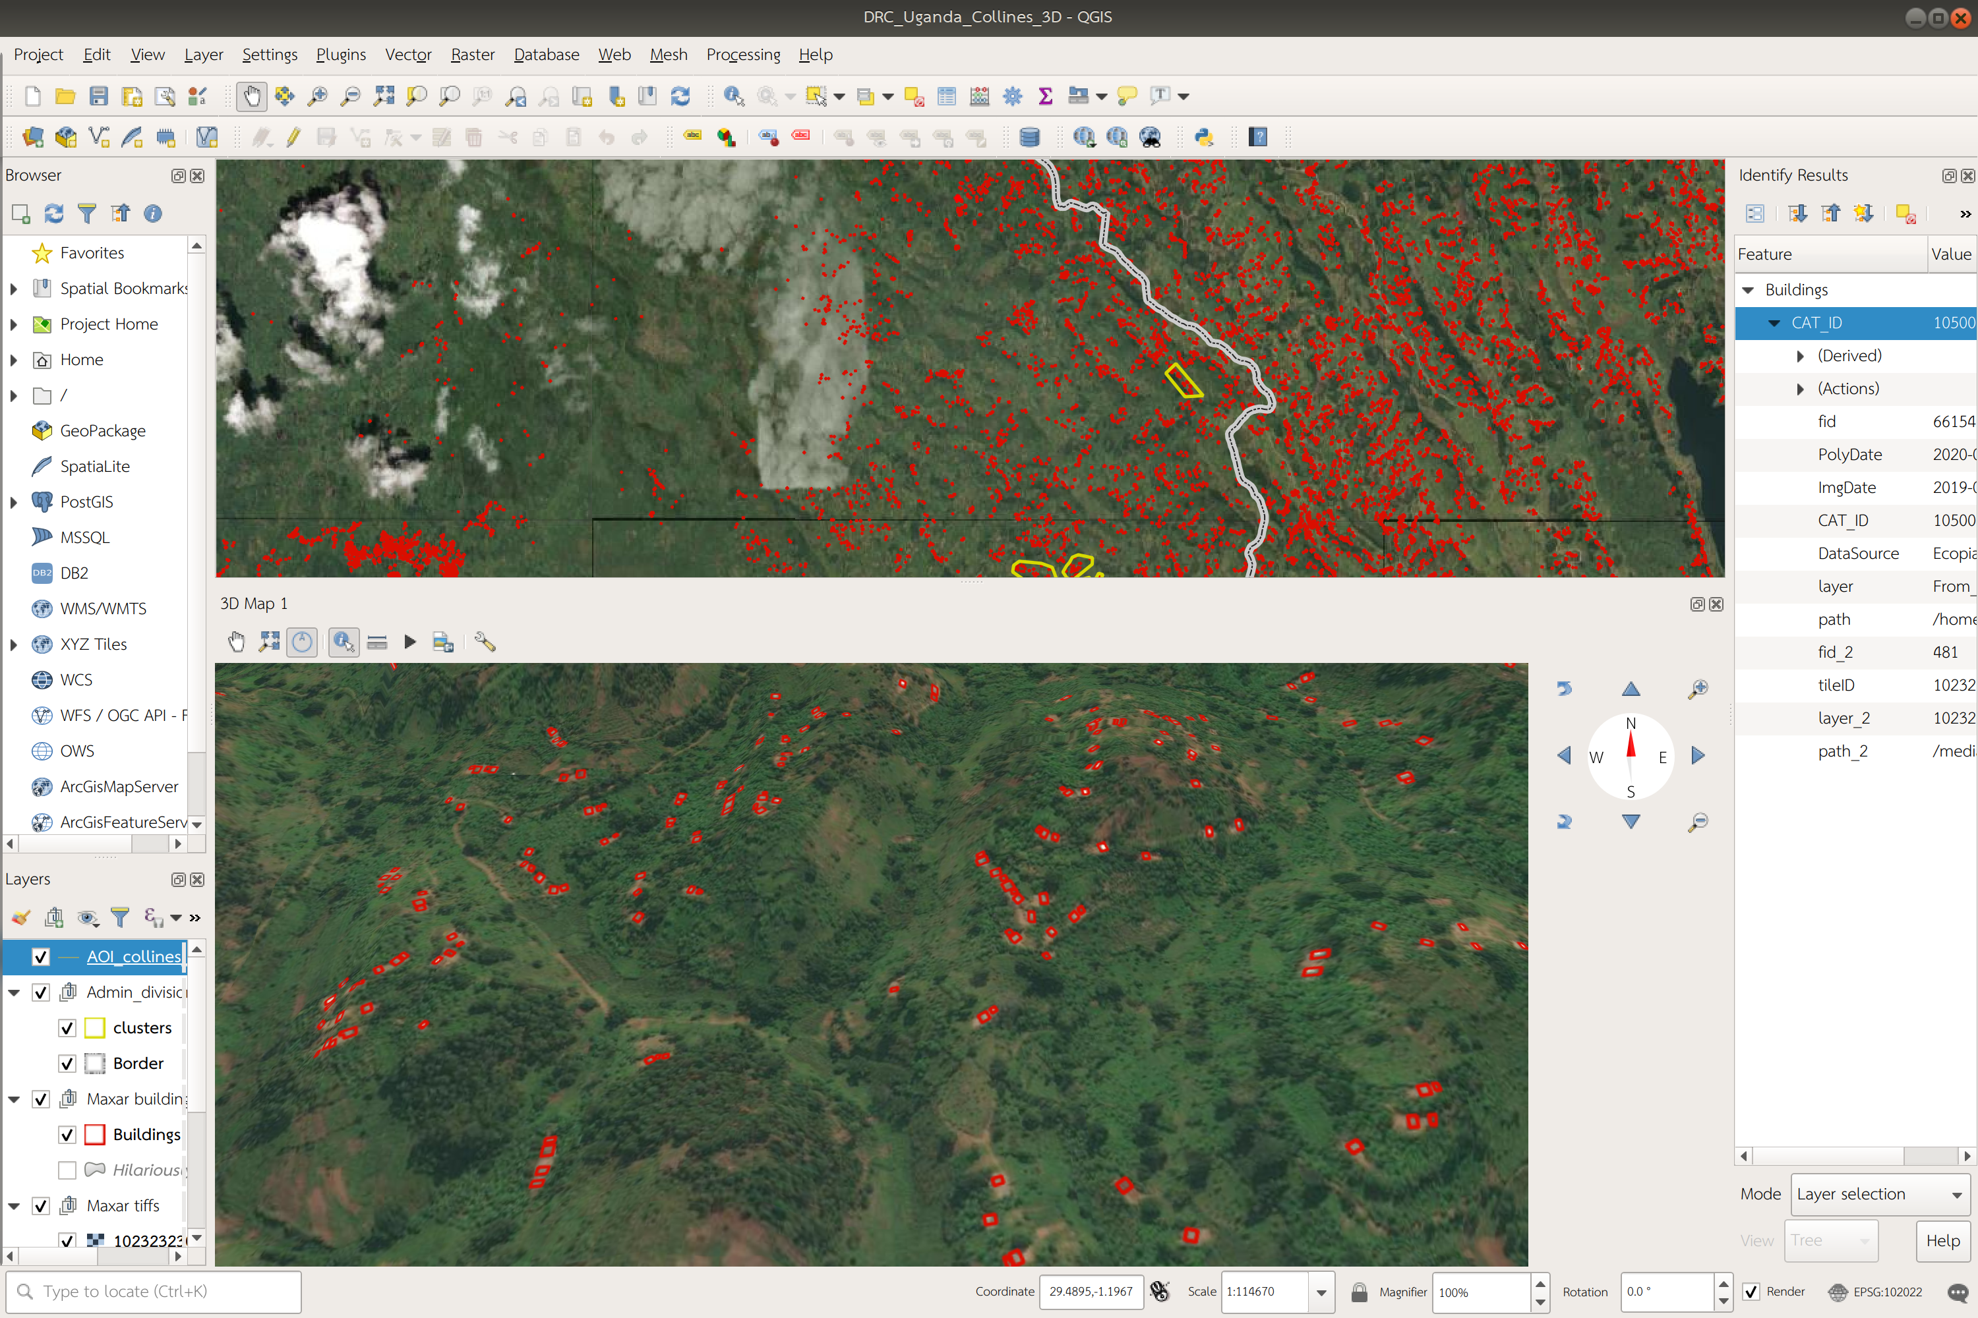
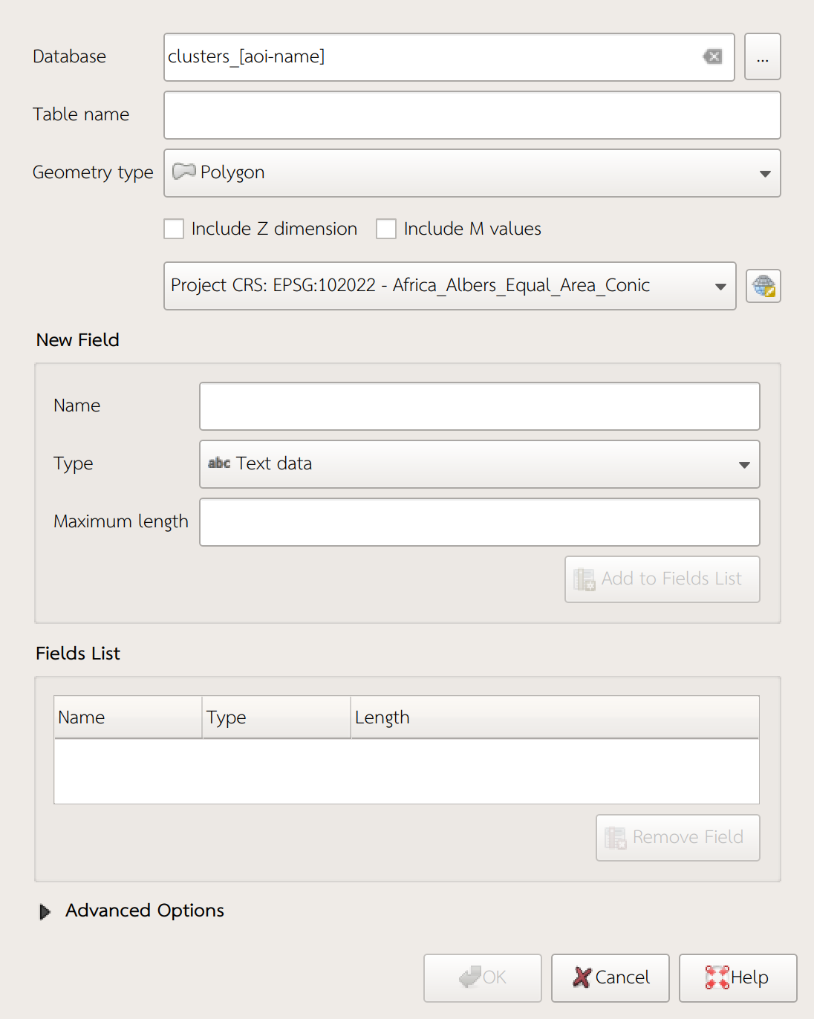
This example has the 2D map (where we will have to do the actual editing) in the top left, the identify pane (needed to connect the 2D and 3D views) to the right, and the 3D view the largest on the bottom. It is useful to have this view the largest so that you can easily view and navigate the hills.

2) Create a new polygon .gpkg layer for the clusters:
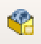

- Make sure this is a polygon file and save in your “vector” folder with the other project files.


3) Locate a colline in the 3D view. Zoom in to one building on the hill and use the “identify” tool to click on a building on the hill.

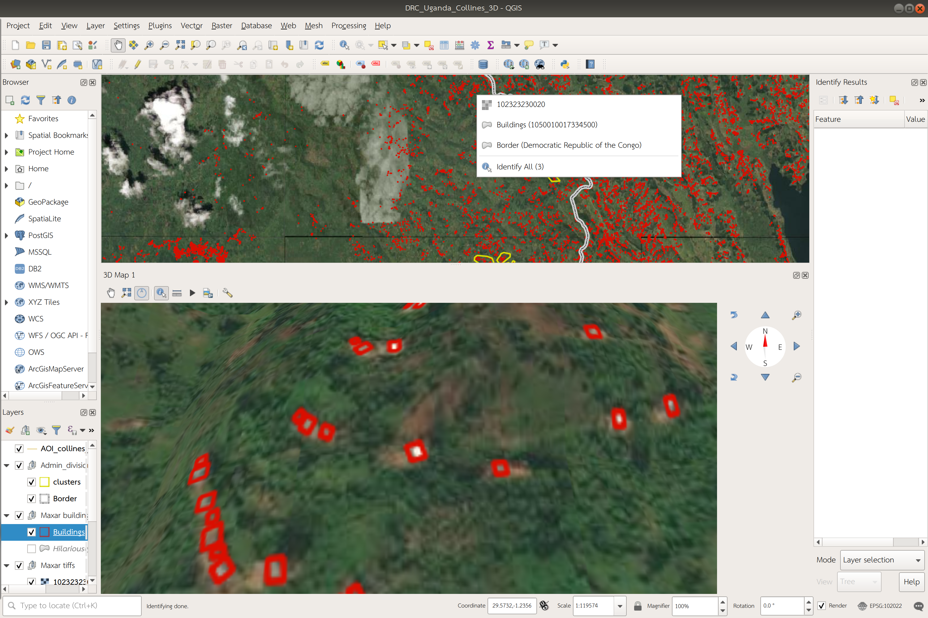
- When you click on the building you should see several options come up for layers that you can identify. Make sure you click the buildings layer.
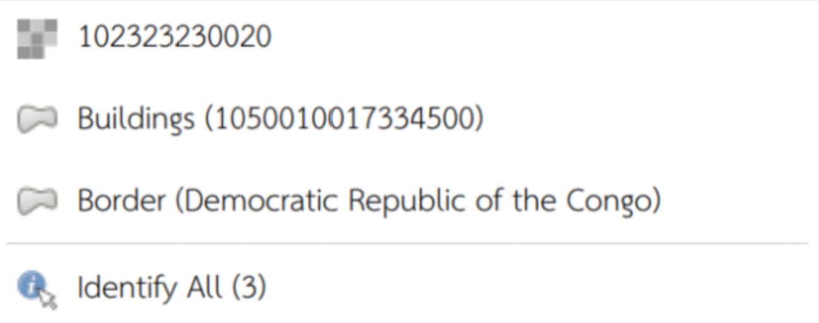

- If you don’t see the buildings layer at a specific zoom level, zoom in more and try clicking “identify” on the building again. Sometimes you need to zoom very close to get it to register.

4. Click on the “Buildings”

5. In the “identify Results” panel, right click on “CAT_ID”, then click on “Zoom to Feature”
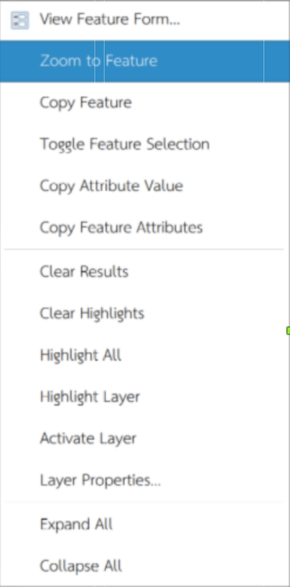

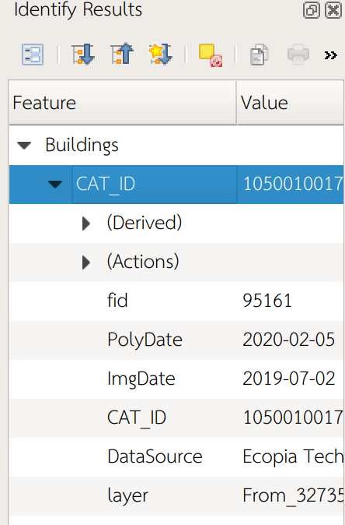

6. You should now be zoomed to a specific building in the 2D view. Zoom out a bit so that you can see the cluster of buildings that you see in the 3D view (see below).
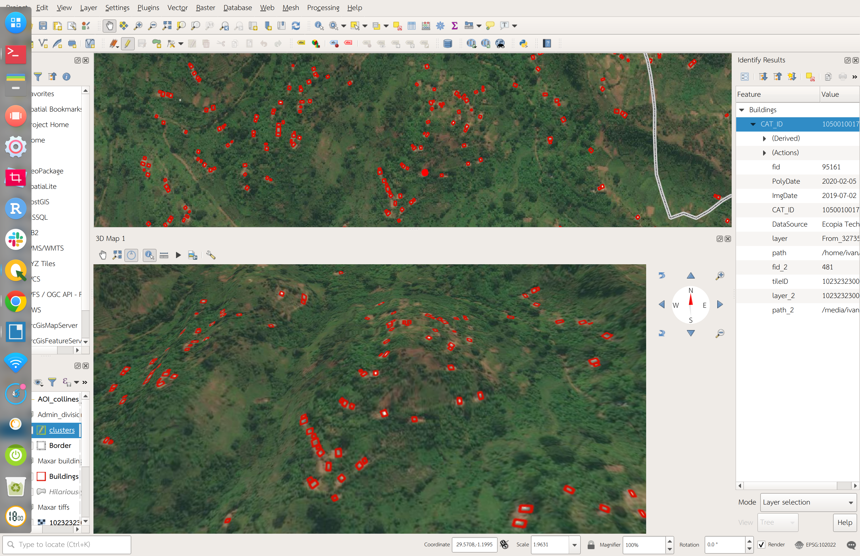

7. Select the layer for the clusters and click the edit button. Click create polygon. In the 2D view, draw a polygon around the cluster of buildings. Right click when you are finished drawing. A window will pop up. If it says “Autogenerate,” accept this default, as this will create the Feature ID (FID) automatically. Click save in the editing toolbar to save your edit.

8. After you click to create the polygon, it should show up immediately in your 3D view. Check the 3D view to ensure you included all the polygons you wanted to cluster.

9. If you need to edit your cluster polygon, you need to have the layer selected, the editing on, and click the “Vertex Tool” to move or create new vertices on a cluster polygon.

Save your project periodically to prevent loss of data!

