Access KML or GPX files in OSMAND

1) Transfer or download .kml or .gpx files to your Android device. Put files in an easy to access location like “Downloads” or “Documents”.

2) Open OSMAND app.

3) Download basemap data for Mali (if not already downloaded)

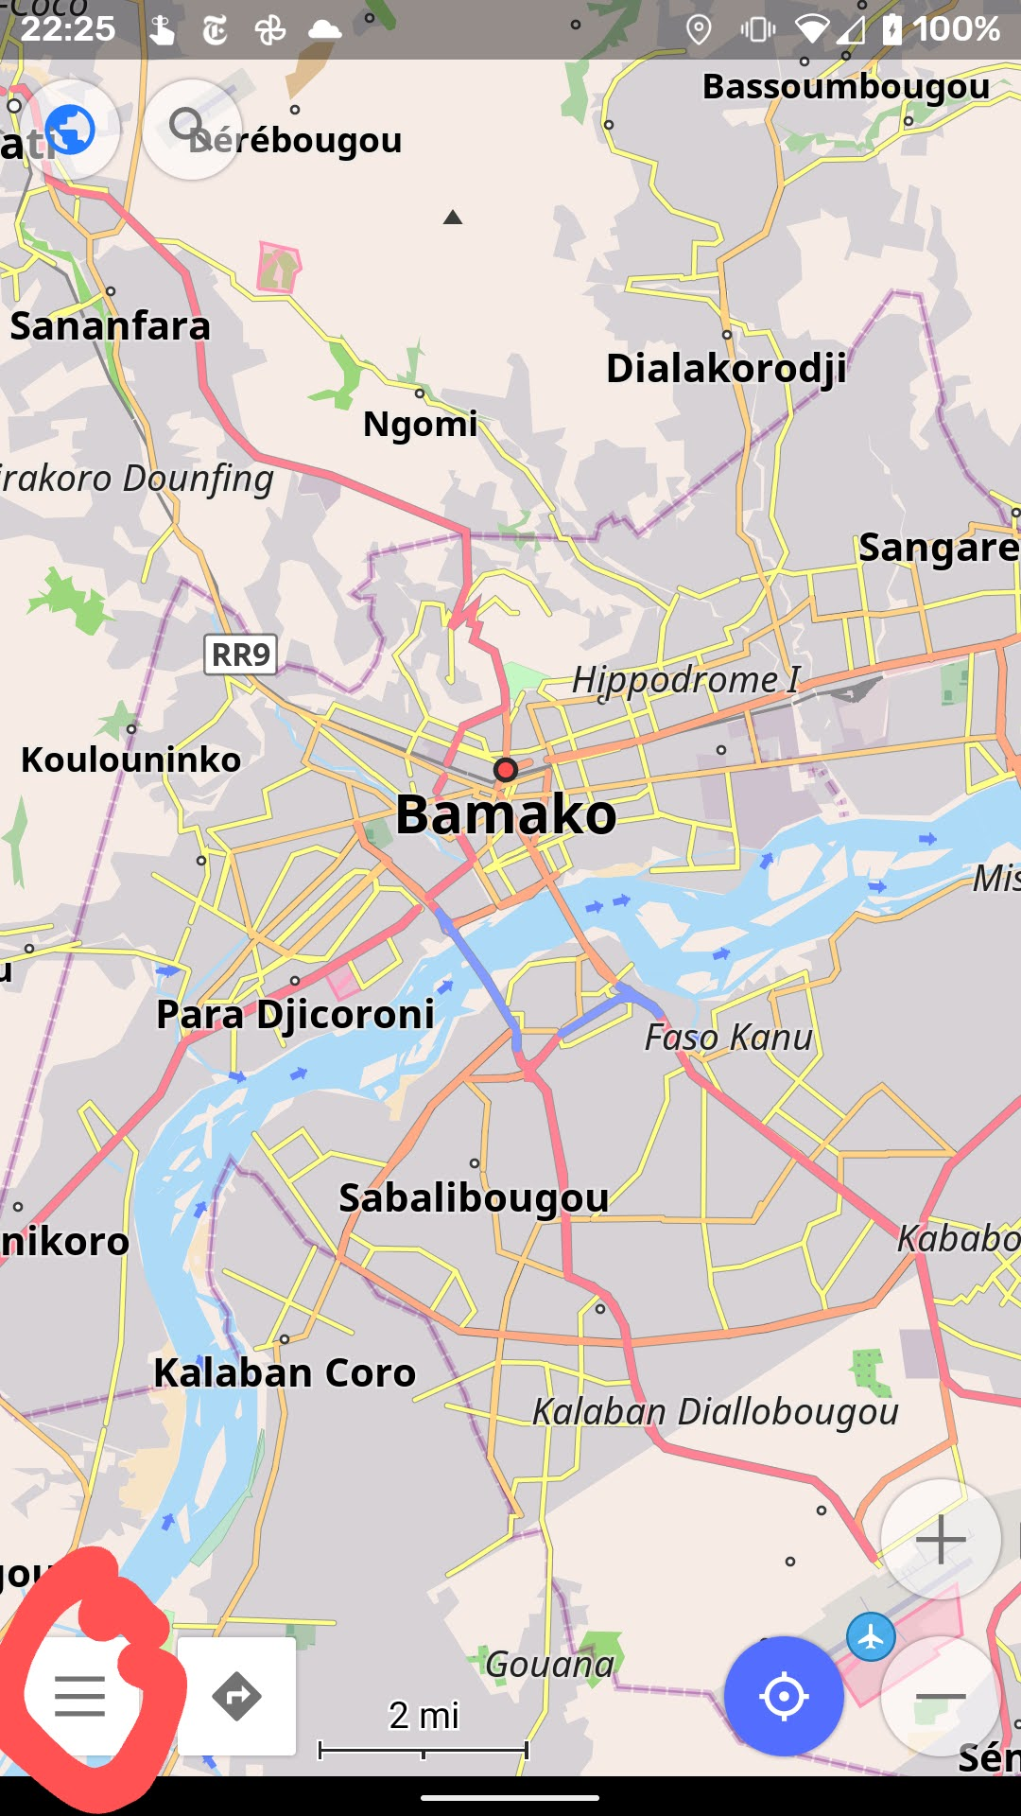
4) Click on the icon with 3 lines in the bottom right (see below)

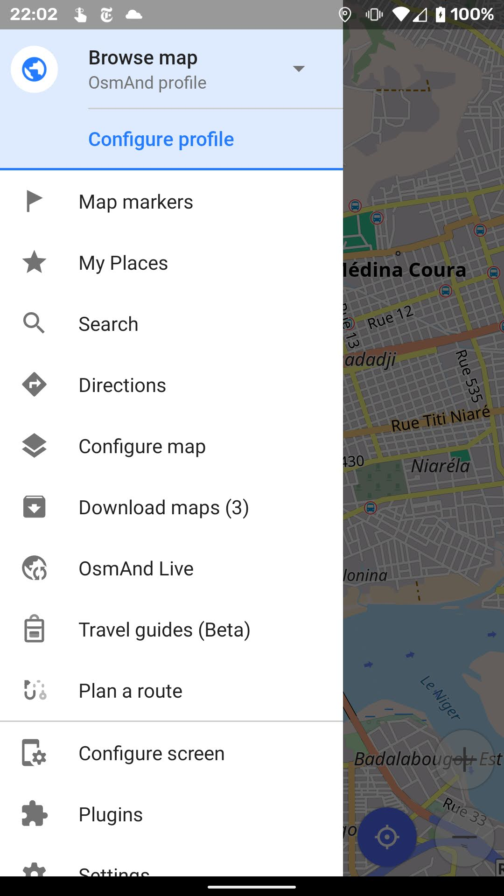
5) Choose “My Places”

6) Go to the “Tracks” tab and press “Import” in the middle.
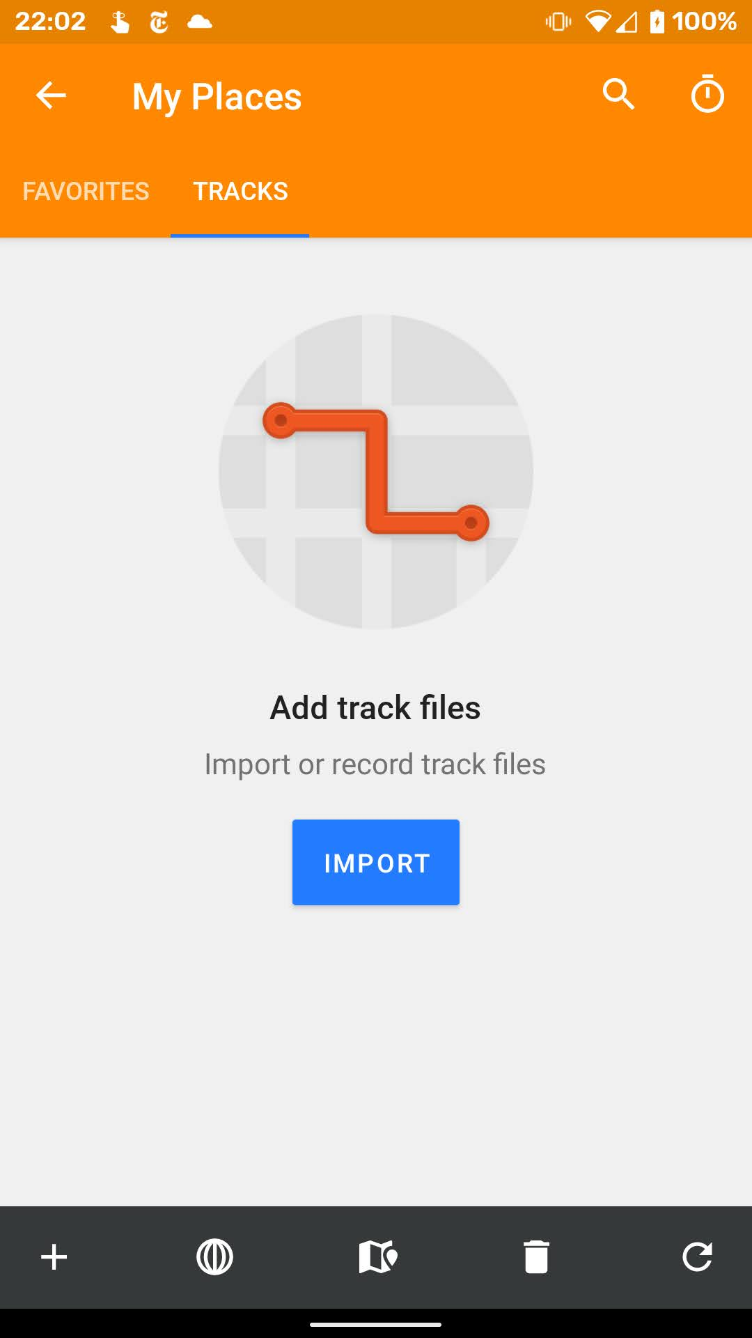

7) Navigate to the folder where the .kml files are saved press on each file that you want to add. The points should automatically show on the map.

