DNACPN Matching Analysis README

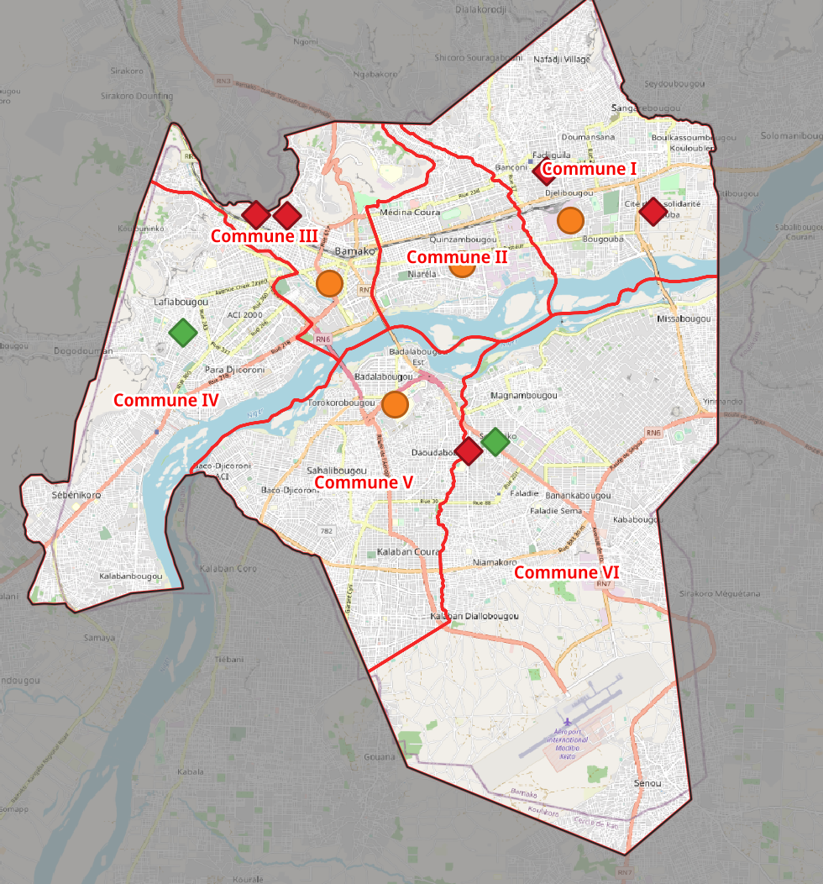
Health – CSREF

I matched the “Centres de Sante References” that we collected with those from the DNACPN sheet and categorized by True Positive (Green), False Positive (Red, those that we said were CSREF, but did not agree with the DNACPN sheet), and True Negative (Orange, those that we did not collect as CSREF).

In the “DNACPN_Matching” QGIS file included in this folder, the “DNACPN_Latrine_CSREF_Validation” can be found in the “DNACPN Matching” group. See screenshot at right. There were 2 of 6 True Positive (matched) CSREFs.

A file with the analysis of the data we collected, broken out to only CSREF can be found in the “Health” group and is called “02_health_facilities_CSREF_v5_DNACPN_Matching”

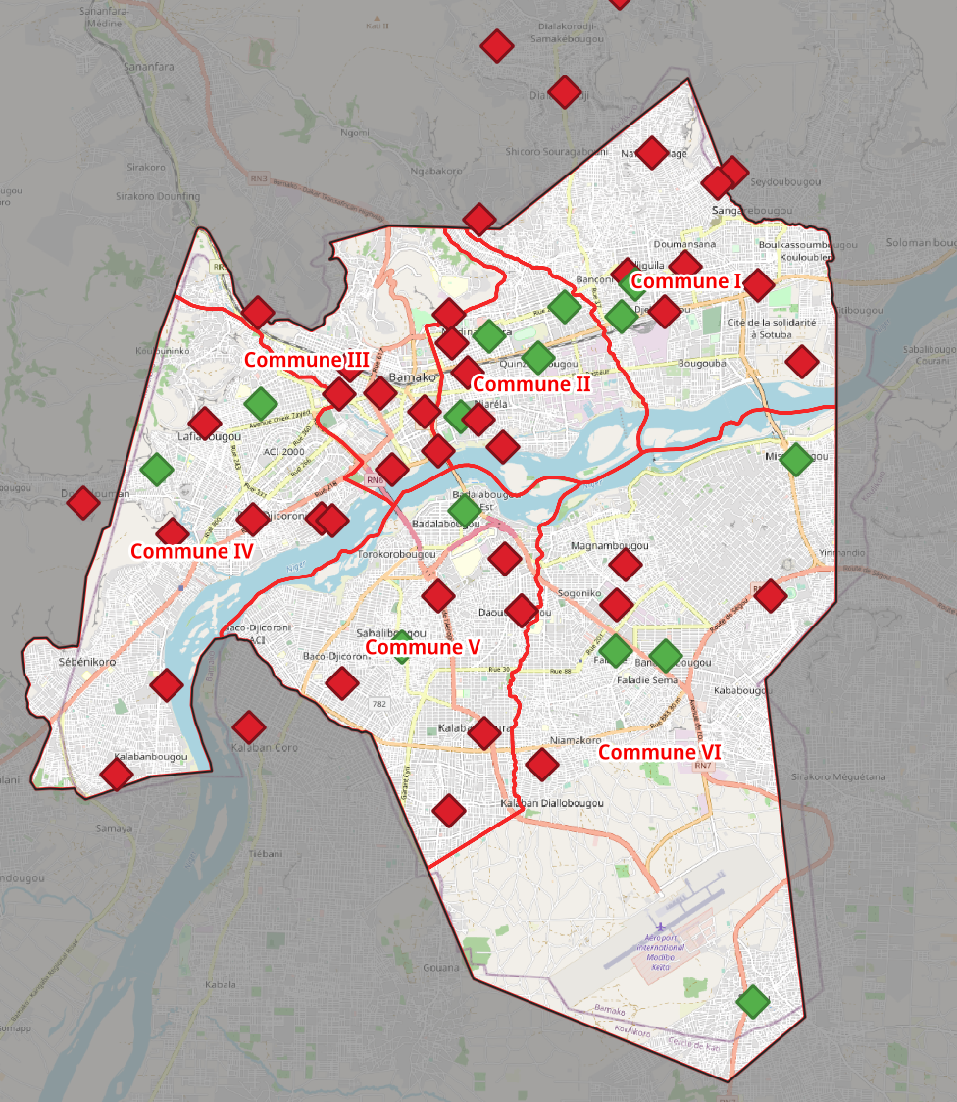
Health – CSCOM

This time I matched the CSCOM data in the DNACPN sheet with the health data with only locations listed as “clinics” and “Community Health Centers”. I chose to also include clinics because it appears that some of these my have actually been CSCOMs and incorrectly labeled as “clinics”.

The “DNACPN_Latrines_CSCOM_Validation” can be found in the “DNACPN Matching” matching group and includes all the DNACPN CSCOM data categorized as “Yes” (matched with OCA Bamako data, in Green), and “No” (not a match, Red). This is based on a added field in the attribute table called “OCA_Collected”. See screenshot at right. 14 out of 82 CSCOM were matched with the OCA Bamako data.

A file with the clinics and CSCOM collected by OCA Bamako is called “02_health_facilities_clinics_comhealthcenters_DNACPN_Matching” and can be found in the “Health” group. This file includes a new column in the attribute table called “DNACPN_Match” with a Yes/No value for each point. Some of these facilities include multiple points that matched with a DNACPN facility, so these should be verified.

I performed a full quality check on this layer to ensure that the matched data truly matched in name and location with the OCA Bamako layers. Some changes were made to both layers above as a result.

Education – Ecoles
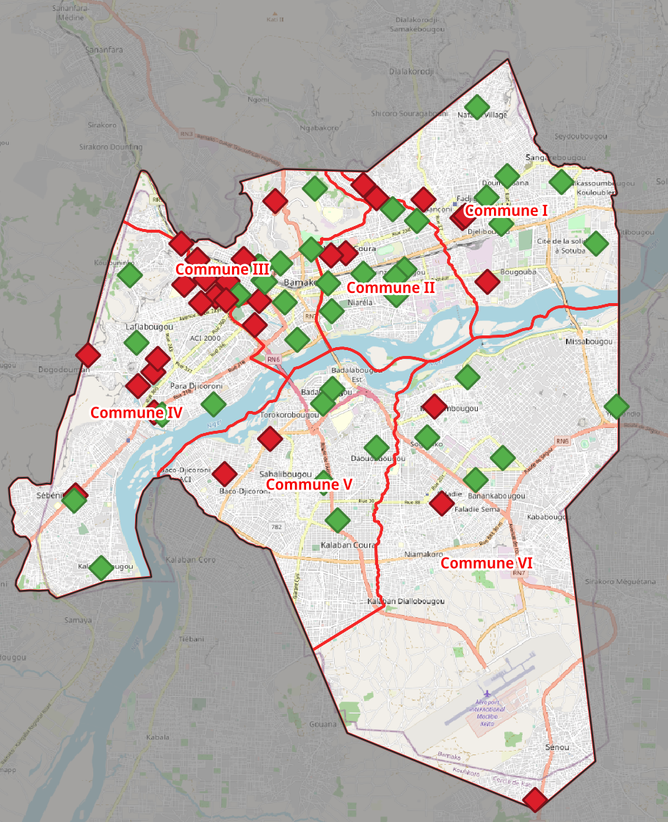
I followed a the same procedure here as with CSCOM above, but matched all school categories with the ecoles listed in the DNACPN sheet, since our data has not been validated.

The “DNACPN_Latrines_Ecoles_Validation” layer can be found in the “DNACPN Matching” matching group and includes all the DNACPN Ecoles data categorized as “Yes” (matched with OCA Bamako data, in Green), and “No” (not a match, Red). This is based on an added field in the attribute table called “OCA_Collected”. See screenshot at right. There were 40 out of 71 schools matched.

A file with all the schools collected by OCA Bamako is called “03_education_all_DNACPN” and can be found in the “Education” group. This file includes a new column in the attribute table called “DNACPN_Match” with a Yes/No value for each point. There is also a file with only the matched OCA Bamako education facilities here called “03_education_DNACPN_Matching”. Many of the DNACPN facilities included multiple points that matched, so these should be verified.

I performed a full quality check on this layer to ensure that the matched data truly matched in name and location with the OCA Bamako layers. Some changes were made to both layers above as a result.

NOTE: An important note on this layer is that several of the schools in the DNACPN layer did not seem to fall in a large school yard area on the map. Some of these schools may be smaller or built vertically in a building, but a few were obviously points in the wrong place (perhaps 150 or 200 meters away from the school denoted). I would suggest visiting and verifying all of these schools (even the matched ones) as part of the next field work.

General Methodology

I followed the same general methodology for spatially matching the OCA Bamako data collected with the DNACPN spreadsheet. After bringing each sheet in as a .csv and saving the point layers as .gpkg files, I reprojected to a CRS in meters (I just used Africa Albers Equal Area projection). I then created buffers for each of the DNACPN point layers (CSREF, CSCOM, Ecoles) with the same distance of 150 meters (which seemed to capture all relevant OCA Bamako data collected based on visual inspection.

With these buffers, I used the “Select by location” tool to select the respective data from CSREF, CSCOM and Ecoles collected by OCA Bamako that intersected with the 150m buffers. Specific details notating the matching of the DNACPN data and the OCA Africa layers are below.
To show matching in the DNACPN data, I used “Select by location” in reverse, this time selecting only the buffers that intersected with the selected OCA Bamako data, then using “select by location” again to match the final validation layers.

