EUCALL-SIMEX: Development for Laser Plasma Accelerator driven Free Electron Laser source
A.Sharma¹ Axel Huebl², Carsten Fortmann-Grote³, and Michael Bussmann²
¹ELI-LAPS, Szeged, Hungary.
²HZDR, Dresden, Germany.
³XFEL, Hamburg, Germany.

In proposed SIMEX development project, we focus to investigate the possible route for experimental realization of laser plasma accelerator based coherent light source (FELs)¹. Since the conventional accelerator has the limit of the gradient due to the structure surface field limit, the best gradient achieved now is less than 100MeV/m. Laser plasma accelerator (LPA)²⁻⁴ will be the next generation accelerator facilities with the ultrahigh gradient which will reach 100GeV/m. Due to the ultrahigh gradient of LPA, the accelerator facility will be miniaturized greatly.
Here we are employing an extension of SIMEX platform to enable simulation of LWFA based coherent light sources (FELs) by coupling a particle-in-cell (PIC) code (PIConGPU)⁵ that describes the LWFA to a FEL simulation code (GENESIS)⁶.

Proposed Setup for SIMEX:
Our proposed setup is shown in Fig. 1; starting from electron beam generation from a laser plasma source to the generation of femtosecond and/or attosecond EUV/XUV pulse from the radiation undulator at endpoint. In this scheme an intense.

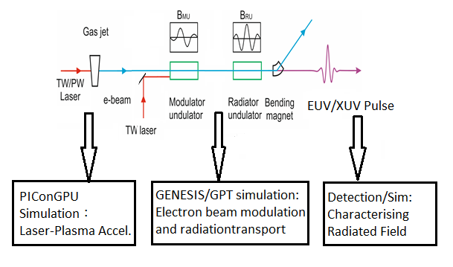

Fig. 1. Scheme of the proposed setup

(TW/PW power) laser is focused on gas jet/ gas filled capillary for producing a relativistic electron beam. Initial energy spread of the electron beam of a LPAs (1-5%) is typically much larger than that of a LINAC (about 0.05 %), so reduction of the slice energy spread is necessary. The electron beam is sent through a modulator undulator (MU) together with a TW-power laser beam, where the interaction between the electrons, the magnetic field of the undulator and the electromagnetic field of the laser introduces a periodic energy modulation of the electrons. This energy modulation leads to the formation of nanobunches (ultrashort electron layers). The nanobunched electron beam then passes through a radiator undulator (RU) consisting of a single or a few periods and creates EUV/XUV pulses.

We proceed in this SIMEX development for LPA-FEL following two parallel path:

- Development of SIMEX setup for LPA-FEL by combining PIConGPU and GENESIS,
- Utilisation of experimentally achieved high quality electron beam as an input to FEL simulation code GPT/GENESIS, for investigation of coherent radiation generation.

Since February, we investigated both case as listed below:

- Development of SIMEX setup for LPA-FEL (with Carsten and HZDR team)

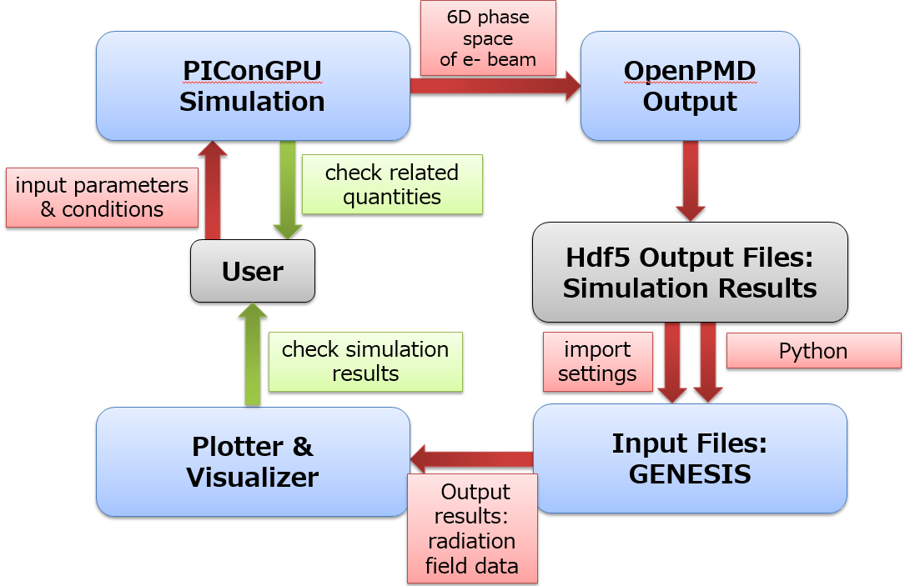
Figure 2: Layout for Simulation Setup

- Laser-plasma accelerator based single-cycle attosecond undulator source (in collaboration with T. Zoltan and Prof. Hebling, Pecs University Hungary)

Example Results: Complete details on the following results can be accessed at https://arxiv.org/pdf/1708.09384.pdf
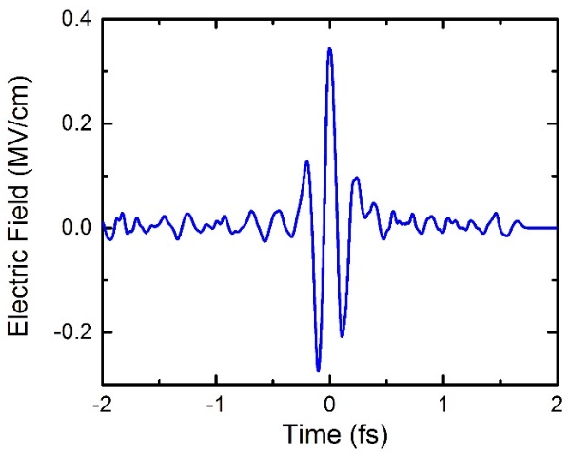(a) | 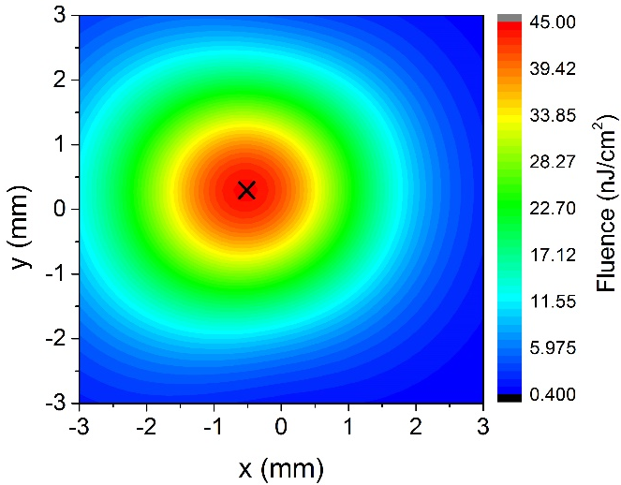(b)
Fig. 3 - GPT Simulation Results: (a) CEP-controlled EUV waveforms (b) and its spatial beam profile.
Figure shown here, displays the simulated waveform of the generated attosecond pulse and the beam profile at 60 nm radiation wavelength. The location of the waveform in fig (a) is shown in figure (b) marked with a symbol x. In other wavelengths the shape of the attosecond pulses are nearly identical with the shape shown in fig (a) so these pulses are CEP controlled too.

Acknowledgements
This project has received funding from the European Union Horizon 2020 research and innovation programme under grant agreement No 654220.

b)
a)

References

[1] P. Emma, K. Bane, M. Cornacchia, Z. Huang, H. Schlarb, G. Stupakov, and D. Walz, Phys. Rev. Lett. 92, 074801 (2004)

[2] W. P. Leemans et al, Nat. Phys. 2, 696 (2006)

[3] E. Esarey et al, Rev. Mod. Phys. 81, 1229 (2009)

[4] T. Tajima and J. M. Dawson, Phys. Rev. Lett. 43, 267 (1979).
[5] M. Bussmann et al, Proceedings SC13: International Conference for High Performance Computing, Networking, Storage and Analysis 5-1, 2013.

[6] GPT: online at http://www.pulsar.nl/gpt

[7] GENESIS: online at http://genesis.web.psi.ch/

