The moviedb API - <https://www.themoviedb.org/> . is very tedious to work with. On one hand when testing using postman, this

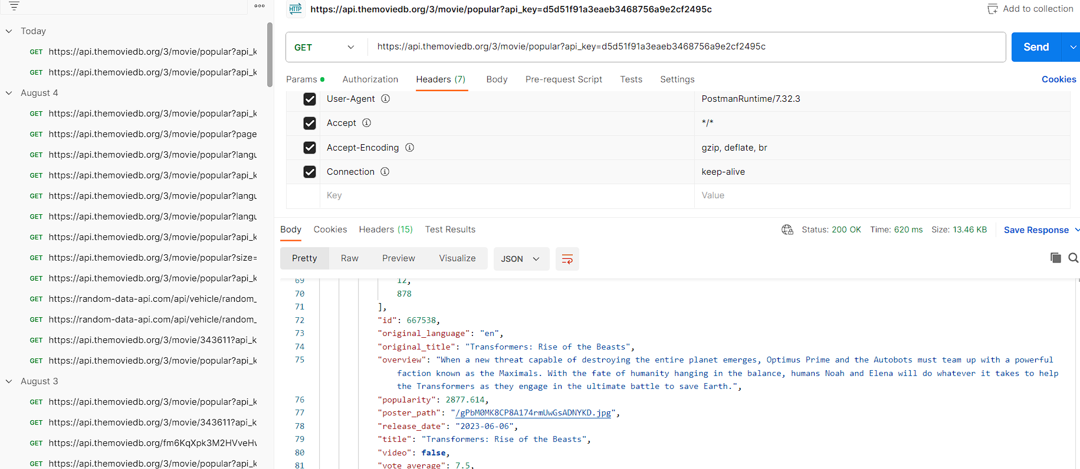

And when using retrofit with coroutines, the full data doesn't come out due to APIs being selective of the headers sent by the application which affected the images and text.

