EUCP convection permitting simulations for Europe - experiment details

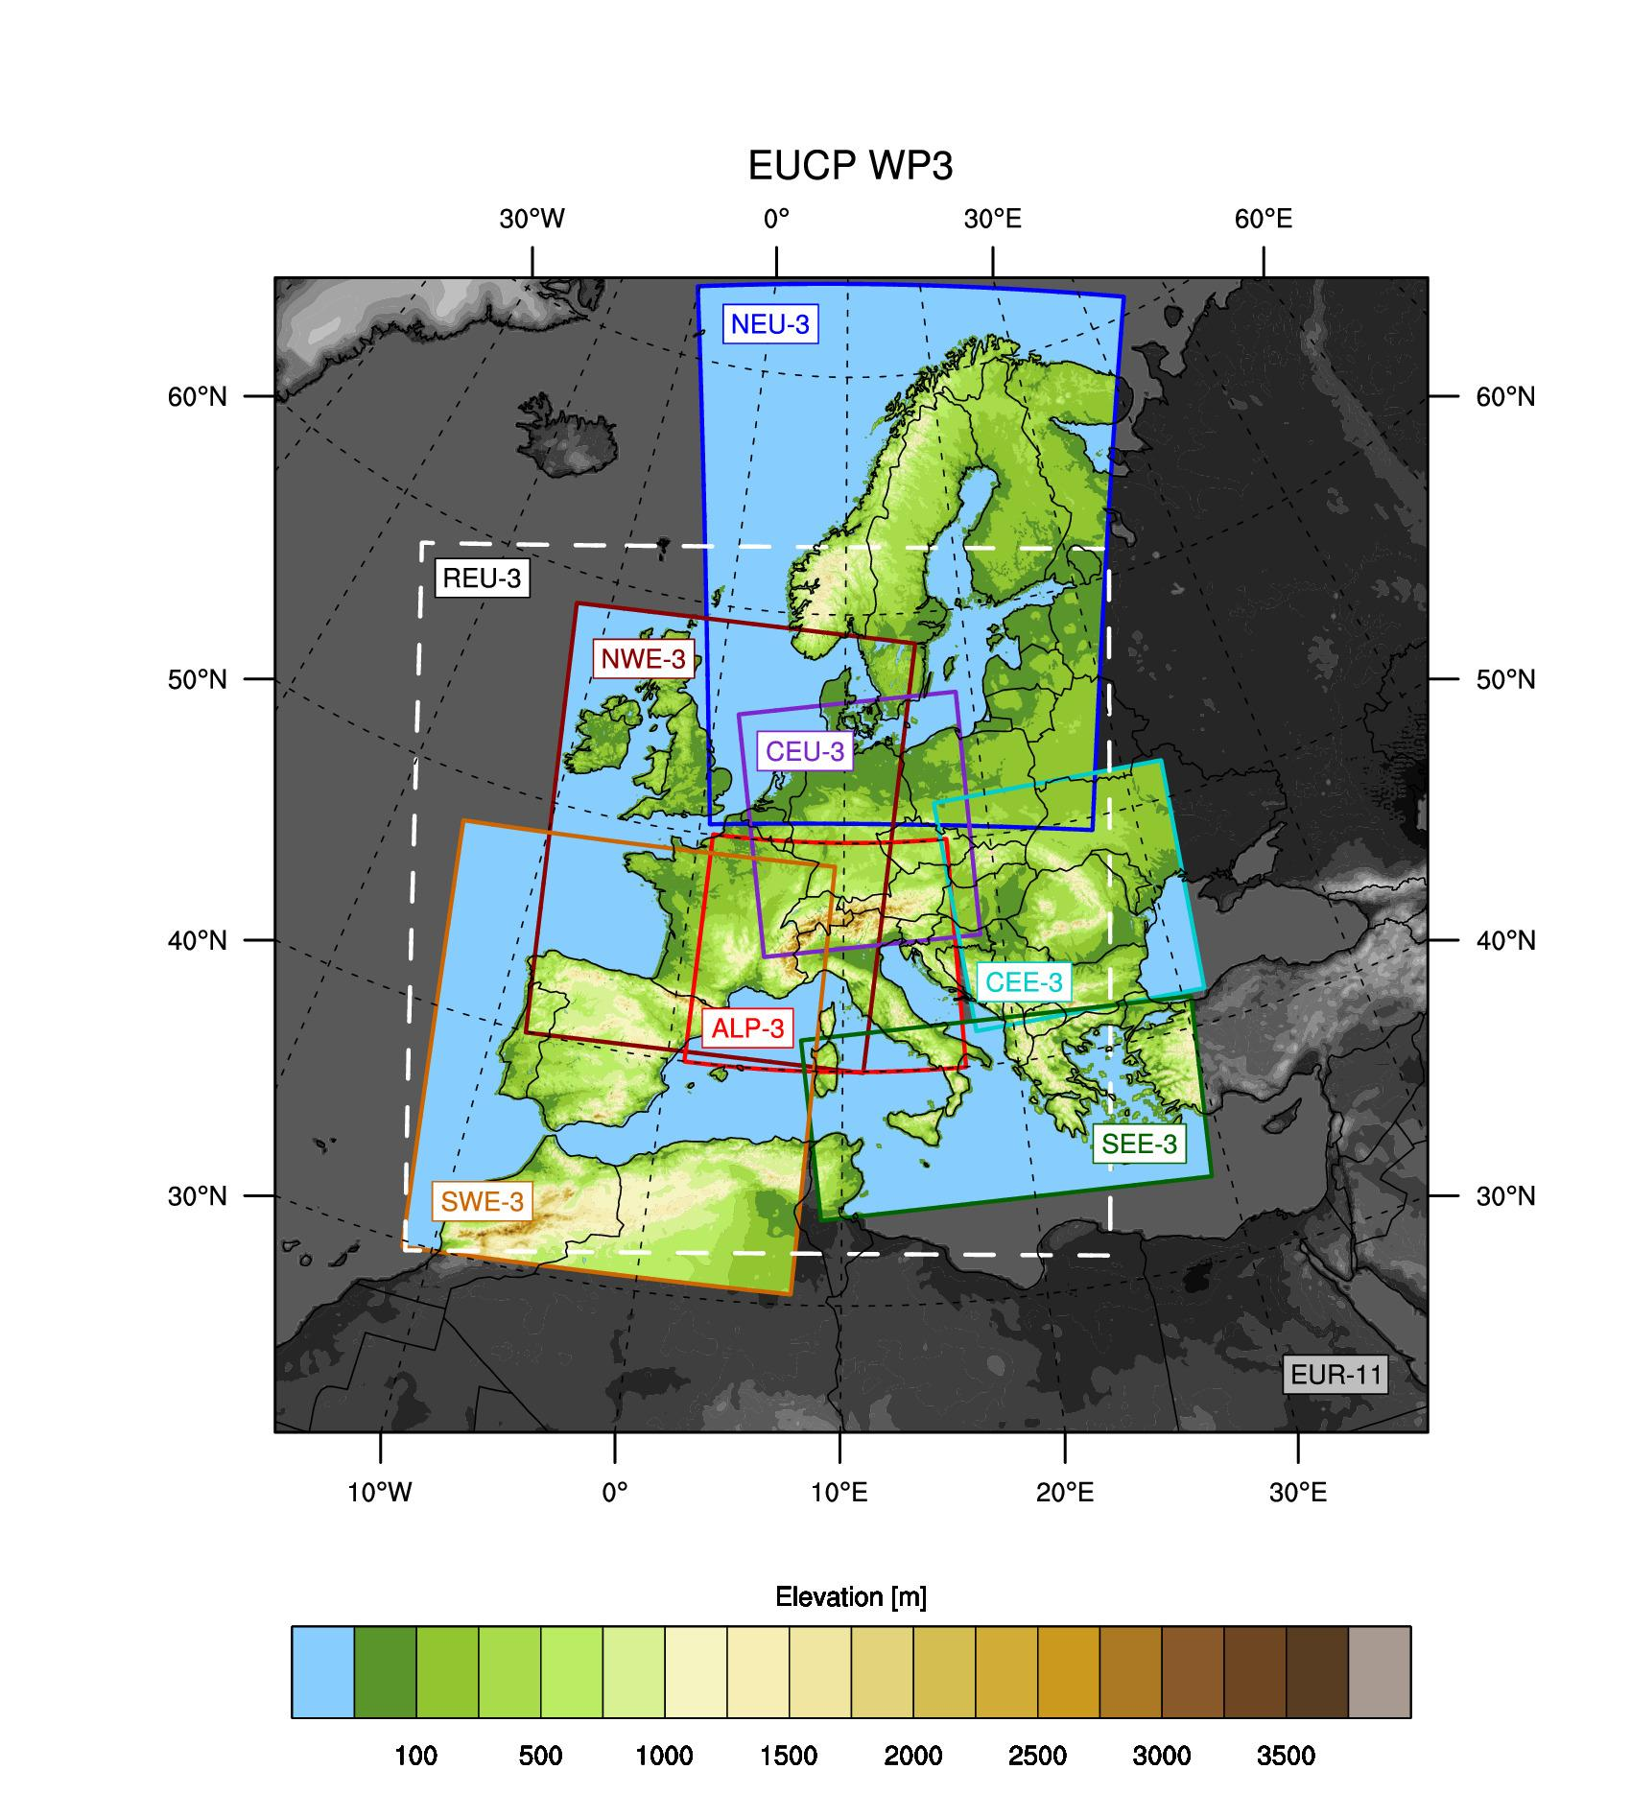

*Figure 1: Set of domains used for CPM simulations. In addition to the sub-continental domains covered by the modelling groups, the dashed box indicates the Reduced Europe domain (REU-3) used by ETH and UKMO.*

***Table 1: Experiment Time periods***

|  |  |
| --- | --- |
| **SIMULATION TYPE** | **PERIOD\*\*** |
| Evaluation run (ERA-Interim) | 1/1/2000 - 31/12/2009 |
| Historical run (GCM) | 1/1/1996 - 31/12/2005 |
| Near future run (GCM, RCP8.5) | 1/1/2041 - 31/12/2050 |
| *Optional: End of century future climate (GCM, RCP8.5)* | *1/1/2090 - 31/12/2099* |

***Table 2: Modelling systems used by the participating groups.***

|  |  |  |  |  |  |  |
| --- | --- | --- | --- | --- | --- | --- |
| **GROUP** | **CPM** | **dx (km)** | **RCM** | **RCM domaina / dx (km)** | **GCM** | **CMIPx** |
| CMCC | CCLM | 3 | CCLM | EC/12 | EC-Earth r12 | CMIP5 |
| CNRM | AROME41t1 | 2.5 | ALADIN63 | EC/12 | CNRM-CERFACS-CNRM-CM5 r1 | CMIP5 |
| DMI/ SMHI | HCLIM38- AROME | 3 | HCLIM38- ALADIN | Europe/12 | EC-Earth r12 | CMIP5 |
| KNMI | HCLIM38- AROME | 2.5 | RACMO | Europe/12 | EC-Earth | No |
| ETHZ | CCLM-GPU | 2.2 | CCLM | Europe/12 | MPI-ESM-LR r1 | CMIP5 |
| GERICS | REMO | 3 | REMO | Europe/12 | MPI-ESM-LR r3 | CMIP5 |
| ICTP | RegCM4 | 3 | RegCM4 | Europe/12 | HadGEM2-ES r1 | CMIP5 |
| IPSL | WRF, RegIPSL | 3 | WRF, RegIPSL | EC/15b, MC/18c | IPSL-CM5-MRb, IPSL-CM6c | CMIP5b, CMIP6c |
| UKMO | UM | 2.2 | HadGEM3-GC3.1-N512 (HiresMIP) | Global/25d | HadGEM2-ES r1 | AMIP- CMIP5 SST |

***Table 3: Distribution of modelling groups over the eight European simulation and analysis domains. No. MEMBERS indicates the sizes of CPM ensembles per domain.***

|  |  |  |  |
| --- | --- | --- | --- |
| **DOMAINa** | **FULL NAME** | **GROUPS** | **No. MEMBERS** |
| ALP-3 | Pan-Alpine | All | 9 |
| NWE-3 | North-West Europe | CNRM, KNMIb, (ETHc,d, UKMOc­­­) | 4 |
| SWE-3 | South-West Europe | CMCC, IPSL (ETH, UKMO) | 4 |
| SEE-3 | South-East Europe | ICTP (ETH, UKMO) | 3 |
| CEU-3 | Central Europe | GERICS (ETH, UKMO) | 3 |
| CEE-3 | Central East Europe | ICTP, SMHI (ETH, UKMO) | 4 |
| NEU-3 | North Europe | GERICS, SMHI/DMI | 2 |
| REU-3e | Europe | ETH, UKMO | 2 |

aDomain names consist of the geographical location indicator and the maximum allowed horizontal grid spacing. Note that some groups used smaller grid spacing, shown in Table 1.  
bKNMI used the Pseudo-Global Warming (PGW) approach for NWE-3, where the future change is added on the ERA-Interim reanalysis fields.  
cETH and UKMO used the REU-3 simulation domain (cf Fig. 1), which includes large parts of the other seven analysis domains. For some analysis domains REU-3 covers only their parts. To address this issue and to maximise the number of members in each domain’s ensemble, for SEE-3 and CEE-3 reduced analysis domains are used (marked with “R”) which overlap with REU-3, while for NEU-3 an additional domain S-NEU-3 is created.  
dETH applied the PGW approach for REU-3, which is used for all the analysis domains except ALP-3. They used a traditional downscaling for a separate ALP-3 simulation.