Operational Comparison of ANS Performance
DECEA Performance Section, EUROCONTROL Performance Review Unit
2025-04-24
Table of contents

Preface
A continuing partnership
This fourth and best edition of the bi-regional Brazil-Europe comparison report of Air Navigation System Performance continues to add transparent and robust data to support an informed discussion about operational performance in both regions. Further, it strengthens the close collaboration between DECEA and EUROCONTROL. This report is jointly developed by the Performance Section of the Department of Airspace Control (DECEA) and EUROCONTROL’s Performance Review Unit (PRU).
For any questions, please do not hesitate to contact one of the authoring organisations.
Performance Section, DECEA Performance Review Unit, EUROCONTROL
$$\\[1in]$$
COPYRIGHT NOTICE AND DISCLAIMER
Every possible effort was made to ensure that the information and analysis contained in this document are as accurate and complete as possible. Should you find any errors or inconsistencies we would be grateful if you could bring them to our attention.
The views expressed herein do not necessarily reflect the offical views or policy of DECEA or EUROCONTROL, which - both jointly or individually - make no warranty, either implied or express, for the information contained in this document, neither do both organisations assume any legal liability or responsibility for the accuracy, completeness or usefulness of this information.
This document is jointly published by EUROCONTROL and DECEA for information purposes. It may be copied in whole or in part, provided that EUROCONTROL and DECEA are mentioned as the source and it is not used for commercial purposes (i.e. for financial gain). The information in this document may not be modified without prior written permission from EUROCONTROL and DECEA.
www.eurocontrol.int & www.decea.mil.br

Foreword


$$\\[0.5in]$$

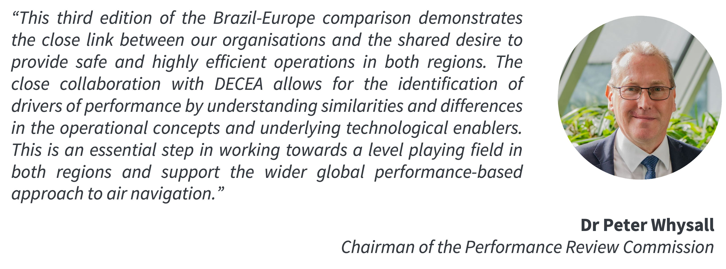

Executive Summary
The Performance Section of the Brazilian Department of Airspace Control and the Performance Review Unit of EUROCONTROL jointly developed this fourth edition of the Brazil-Europe comparison of Air Navigation System Performance. This edition of the bi-regional report builds on the previous comparison reports using commonly agreed metrics and definitions to compare, understand, and improve the performance of air navigation services. This report and previous editions are available at * https://ansperformance.eu/global/brazil or * https://performance.decea.mil.br/.
This report revises the assessment of both the Brazilian and European air navigation systems, extending the time frame and incorporating additional analyses.
more clever text …such as point merge system and a short Curitiba and Lisbon ACC comparison
The report strongly focuses on a subset of the eleven Key Performance Areas identified by the ICAO Global Air Navigation Plan. The focus of this report is on operational air navigation system performance, in particular Predictability, Capacity and Efficiency.
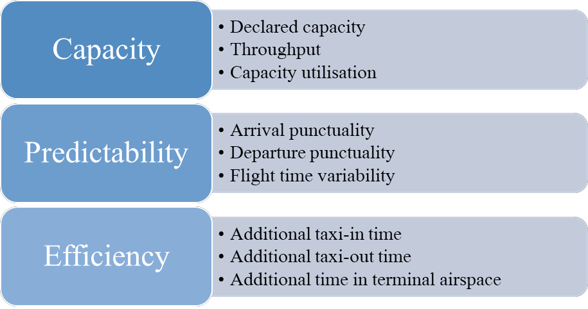
Figure 1: Key Performance Areas addressed in this edition
The comparison shows similarities and differences in the air navigation service provision and observed performance in both regions. Major take-aways of this report include:
- The close collaboration between DECEA and EUROCONTROL is highlighted sharing insights and experiences with the international aviation communities, thus assisting in advancing ATM performance management worldwide.
- Brazil saw a rise in the ATCOs number, whereas Europe observed a considerable decrease, highlighting a substantial contrast in the systems’ responsiveness to the challenges of COVID/re-emerging demand for air traffic.
- In 2022, the commercial flight distribution reveals that a smaller number of airports manage 80% of commercial takeoffs, with Brazil showing a slightly greater concentration compared to Europe.
- Regarding punctuality, unique trends were evident in both regions, not solely attributable to the extent of traffic resurgence. In Brazil, a consistently higher proportion of flights arrived significantly early, a pattern largely unaffected when comparing 2019 to 2022. Conversely, the documented challenges of European airports in coping with the recovering traffic demand in 2022 highlighted the repercussions of their lower preparedness levels.
- The recorded throughput at Brazilian airports exhibited less variability amid the pandemic, indicating a sustained demand concentration during peak operational hours. In the European context, innovative operational ideas present the most substantial potential for growth, considering the existing runway systems and associated capacities, which set an upper limit.
- The fresh dataset for Brazil reaffirmed past patterns regarding the extra time spent in terminal airspace. Typically, arrival sequencing and limited capacity lead to extended times during the arrival phase. In Europe, reduced air traffic translated to less strain on arrival sequencing. Yet, the notable rise from 2021 to 2022 in multiple airports implies that constraints and heightened sequencing might resurface as demand increases.
This report will be updated throughout the coming years under the umbrella of the DECEA-EUROCONTROL memorandum of cooperation. It is also planned to establish a web-based rolling monitoring updated on a regular basis.
Future editions will complement the data time series and support the development of further use-case analyses. The lessons learnt of this joint project will be coordinated with the multi-national Performance Benchmarking Working Group (PBWG) and the ICAO GANP Study sub-group concerned with the further development of the GANP Key Performance Indicators (KPIs).

1. Introduction

1.1 Background
Air transportation is a key economic driver in Brazil and Europe. Both regions share the political goal of a performance-based approach to foster the continual growth and efficiency of air transport. It is recognised that Air Navigation Services (ANS) play a critical role in terms of limiting the constraints on airspace user operations. Accordingly, the analysis and regional comparison of operational ANS performance informs about trends over time, the success of change implementation, and potential performance benefit pools for future exploitation.
With a view to a tigher collaboration between Brazil and Europe, DECEA and EUROCONTROL signed a cooperation agreement in 2015. This agreement encompasses various activities, most notably cooperation and joint initiatives in the domain of operational performance benchmarking of ANS.
The close technical collaboration of the Performance Section of DECEA and EUROCONTROL’s Performance Review Unit comprises the further development and validation of proposed ICAO GANP indicators, regular performance related data exchange, and the production of regional or multi-regional performance reports. An essential part of this work entails the identification and validation of comparable data sources, the development of a joint data prepartory process, and supporting analyses to produce this report or contribute to the aforementioned international activities.
This report represents the third edition of joint comparisons between Brazil and Europe.

1.2 Performance Areas
Establishing shared definitions and a mutual understanding is essential to facilitate comparisons and operational benchmarking activities. Therefore, the groundwork presented in this report is rooted in commonly accepted findings from prior work conducted by ICAO, other regional or multi-regional operational benchmarking initiatives (e.g., PBWG ), and practices within various regional or organisational settings.
The key performance indicators (KPIs) utilised in this study have been developed through a rigorous process that integrates the best available data from both the DECEA Performance Section and PRU. It is important to note that the comparative analysis outlined in this iteration of the report does not encompass all eleven Key Performance Areas (KPA) as presented in Figure 1.
From an indicator perspective, the DECEA Performance Section and PRU have reached a consensus to concentrate on operational benchmarking and aligning their efforts with the performance indicators proposed by ICAO in conjunction with the update of the Global Air Navigation Plan (GANP). Future work may also include aspects of cost-effectiveness.

1.3 Geographical Scope
This report’s geographical focus encompasses Brazil and Europe.
Airspace control in Brazil is a fully integrated civil-military operation. The Brazilian Air Force is responsible for air defence and air traffic control functions. Within this framework, the Department of Airspace Control (DECEA) operates as a governmental entity under the authority of the Brazilian Air Force Command. DECEA plays a pivotal role by coordinating and furnishing human resources and technical equipment to all air traffic units operating within Brazilian territory. This collaboration ensures air traffic safety while contributing to military defence efforts.
DECEA is the cornerstone of the Brazilian Airspace Control System (SISCEAB). This department provides air navigation services for the vast airspace jurisdiction covering 22 million square kilometres, including oceanic areas. The Brazilian airspace is further divided into five Flight Information Regions (FIR) and the areas of responsibility of these integrated Centres for Air Defence and Air Traffic Control (CINDACTA) are depicted in Figure 1.1.
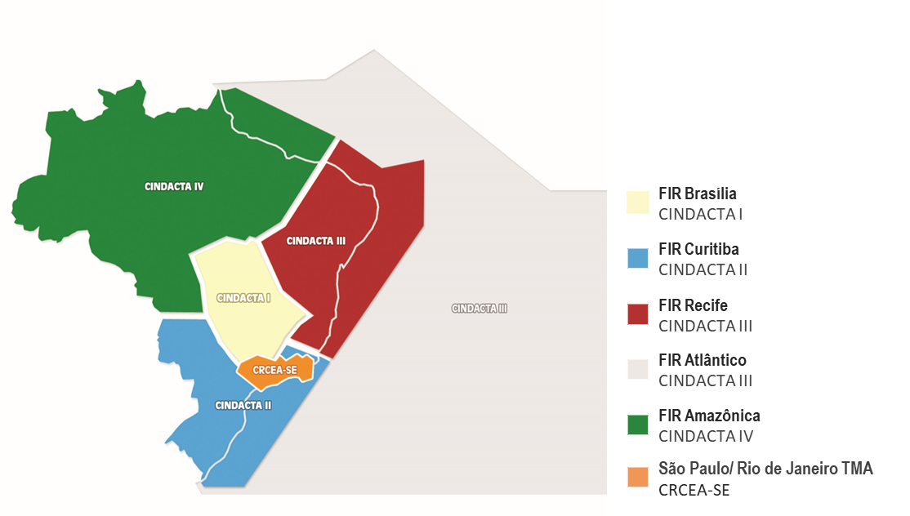
Figure 1.1: Brazilian Airspace Structure/FIRs (CINDACTAs)
The CINDACTAs merge civilian air traffic control with military air defence operations. In addition to the CINDACTAs, there’s the Regional Center of Southeast Airspace Control (CRCEA-SE), tasked with managing air traffic in the densely congested terminal areas of São Paulo and Rio de Janeiro.
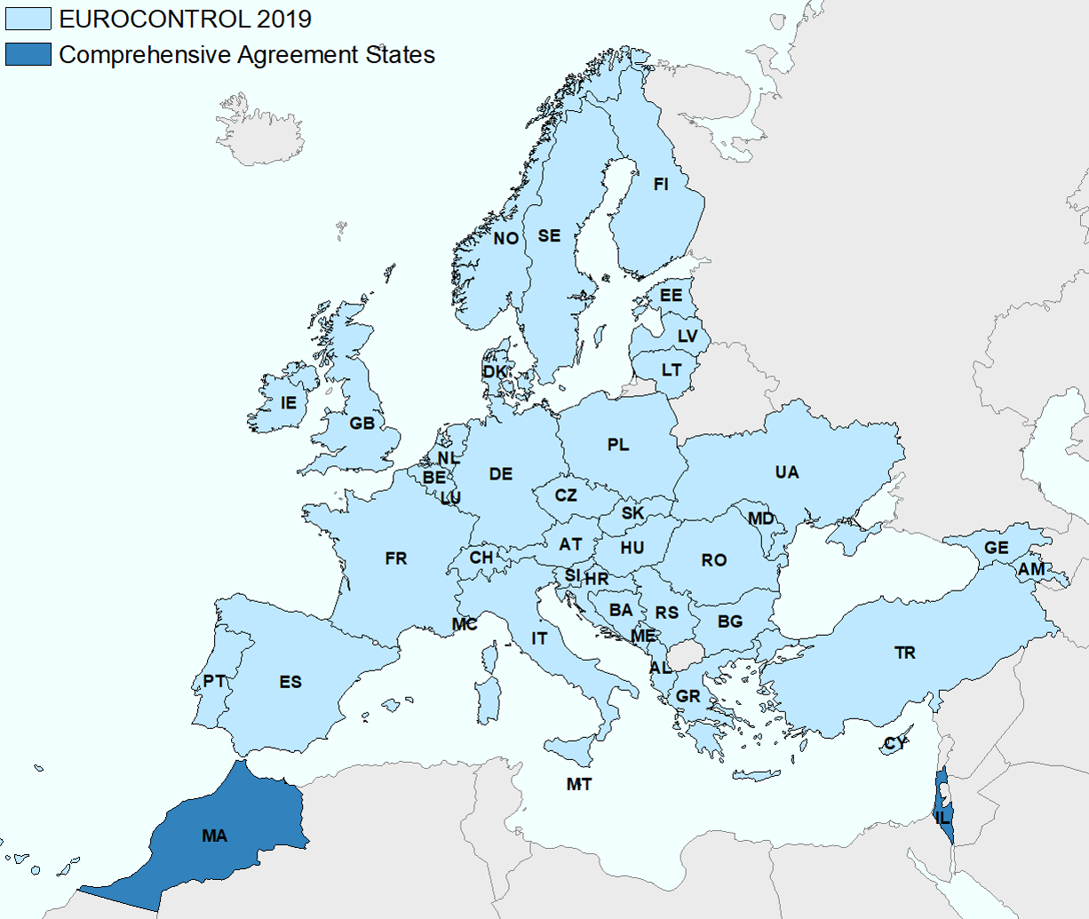
Figure 1.2: European Airspace and EUROCONTROL Member States
In this report, Europe, i.e. the European airspace, is defined as the area where the 42 EUROCONTROL member states provide air navigation services, excluding the oceanic areas and the Canary islands (c.f. Figure 1.2). In 2016, EUROCONTROL signed a comprehensive agreement with Israel and Morocco. Both comprehensive agreement States will be successively fully integrated into the working structures of EUROCONTROL, including performance monitoring. Within this report, these states are included in the reported network traffic volumes.
EUROCONTROL is an inter-governmental organisation working towards a highly harmonised European air traffic management system. In general, air traffic services are provided by air navigation service providers entrusted by the different EUROCONTROL member states. Dependent on the local and national regimes, there is a mix of civil and military service providers, and integrated service provision.
The Maastricht Upper Area Control Center is operated by EUROCONTROL on behalf of 4 States (Netherlands, Belgium, Luxemburg, and Germany). It is the only multi-national cross-border air traffic unit in Europe at the time being. Given the European context and airspace structure, the European area comprises 37 ANSPs with 62 en-route centres and 16 stand-alone Approach Control Units (i.e. totalling 78 air traffic service units).
Europe employs a collaborative approach to manage and service airspace and air traffic. This includes the integration of military objectives and requirements which need to be fully coordinated within the ATM System. A variety of coordination cells/procedures exists between civil air traffic control centres and air defence units reflecting the local practices. Many EUROCONTROL member states are members of NATO and have their air defence centres / processes for civil-military coordination aligned under the integrated NATO air defence system.
Further details on the organisation of the regional air navigation systems in Brazil and Europe will be provided in Section 2.1.

1.3.1 Study Airports
As concerns airport-related operational air navigation performance, this edition of the comparison report addresses the performance at a set of selected airports. These airports represent the top-10 or most relevant airports in terms of IFR movements in both regions and allow to make meaningful comparisons.
In Brazil, the selected airports play a significant role for the national and regional connectivity, including the major hubs for international air traffic. These study airports have consolidated systems and structured processes for data collection in support of this comparison report.
For the European context, the study airports comprise the busiest airports in several states exhibiting a mix of national, regional, and international air traffic. These airports are also characterised by varying operational constraints that make them excellent candidates for an international comparison. All of these airports are subject to the performance monitoring under the EUROCONTROL Performance Review System and provide movement related data on the basis of a harmonised data specification.
Figure 1.3 provides an overview of the location of the chosen study airports within both regions. The airports are also listed in Table 1.1.
Table 1.1: List of study airports for the Brazil / Europe operational ANS performance comparison
Brazil | Europe
Brasília (SBBR) | Amsterdam Schiphol (EHAM)
São Paulo Guarulhos (SBGR) | Paris Charles de Gaulle (LFPG)
São Paulo Congonhas (SBSP) | London Heathrow (EGLL)
Campinas (SBKP) | Frankfurt (EDDF)
Rio de Janeiro S. Dumont (SBRJ) | Munich (EDDM)
Rio de Janeiro Galeão (SBGL) | Madrid (LEMD)
Belo Horizonte Confins (SBCF) | Rome Fiumicino (LIRF)
Salvador (SBSV) | Barcelona (LEBL)
Porto Alegre (SBPA) | London Gatwick (EGKK)
Curitiba (SBCT) | Zurich (LSZH)
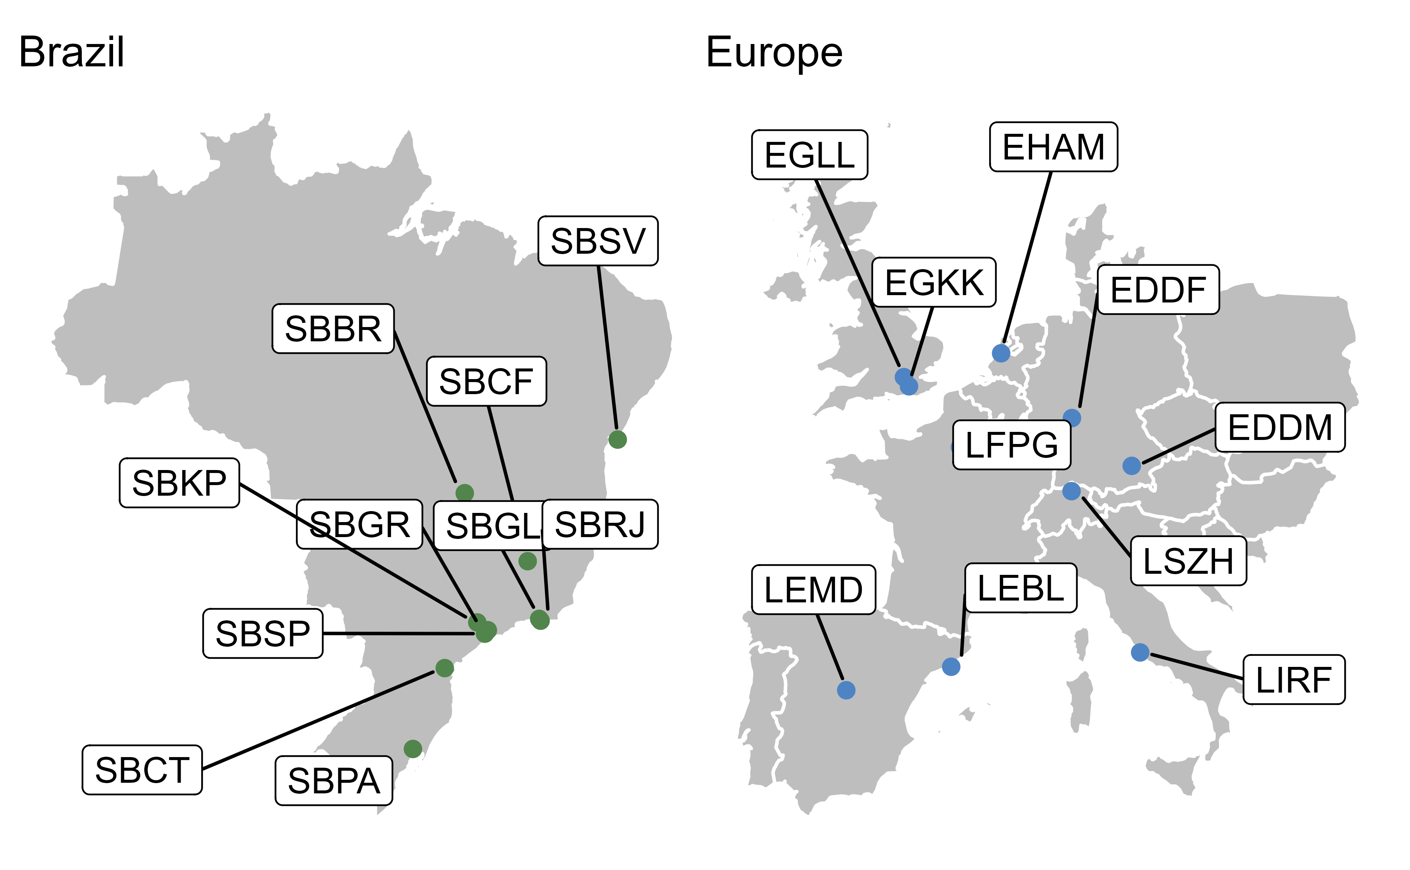
Figure 1.3: Study airports of Brazil/Europe Comparison

1.3.2 Temporal Scope
This report focuses on the period from January 2019 to December 2024. With this report, the focus is on building a timeline with comparable data to be augmented in future editions.
Throughout the report, summary statistics will be given with reference to calendar years of this comparison study.

1.4 Data Sources
The nature of the performance indicator requires the collection of data from different sources. DECEA Performance Section and PRU investigated the comparability of the data available in both regions, including the data pre-processes, data cleaning and aggregation, to ensure a harmonised set of data for performance comparison purposes.
DECEA mainly uses data from the tower systems of the main airports as a data source for performance studies. The control tower system collects and provides data for each landing and take-off operation automatically. This edition blended ANAC (Brazilian CAA) official and public data with DECEA’s data to increase precision for specific indicators, adding a pre-processing phase to the data analytical work. The provided data include such items as the times of operations, gate entry and exit, and flight origin and destination.
Within the European context, PRU has established a variety of performance-related data collection processes. For this report the main sources are the European Air Traffic Flow Management System (ETFMS ) complemented with airport operator reported data. These sources are combined to establish a flight-by-flight record. This ensures consistent data for arrivals and departures at the chosen study airports. The data is collected on a monthly basis and typically processed for the regular performance reporting under the EUROCONTROL Performance Review System and the Single European Sky Performance and Charging Scheme (EUROCONTROL 2019).

1.5 Structure of the Report
This third edition of the Brazil-Europe comparison report is organised as follows:
- Introduction – overview, purpose and scope of the comparison report; short description of data sources used;
- Air Navigation System Characteristics – high-level description of the two regional systems, i.e. areas of responsibility, organisation of ANS, and high-level air navigation system characteristics;
- Traffic Characterisation – network level and airport level air traffic movements; peak day demand, and fleet composition observed at the study airports;
- Predictability observed arrival and departure punctuality;
- Capacity and Throughput assessment of the declared capacity at the study airports and the observed throughput, including runway system utilisation comparing achieved peak throughput to the declared capacity;
- Efficiency analysis of taxi-in, taxi-out, and terminal airspace operations; and
- Conclusions summary of this report and associated conclusions; and next steps.
::: point merge and ACC CTB LIS comparison?????? :::

2. Air Navigation System Characterisation
What come here is referring to 2024.
This section presents key characteristics of the air navigation systems of Brazil and Europe. In broad strokes, the provision of air navigation services in both regions relies on similar operational concepts, procedures, and supporting technology. Nonetheless, there are several distinctions between the two systems, which help to account for the similarities and differences in key performance indicators documented in this report.

2.1 Organisation of Air Navigation Services
One of the major difference between the air navigation systems of Brazil and Europe is the respective organisational structure. In Brazil, a single entity serves as the primary air navigation services provider, i.e. the Department of Airspace Control (DECEA). In contrast, in Europe, each member state has delegated the responsibility for service provision to either national or local providers.
DECEA holds the vital role of overseeing all activities related to the safety and efficiency of Brazilian airspace control. Its mission encompasses the management and control of all air traffic within the sovereign Brazilian airspace, with a significant emphasis on contributing to national defence efforts. To achieve this, DECEA operates a comprehensive and fully integrated civil-military system.
In 2021, a public company, NAV Brasil, was created to take over some facilities that were linked to an old airport infrastructure provider company in Brazil (INFRAERO). Today, this company has 1698 employees in 44 different units, providing aerodrome control services, nonradar approach, meteorology and aeronautical information for these locations. Despite having important numbers, Nav Brasil does not plan to establish radar facilities or provide en-route services.
The Brazilian airspace, covering an area of approximately 22 million square kilometres (8.5 million square nautical miles of non-oceanic airspace), is divided into five Flight Information Regions. These regions are further subdivided and managed by five Area Control Centers (ACC), 57 Tower facilities (TWR), one digital tower (D-TWR), 41 Approach Units (APP) and 79 AFIS/Remote-AFIS.
The non-oceanic airspace in Europe covers an area of 11.5 million square kilometres. When it comes to the provision of air traffic services, the European approach involves a multitude of service providers, with 37 distinct en-route Air Navigation Service Providers (ANSPs), each responsible for different geographical regions. These services are primarily organised along state boundaries and FIR (Flight Information Region) borders, with limited cross-border agreements in place between adjacent airspaces and air traffic service units.
A noteworthy exception to this predominantly national approach is the Maastricht Upper Area Control (UAC), which represents a unique multinational collaboration offering air traffic services in the upper airspace of northern Germany, the Netherlands, Belgium, and Luxembourg.
Civil-military integration levels across European countries vary. Within the European context, the central coordination of Air Traffic Flow Management (ATFM) and Airspace Management (ASM) is facilitated by the Network Manager. The design of airspace and related procedures is no longer developed and implemented in isolation in Europe. Inefficiencies in the design and utilisation of the air route network are recognised as contributing factors to flight inefficiencies in the region. Therefore, as part of the European Union’s Single European Sky initiative, the Network Manager is tasked with developing an integrated European Route Network Design. This is achieved through a Collaborative Decision-Making (CDM) process involving all stakeholders.
Another critical responsibility of the Network Manager is to ensure that air traffic flows do not exceed the safe handling capacity of air traffic service units while optimising available capacity. To accomplish this, the Network Manager Operations Centre (NMOC) continuously monitors the air traffic situation and proposes flow management measures through the CDM process in coordination with the respective local authorities. This coordination typically occurs with the local Flow Management Positions (FMP) within the respective area control centres. Subsequently, the NMOC implements the relevant flow management initiatives as requested by the authorities or FMPs.

2.2 High Level System Comparison
Figure 2.1 summarises the key characteristics of the Brazilian and European air navigation system for 2024. Comparing the high-level numbers, Brazil utilised an increased number of Air Traffic Controllers (ATCOs) even during the pandemic period. In contrast, the European system showed a reduction of total ATCOs in service. The different behaviour suggests a difference in work force flexibility between the systems. This may be partly explained by the fact that DECEA shares part of the structure used in basic training with other Air Force training processes. This leads to a more centralised and rigid process, in which abrupt reactions in hiring planning are unwanted due to the lengthy process of calling for candidates according to Brazilian laws related to public service jobs. In Europe, there exists a mix of organisational models and labour contracts ranging from public service to fully commercial organisation. En gros, European providers were able to react to the lower demand levels by delaying/stopping recruitment/training and offering early retirement packages.
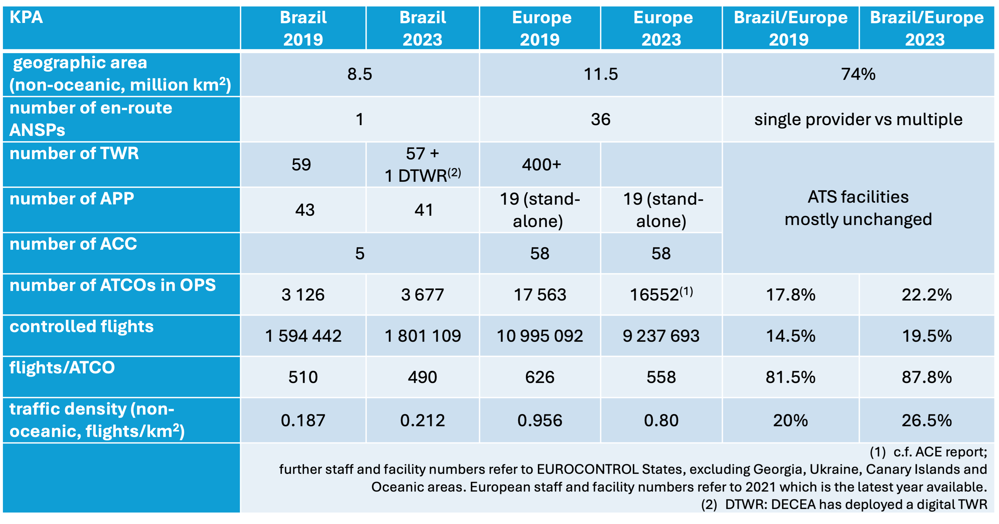
Figure 2.1: High Level Comparison 2024
Another key difference affecting performance in both regions for this report is the development of air traffic demand. Unlike in Europe, it is interesting to note that Brazil ended 2022 already servicing air traffic movements above the pre-pandemic (i.e. 2019) level. However, as will be shown later, much of this growth was due to the strong increase in general aviation and only to a lower extent in commercial aviation.
Overall, the volume of air traffic also rebounded in Europe. At the end of 2023, the level reached about 90% of the pre-pandemc air traffic (vs about 85% in 2022).
Both regions operate with similar operational concepts, procedures and supporting technology. Yet, Brazil, with lower traffic density related to airspace use, finds probably a more challenging cost-benefit ratio to maintain communication coverage and surveillance for regions with low-traffic.
In comparison, the European region faces more considerable challenges in coordinating efforts to adress operational constraints and service the current demand.
 | The following graphic is a snapshot made in early April.  The network analysis is work in progress. Thus, the visualisation and section may change, and with a smaller data set.
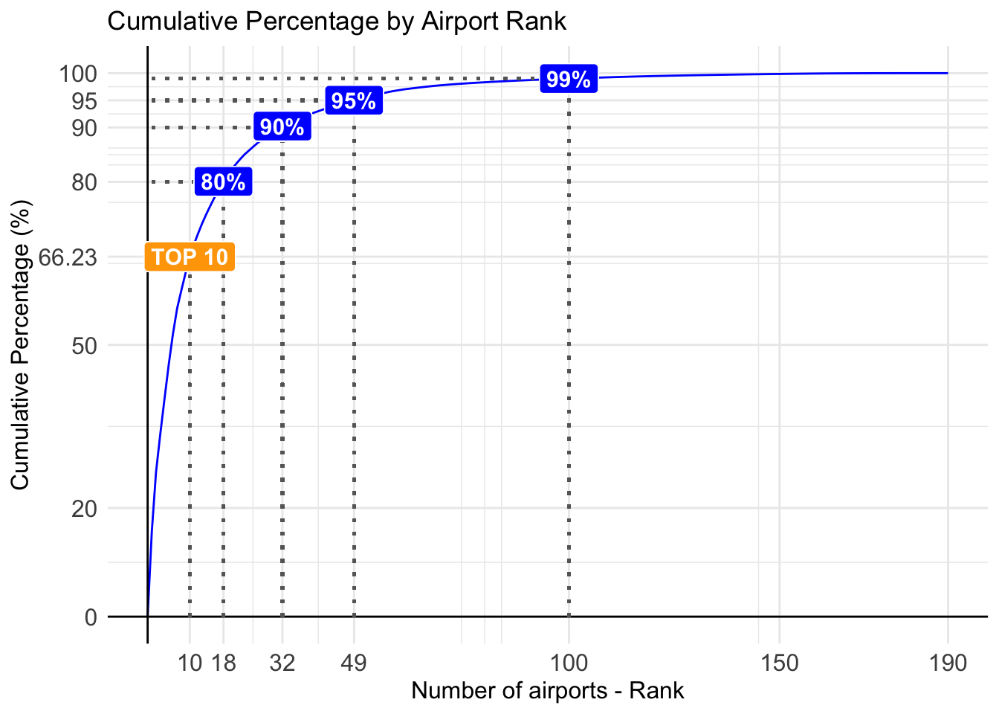
Figure 2.2: Airport Rank Comparison 2024
 | The distribution of air traffic in Brazil confirms that most flights are concentrated in a small number of airports. In 2024, the 10 busiest airports handled 66.23% of all flights. The top 18 airports accounted for 80% of operations, while 90% of all flights took place at just 32 airports. If we consider the 49 busiest airports, they covered 95% of traffic, and 99% of all flights occurred at the top 100 airports in the country. The latest edition of Brazil’s Annual Performance Report (it can be found on http://performance.decea.mil.br reflects this reality. It now includes 100 airport locations instead of only the top 34, ensuring that almost all flights are included in the analysis. This distribution shows that many aerodromes operate with low traffic volumes. Because of that, it is important to study alternative ways to provide air traffic services.  In Brazil, the Aerodrome Flight Information Service (AFIS) has been an effective strategy to ensure safety at locations where the traffic does not justify the installation of a control tower (TWR). This service, usually provided via Radio, gives essential information to pilots, helping to use resources efficiently and keeping safe operations. Since 2016, Brazil has been expanding the use of remote AFIS units (R-AFIS), especially in strategic areas like the Amazon region. These services are provided from ACCs (Area Control Centers), which means they don’t need dedicated local infrastructure. Also, in 2024, demand for air traffic services continued to grow. This shows the need to review and improve how services are organized in Brazil. Expanding the use of the AFIS model in strategic areas may be a smart and safe way to meet future needs and make better use of SISCEAB’s resources.  The distribution of air traffic in Brazil confirms that most flights are concentrated in a small number of airports. In 2024, the 10 busiest airports handled 66.23% of all flights. The top 18 airports accounted for 80% of operations, while 90% of all flights took place at just 32 airports. If we consider the 49 busiest airports, they covered 95% of traffic, and 99% of all flights occurred at the top 100 airports in the country. The latest edition of Brazil’s Annual Performance Report (it can be found on http://performance.decea.mil.br reflects this reality. It now includes 100 airport locations instead of only the top 34, ensuring that almost all flights are included in the analysis. This distribution shows that many aerodromes operate with low traffic volumes. Because of that, it is important to study alternative ways to provide air traffic services.  In Brazil, the Aerodrome Flight Information Service (AFIS) has been an effective strategy to ensure safety at locations where the traffic does not justify the installation of a control tower (TWR). This service, usually provided via Radio, gives essential information to pilots, helping to use resources efficiently and keeping safe operations. Since 2016, Brazil has been expanding the use of remote AFIS units (R-AFIS), especially in strategic areas like the Amazon region. These services are provided from ACCs (Area Control Centers), which means they don’t need dedicated local infrastructure. Also, in 2024, demand for air traffic services continued to grow. This shows the need to review and improve how services are organized in Brazil. Expanding the use of the AFIS model in strategic areas may be a smart and safe way to meet future needs and make better use of SISCEAB’s resources.
This report launched a first analysis of the systems’ network utilisation, taking advantage of the rich experience in comparing two regional aviation systems. Aviation infrastructure is always expensive and complex to maintain, including cost for the provision of air navigation services. The analysis of the facilities’ locations distribution for this service has always basically accompanied the distribution of airports in a region. Recently, technological feasibility modified this logic with the possibility of remote services and still with the possibility of joining more than one remote installation to provide services to several locations simultaneously.
Still, a closer look at the dynamics of these routes and potential connectivity between sites may indicate the potential for capacity to be exploited by the aviation community or that idle capacity is installed without reasonable prospects for use.
In Figure 2.2, we see the distribution of commercial departures for 2022 in both regions. Note that the concentration is proportionally slightly higher on the Brazilian side, with less than 50 airports handlinging 80% of the commercial take-offs that year. In comparison, the European system distributed the same percentage over approximately 100 airports.
For both regions, the aforementioned share of air traffic is centralised in a small subset of airports. On the other hand, the cumulative charts in Figure 2.2 show that a high number of airports service under 1% of the regional air traffic volume. In both systems, this represents more than half of the airports that serve commercial flights. In Europe, approximately 486 airports handle only 1% of the movements, while in Brazil, there are 210 for the same percentage.
Despite being an already historically established distribution and somewhat expected, the aviation sector agents must revisit this data constantly to verify the use of deployed resources and capacity. There is scope for further assessing the service provision at smaller operations with a view to accommodate demand and capacity.
Analysing the part of ANS, specifically on the Brazilian side, the proportion of flights using AFIS aerodromes in this sample is 10.73%. Among them, the busiest airport serviced approximately 4146 commercial departures in 2022 while only 124 were handled at the least busy AFIS aerodrome. In most cases, these operations represent remote airports where aviation is deemed needed to give access to that community. For the European data, a similar pattern is expected. The current data does not allow for a labelling of all aerodromes in terms of ATS service provision (in particular, the identification of AFIS-only services).
Future work may highlight to what extent also resources within the European context are bound to establishing basic connectivity. Further research can explore how both regions can maximise installed capacity, benefit from novel operational or technical concepts, and suggest improvements for ANS provision.

2.3 Regional Approach to Operational Performance Monitoring
The previous report detailed the historic setup of the performance monitoring systems in Brazil and Europe.
The implementation of the performance-based approach is not a fundamental new activity in Europe. The Performance Review Commission (PRC) was established within EUROCONTROL in 1998 aiming to establish and implement an independent European air traffic management (ATM) performance review capability in response to the European Civil Aviation Conference (ECAC) Institutional Strategy. The main goal of the PRC is to offer impartial advice on pan-European ATM performance to EUROCONTROL’s governing bodies. Supported by the Performance Review Unit (PRU), the PRC conducts extensive research, data analysis, and consultations to provide objective insights and recommendations. EUROCONTROL’s performance review system, a pioneering initiative in the late 1990s, has influenced broader forums like ICAO’s global performance approach and the Single European Sky (SES) performance scheme. Collaborating internationally, particularly with ICAO, the PRC aims to harmonise air navigation practices. The PRC produces annual reports (ACE and PRR) and provides operational performance monitoring through various data products and online tools. Continuous efforts are made to expand the online reporting for stakeholders and ensure access to independent performance data for informed decision-making.
It is noteworthy to recall that DECEA, influenced by ICAO publications, embraced a performance-based approach, notably advancing the national state-of-the-art in collaboration with EUROCONTROL. Beginning with the SIRIUS Brazil Program in 2012, DECEA faced challenges defining metrics, but made significant progress after signing a Cooperation Agreement with EUROCONTROL in 2015. DECEA published crucial documents for ICAO’s Global Air Navigation Plan, prompting an organisational transformation and adaptation of practices. Establishing the ATM Performance Section in 2019, akin to EUROCONTROL’s PRU, DECEA accelerated the build-up of expertise in operational performance monitoring. This culminated in the publication of the first Brazilian ATM Performance Plan for 2022-2023. Actively fostering an open culture of knowledge-sharing within South America, DECEA engaged in workshops and seminars, and inviting EUROCONTROL for collaboration.
Finally, it should be noted that the recurrent use of indicators by EUROCONTROL and DECEA and the close technical collaboration taking place during the analysis periods for joint conclusions enrich not only the two regions but also have a global impact. Embracing transparency, both agencies made indicators and databases publicly accessible, perpetuating a culture of reciprocity and transparency for mutual advancement. Looking for broader validation and harmonisation, the lessons learned from this scheme are systematically shared with the multi-national Performance Benchmarking Working Group (PBWG) and the Performance Expert Group of the ICAO GANP Study Group, which deals with the development of GANP Key Performance Indicators (KPIs). In this respect, this collaboration between both parties serves as a role model for ANS performance management on a global level.
Updated dashboards, previous work, and supporting historical data are available at https://ansperformance.eu/global/brazil/ or https://performance.decea.mil.br/.

2.4 Summary
While both regions operate on similar operational concepts and technologies, there exists key characteristics and distinctions in both regions. One of the key differences is the overall organisation of air navigation services. Brazil’s air navigation services are centralised under DECEA, overseeing all airspace control and contributing to national defense. In contrast, Europe’s air navigation services are provided by multiple entities and ANSPs operating predominantly within their national state boundaries and FIR borders.
Also remarkable is the comparison of the number of air traffic controllers between Brazil and Europe during the pandemic. This revealed contrasting trends. Brazil experienced an increase in ATCOs, while Europe witnessed a notable reduction. This disparity underscores a significant difference in the systems’ responsiveness, partly attributed to Brazil’s centralised and rigid hiring process. At the same time, European providers operate with greater independence and flexibility enabling easier adjustments to the management of the ATCO workforce.
The distribution of commercial flights in 2022 indicates that only a subset of airports handle 80% of commercial take-offs. The concentration effect is higher in Brazil than in Europe. On the other hand, a high number of airports operating commercial flights represent handle only a marginal share of 1% of the movements in both systems. This duality may inform decision-makers about potential performance benefit pools with a view to allocate scarce ANS resources and capabilities and ensure the proper balancing of demand and capacity.
This report documents the close collaboration between DECEA and EUROCONTROL. The effort benefits the two regions and contributes globally by sharing insights and lessons learned with international aviation communities, aiding the development of ATM performance management worldwide.

3. Test

4. Traffic Characterisation
To facilitate operational comparisons, it is crucial to have a good understanding of the level and composition of air traffic. The preceding section provided an overview of the context and organisation of air navigation services in Brazil and Europe. This chapter presents some air traffic characteristics for both regions to provide a framework for the observed operational performance in subsequent parts of the report.

4.1 Network Level Air Traffic
Figure 4.1 shows the regional traffic development in Brazil and Europe.
For Brazil, it is important to remember that Figure shows the aggregated movements per airport at the whole network level. The shown total does not necessarily reflect the total number of flights. Another important observation related to the data is that Brazil’s number of airports served with the TATIC tool (Tower ATC System) has increased. Despite raising the processed total daily flight number, this difference is mostly transparent for this study as these additional airports handle only a small number of movements on a day-to-day basis.
 | TO BE CLEANED LATER  - reduce number of labels for BRA  - add associated labels to EUR
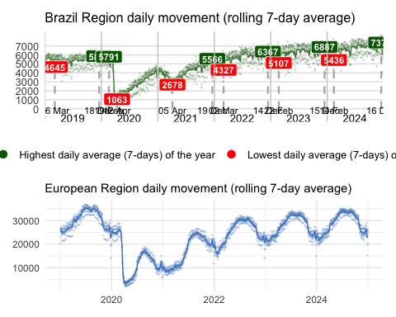
Figure 4.1: Regional daily air traffic
Brazilian air traffic continues to exceed 2019 levels, marking a phase of real growth, not just post-pandemic recovery. Since 2022, traffic has grown steadily, showing a structured recovery in demand. However, commercial aviation is still adjusting its route network in some regions to fully match 2019 levels.
Figure 4.1 showing the daily evolution of air traffic in Brazil (7-day moving average) highlights the busiest and quietest periods of recent years. Over the past three years, the day with the lowest average traffic in Brazil typically falls on the Wednesday after Carnival. Meanwhile, the annual peak usually happens in late December, close to Christmas, reinforcing a well-established seasonal pattern in the Brazilian air transport market.Overall, despite short-term fluctuations, the general trend is upward, confirming that Brazil is on a steady growth path. It is important to note that the Brazilian data only includes commercial flights (excluding general and military aviation) and is based on UTC time.
When we compare this with the European Region, a different dynamic becomes visible. In terms of total network-level air traffic, Europe still lags behind its pre-pandemic levels. However, if current trends continue, the region is expected to reach or slightly surpass 2019 traffic levels by 2025. Low-cost carriers have outperformed mainline airlines in the recovery phase. Their business model allowed for faster adjustments in staffing, crewing, and servicing. At the same time, national support programs for legacy carriers often included conditions such as slot restrictions or reduced domestic operations, which contributed to a decrease in overall network connectivity and frequency between airports.
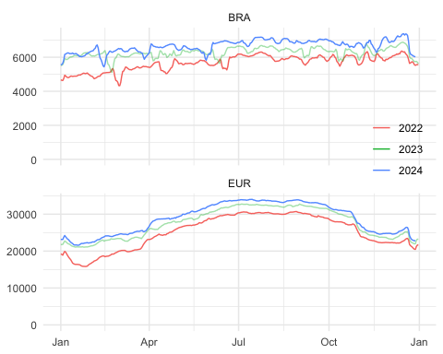
Figure 4.2: Evolution of annual network traffic
Figure 4.2 compares the evolution of daily air traffic in the Brazil and European regions across the last three years. Each line represents a 7-day moving average of flight numbers, allowing seasonal patterns and year-over-year changes to be visualized clearly.
In the Brazilian region, the data shows a consistent upward trend, with each year positioned above the previous one, especially in the first and second quarters. This indicates that Brazil’s aviation sector not only recovered from the pandemic but has entered a period of sustained organic growth. The seasonal curve in Brazil is more stable throughout the year, reflecting a demand pattern that is less affected by strong seasonal variations.
In contrast, the European region displays strong seasonality, with pronounced peaks during the summer months (June to September) and sharp drops in winter. This pattern aligns with Europe’s tourism-driven traffic, where demand is concentrated in holiday periods. While traffic levels have improved, the variation between seasons remains substantial.
The analysis of annual trends also reveals how regional disruptions can impact national networks. In Brazil, traffic volume dropped significantly in May 2024, due to heavy rainfall in the south starting in late April. The floods led to the prolonged closure of Salgado Filho International Airport (SBPA) in Porto Alegre, which remained out of operation until October. This disruption had a clear impact on domestic commercial aviation and reduced overall national traffic during that period.
While Brazil shows less seasonal fluctuation overall, Europe’s variation in traffic volume is much more pronounced. This contrast points to the importance of adjusting capacity and optimizing airport infrastructure to better respond to periods of high demand.

4.2 Airport Level Air Traffic
The previous section showed the air traffic development on the network level. As airports represent nodes in this overall network, changes to the overall traffic situation will ripple down to the airport level. This demand on terminal and airport air navigation services forms a substantial input to understand how the operational performance measures in this report developed over time for the selected study airports. This reports looks in particular at the performance levels observed at 10 key airports in each region (c.f. scope)
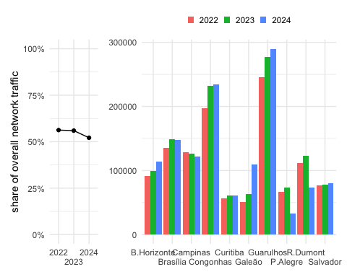
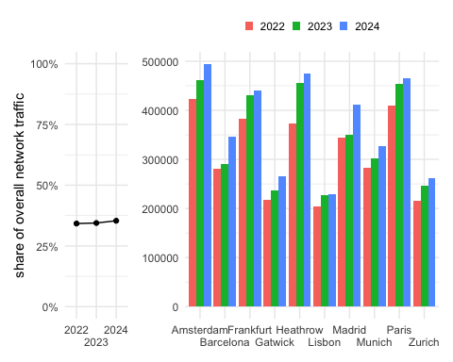
Figure 4.3: Europeaan airport level traffic
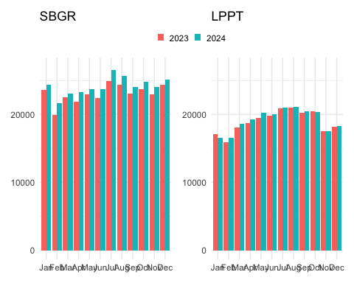
Figure 4.4: Monthly traffic evolution at SBGR and LPPT
xxxxxx The suggestion is to insert the fifth europe airport eith 2023 and 2024 levels.named this airport on the text.
The figure shows the monthly evolution of traffic at Guarulhos International Airport (SBGR) during 2023 and 2024, which remains the top airport in Brazil. A steady increase in operations can be seen throughout 2024 compared to 2023, with July standing out as the month with the highest volume during the period analyzed. This trend reflects the continued strengthening of commercial aviation at Brazil’s main hub, both for domestic and international flights.
Guarulhos’ performance becomes even more relevant when compared to the busiest airports in Europe. The fifth busiest airport in Europe in 2024 had traffic levels similar to those of Guarulhos, highlighting the different realities of each region. This comparison helps illustrate the structural complexity and differences between the two systems. While Brazil concentrates much of its traffic in a few key airports like SBGR, Europe spreads its operations across a larger network of major airports, often with more robust infrastructure (such as more runways). Therefore, direct comparisons between the “top 1” airports in each region may not accurately reflect their unique operational contexts.
Analyzing the movement of the leading Brazilian airports, it is evident that they were not responsible for the return to 2019 levels, considering that only Campinas - SBKP and Santos Dumont - SBRJ slightly exceeded 2019 levels. This phenomenon can be explained by the greater difficulty of airlines in resuming activity in contrast to general/business aviation. This last share is an essential component of the Brazilian air movement but is a rare user of main airports.
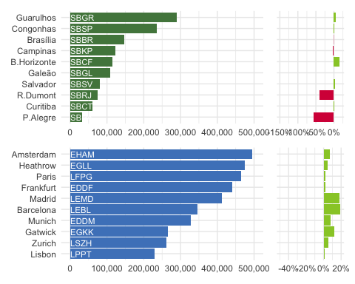
Figure 4.5: Annual traffic at study airports in 2024 and variation 2024/2023
The 2024 air traffic analysis highlights the importance of understanding the structural differences between the Brazilian and European networks. While Guarulhos (SBGR) remains the busiest airport in Brazil, its traffic volume is comparable to that of the fifth and sixth busiest airports in Europe— Munich and Gatwick. This shows that direct comparisons between the top airports in each region may not fully reflect their operational realities. Factors such as the number of runways, network architecture, and traffic density create unique operational complexities in each case.
::: callout note Graph is not clear. and is not appears Amsterdan, Heatrow and Paris levels :::
In Brazil, the largest traffic drop in 2024 occurred at Porto Alegre Airport (SBPA), which was directly impacted by major flooding in May and remained closed until October. Many flights were redirected to nearby airports in southern Brazil, which are not included in the scope of this comparison with Europe.Another change was the increase in traffic at Galeão International Airport (SBGL), which rose to sixth place among Brazil’s busiest airports. This shift was mainly driven by restrictions applied at Santos Dumont Airport (SBRJ), leading to a reallocation of flights from SBRJ to SBGL. As a result, SBRJ saw a decline, while SBGL experienced gradual growth in operations. This redistribution not only affects annual totals but will also have direct impacts on other indicators, such as the peak day of operations, which will be discussed later in this report.
In addition, the share of total traffic handled by the top airports in Brazil has shown a slight downward trend from 2022 to 2024, suggesting a modest redistribution of traffic across a broader set of airports. This may result from regional recovery, airline strategy shifts, or temporary infrastructure limitations—such as the closure of SBPA and the restrictions at SBRJ.
In contrast, in Europe, the share of traffic managed by the busiest airports has shown a slight increase over the same period. This upward movement reflects a temporary concentration of demand as the region works toward pre-pandemic recovery levels, particularly through well-established hubs. Importantly, none of the airports included in this report experienced a decline in traffic, with Madrid and Barcelona recording substantial growth close to 20%, and Gatwick rising by more than 10%, reinforcing their position within the European network.
Altogether, the data illustrates how both the Brazilian and European air networks have adapted to their respective challenges. In Brazil, the system has shown resilience in the face of environmental events and regulatory changes, while in Europe, traffic growth is becoming more concentrated at major hubs as the region continues to recover toward pre-pandemic levels. These dynamics highlight the importance of continuous monitoring and flexible planning to ensure operational efficiency and network stability in both regions.
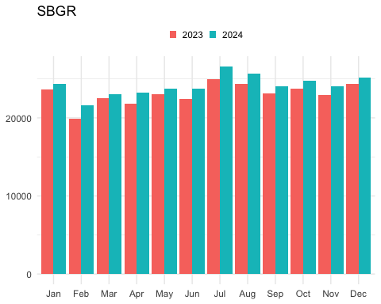
 | xxxxxx The suggestion is to insert the sixth europe airport - munich?? with 2023 and 2024 levels.
?@fig-bra-gru-apt shows the monthly evolution of traffic at Guarulhos International Airport (SBGR) during 2023 and 2024, which remains the top airport in Brazil. A steady increase in operations can be seen throughout 2024 compared to 2023, with July standing out as the month with the highest volume during the period analyzed. This trend reflects the continued strengthening of commercial aviation at Brazil’s main hub, both for domestic and international flights.
Guarulhos’ performance becomes even more relevant when placed in a global context. In 2024, Munich (MUC)—the fifth busiest airport in Europe—recorded approximately 50,000 more operations than SBGR, highlighting the different realities and scales of each region. This comparison helps illustrate the structural complexity and operational differences between the two systems. While Brazil concentrates a large share of its traffic in a few key airports like SBGR, Europe spreads its operations across a wider network of major airports, often supported by more robust infrastructure, such as multiple runways. Therefore, direct comparisons between the “top 1” airports in each region may not fully reflect their distinct operational and geographic contexts.

4.3 Peak Day Traffic
While the annual traffic provides insights in the total air traffic volume and the associated demand, it does not provide insights on the upper bound of achievable daily movement numbers. The latter depends on demand, operational procedures and/or associated constraints, and the use of the runway system infrastructure. The peak day traffic is determined as the 99th percentile of the total number of daily movements (arrivals and departures). The measure represents thus an upper bound for comparison purposes.

4.4 Peak Day
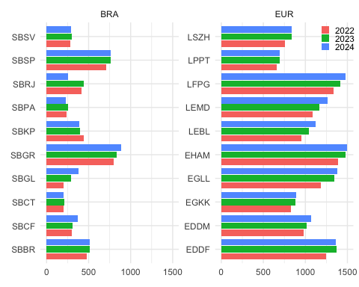
Figure 4.6: Airport peak daily traffic (2022 - 2024)
Figure 4.6 shows the evolution of peak day traffic between 2022 and 2024 across the Brazilian airports included in this study, serving as a useful complement to average daily movement metrics.
Overall, the data shows a general stability in operational volumes across most major airports in Brazil. Still, some variations stand out:
- Guarulhos (SBGR), Galeão (SBGL), and Confins (SBCF) recorded increases in their peak day movements, reflecting their greater capacity to absorb traffic and some redistribution of demand within the national network.
- Santos Dumont (SBRJ), on the other hand, shows a notable drop, directly tied to the operational restrictions implemented during 2024, which limited its capacity and led to the transfer of some flights to SBGL.
- In the case of Porto Alegre (SBPA), even though it was severely affected by floods starting in May 2024, the data does not show a significant drop in its peak day value. This is likely because the peak occurred either before May or after limited operations resumed in October.
The comparison between the Brazilian and European contexts reinforces the importance of considering each network’s structure, operational model, and geographic distribution when evaluating airport performance. It also shows how peak day traffic can offer unique insights—especially during periods of recovery or transition—by highlighting the maximum operational load airports can reach, regardless of their average daily traffic.
::: callout note Is it possible to include rwy number on the graph of the last 3 years peak day? No peak day graphs for europe? :::
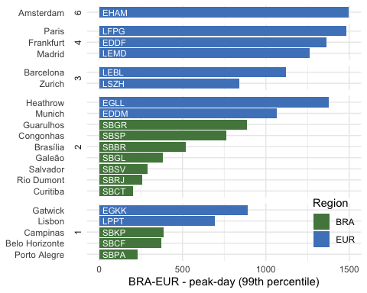
Figure 4.7: Airport peak daily traffic (2024)
::: callout note For European with more than 2 runways it needs to be noted that the runway system does not support independent operations of all available runways. Thus, the serviced peak traffic is also impacted by the runway system configuration.
The measure signals the use of the available runway system. :::
#| label: fig-timeline-peak-day
#| fig-cap: Evolution of peak-day traffic at study airports
#| message: false
timeline_peak_day(c(2019:2024))
 | CHECK - TIMELINE - REMOVED  The figure shows historical data from 2019 to 2024, providing a broader view of the recovery path in both regions. In Brazil, Guarulhos (SBGR) remains the busiest airport every year. Other airports—such as Congonhas (SBSP), Brasília (SBBR), Campinas (SBKP), and Confins (SBCF)—also show steady growth, with some already surpassing pre-pandemic levels. In Europe, xxxxxxxxx These insights show the importance of analyzing peak day traffic as a complementary indicator to average daily movements, especially during periods of recovery or operational adjustments. The comparison between Brazilian and European contexts highlights the need for assessments tailored to the reality of each network, considering the structural, operational, and geographic factors that directly affect airport responsiveness and capacity.

The year-to-year change of the peak day traffic between 2019 and 2022 is shown in @fig-timeline-peak-day.
For the European study airports, Frankfurt (EDDF), Munich (EDDM), Paris (LFPG), and Rome (LIRF) experienced a higher drop of the daily peak traffic in comparison to 2019.
Despite the not yet fully recovered demand situation at London Gatwick (EGKK) and Zurich (LSZH) showed a moderate reduction of the daily peak traffic in 2022.
This suggest that airports with limited airport runway capacity managed

4.5 Fleet Mix
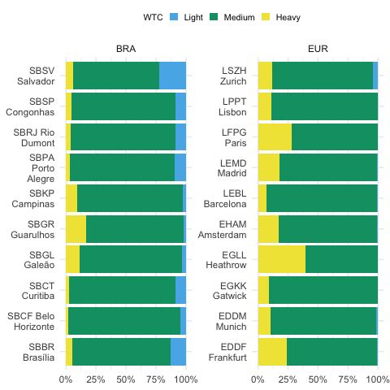
Figure 4.8: Fleet mix observed at the study airports in 2024
Figure 4.8 confirms the dominance of the “medium” aircraft category at the airports analyzed in both Brazil and Europe. Fleet mix plays a key role in airport capacity, directly impacting traffic flow and operational efficiency. Generally, a higher share of “heavy” aircraft can reduce runway throughput due to wake turbulence separation requirements and longer landing and takeoff times.
In Brazil, the main international hubs—Guarulhos (SBGR), Galeão (SBGL), and Campinas (SBKP)—showed a 15% to 20% share of “heavy” aircraft, reinforcing their role as the country’s key international gateways. Campinas, in particular, stands out as the main hub for Azul Linhas Aéreas and also handles a large volume of cargo operations, which contributes to its diverse fleet profile and operational complexity.
Some Brazilian airports such as Brasília (SBBR) and Salvador (SBSV) also reported a significant share of “light” aircraft, a category that is nearly absent among the European airports analyzed—except for Zurich (LSZH). In Salvador, light aircraft account for nearly 20% of all movements, and a similar pattern is observed in Campinas, reflecting their regional and logistical roles.
In contrast, major European hubs like Frankfurt (EDDF), Heathrow (EGLL), and Charles de Gaulle (LFPG) operate with a higher proportion of “heavy” aircraft, in line with their function as large-scale global connection points. These structural differences reflect how each region organizes its connectivity: Brazil tends to centralize long-haul operations in a few key airports, while Europe distributes them across a broader set of hubs.
Based on continuous monitoring throughout the year, this pattern has proven to be remarkably stable. The distribution of aircraft categories has remained consistent even during periods of disruption, such as extreme weather or localized infrastructure constraints. These observations suggest that the fleet mix at the analyzed airports is shaped more by long-term structural factors than by short-term fluctuations.
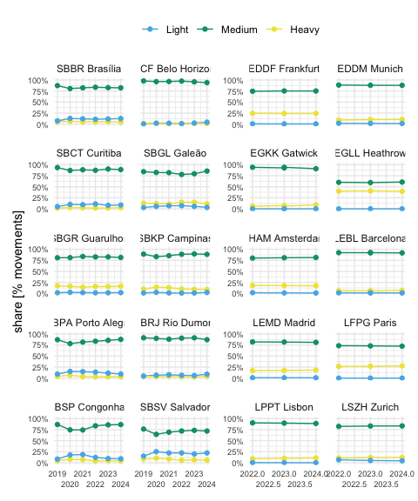
Figure 4.9: Fleet mix change over time observed at study airports
 | fleet mix timeline is necessary?
On average, Figure 4.9 shows that the fleetmix remained fairly stable over the years. It is interesting to observe that the unprecedented decline in air transport during the pandemic phase did not substantially break this pattern. This suggests that the contraction of the traffic volume hit all segments at a similar rate .

4.6 Summary
This chapter provided a comprehensive overview of air traffic dynamics across Brazil and Europe, covering both network-wide and airport-level perspectives.
The data confirms that Brazilian air traffic has surpassed pre-pandemic levels, reflecting a phase of real growth, while Europe continues a gradual recovery, marked by strong seasonal peaks and a more fragmented network structure. If current trends persist, Europe is expected to return to pre-pandemic traffic levels by 2025, particularly driven by robust summer activity and the continued normalization of international demand. Despite these differences, both regions show signs of stability and resilience, even when affected by disruptions such as extreme weather or regulatory adjustments.
At the airport level, Brazilian traffic remains highly concentrated in a few major hubs, whereas Europe distributes operations more evenly across several national gateways. Events like the prolonged closure of Porto Alegre (SBPA) and restrictions at Santos Dumont (SBRJ) highlighted the sensitivity of localized operations and the capacity of the network to adapt.
The peak day analysis complemented the annual view by illustrating the operational limits reached under maximum demand. Although volumes remained stable overall, individual airports showed notable variations—either from growth, as in SBGL and SBCF, or contraction, as seen in SBRJ.
Finally, the fleet mix analysis reinforced the structural differences in how each region operates: Brazil shows a higher presence of light aircraft in some regional airports and a centralized model for long-haul traffic, while Europe maintains a broader use of heavy aircraft, consistent with its global connectivity model.
Together, these findings establish a base to understanding the operational performance indicators in the next chapters.

5. Predictability
The preceding sections have demonstrated that both systems exhibit unique reactions to the broader developments in air transport. Predictability plays a crucial role in these systems, impacting their functioning during both the strategic phase, where airline schedules are formulated, and the operational phase, where Air Navigation Service Providers (ANSPs) and stakeholders manage the delicate balance between demand and capacity. Enhanced predictability stands to be advantageous for ANSPs, mainly when serving airspace users, as it contributes to highly efficient operations, even during periods of peak demand. This chapter focuses on arrival and departure punctuality as crucial predictability indicators.

5.1 Arrival Punctuality
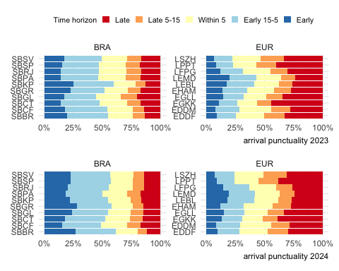
(a) Arrival punctuality 2023

Figure 5.1: Evolution of arrival punctuality at study airports (2023 vs 2024)
Figure 5.1 shows the evolution of arrival punctuality for the select airports in Brazil and Europe. When comparing both regions in 2019 and 2022, Brazil’s share of early arrivals (earlier than 15 minutes before the scheduled arrival) is significantly higher than the same European portion. The share of early arrivals accounts for 20-25% across all Brazilian airports. In Europe, flights tend not to arrive significantly earlier than their scheduled time. On average, early arrival range between 8-15% in Europe in 2019. Recent studies conducted by the CGNA/DECEA show that air operators in Brazil declare flight times significantly longer than observed. Similar behaviour is also observed in Europe. Built in buffer times help to achieve a high “on-time-performance” record and appeal to passengers favouring a timely arrival performance. Furthermore, both regions have regulations for passenger compensation in place which are triggered in the case of arrival delays. DECEA has already established a forum with the air operator regulator to discuss and propose solutions.
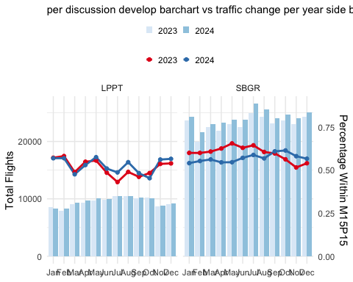
Figure 5.2: Arrival Punctuality at two comparison study airports
This report highlights the performance at Guarulhos (SBGR) and Lisbon (LPPT). Figure 5.2 shows the level of air traffic variation between 2023 and 2024 compared to the observed arrival punctuality.
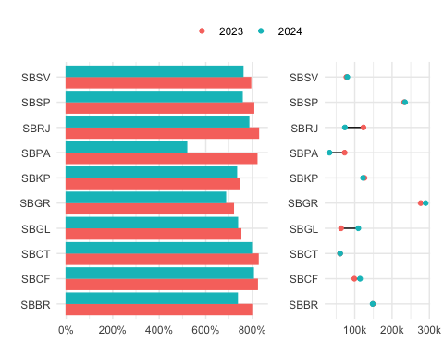
Figure 5.3: Evolution of arrival punctuality -/+15 min vs traffic
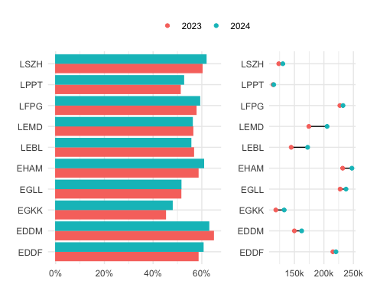
Figure 5.4: Evolution of arrival punctuality -/+15 min vs traffic
European airports saw their share of punctual flights in 2022 decrease broadly compared to 2019, even with a more proportional distribution than the Brazilian system. For European operators, there were two primary factors contributing the the lower performance in 2022. The most significant is the cumulative effect, showing that the network of flights has little ability to absorb the delay of one specific delayed flight. The knock-on effect was amplified by the local resource constraints in terms of passenger and turn-around facilitation. The incrasing traffic demand posed challenges at many airports in Europe. Delayed arrivals accumulated further reactionary delay and ultimately passed the delay systematically on to next flights. Further constraints were linked to air space and flow restrictions resulting from the geo-political conflict surrounding the Russian invasion in Ukraine. On average, arrival delays of 15 minutes or more compared to the schedule ranged between 25-35% across the Europen study airports in 2022.
The previous section highlighted the overall arrival punctuality observed at the study airports. Lower levels of punctuality can negatively impact predictability of operations and thus put a stronger strain on resources managing the arrival flow. Next to the arrival airspace capacity, stronger variations of the scheduled arrival times pose challenges for the surface management, as taxi operations, including stand allocation and availability, might result in changes of the taxi patterns, queuing within the taxiway and apron/stand system. Figure 5.5 shows the share of flights arriving more than 15 minutes before and after their scheduled arrival time.
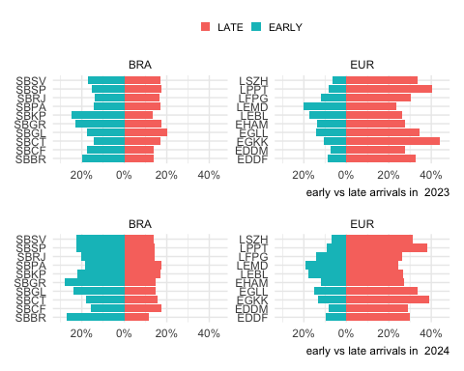
Figure 5.5: Change of share of early and late arrivals (2023 vs 2024)
Figure 5.5 compares the share of early and late arrivals at each study airport in 2019 and 2022. From a high-level perspective, air traffic tends to arrive well ahead of schedule in Brazil, while Europe observes a higher share of delayed arrivals. Guarulhos (SBGR) remained the Brazilian airport with the highest share of early flights in 2022 (i.e. 33%), followed by Campinas (SBKP) with 30%. Both airports are essential hubs in the country, and anticipation can be a consequence sought by air operators for better accommodation of the flight network. However, for flow control, this lack of precision is equally problematic, affecting the optimal allocation of resources for the provision of air traffic control and flow service. In turn, Madrid (LEMD) was the European element with the most significant share of early arrivals (i.e. 22%) in 2022. Pre-pandemic such a share was observed at London Heathrow in 2019. These shares still range about 11% lower than the highest shares in Brazil. The distorted nature of the European network in 2022 becomes apparent when observing the share of delayed flights. For example services at London Gatwick (EGKK) faced a share of 39% of delayed flights. Airport operators were identified as the major contributors to primary delays (ground handling, staff shortage), followed by ATFM delays. However, the aforementioned reactionary effect was the main driver of knock-on delays (EUROCONTROL Central Office of Delay Analysis 2023) .

5.2 Departure Punctuality
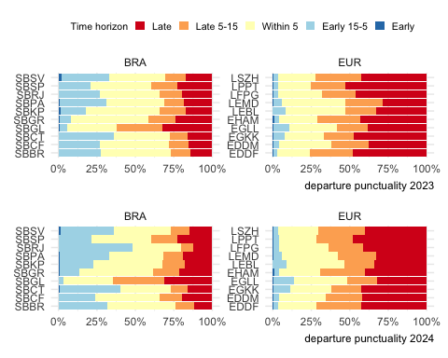
(a) Departure punctuality 2023

Figure 5.6: Evolution of departure punctuality at study airports (2023 vs 2024)
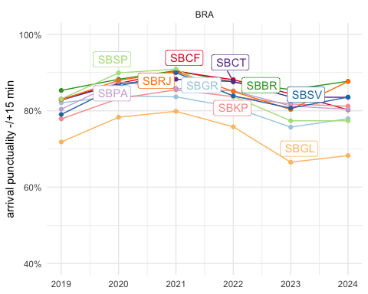
Figure 5.7: Evolution of departure punctuality window
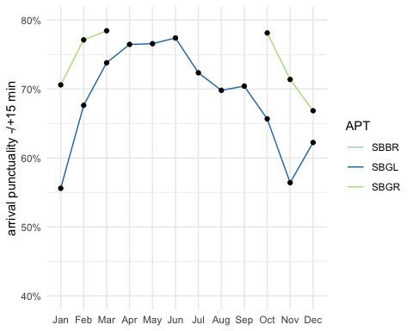
Figure 5.8: Evolution of arrival punctuality window by month
The preceding section highlighted how the general traffic conditions in the previous years influenced the dependability of arrival schedules. In this section, we assess the degree of departure punctuality measured as the difference between the scheduled (i.e. planned) departure versus the observed actual off-block time. Figure 5.6 shows the overall departure punctuality at Brazilian and European airports in 2019 compared to 2022. Despite traffic levels in 2022 still ranging below their 2019 pre-pandemic levels, the departure punctuality in 2022 was - on average - lower than before COVID.
The difference in departure and arrival punctuality between 2022 and 2019 was significantly more pronounced for Europe indicating an increased strain on the turnaround processes. There has been a significant increase in poor performance days, with departure punctuality falling below 50% and arrival punctuality dropping below 60%, occurring more frequently than in 2019. On the Brazilian side, the Galeão airport (SBGL) observed the highest share of delayed departure flights. It should be noted that the SBGL is the only airport with the Apron Control service directly provided by the airport. Some inefficiency in the coordination between Tower and Apron or divergence at the indicator collection point for the location may be contributing to the observed performance.
Departure punctuality appeared slightly higher in Brazil in 2022 in comparison to 2019 and outperforms the punctuality levels observed in Europe. It is also notworthy, that in Brazil there is a higher share of flights blocking off between 15 to 5 minutes before their scheduled time. Further research may help to clarify the factors driving this phenomenon.
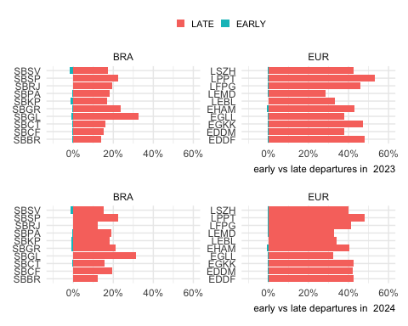
Figure 5.9: Change of share of early and late departures (2023 vs 2024)
The change of the share of early and late departures in 2019 and 2022 is shown in Figure 5.9. This presentation highlights the earlier observations. On average, European airports observed a higher share of delayed departures by a factor of 2-3 in comparison to Brazil. While the picture varies, the distored nature of the traffic in 2022 is visible in the higher share of delay departures in 2022 in Europe in comparison to the pre-pandemic levels in 2019. This put a strain on the schedule stability across Europe. Local issues (e.g. reduced facilication capacity at airports) affected air traffic services in terms of surface movement, but also rippled into the network affecting the sequencing of arrivals and departure traffic.

5.3 Summary
Arrival and departure punctuality play an important role in terms of balancing demand and capacity. Strong distortions of the schedule will ultimately ripple down into reactionary delay and require a higher effort for both the arrival flow and surface movement control. Turnaround distortions affect therefore the planning accuracy of air navigation services and may lead to unwanted side-effects (e.g. longer sequencing and holding in the terminal airspace, passenger inconvenience due to longer taxi-times/blocked gates).
Distinct patterns were observed in both regions that cannot only be explained by the level of traffic recovery. On average, a higher share of flights arrives well ahead of schedule in Brazil. This pattern is largely unchanged when comparing 2019 and 2022. The ripple effect of the low preparedness level of European airports to address the returning traffic in 2022 is well documented. This yielded a significant low performance in terms of departure punctuality exceeding levels observed in Brazil by a factor of 2-3. Distortions of the local schedule can have knock-on effects on the air navigation service provision, both in terms of surface movement and arrival sequencing. More research is needed to investigate and understand the underlying drivers and to what extent regional connectivity influences the observed patterns.

6. Capacity and Throughput
Maintaining an optimal network flow necessitates a equilibrium between airport capacity and flight demand. This section delves into assessing capacity and throughput using various key performance indicators (KPIs) at the airport level. Airspace users expect sufficient capacity provision addressing the levels of demand. With higher levels of capacity utilisation, airspace users will experience congestion and constraints (e.g. higher inefficiency, increased delay/lower punctuality and predictability). However, planning and staffing for peak situations may come at significant costs to airspace user as well. In that respect it is essential to understand the trade-off between capacity provision and capacity consumption (i.e. traffic demand) as it impacts the overall system performance. Capacity and throughput analyses are therefore showing to what extent air navigation services are capable to accommodate the demand. The previous sections showed the level of overall traffic recovery in both regions. The increasing demand put strain on the systems and local knock-on effects amplified the uncertainty and variability of the expected traffic levels. This chapter may therefore also highlight the flexibility of air navigation services to accommodate such distortions of the schedule.

6.1 Peak Declared Capacity
Peak Declared Capacity refers to the highest movement rate (arrivals and landings) at an airport using the most favourable runway configuration under optimal conditions. The capacity value might be subject to local or national decision-making processes. The indicator represents the highest number of landings an airport can accept in a one-hour period.
In both regions, peak capacity is declared by the respective authority. In Brazil, this function is performed by DECEA. Within the European region, the airport peak capacity is determined on a local or national level. The processes consider local operational constraints (e.g. political caps, noise quota and abatement procedures) and infrastructure related limitations (e.g. apron/stand availability, passenger facilities).
Figure 6.1 shows the evolution of the declared capacity for the airport services in this comparison report. Throughout the last years, no substantial change in the peak declared capacity was observed at European airports. In Brazil, on the other hand, 2019 and 2020 showed a revised capacity declaration at most of the Brazilian airports. In 2018 CGNA had developed a refined method for the determination of the runway system capacity.
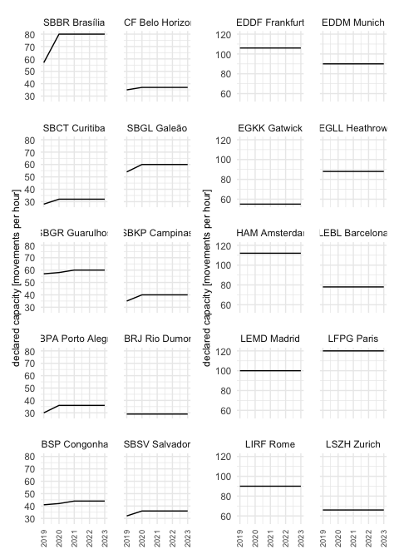
Figure 6.1: Evolution of Declared Capacities at study airports.
The capacity of airports (and the associated runway system) is predominantly influenced by their infrastructure. The existence of independent parallel runways, e.g. Brasilia (SBBR) and Munich (EDDM), can support decisively the resulting capacity. Furthermore, operational procedures can lead to increased in airport capacity. London Heathrow (EGLL), in the past, and Guarulhos (SBGR) in recent years show that changes in operational procedures can help the airport absorb significant traffic increases or reduce the additional sequencing time in the terminal airspace. Guarulhos, for example, benefited from the implementation of segregated operations under VMC conditions, and Heathrow increased its capacity through the introduction of time-based separation on final.
In this context, Figure 6.2 shows the declared peak capacity for the study airports. As observable in the case of Amsterdam Schiphol (EHAM, 6 runways), the number of runways is not a direct indication of the maximum capacity. For example, the two-runway airports Brasilia (SBBR), London Heathrow (EGLL), and Munich (EDDM) share a similar runway system layout and range above the 3-runway systems of Barcelona (LEBL) and Zurich (LSZH). London Gatwick (EGKK) is reknown for its maximisation of its single-runway throughput.
As mentioned above, the capacity declaration/determination process takes into account the varying local conditions and constraints. It balances the need to accommodate growth vs policy priorities and public interests. A potential area for further research could be a closer investigation of the operational concepts deployed and the variations of the declared capacity with the local runway system characteristics.
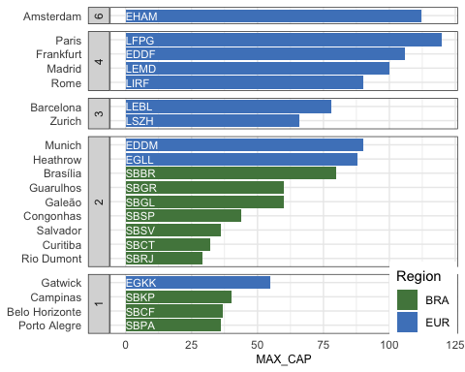
Figure 6.2: Peak declared capacity 2024

6.2 Peak Arrival Throughput
This comparison report uses the GANP KPI to measure the peak arrival throughput as the 95th percentile of the hourly number of landings observed at an airport (ICAO 2019a). The measure gives an indication of the achievable landing rates during “busy-hours”. It is an indication to what extent arrival traffic can be accommodated at an airport. For congested airports, the throughput provides a measure of the effectively realized capacity. Throughput is a measure of demand and therefore comprises already air traffic flow or sequencing measures applied by ATM or ATC in the en-route and terminal phase. For non-congested airports, throughput serves as a measure of showing the level of (peak) demand at this airport.
Figure 6.3 compares the observed annual peak arrival throughput at the study airports in Brazil and Europe. On average, the busiest hour of the Brazilian airports under study did not suffer a significant reduction. This signals that peak arrival demand remained fairly constant during the pandemic. An increased arrival peak throughput was serviced at Brasilia (SBBR), Campinas (SBKP), Rio de Janeiro (SBRJ), and Confins (SBCF). Services at Galeão (SBGL) observed a significant shift in the traffic pattern. The peak arrival throughput fell sharply with the pandemic and has not yet recovered. This overall picture is contrasted by the pandemic related drop of overall traffic at European airports. The overall reduction resulted in significantly lower peak hours. The recovery pattern is also visible in the peak arrival throughput behaviour.
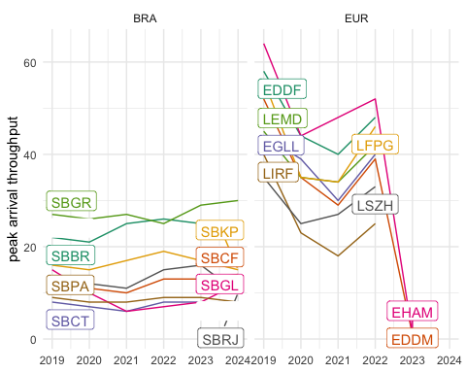
Figure 6.3: Evolution of annual arrival throughput

6.3 Peak Departure Throughput
In analogy to the previous section, Figure 6.4 shows the peak departure throughput. The latter is determined as the 95th percentile of the hourly number of departures.
In Brazil, and with the exemption of Galeão, an interesting trend emerged. On average, “busy hour” throughput increased in comparison to the pre-pandemic levels. In the first chapters the overall recovery and growth of air traffic demand in Brazil was shown. With a reasonable lower departure delay performance, there exists a higher departure demand.
The pattern at the European airports follows the arrival throughput trend and on average similar values were serviced. This suggests widely homogeneous demand patterns and iteratively recovery of air traffic services at the European airports.
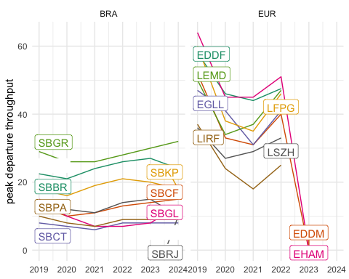
Figure 6.4: Evolution of departure throughput at study airports

6.4 Declared Capacity and Peak Throughput
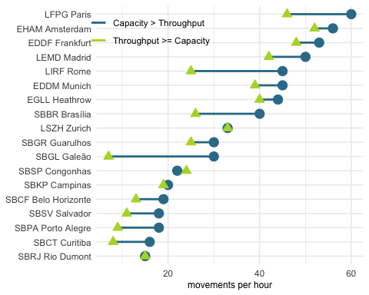
Figure 6.5: Comparison of declared capacity and throughput for arrival phase.
Comparing the peak declared (arrival) capacity and throughput serviced at the differnt airports reveals a varying picture. On average, Figure 6.5 evidences that the majority of the airports do not yet observe capacity constraints. In many instances, the achieved throughput ranges 5 to 10 flights per hour below the maximum declared capacity. In 2023, a low utilisation was observed at Galeão (SBGL), Brasilia (SBBR), and Rome Fiumicino (LIRF) where the spread between capacity and throughput exceeds 15 flights per hour. It is also noteworthy, that a subset of airport services operate at their maximum declared capacity (e.g. SBRJ, SBKP, LSZH). These airports are also characterised by a combination of complexity of the aerodrome layout and operational context. It will be interesting to study how these airports facilitate higher levels of demand. Sao Paulo (SBSP) is the only airport that serviced a slightly higher peak arrival rate than its declared capacity suggests.
The analysis of the spread of the declared capacity vs achieved throughput is useful. However, it gives now indication on how often the demand reaches the declared capacity level.
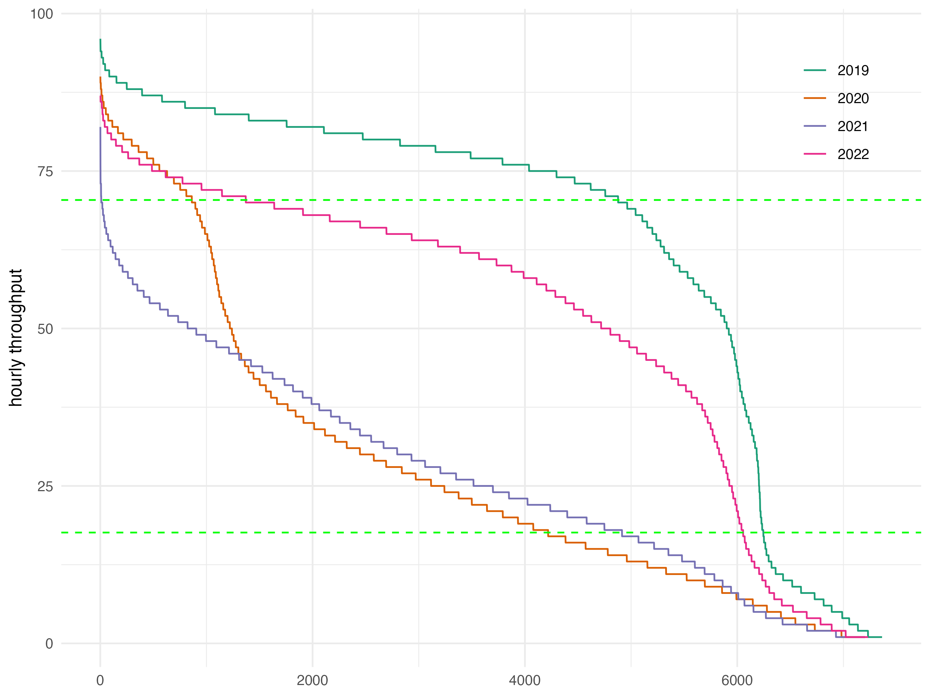  Figure 6.6: Example of ordered hourly throughout in different years | - Figure 6.6 shows the ordered set of hourly throughputs for the past years.  - this allows to identify when the achieved total throughput ranges above characteristics levels (i.e. base load index := 20% of max capcaity, peak load index := 80% of max capacity)
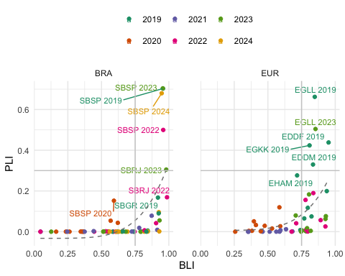
Figure 6.7: Capacity utilisation (base load index vs peak load index)
Figure 6.7 provides an overview of the utilisation of the available capacity during the course of a year. In Brazil, we observe a high utilisation of the capacity at Sao Paulo (SBSP) and Rio de Janeiro (SBRJ) in 2023 compared to earlier years (e.g. 2022). However, it must be noted that both aerodromes are characterised by a relatively conservative and low capacity declaration. The major hub in Brazil, SBGR shows a relatively high base-load-index (BLI), however rarely observed peak loads back in 2019. The associated values for 2022 or 2023 still range below the pre-pandemic performance. Within the European context, a high utilisation of the available system capacity was observed for London Heathrow, Frankfurt, and Gatwick in 2019 with a BLI above 0.8 and the associated PLI above 0.4 (top right quadrant). It is noteworthy that in the European region in 2023 only London Heathrow returned to similar levels of capacity utilisation. For the majority of European airports, the peak load index ranges relatively low. This suggests that most of the airports operate currently concentrated short peaks or have not yet seen a return to pre-pandemic patterns. Using a regression analysis, we can also see a difference in the trend in Europe in comparison to Brazil. Amongst the study airports, there is a higher share of airports with a more peak operating hours than in Brazil. This might be related to the overall role of the airports and underlying connectivity structure and demand levels already described in earlier chapters. Future work on understanding the drivers between operational concepts and demand may reveal further characteristics of the service provision in both systems.

6.5 Summary
Traffic growth in Brazil exceeds pre-pandemic levels. In Europe demand is about to reach the pre-COVID levels. Throughout the past years the declared capacities have not been adapted. On average the declared peak capacities at Brazilian airports tend to be lower than in Europe. This suggests that Brazil possesses more flexibility in accommodating the projected future growth of traffic at its major airports. Within the European context, novel operational concepts offer the biggest growth potential, as the prevailing separation standards and capacities of the runway system provide for an upper bound.
The observed throughput at Brazilian airports shows lower variability during the pandemic period. This suggests that demand remained concentrated during the peak operating hours. Comparing the utilisation of the capacity on the basis of a novel indicator reveals interesting patterns. With SBSP being one of the most constraint aerodrome facilities, but seeing the available capacity regularly utilised across the years and reaching pre-pandemic levels.
On average the declared arrival capacity is commensurate with the peak traffic observed at the airports. This suggests that - at the time being - runway system capacities are not a limiting factor for servicing traffic in both regions. It will be interesting to study to what extent the various operational procedures applied across the airport support or impede the projected recovery and growth of air traffic.

7. Efficiency
Operational efficiency is a critical component in assessing the management and execution of operations. It provides insights in the management of arrival and departure flows and the associated separation and synchronisation activities. Inefficiencies can have an impact on user operations in terms of delays or excessive fuel burn. In light of the previous chapters it is therefore interesting to study how the available capacity was utilised to service demand during the different flight phases.
The measures reported in this comparison report are based on the observed travel time for surface operations (i.e. taxi-in and taxi-out) and during the arrival phase. These travel times are compared with an associated reference time for a group of flights showing similar operational characteristics. The determined difference (i.e. additional time) measures the level of inefficiency. It must be noted that high performance operations will still yield a certain share of measured additional times. Operational efficiency is therefore aiming at minimising rather than eliminating these additional times as they cannot be zero.

7.1 Additional Taxi-In Time
The additional taxi-in time measures the travel time of an arriving aircraft from its touchdown, i.e. the actual landing time, to its stand/gate position, i.e. actual in-block time). This elapsed taxi-in time is compared to an anticipated reference time for aircraft arriving at the same runway and taxiing to the same (group of) stand/gate position(s). Research showed that the taxi-times are not dependent on the type of aircraft. The additional taxi-in time indicator provides a measure of the management of inbound surface traffic.
This report utilises another source for the movement times at Brazilian airports. Next to the actual taxi-times, the new data source provides also gate/stand information. Accordingly, additional taxi-times can be now determined on a per-gate basis. Previous studies did not support this higher level of granularity. The reader needs therefore to bear in mind that the reported results and trends differ from previous reports which were based on an airport-wide aggregation. The latter may be influenced by the predominant runway system configuration and frequently used stand/parking positions.

7.1.1 Annual Evolution of Additional Taxi-in Times
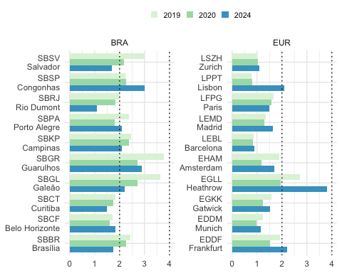
Figure 7.1: Additional taxi-in time [min/arr] (2023-2024)
The annual development of the average additional taxi-in times at the study airports is depicted by Figure 7.1. The indicator varies across the different airports. A threshold of 2 minutes per arrival emerges as an upper bound for the taxi-in performance.
On average, taxi-in performance in Brazil ranged in 2022 well below this 2-minute-threshold for the majority of the airports. In general, taxi-in performance at Brazilian airports improved over the period 2019 to 2022. However, taxi-in performance decreased in 2023 at all studied airports. The pandemic-related drop in surface movements and pressure on the ground infrastructure is visible for the major hubs, i.e. Sao Paulo’s (SBGR), Rio de Janeiro’s Galeão (SBGL), Campinas (SBKP). Taxi-in performance at Campinas remained fairly constant ranging around 2.5 min/arr across the years with a discernible reduction in 2021. The picture at SBGL and SBGR is more varied. Taxi-in performance improved by about 1.5 min/arr comparing the pre-pandemic year 2019 with the performance observed in 2022. While the observed taxi-in inefficiencies in 2023 remained stable in SBGL, an increasing trend is observed in SBGR (which is the busiest airport in Brazil).
In Europe, the average additional taxi-in times ranged generally below the 2-minute-threshold for most of the study airports . Amongst the European study airports, Rome Fiumicino (LIRF) and London Heathrow (EGLL) showed regularly higher levels of inefficiency during the taxi-in phase. Taxi-in performance deteriorated in London Heathrow (EGLL) in 2022 ranging just under 5 minutes per arrival and exceeding the pro-COVID performance by about 2 minutes per incoming flight. In 2023, the average additional taxi-in improved by about 1 minute per arrival. Rome Fiumicino observed a stable taxi-in performance ranging above 2.5 minutes per arrival. This suggests that the complexity of the aerodrome layout requires a higher effort to deconflict arrivals from other arrivals or taxiing departures. Taxi-in performance in 2023 dropped further at LIRF to just under 3 minutes per arrival. Several airports in Europe showed higher or less improved additional taxi-in times during the pandemic years. This is related to the fact that airports closed down portions of the infrastructure (e.g. terminals) to account for the lower demand in air traffic. In some cases, this resulted in less favourable runway and gate/stand combinations. In Europe, the year 2022 is also characterised by a surge in delays due to the returning demand for air travel. Associated ripple effects were still observed in 2023. The lower punctuality also posed challenges for arriving traffic as incoming flights had to be serviced to other gates/stands to deconflict from delayed departures. The latter phenomenon shows more clearly for the major hubs amongst the study airports.

7.1.2 Monthly Variation of Additional Taxi-in Times
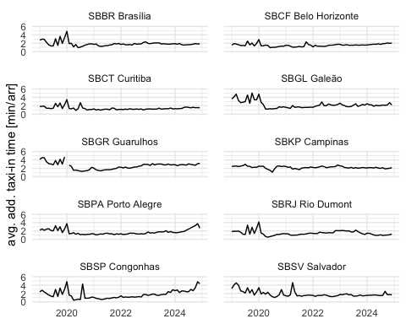
Figure 7.2: Evolution of average additional taxi-in time at Brazilian airports
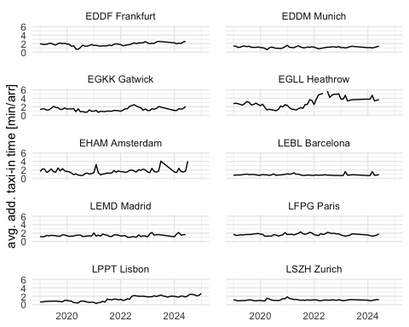
Figure 7.3: Evolution of average additional taxi-in time at European airports
The evolution of the taxi-in times at the study airports in Brazil and Europe is shown in Figure 7.2 and Figure 7.3. In Figure 7.2, we can see that the variation of additional taxi-in time smoothened over time on the Brazilian side. This effect appears to be associated broadly with the beginning of the pandemic. Despite the significant return of demand in 2022 and continual growth in 2023, there are no significant monthly variations in the average additional time-in across the Brazilian airports. Operations at the larger airports, e.g. Guarulhos (SBGR), Rio de Janeiro (SBRJ), Brasilia (SBBR) observed a more systematic increase of the monthly average additional taxi-in times. These trends should be monitored for the coming period.
The observed average additional taxi-in time varies across European airports on a monthly basis. In general, seasonality is a strong driver for month-on-month changes, as weather or seasonal traffic demand pose additional strains on the servicing of ground movements. To a certain degree, the pandemic period is discernible in the charts, except for Barcelona and Zurich, which showed a slight higher leve of taxi-in inefficiency. Such less efficient average additional taxi-in times point to changes in the taxi-in procedures during the pandemic. Also noteworthy is Heathrow’s behaviour, which showed an increase in its monthly average additional taxi-in times. This may be linked to difficulties accommodating the returning traffic. It will be interesting to study which factors impacted the significant increase in the taxi-in inefficiency.

7.2 Taxi-Out Times

7.2.1 Annual Evolution of Additional Taxi-out Times
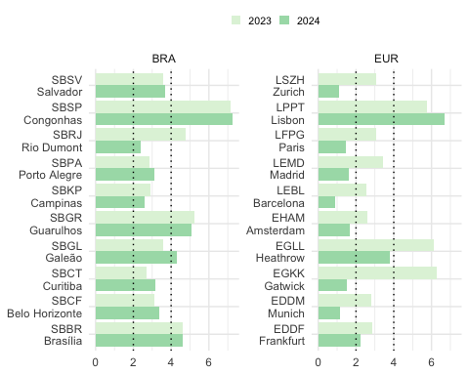
Figure 7.4: Average additional taxi-out time [min/dep] (2023-2024)
On average, higher additional times for taxi-out are observed across all airports (c.f. Figure 7.4). During the pandemic, lower traffic demand resulted in 2020 and 2021 to a significant drop of the average additional taxi-out times. In comparison to the addtional taxi-in time, the taxi-out phase requires a higher level of management of the surface movements. Departure procedures and flow control can impact the departure queue. Comparing the observed taxi-out performance across all study airports ( Figure 7.4), the interval of two to four minutes of average additional taxi-out time can serve as a benchmark. There is a varied picture with several airports observing additinal taxi-out times of more than 4 minutes per departure, e.g. SBSP, SBRJ, SBGR in Brazil and LIRF, EGLL, and EGKK in Europe. In many instances the higher taxi-out times in 2022 and 2023 evidence the general increase in air traffic and the reopening of closed parts of the aerodrome infrastructure.

7.2.2 Monthly Variation of Additional Taxi-out Times
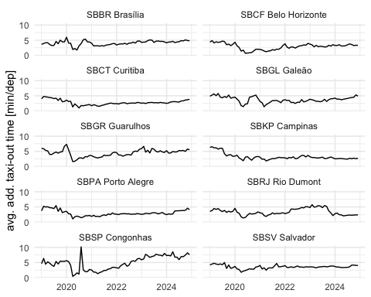
Figure 7.5: Brazil - Monthly Evolution of taxi-out times
Moving from the annual overview to the monthly level a more finegrained pattern emerges. Within the Brazilian context taxi-out performance increased during the beginning of COVID (c.f. Figure 7.5). The actual order of magnitude varies across the airports, however a clear reaction can be observed for the initial phase (i.e. following the WHO pandemic declaration in March).
The reaction to the unprecedented decline in air traffic is more prominent for European airports (c.f Figure 7.6). London Heathrow (EGLL) and London Gatwick (EGKK) evidenced a strong decline of traffic and associated additional taxi-out times following the start of the pandemic. Strong weather influences drove the taxi-out performance at Amsterdam Schiphol (EHAM), Munich (EDDM) and Zurich (LSZH) in early 2021.
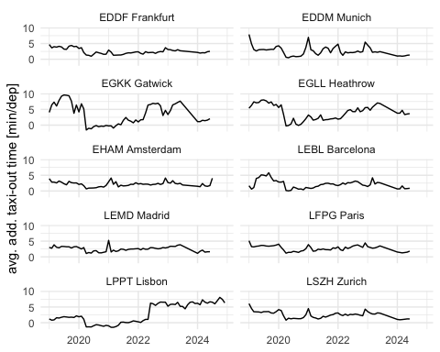
Figure 7.6: Europe - Monthly Evolution of taxi-out times

7.3 Mapping Additional Taxi-in and Taxi-out Times
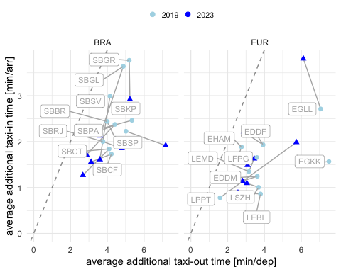
Figure 7.7: Mapping of additional taxi-in and taxi-out times
This analysis builds on the previous sections. Figure 7.7 compares the relationship between the taxi-in and taxi-out performance observed pre-pandemic (i.e. 2019) with the observed performance in 2023. It also shows that on average taxi-out operations accrued more additional time than taxi-in operations (data points range below the dotted unit line, and as shown in the previous sections). For most of the airports, the overall performance shows a reduction in additional taxi-out times (i.e. characterised by a leftshift along the x-axis) when comparing the pre-pandemic year 2019 to 2023. A significant improvement in taxi-in performance can be obsered in Brazil across all study airports (i.e. decreasing trend along y-axis). This is contrasted by the behaviour in Europe. The majority of European airports observed no significant change in their taxi-in performance (i.e. no vertical trend). The noteworthy exemption is London Heathrow (EGLL). EGLL faced a significant increase in average additional taxi-in time in 2023 in comparison to the pre-pandemic performance level observed in 2019. The lower performance in terms of taxi-in is observed in Figure 7.3 which shows a strong increase in the second half of 2023. Figure 7.7 also shows that the overall taxi-performance in Europe tends to show lower levels of variation between pre-pandemic and post-pandemic. Exemptions are London Heathrow (EGLL) and Rome Fiumincino (LIRF) that saw a discernible rise in taxi-in inefficiencies and exceeding the levels observed at Brazilian study airports.

7.4 Additional Time in Terminal Airspace
The additional time in terminal airspace is calculated as the difference of the actual flying time from entering the sequencing area (i.e. 100NM radius around the airport) to the actual landing time. Previous research and guidance suggests that reference time can be build for flights sharing similar operational characteristics (entry sector, aircraft class, and landing runway).
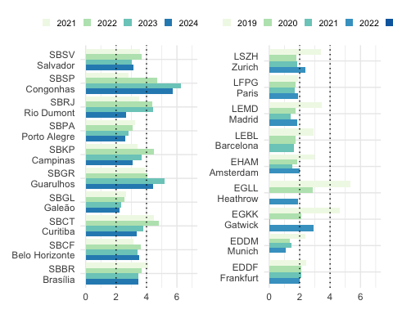
Figure 7.8: Additional time in terminal airspace
Figure 7.8 compares the annual average of additional times in terminal airspace across the study airports. On average, the arrival flows at European airports are less constraint than in Brazil.
At London Heathrow (EGLL) a change in the operational concept helped to reduce the excessive additional ASMA times observed pre-COVID. It must be noted that the minimal results for both London airports (Heathrow and Gatwick) in 2021 are a data artefact. The reference times for this study are build on the basis of the performance observed in 2019. The lower traffic levels resulted in more efficient and shorter terminal sequencing operations. Compared to the 2019 reference times yields therefore minimal additional times. Although there are improvements across the operations at European airports in comparison to 2019, it appears that with higher demand, procedural aspects applied before the pandmic are being reintroduced.
During the pandemic, Brazilian aviation authorities relieved regulations for general aviation in the São Paulo Congonhas (SBSP) airport. As this relief was still in force during the recovery in 2021 and 2022, balancing demand was difficult and caused higher additional time as the traffic increased back. For example, in May 2022, the lack of slots, associated with the gradual increase in demand, impacted the operations of Congonhas airport (SBSP). From June 2022, the need for slot for General aviation returned in force, but in October operations were again impacted by the amount of storms above expected for the season.
For future reports, the data for for the assessment of the additional time in terminal airspace will be complemented for Brazil. This will allow to better investigate the changes observed across the years.
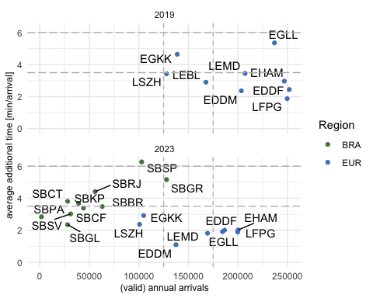
Figure 7.9: Comparison of additional time in terminal airspace
Figure 7.9 depicts the change in terms of the average additional time in terminal airspace comparing 2019 and 2022. It must be noted that with respect to traffic, the Brazilian data set does not comprise all arriving traffic (c.f. traffic figures reported in earlier chapters).
The comparison shows the effect of the decline of air traffic on the performance in the European region. The contraction of demand resulted in lower observed additional times accrued by the arriving traffic. For some airports in the Brazil region it can be observed how procedural aspects influence the additional time in terminal airspace. For example, despite the variation of the traffic levels considered, the additional time remained fairly stable at SBGR comparing pre- and post-pandemic years.

7.5 Summary
Operational efficiency provides an insight in terms of available benefit pools that can be exploited. In light of the ongoing climate change discussion, improvements in operational efficiency are directly linked with the aircraft flying time and can help to reduce unnecessary emissions.
Comparing the surface movement performance in Brazil and Europe shows similar trends. On average, taxi-in operations are less constraint than taxi-out movements. The latter observed higher additional times. This may be subject to deconfliction of the traffic during the taxi-out phase, the establishment of the departure sequence, and holding at/close to the runway to maximise the runway utilisation.
The analysis of the additional time in terminal airspace on the basis of the new data set for Brazil confirmed previous trends. On average, arrival sequencing in combination with the lower capacity result in higher additional times within the terminal airspace. It must be noted that Brazil undertook a major airspace redesign project in 2021 that influences the interface between the terminal airspace and the enroute network. In the European region, the reduced level of air traffic resulted in lower pressure on the sequencing of arrivals. However, the step increase between 2021 and 2022 for several airports suggests that constraints and more sequencing may come back with the increasing demand.
It will be interesting to study in future iterations of this comparison report to what extent arrival managment concepts deployed in the different regions contribute to the observed additional times.

8. Conclusions
 | What is shown in this report  Generic start - good. Maybe refine a bit.
This forth edition of the Brazil-Europe operational ANS performance comparison report builds on the joint project between the Performance Section of DECEA and the Performance Review Unit of EUROCONTROL. The collaboration aims at fostering the understanding and support the further development of approaches to measure operational performance in both regions. This report builds on a subset of indicators and metrics established under the umbrella of ICAO’s Global Air Navigation Plan ICAO (2019b). The work is also used to showcase the application of the GANP indicators within a bi-regional and multi-regional project. DECEA and EUROCONTROL engage actively within the international community and share their findings of their joint bi-regional work.
This iteration also comprised the integration of additional data sources on the Brazilian side.
The new data sources offer to perform more fine-grained analyses of the observed operational efficiency performance.
This will allow to further develop and complement the framework.
The report also identified several observations and ideas for future research which pave the way ahead for augmenting the associated set of comparison analyses.
 | Major findings

This report kicked off by examining the commonalities and differences in terms of the organisation of air navigation services in both regions.
This was complemented by investigating the air traffic demand to better understand the factors influencing operational performance.
The air navigation service provision is less fragmented in Brazil than in Europe.
This plays out in the total number of air traffic service units.
Both regions operate a central flow management function to ensure network wide flow management.
In terms of air traffic demand, both regions were impacted by the unprecedented decline of air traffic.
Regional and global traffic restrictions resulted in different patterns.
The recovery in Brazil followed a more continual path, while Europe experienced setbacks due to the variety of national and pan-European measures deployed to curb the spread of COVID.
In 2022, the Brazilian system serviced more traffic than pre-pandemic.
In terms of traffic volume, Europe is still lagging behind with about 85-90% of pre-pandemic network level traffic in 2022.
The traffic situation is also reflected by the demand at the study airports.
There is also a higher level of diversity in terms of air traffic evidenced by the share of light types serviced at the comparison airports.
International traffic is more centralised in Brazil than in Europe.
The observed punctuality in both regions was strongly influenced by the prevailing COVID-19 recovery.
Particularly, Europe suffered strongly from the surge of air traffic demand in early 2022 which is evidenced by the high share of departure delays.
The reactionary knock-on effect amplified further the overall punctuality performance.
The utilisation of available runway system capacities is a fundamental enabler for high levels of operational performance.
This report showed that associated capacities are commensurate with the current traffic levels.
For the majority of airports, the realised throughput ranges still below the maximum declared capacities.
Operational efficiency is measured in this report in the form of the additional time during the surface movement phases and the terminal arrival phase.
On average, taxi-in operations are less constrained than taxi-out operations.
The observed performance varies across the airports and timeframe.
In terms of arrival management, air traffic in Brazil observed higher additional times in the terminal airspace.
This report showed that the scale effect of lower air traffic are potentially masked by the effects of airspace redesign in Brazil.
In the European region, it appears that the higher level of air traffic demand puts pressure on the arrival management and sequencing, and 2022 marks a return to higher additional times within the terminal airspace.
Further research can help to identify drivers and performance enablers.
 | Outlook
This fourth edition of the bi-regional comparison report documents the continued technical collaboration between DECEA and EUROCONTROL.
The joint work also helped to promote the approach and state-of-the-art with the international community.
Both groups are contributing to the ICAO GANP Performance Expert Group and the multi-national Performance Benchmarking Working Group.
The wider harmonisation of performance related data and joint refinement of the guidance material and application of the performance framework start paying dividends.
For example, PBWG concluded in its most recent meeting to collaborate on topics of mutual interest for which this report supported the initial research and validation.
A further outcome of the project is the close technical collaboration.
It is planned to augment the report and its future editions with a rolling web-based monitoring, including regular updates of the underlying data.
This and future reports will help to complement the time series of the measures tracked.

9. Studies
Throughout 2024, joint work between DECEA and EUROCONTROL involved the preparatory action for assessing the operational performance benefits of point-merge operations and comparing service provision within two units. This chapter provides a first summary of the work to help refine the future work.

9.1 Point-Merge Operations
Point Merge System (PMS) is an innovative air traffic sequencing technique designed to optimise aircraft arrival sequences, reduce flight times (???), and enhance operational safety. PMS operates efficiently under high traffic loads without the need for radar vectoring. It relies on a specific Precision-Area Navigation (P-RNAV) route structure, comprising a merge point and equidistant pre-defined sequencing legs. Traffic sequencing is achieved through a “direct-to” instruction to the merge point at the appropriate time. The sequencing legs are used to extend the flight path of an aircraft along the leg only when necessary. The length of these legs reflects the required delay absorption capacity, ensuring a streamlined and predictable arrival flow. This method simplifies controller tasks, reduces communication and workload, enhances pilot situational awareness, and improves the predictability and efficiency of flight trajectories. Figure 9.1 illustrates the Point Merge system and its components.
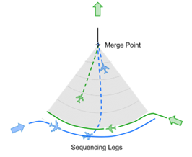
Figure 9.1: Point-merge overview
The Point Merge System has been successfully implemented at various airports worldwide, demonstrating its effectiveness in enhancing airspace efficiency and reducing the environmental impact of fuel consumption. In Brazil, Guarulhos International Airport (SBGR) — one of the busiest hubs in Latin America — faces daily challenges related to high traffic density. To address these issues, PMS was implemented for arrival procedures at SBGR in May 2021. With a recent deployment in 2024, PMS was introduced at Lisbon Airport (LPPT). The following is an illustration of flight trajectories at SBGR and LPPT during periods before and after the implementation of the Point Merge System (PMS).
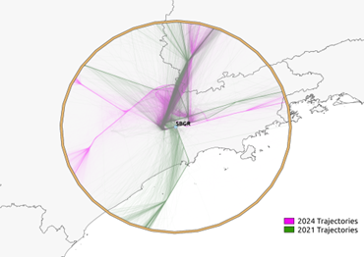
Figure 9.2: Point-merge operations at Guarulhos (SBGR) (2019 vs 2024)
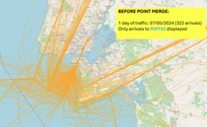  LPPT runway 02 - before point-merge | 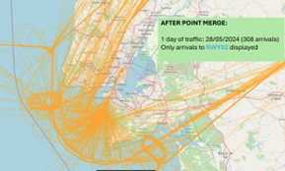  - post point-merge deployment

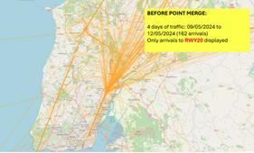  LPPT runway 20 - before point-merge | 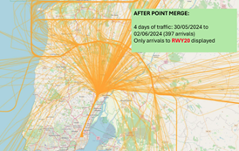  - post point-merge deployment
Monitoring Additional Time in TMA is valuable for assessing the impact of the Point Merge System (PMS) implementation on airspace operational performance. This indicator reflects the extra time an aircraft spends in the TMA compared to an ideal flight profile. A comparison of KPI08 values was conducted for periods before and after the implementation of PMS. For SBGR, the analysis covered the years 2019 (pre-PMS) and 2024 (post-PMS). These periods were chosen to avoid analytical bias, since PMS implementation at Guarulhos took place during the COVID-19 pandemic. The analysis period for LPPT spanned from March 2023 to July 2024. The following graph presents the results obtained. Reference times and additional times were calculated on a monthly basis.
 | [] convert figures to study data set –> ASMA [] include runway throughput ~ peak arrival rate ~ consistency during peak hours
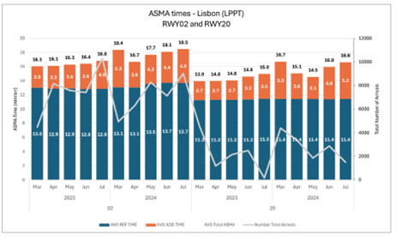
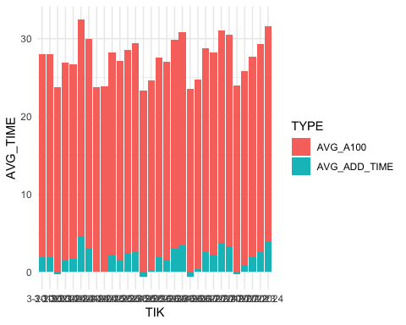
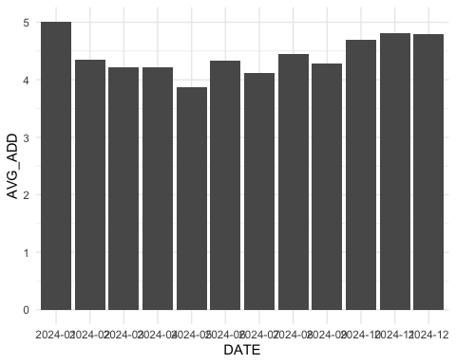
Figure 9.3: Monthly evolution of the additional time in terminal airspace in SBGR
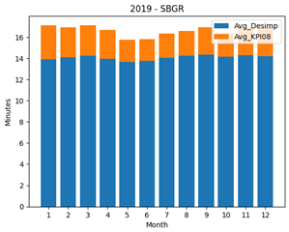
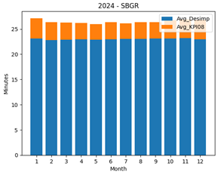
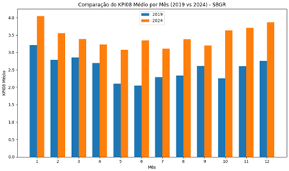
The results indicated an increase in additional time for both airports following the implementation of the PMS. This suggests that, operationally, the PMS enabled a higher occupancy rate within the TMA. By design, the PMS enhances the terminal’s capacity to manage and organize inbound traffic more efficiently. However, the runway throughput remained unchanged, as increasing runway capacity would require physical infrastructure modifications. Consequently, although the terminal airspace can now accommodate a greater number of approaches simultaneously, the airport’s ground infrastructure cannot absorb this increased demand at the same pace. This mismatch leads to longer dwell times within the terminal area as aircraft await clearance to land.
References
Eurocontrol. (2014). Point Merge: Integration of Arrival Flows Enabling Extensive RNAV Application and Continuous Descent. Eurocontrol Experimental Centre.
FRANZINI, Bruno Monteiro et al. (2024). Analysis of Guarulhos Point Merge Adherence Based On Additional Time In Tma And Trajectory Clustering.. In: Anais do XXI Simpósio de Transporte Aéreo - SITRAER 2024.
ICAO. (2016). Continuous Descent Operations (CDO) Manual. International Civil Aviation Organization.

9.2 Air Traffic Services at Curitiba and Lisbon Continental
The Curitiba Area Control Center (ACC-CW) is one of four Area Control Centers strategically distributed across Brazil. Located in the city of Curitiba, in the state of Paraná, ACC-CW plays a crucial role in controlling the airspace of the southern region of the country, ensuring safe and efficient operations for both civil and military aircraft.
ACC-CW’s jurisdiction covers the entire portion of the Curitiba Flight Information Region (FIR-CW), excluding the airspace delegated to the Southeast Regional Airspace Control Center (CRCEA-SE). This jurisdiction totals approximately 1.7 million km², representing 7.7% of the airspace delegated to Brazil. Within this airspace, the Air Traffic Control Service, Flight Information Service, and Alert Service are provided.
The Air Traffic Control Service is provided to all aircraft flying above FL 150. Additionally, this service is exclusively provided to aircraft flying above FL 120 in CTA 2 (departures and arrivals for Viracopos Airport in Campinas-SP) and CTA 4 (departures and arrivals for Vitória Airport in Espírito Santo).
In 2024, traffic within FIR-CW exceeded 492,000 flights, representing a 25% increase compared to 2023 (394,000 flights). Notably, 11 of the 30 busiest aerodromes in Brazil in 2024 are located within FIR-CW.
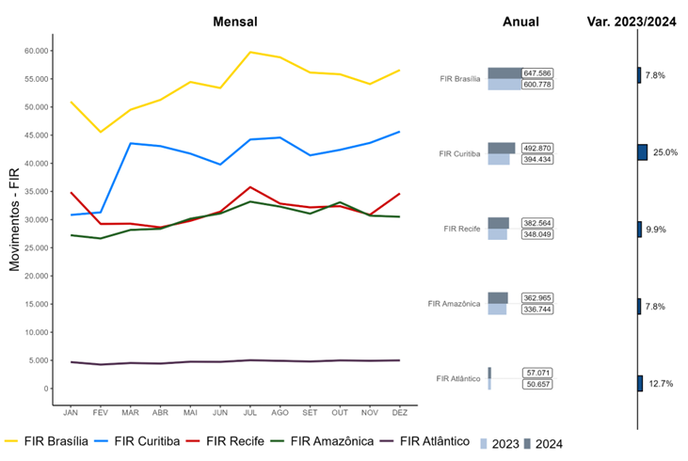
The FIR-CW encompasses the Terminal Control Areas (TMA) of São Paulo, Rio de Janeiro, Curitiba, Florianópolis, Porto Alegre, Foz do Iguaçu, Campo Grande, Santa Maria, Macaé, Londrina, and Presidente Prudente.
Currently, ACC-CW is divided into 18 sectors and two regions: North and South.
Comparison with EUROCONTROL
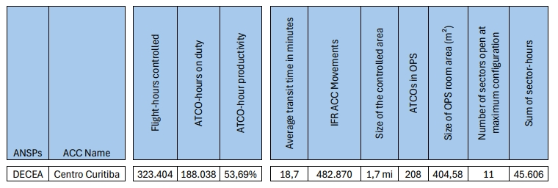
Flight-hours controlled:
The total number of controlled flight hours was calculated for the year 2023.
ATCO-hours on duty:
The total monthly scheduled hours of operators in the year 2024 were summed, considering the operational positions: Controller, Control Assistant, Coordinator, and Supervisor.
Average transit time in minutes:
The average transit time in minutes was calculated per sector for the year 2023, as it provides a complete annual sample
ATCOs in OPS:
The number of ATCOs in operation was calculated based on the monthly average of qualified operators at ACC-CW, as recorded in SGPO. Currently, ACC-CW has 2,013 operators and 10 trainees.

References
EUROCONTROL. 2019. “Eurocontrol Specification for Operational ANS Performance Monitoring - Airport Operator Data Flow.” https://www.eurocontrol.int/publication/eurocontrol-specification-operational-ans-performance-monitoring.
EUROCONTROL Central Office of Delay Analysis. 2023. “All-Causes Delays to Air Transport in Europe, Annual 2022.” https://www.eurocontrol.int/publication/all-causes-delays-air-transport-europe-annual-2022.
ICAO. 2019b. Doc 9750, Capacity & Efficiency, Global Air Navigation Plan 2016-2030. Sixth Edition. Montreal, Canada: International Civil Aviation Organization.
ICAO. 2019a. Doc 9750, Capacity & Efficiency, Global Air Navigation Plan 2016-2030. Sixth Edition. Montreal, Canada: International Civil Aviation Organization.

The Performance Benchmarking Working Group (PBWG) comprises participants from Brazil (DECEA), China (CAA-OSC), Japan (JCAB), Singapore (CAA), Thailand (AEROTHAI), United States (FAA-ATO), and EUROCONTROL.
Enhanced Traffic Flow Management System
It must be noted that conceptually, the number of aircraft remained unchanged in the both regions. The higher utilisation of “heavy” aircraft for logistical support appeared to have offset the lower number international / long-haul passenger flights. For the first six month of 2023, this pattern is continued
See CODA report at https://www.eurocontrol.int/publication/all-causes-delays-air-transport-europe-annual-2022.
While general trends are consistent with previous reports, the changed and improved data source provides now runway and stand/gate information for taxi-in operations. This allows for a more fine-grained analysis of the additional surface movement times. Accordingly, observed (and reported) taxi-in performance values differ from the earlier reports (which are based on airport-wide reference times).
To account for the low traffic demand during the pandemic years, the European data builds on modulated reference times for the period 2019 through 2022. This accounts for the high number of changed surface movement patterns (e.g. different runway/gate combinations infrequently or not used before the pandemic). While the overall trend is consistent, previous reports may show differnt values for the observed surface movement performance.
The assessment of the additional time in terminal airspace for Brazil is based on a data set starting in 2021. This may also result in reasonable small reference times and increase the measured values for Brazil. With a complemented dataset and a change of the base year for future reports, these data phenomena will be addressed.

