Operational Comparison of ANS Performance

DECEA Performance Section, EUROCONTROL Performance Review Unit

2025-04-04

Table of contents

# Preface

**A continuing partnership**

This fourth and best edition of the bi-regional Brazil-Europe comparison report of Air Navigation System Performance continues to add transparent and robust data to support an informed discussion about operational performance in both regions. Further, it strengthens the close collaboration between DECEA and EUROCONTROL. This report is jointly developed by the Performance Section of the Department of Airspace Control (DECEA) and EUROCONTROL’s Performance Review Unit (PRU).

For any questions, please do not hesitate to contact one of the authoring organisations.

Performance Section, DECEA Performance Review Unit, EUROCONTROL

$$\\[1in]$$

**COPYRIGHT NOTICE AND DISCLAIMER**

Every possible effort was made to ensure that the information and analysis contained in this document are as accurate and complete as possible. Should you find any errors or inconsistencies we would be grateful if you could bring them to our attention.

The views expressed herein do not necessarily reflect the offical views or policy of DECEA or EUROCONTROL, which - both jointly or individually - make no warranty, either implied or express, for the information contained in this document, neither do both organisations assume any legal liability or responsibility for the accuracy, completeness or usefulness of this information.

This document is jointly published by EUROCONTROL and DECEA for information purposes. It may be copied in whole or in part, provided that EUROCONTROL and DECEA are mentioned as the source and it is not used for commercial purposes (i.e. for financial gain). The information in this document may not be modified without prior written permission from EUROCONTROL and DECEA.

www.eurocontrol.int & www.decea.mil.br

# Foreword

|  |
| --- |
|  |

|  |
| --- |
| $$\\[0.5in]$$ |

|  |
| --- |
|  |

# Executive Summary

The Performance Section of the Brazilian Department of Airspace Control and the Performance Review Unit of EUROCONTROL jointly developed this third edition of the Brazil-Europe comparison of Air Navigation System Performance. This edition of the bi-regional report builds on the previous comparison reports using commonly agreed metrics and definitions to compare, understand, and improve the performance of air navigation services. This report and previous editions are available at * <https://ansperformance.eu/global/brazil> or * <https://performance.decea.mil.br/>.

This report revises the assessment of both the Brazilian and European air navigation systems, extending the time frame and incorporating additional analyses. The report focuses on a subset of the eleven Key Performance Areas identified by the ICAO Global Air Navigation Plan. The focus of this report is on operational air navigation system performance, in particular Predictability, Capacity and Efficiency.

|  |
| --- |
| Figure 1: Key Performance Areas addressed in this edition |

The comparison shows similarities and differences in the air navigation service provision and observed performance in both regions. Major take-aways of this report include:

* The close collaboration between DECEA and EUROCONTROL is highlighted sharing insights and experiences with the international aviation communities, thus assisting in advancing ATM performance management worldwide.
* Brazil saw a rise in the ATCOs number, whereas Europe observed a considerable decrease, highlighting a substantial contrast in the systems’ responsiveness to the challenges of COVID/re-emerging demand for air traffic.
* In 2022, the commercial flight distribution reveals that a smaller number of airports manage 80% of commercial takeoffs, with Brazil showing a slightly greater concentration compared to Europe.
* Regarding punctuality, unique trends were evident in both regions, not solely attributable to the extent of traffic resurgence. In Brazil, a consistently higher proportion of flights arrived significantly early, a pattern largely unaffected when comparing 2019 to 2022. Conversely, the documented challenges of European airports in coping with the recovering traffic demand in 2022 highlighted the repercussions of their lower preparedness levels.
* The recorded throughput at Brazilian airports exhibited less variability amid the pandemic, indicating a sustained demand concentration during peak operational hours. In the European context, innovative operational ideas present the most substantial potential for growth, considering the existing runway systems and associated capacities, which set an upper limit.
* The fresh dataset for Brazil reaffirmed past patterns regarding the extra time spent in terminal airspace. Typically, arrival sequencing and limited capacity lead to extended times during the arrival phase. In Europe, reduced air traffic translated to less strain on arrival sequencing. Yet, the notable rise from 2021 to 2022 in multiple airports implies that constraints and heightened sequencing might resurface as demand increases.

This report will be updated throughout the coming years under the umbrella of the DECEA-EUROCONTROL memorandum of cooperation. It is also planned to establish a web-based rolling monitoring updated on a regular basis.

Future editions will complement the data time series and support the development of further use-case analyses. The lessons learnt of this joint project will be coordinated with the multi-national Performance Benchmarking Working Group (PBWG) and the ICAO GANP Study sub-group concerned with the further development of the GANP Key Performance Indicators (KPIs).

# 1. Introduction

## 1.1 Background

Air transportation is a key economic driver in Brazil and Europe. Both regions share the political goal of a performance-based approach to foster the continual growth and efficiency of air transport. It is recognised that Air Navigation Services (ANS) play a critical role in terms of limiting the constraints on airspace user operations. Accordingly, the analysis and regional comparison of operational ANS performance informs about trends over time, the success of change implementation, and potential performance benefit pools for future exploitation.

With a view to a tigher collaboration between Brazil and Europe, DECEA and EUROCONTROL signed a cooperation agreement in 2015. This agreement encompasses various activities, most notably cooperation and joint initiatives in the domain of operational performance benchmarking of ANS.

The close technical collaboration of the Performance Section of DECEA and EUROCONTROL’s Performance Review Unit comprises the further development and validation of proposed ICAO GANP indicators, regular performance related data exchange, and the production of regional or multi-regional performance reports. An essential part of this work entails the identification and validation of comparable data sources, the development of a joint data prepartory process, and supporting analyses to produce this report or contribute to the aforementioned international activities.  
This report represents the third edition of joint comparisons between Brazil and Europe.

## 1.2 Performance Areas

Establishing shared definitions and a mutual understanding is essential to facilitate comparisons and operational benchmarking activities. Therefore, the groundwork presented in this report is rooted in commonly accepted findings from prior work conducted by ICAO, other regional or multi-regional operational benchmarking initiatives (e.g., PBWG [1]), and practices within various regional or organisational settings.

The key performance indicators (KPIs) utilised in this study have been developed through a rigorous process that integrates the best available data from both the DECEA Performance Section and PRU. It is important to note that the comparative analysis outlined in this iteration of the report does not encompass all eleven Key Performance Areas (KPA) as presented in Figure 1.

From an indicator perspective, the DECEA Performance Section and PRU have reached a consensus to concentrate on operational benchmarking and aligning their efforts with the performance indicators proposed by ICAO in conjunction with the update of the Global Air Navigation Plan (GANP). Future work may also include aspects of cost-effectiveness.

## 1.3 Geographical Scope

This report’s geographical focus encompasses Brazil and Europe.

Airspace control in Brazil is a fully integrated civil-military operation. The Brazilian Air Force is responsible for air defence and air traffic control functions. Within this framework, the Department of Airspace Control (DECEA) operates as a governmental entity under the authority of the Brazilian Air Force Command. DECEA plays a pivotal role by coordinating and furnishing human resources and technical equipment to all air traffic units operating within Brazilian territory. This collaboration ensures air traffic safety while contributing to military defence efforts.

DECEA is the cornerstone of the Brazilian Airspace Control System (SISCEAB). This department provides air navigation services for the vast airspace jurisdiction covering 22 million square kilometres, including oceanic areas. The Brazilian airspace is further divided into five Flight Information Regions (FIR) and the areas of responsibility of these integrated Centres for Air Defence and Air Traffic Control (CINDACTA) are depicted in Figure 1.1.

|  |
| --- |
| Figure 1.1: Brazilian Airspace Structure/FIRs (CINDACTAs) |

The CINDACTAs merge civilian air traffic control with military air defence operations. In addition to the CINDACTAs, there’s the Regional Center of Southeast Airspace Control (CRCEA-SE), tasked with managing air traffic in the densely congested terminal areas of São Paulo and Rio de Janeiro.

|  |
| --- |
| Figure 1.2: European Airspace and EUROCONTROL Member States |

In this report, Europe, i.e. the European airspace, is defined as the area where the 41 EUROCONTROL member states provide air navigation services, excluding the oceanic areas and the Canary islands (c.f. Figure 1.2). In 2016, EUROCONTROL signed a comprehensive agreement with Israel and Morocco. Both comprehensive agreement States will be successively fully integrated into the working structures of EUROCONTROL, including performance monitoring. Within this report, these states are included in the reported network traffic volumes.

EUROCONTROL is an inter-governmental organisation working towards a highly harmonised European air traffic management system. In general, air traffic services are provided by air navigation service providers entrusted by the different EUROCONTROL member states. Dependent on the local and national regimes, there is a mix of civil and military service providers, and integrated service provision.  
The Maastricht Upper Area Control Center is operated by EUROCONTROL on behalf of 4 States (Netherlands, Belgium, Luxemburg, and Germany). It is the only multi-national cross-border air traffic unit in Europe at the time being. Given the European context and airspace structure, the European area comprises 37 ANSPs with 62 en-route centres and 16 stand-alone Approach Control Units (i.e. totalling 78 air traffic service units).

Europe employs a collaborative approach to manage and service airspace and air traffic. This includes the integration of military objectives and requirements which need to be fully coordinated within the ATM System. A variety of coordination cells/procedures exists between civil air traffic control centres and air defence units reflecting the local practices. Many EUROCONTROL member states are members of NATO and have their air defence centres / processes for civil-military coordination aligned under the integrated NATO air defence system.

Further details on the organisation of the regional air navigation systems in Brazil and Europe will be provided in Section 2.1.

### 1.3.1 Study Airports

As concerns airport-related operational air navigation performance, this edition of the comparison report addresses the performance at a set of selected airports. These airports represent the top-10 or most relevant airports in terms of IFR movements in both regions and allow to make meaningful comparisons.  
In Brazil, the selected airports play a significant role for the national and regional connectivity, including the major hubs for international air traffic. These study airports have consolidated systems and structured processes for data collection in support of this comparison report.  
For the European context, the study airports comprise the busiest airports in several states exhibiting a mix of national, regional, and international air traffic. These airports are also characterised by varying operational constraints that make them excellent candidates for an international comparison. All of these airports are subject to the performance monitoring under the EUROCONTROL Performance Review System and provide movement related data on the basis of a harmonised data specification.

Figure 1.3 provides an overview of the location of the chosen study airports within both regions. The airports are also listed in Table 1.1.

|  |  |  |  |  |  |  |  |  |  |  |  |  |  |  |  |  |  |  |  |  |  |  |
| --- | --- | --- | --- | --- | --- | --- | --- | --- | --- | --- | --- | --- | --- | --- | --- | --- | --- | --- | --- | --- | --- | --- |
| Table 1.1: List of study airports for the Brazil / Europe operational ANS performance comparison   | Brazil | Europe | | --- | --- | | Brasília (SBBR) | Amsterdam Schiphol (EHAM) | | São Paulo Guarulhos (SBGR) | Paris Charles de Gaulle (LFPG) | | São Paulo Congonhas (SBSP) | London Heathrow (EGLL) | | Campinas (SBKP) | Frankfurt (EDDF) | | Rio de Janeiro S. Dumont (SBRJ) | Munich (EDDM) | | Rio de Janeiro Galeão (SBGL) | Madrid (LEMD) | | Belo Horizonte Confins (SBCF) | Rome Fiumicino (LIRF) | | Salvador (SBSV) | Barcelona (LEBL) | | Porto Alegre (SBPA) | London Gatwick (EGKK) | | Curitiba (SBCT) | Zurich (LSZH) | |

|  |
| --- |
| Figure 1.3: Study airports of Brazil/Europe Comparison |

### 1.3.2 Temporal Scope

This report focuses on the period from January 2019 to December 2023. With this report, the focus is on building a timeline with comparable data to be augmented in future editions.

Throughout the report, summary statistics will be given with reference to calendar years of this comparison study.

## 1.4 Data Sources

The nature of the performance indicator requires the collection of data from different sources. DECEA Performance Section and PRU investigated the comparability of the data available in both regions, including the data pre-processes, data cleaning and aggregation, to ensure a harmonised set of data for performance comparison purposes.

DECEA mainly uses data from the tower systems of the main airports as a data source for performance studies. The control tower system collects and provides data for each landing and take-off operation automatically. This edition blended ANAC (Brazilian CAA) official and public data with DECEA’s data to increase precision for specific indicators, adding a pre-processing phase to the data analytical work. The provided data include such items as the times of operations, gate entry and exit, and flight origin and destination.

Within the European context, PRU has established a variety of performance-related data collection processes. For this report the main sources are the European Air Traffic Flow Management System (ETFMS [2]) complemented with airport operator reported data. These sources are combined to establish a flight-by-flight record. This ensures consistent data for arrivals and departures at the chosen study airports. The data is collected on a monthly basis and typically processed for the regular performance reporting under the EUROCONTROL Performance Review System and the Single European Sky Performance and Charging Scheme (EUROCONTROL 2019).

## 1.5 Structure of the Report

This third edition of the Brazil-Europe comparison report is organised as follows:

* **Introduction** – overview, purpose and scope of the comparison report; short description of data sources used;
* **Air Navigation System Characteristics** – high-level description of the two regional systems, i.e. areas of responsibility, organisation of ANS, and high-level air navigation system characteristics;
* **Traffic Characterisation** – network level and airport level air traffic movements; peak day demand, and fleet composition observed at the study airports;
* **Predictability** observed arrival and departure punctuality;
* **Capacity and Throughput** assessment of the declared capacity at the study airports and the observed throughput, including runway system utilisation comparing achieved peak throughput to the declared capacity;
* **Efficiency** analysis of taxi-in, taxi-out, and terminal airspace operations; and
* **Conclusions** summary of this report and associated conclusions; and next steps.

# 2. Traffic Characterisation

To facilitate operational comparisons, it is crucial to have a good understanding of the level and composition of air traffic. The preceding section provided an overview of the context and organisation of air navigation services in Brazil and Europe. This chapter presents some air traffic characteristics for both regions to provide a framework for the observed operational performance in subsequent parts of the report.

## 2.1 Network Level Air Traffic

Figure 2.1 shows the regional traffic development in Brazil and Europe. In both regions the unprecedented decline in air traffic occurred in March 2020 in the aftermath of the pandemic-declaration by the World Health Organisation. However, there is a difference in terms of the overall recovery. The European recovery is characterised by two waves, while a single setback is observed in Brazil in second quarter of 2021. The European pattern demonstrates the difficulty in the coordination of a joint policy of curbing the pandemic and managing travel related constraints. With different states in Europe introducing public health and travel constraints at differnt times, intra-European traffic was affected by the piece-meal approach. Brazil - and its policy on air transport - benefitted from single stance on policy implementation.

|  |
| --- |
| Figure 2.1: Regional daily air traffic |

For Brazil, it is important to remember that Figure 2.1 shows the aggregated movements per airport at the whole network level. The shown total does not necessarily reflect the total number of flights. Another important observation related to the data is that Brazil’s number of airports served with the TATIC tool (Tower ATC System) has increased. Despite raising the processed total daily flight number, this difference is mostly transparent for this study as these additional airports handle only a small number of movements on a day-to-day basis.

The movements already surpassed the 2019 levels for the Brazilian region, confirming some economic recovery in the market. According to the CGNA (Brazilian Network Manager) assessment, general aviation is the leading actor in this frame. The share of “Light” aircraft in the fleet mix observed at Brazilian airports and the prevailing airline traffic levels still below the 2019 traffic in the airlines’ preferred airports help to confirm this thesis.

In terms of total network level air traffic, the European region is still lagging behind its pre-pandemic levels. Other analyses showed that low-cost carriers recovered more agile than the classical mainline carriers. The low-cost sector, thus, shows a higher numbers of operations than pre-pandemic as their financial model allowed for a more agile reaction in terms of staffing/crewing/servicing flights. The higher share can also be explained by a side-effect of the national support measures for some of the mainline carriers. These measures included freeing slots at major hubs and the reduction of domestic / short-haul operations. Accordingly, the European network is characterised by a change in the level of connectivity and frequency of services between the different airports.

|  |
| --- |
| Figure 2.2: Evolution of annual network traffic |

* For Brazil, traffic in the first half of 2023 exceeded the pre-pandemic traffic level
* On a network level, the continual recovery of the traffic is on-going in Europe.
* The first half of 2023 saw traffic levels at about 90-95% of the pre-pandemic network traffic and started following a classical *seasonal* pattern. However, traffic recovery in Europe is not at the same level for each pre-pandemic service/connection. The recovery also resulted in a light modification of network connectivity. The Russian invasion of Ukraine resulted in the closure of a significant portion of the airspace (about 20%). However, the overall impact of the closure on air traffic - on a network level - was relatively small.

This high-level network perspective shows that traffic in both regions is comparable to pre-pandemic levels. It will be interesting to observe the further evolution and growth of air traffic.

## 2.2 Airport Level Air Traffic

The previous section showed the air traffic development on the network level. As airports represent nodes in this overall network, changes to the overall traffic situation will ripple down to the airport level. This demand on terminal and airport air navigation services forms a substantial input to understand how the operational performance measures in this report developed over time for the selected study airports. This reports looks in particular at the performance levels observed at 10 key airports in each region (c.f. scope)

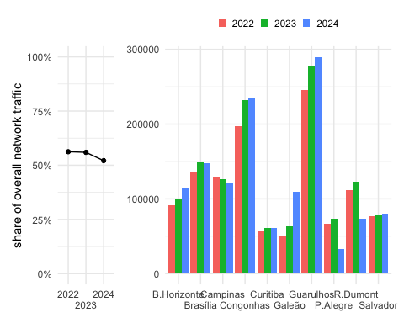

|  |
| --- |
| Figure 2.3: Europeaan airport level traffic |

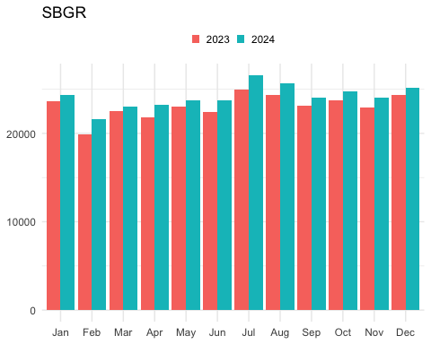

Analyzing the movement of the leading Brazilian airports, it is evident that they were not responsible for the return to 2019 levels, considering that only Campinas - SBKP and Santos Dumont - SBRJ slightly exceeded 2019 levels. This phenomenon can be explained by the greater difficulty of airlines in resuming activity in contrast to general/business aviation. This last share is an essential component of the Brazilian air movement but is a rare user of main airports.

|  |
| --- |
| Figure 2.4: Annual traffic at study airports in 2022 and variation 2022/2019 |

Figure 2.4 shows the annual change of the traffic served at the study airports in 2022 and the associated change of the traffic levels comparing 2022 and 2019.

With Campinas (SBKP) and Rio de Janeiro (SBRJ), there are two study airports in Brazil that serviced a higher level of traffic in 2022 than in 2019. Both airports are key nodes for the domestic traffic in Brazil. Salvador (SBSV) ranged at the pre-pandemic level. The other Brazilian airports have seen - on average - a decrease of 10-20% of traffic. This suggests that the observed network level increase in movements is distributed across the Brazilian network and not focussed on the airports covered in this study.

The European airport level traffic - on average - ranged at 20% below the pre-pandemic levels. Munich (EDDM) and Rome (LIRF) observed higher reductions. With an overall weaker recovery of the air traffic demand across Europe in 2022, a similar pattern emerged. The increased network level traffic (ranging about 10% under the pre-pandemic level) is distributed across the European network and other aerodrome connections.

## 2.3 Peak Day Traffic

While the annual traffic provides insights in the total air traffic volume and the associated demand, it does not provide insights on the upper bound of achievable daily movement numbers. The latter depends on demand, operational procedures and/or associated constraints, and the use of the runway system infrastructure. The peak day traffic is determined as the 99th percentile of the total number of daily movements (arrivals and departures). The measure represents thus an upper bound for comparison purposes.

## 2.4 Peak Day

THERE IS A LOT OF CODE AND WE WORK WITH INTERIM AND “FIX” FILES.

It is not transparent how these files / values are generated. On a first level, I could not fix it. What needs to be done:

* [] produce consistent daily traffic files in PBWG format for BRA and EUR
* [] rewrite functions to read the PBWG format and aggregate as desired
* [] if desired bind the BRA and EUR data set to build the graphics

== CLEAN UP CODE!

.years <- c(2023,2024)  
pk_day_plot(.years)

#| label: fig-peak-day  
#| fig-cap: Airport peak daily traffic (2024)  
#| message: false  
  
peak_day_pct_plot(2024)

**?@fig-peak-day** shows the peak day traffic in 2022 for the study airports with reference to the number of runways. A varied picture can be seen for Europe. For European with more than 2 runways it needs to be noted that the runway system does not support independent operations of all available runways. Thus, the serviced peak traffic is also impacted by the runway system configuration.

The measure signals the use of the available runway system.

#| label: fig-timeline-peak-day  
#| fig-cap: Evolution of peak-day traffic at study airports  
#| message: false  
  
timeline_peak_day(c(2019:2024))

The year-to-year change of the peak day traffic between 2019 and 2022 is shown in **?@fig-timeline-peak-day**. For the European study airports, Frankfurt (EDDF), Munich (EDDM), Paris (LFPG), and Rome (LIRF) experienced a higher drop of the daily peak traffic in comparison to 2019. Despite the not yet fully recovered demand situation at London Gatwick (EGKK) and Zurich (LSZH) showed a moderate reduction of the daily peak traffic in 2022. This suggest that airports with limited airport runway capacity managed

## 2.5 Fleet Mix

|  |
| --- |
| Figure 2.5: Fleet mix observed at the study airports in 2024 |

Figure 2.5 depicts the observed share of different wake turbulence categories (WTC) across the study airports in 2024. In both regions, “medium” aircraft types are the predominant aircraft type. The fleet mix - and in particular the separation requirements between the different aircraft types - is an important influencing factor for the capacity and observed (and achievable) throughput. In general, a larger proportions of heavy aircraft or aircraft with longer runway occupancy times may result in lower throughput due to the required larger wake turbulence separation or time spent on the runway. The locally defined capacity values may therefore differ based on the predominant fleet mix and operational characteristics, and ultimately result in different observed peak movement numbers or influence surface and terminal operations.

In Brazil, a significant number of “light” types operated in 2023. For example Salvador (SBSV) serviced about 20% of “light” types. The major hubs, i.e. São Paulo Guarulhos (SBGR), Rio de Janeiro Galeão (SBGL), and Campinas (SBKP) observed a share of 15-20% of “heavy” aircraft. These airports serve also as destinations for international long-haul flights.

With the exception of Zurich (LSZH), the share of “light” types is negligible at the European study airport in 2023. London Heathrow (EGLL), Paris Charles de Gaule (LFPG), and Frankfurt (EDDF) observed the highest shares of “heavy” types.

Within the European region - and its multitude of national hubs - a significant number of international long-haul flights is operated at the chosen study airports. In Brazil, the highlighted airports, Guarulhos (SBGR), Galeão (SBGL), and Campinas (SBKP), play a major role in terms of international connectivity. It follows that medium and light types are used predominantly for inter-reginal connections. Based on the selected study airports, the underlying decentralised structure of the European network becomes more visible. Due to the geo-political composition, airports serving capitals or representing a main national hub are more frequent in Europe. This is in contrast to Brazil, where the international and heavy air traffic appears more centralised at 2-3 pre-dominant hubs.

|  |
| --- |
| Figure 2.6: Fleet mix change over time observed at study airports |

On average, Figure 2.6 shows that the fleetmix remained fairly stable over the years. It is interesting to observe that the unprecedented decline in air transport during the pandemic phase did not substantially break this pattern. This suggests that the contraction of the traffic volume hit all segments at a similar rate [3].

## 2.6 Summary

This chapter described the overall evolution of air traffic in Brazil and Europe on the network and study airport level. Air traffic observed an unprecedented decline in both regions in response to COVID19. However, the recovery path in both regions differed. Overall, the Brazilian demand recovered substantially smoother than the European. As national governments varied in their assessments and introduction of public health measures, including travel restrictions, intra-European air connectivity observed several setbacks. On a network level, air traffic in Brazil exceeded the pre-pandemic level, whereas European traffic reaches about 5-10% below the pre-pandemic level.

In 2023, medium aircraft types were predominant in both regions across the studied airports. Brazil hosted proportionally more light aircraft, notably in Salvador (SBSV). At the same time, major hubs like São Paulo Guarulhos (SBGR) and Campinas (SBKP) handled substantial shares of heavy aircraft. Conversely, European airports, except Zurich (LSZH), had minimal shares of light types, with London Heathrow (EGLL), Paris Charles de Gaule (LFPG), and Frankfurt (EDDF) witnessing higher shares of heavy types. The European network demonstrated a decentralized structure with numerous international long-haul flights, while Brazil’s international and heavy air traffic was centralized in 3 primary hubs. Despite pandemic-induced declines in air transport, data suggests a stable fleet mix, indicating a consistent impact across traffic segments.

The overall air traffic demand situation is a key driver for the performance of air navigation services. The observed differences may impact - inter alia - separation and synchronisation of air traffic, and influence the observed performance reported in the other chapters of this report.

# 3. Predictability

The preceding sections have demonstrated that both systems exhibit unique reactions to the broader developments in air transport. Predictability plays a crucial role in these systems, impacting their functioning during both the strategic phase, where airline schedules are formulated, and the operational phase, where Air Navigation Service Providers (ANSPs) and stakeholders manage the delicate balance between demand and capacity. Enhanced predictability stands to be advantageous for ANSPs, mainly when serving airspace users, as it contributes to highly efficient operations, even during periods of peak demand. This chapter focuses on arrival and departure punctuality as crucial predictability indicators.

## 3.1 Arrival Punctuality

|  |  |
| --- | --- |
| |  | | --- | | (a) Arrival punctuality 2023 | |

Figure 3.1: Evolution of arrival punctuality at study airports (2023 vs 2024)

Figure 3.1 shows the evolution of arrival punctuality for the select airports in Brazil and Europe. When comparing both regions in 2019 and 2022, Brazil’s share of early arrivals (earlier than 15 minutes before the scheduled arrival) is significantly higher than the same European portion. The share of early arrivals accounts for 20-25% across all Brazilian airports. In Europe, flights tend not to arrive significantly earlier than their scheduled time. On average, early arrival range between 8-15% in Europe in 2019. Recent studies conducted by the CGNA/DECEA show that air operators in Brazil declare flight times significantly longer than observed. Similar behaviour is also observed in Europe. Built in buffer times help to achieve a high “on-time-performance” record and appeal to passengers favouring a timely arrival performance. Furthermore, both regions have regulations for passenger compensation in place which are triggered in the case of arrival delays. DECEA has already established a forum with the air operator regulator to discuss and propose solutions.

|  |
| --- |
| Figure 3.2: Evolution of arrival punctuality window |

|  |  |
| --- | --- |
|  | speak about truncated axes |

|  |
| --- |
| Figure 3.3: Evolution of arrival punctuality window by month |

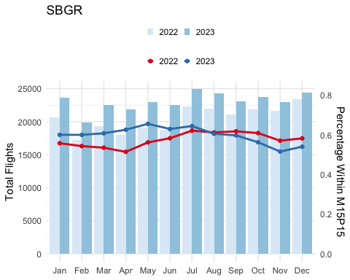

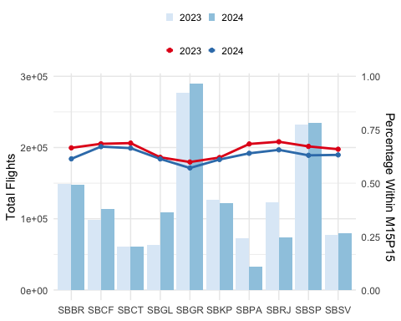

European airports saw their share of punctual flights in 2022 decrease broadly compared to 2019, even with a more proportional distribution than the Brazilian system. For European operators, there were two primary factors contributing the the lower performance in 2022. The most significant is the cumulative effect, showing that the network of flights has little ability to absorb the delay of one specific delayed flight. The knock-on effect was amplified by the local resource constraints in terms of passenger and turn-around facilitation. The incrasing traffic demand posed challenges at many airports in Europe. Delayed arrivals accumulated further reactionary delay and ultimately passed the delay systematically on to next flights. Further constraints were linked to air space and flow restrictions resulting from the geo-political conflict surrounding the Russian invasion in Ukraine. On average, arrival delays of 15 minutes or more compared to the schedule ranged between 25-35% across the Europen study airports in 2022.

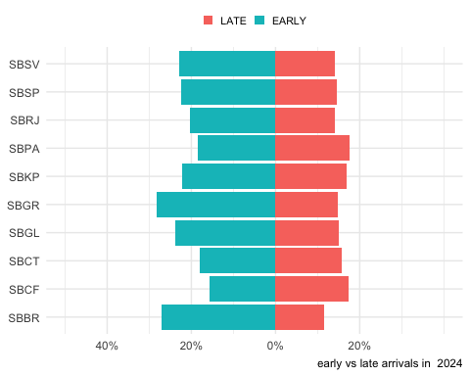

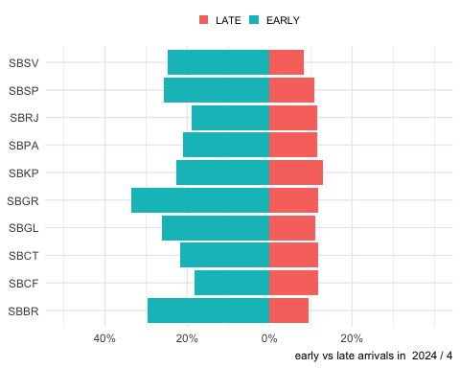

|  |
| --- |
| Figure 3.4: Change of share of early and late arrivals (2019 vs 2022) |

Figure 3.4 compares the share of early and late arrivals at each study airport in 2019 and 2022. From a high-level perspective, air traffic tends to arrive well ahead of schedule in Brazil, while Europe observes a higher share of delayed arrivals. Guarulhos (SBGR) remained the Brazilian airport with the highest share of early flights in 2022 (i.e. 33%), followed by Campinas (SBKP) with 30%. Both airports are essential hubs in the country, and anticipation can be a consequence sought by air operators for better accommodation of the flight network. However, for flow control, this lack of precision is equally problematic, affecting the optimal allocation of resources for the provision of air traffic control and flow service. In turn, Madrid (LEMD) was the European element with the most significant share of early arrivals (i.e. 22%) in 2022. Pre-pandemic such a share was observed at London Heathrow in 2019. These shares still range about 11% lower than the highest shares in Brazil. The distorted nature of the European network in 2022 becomes apparent when observing the share of delayed flights. For example services at London Gatwick (EGKK) faced a share of 39% of delayed flights. Airport operators were identified as the major contributors to primary delays (ground handling, staff shortage), followed by ATFM delays. However, the aforementioned reactionary effect was the main driver of knock-on delays (EUROCONTROL Central Office of Delay Analysis 2023) [4].

## 3.2 Departure Punctuality

|  |  |
| --- | --- |
| |  | | --- | | (a) Departure punctuality 2023 | |

Figure 3.5: Evolution of departure punctuality at study airports (2023 vs 2024)

|  |
| --- |
| Figure 3.6: Evolution of departure punctuality window |

|  |
| --- |
| Figure 3.7: Evolution of arrival punctuality window by month |

The preceding section highlighted how the general traffic conditions in the previous years influenced the dependability of arrival schedules. In this section, we assess the degree of departure punctuality measured as the difference between the scheduled (i.e. planned) departure versus the observed actual off-block time. Figure 3.5 shows the overall departure punctuality at Brazilian and European airports in 2019 compared to 2022. Despite traffic levels in 2022 still ranging below their 2019 pre-pandemic levels, the departure punctuality in 2022 was - on average - lower than before COVID.

The difference in departure and arrival punctuality between 2022 and 2019 was significantly more pronounced for Europe indicating an increased strain on the turnaround processes. There has been a significant increase in poor performance days, with departure punctuality falling below 50% and arrival punctuality dropping below 60%, occurring more frequently than in 2019. On the Brazilian side, the Galeão airport (SBGL) observed the highest share of delayed departure flights. It should be noted that the SBGL is the only airport with the Apron Control service directly provided by the airport. Some inefficiency in the coordination between Tower and Apron or divergence at the indicator collection point for the location may be contributing to the observed performance.

Departure punctuality appeared slightly higher in Brazil in 2022 in comparison to 2019 and outperforms the punctuality levels observed in Europe. It is also notworthy, that in Brazil there is a higher share of flights blocking off between 15 to 5 minutes before their scheduled time. Further research may help to clarify the factors driving this phenomenon.

|  |
| --- |
| Figure 3.8: Change of share of early and late departures (2023 vs 2024) |

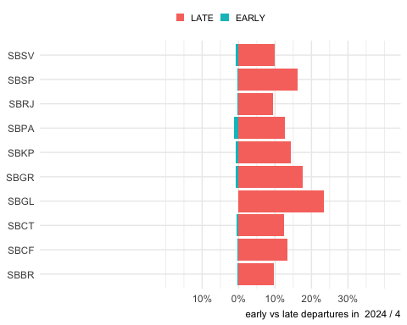

The change of the share of early and late departures in 2019 and 2022 is shown in Figure 3.8. This presentation highlights the earlier observations. On average, European airports observed a higher share of delayed departures by a factor of 2-3 in comparison to Brazil. While the picture varies, the distored nature of the traffic in 2022 is visible in the higher share of delay departures in 2022 in Europe in comparison to the pre-pandemic levels in 2019. This put a strain on the schedule stability across Europe. Local issues (e.g. reduced facilication capacity at airports) affected air traffic services in terms of surface movement, but also rippled into the network affecting the sequencing of arrivals and departure traffic.

## 3.3 Summary

Arrival and departure punctuality play an important role in terms of balancing demand and capacity. Strong distortions of the schedule will ultimately ripple down into reactionary delay and require a higher effort for both the arrival flow and surface movement control. Turnaround distortions affect therefore the planning accuracy of air navigation services and may lead to unwanted side-effects (e.g. longer sequencing and holding in the terminal airspace, passenger inconvenience due to longer taxi-times/blocked gates).

Distinct patterns were observed in both regions that cannot only be explained by the level of traffic recovery. On average, a higher share of flights arrives well ahead of schedule in Brazil. This pattern is largely unchanged when comparing 2019 and 2022. The ripple effect of the low preparedness level of European airports to address the returning traffic in 2022 is well documented. This yielded a significant low performance in terms of departure punctuality exceeding levels observed in Brazil by a factor of 2-3. Distortions of the local schedule can have knock-on effects on the air navigation service provision, both in terms of surface movement and arrival sequencing. More research is needed to investigate and understand the underlying drivers and to what extent regional connectivity influences the observed patterns.

# 4. dumping lot

This is text we should add to chapter 4.

hhhhhhh bhhhh nnnnnn

# 5. Next chapter

This placeholder chapter is used to practice the git workflow.

As a reminder: we can always toggle between the docs folder that is used to serve the site and the **internal** (local testing) by switching the output-dir in _quarto.yml to _books.

We can mock around with it without impacting the exising material.

The workflow will be to update chapter by chapter - and use this for experimental purposes. In the end we simply delete / remove this file.

Just some new text and cool add ons.

next edit

# References

EUROCONTROL. 2019. “Eurocontrol Specification for Operational ANS Performance Monitoring - Airport Operator Data Flow.” <https://www.eurocontrol.int/publication/eurocontrol-specification-operational-ans-performance-monitoring>.

EUROCONTROL Central Office of Delay Analysis. 2023. “All-Causes Delays to Air Transport in Europe, Annual 2022.” <https://www.eurocontrol.int/publication/all-causes-delays-air-transport-europe-annual-2022>.

1. The Performance Benchmarking Working Group (PBWG) comprises participants from Brazil (DECEA), China (CAA-OSC), Japan (JCAB), Singapore (CAA), Thailand (AEROTHAI), United States (FAA-ATO), and EUROCONTROL.
2. Enhanced Traffic Flow Management System
3. It must be noted that conceptually, the number of aircraft remained unchanged in the both regions. The higher utilisation of “heavy” aircraft for logistical support appeared to have offset the lower number international / long-haul passenger flights. For the first six month of 2023, this pattern is continued
4. See CODA report at https://www.eurocontrol.int/publication/all-causes-delays-air-transport-europe-annual-2022.