Tema 4 Computer Vision Cutic Eugen

# Experimente

Efectuate cu parametrii default, cu exceptia celor mentionati.

1. Cel mai bun rezultat (avg. precision) – Obtinut pentru threshold = 2, dar rezulta in multe false pozitives/image:

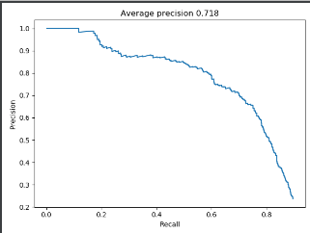

1. Threshold = 4 – avg. precision mai mic, mai putine false pozitives:

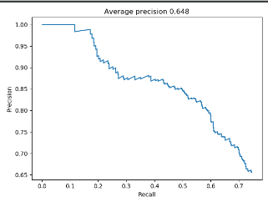

1. Threshold = 2; Scaling_ratio = 0.7

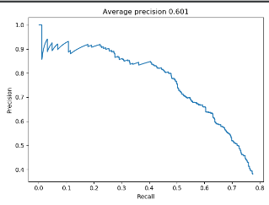

# Vizualizari

