SkyRun Customer Analysis: Findings & Recommendations
Oct 31, 2026 · @AMDARI

Executive summary
SkyRun earned 1.01 billion in revenue from 4,339 identified customers between 1 Dec 2024 and 9 Dec 2025, but 788 customers (18%) drove 58% of it. Only about 20% of new customers buy again in the month after joining, although 66% eventually place a second order, so growth depends on a small loyal core and a steady flow of new buyers.

Headline findings
- Revenue rose 2.6 times in the autumn: from about 64M a month (December to August average) to 165M in November 2025. September to November brought in 393M, 40% of the 12-month total.
- The 788 Champions and 1,216 Cooling Regulars together bring in 86% of revenue. 1,487 customers (34%) are Lapsed One-Timers, averaging 189 days since their last order, and bring in only 7%.
- 34% of customers have bought only once. Only 18% place a second order within 30 days, and the typical second order comes 71 days after the first.
- New customers keep 15-22% in the month after joining (January to August 2025 groups). The September and October groups started stronger (23-24%).

Top recommendations
- Protect the Champions with account management and loyalty perks.
- Win back Cooling Regulars after 75–100 days of silence, before they are lost.
- Run a second-purchase programme for new customers within 14–45 days of their first order.
- Plan stock, staffing and marketing around the September to November peak.

Background and data
This analysis set out to find out how well SkyRun keeps its customers, who its most valuable customers are, and where revenue is at risk. SkyRun wins many new customers, but retention has declined and too few customers come back to buy again. The work covers retention by acquisition month, where customers drop off, customer segments and customer value, and ends with recommendations.
Item | Value
Source file | Skyrun_dataset.csv (transaction lines)
Period covered | 1 Dec 2024 – 9 Dec 2025
Raw rows | 541,909
Rows kept for analysis | 397,924 (143,985 removed: 9,291 cancellations/adjustments and 134,694 rows with no CustomerID)
Unique customers | 4,339
Invoices (orders) | 18,536
Products (stock codes) | 9,000
Product categories | 10
Countries on order lines | 28
Total revenue (identified customers) | 1,015M
Average order value | 54,739 per invoice

Invoices starting with C or A are cancellations or adjustments and were removed. No rows had a zero or negative quantity or unit price, and there were no duplicate rows. Revenue was calculated as quantity × unit price. The data does not state a currency, so amounts are shown in the file's own units (M = million, K = thousand).

Methodology
The analysis used three methods, all in Python (pandas, scikit-learn, seaborn and matplotlib).
- Exploratory analysis: revenue by month, by country and by product category.
- Cohort retention: each customer was assigned to the month of their first purchase. Retention is the share of that group that bought again in each later month. Only complete months (December 2024 to November 2025) are used.
- RFM segmentation: for each customer the analysis measured:
- Recency: days since the last purchase, counted from 10 Dec 2025
- Frequency: number of orders
- Monetary: total revenue
The three measures were log-transformed, standardised and grouped with K-Means into 4 clusters. The number of clusters was chosen with the elbow method and silhouette scores (k = 2–8) and by whether each group calls for a different action. Each cluster was then named from its average profile. A customer is called lost if they have not ordered for more than 102 days, which is longer than nine in ten of the normal gaps between a customer's orders.

Key findings

1. Revenue is concentrated in the autumn
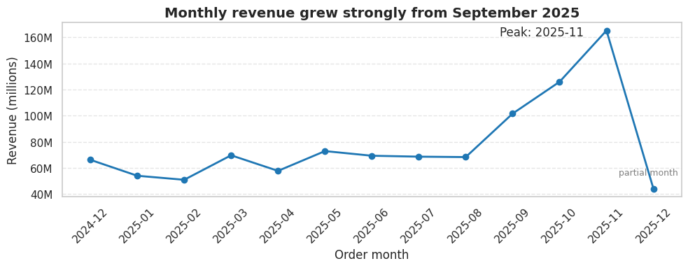
SkyRun_Retention_Analysis.ipynb · revenue = quantity × unit price, identified customers only, cancellations removed, Dec 2024 – 9 Dec 2025
Revenue held at 51–73M a month from December to August, then rose to 165M in November. September to November brought in 393M, 40% of the 12-month total. The number of active customers rose from 935 in August to 1,665 in November, and the average order value rose about 21% (from about 51K to 62K), so the peak comes mostly from more buyers and partly from bigger orders.
Revenue is spread almost evenly across the 10 product categories (each earns 100–102M) and across the 28 countries recorded on order lines (each earns 35–37M). Neither category nor country explains the differences in customer value; customer behaviour does.

2. A few customers drive a large share of revenue
Customers were grouped into four segments by how recently, how often and how much they buy. The top 20% of customers account for 66% of revenue.
Segment | Customers | Share of customers | Avg days since last order | Avg orders | Avg spend per customer | Share of revenue
Champions | 788 | 18% | 12 | 13 | 741K | 58%
Cooling Regulars | 1,216 | 28% | 77 | 3.8 | 234K | 28%
New & Promising | 848 | 20% | 20 | 2.1 | 93K | 8%
Lapsed One-Timers | 1,487 | 34% | 189 | 1.3 | 45K | 7%

- Champions (788 customers) place about 13 orders each and last bought 12 days ago on average. Almost none are lost (0.1%). Each is worth about 741K, roughly 17 times a Lapsed One-Timer.
- Cooling Regulars (1,216) are the group to rescue: 3.8 orders each, but the last order was about 77 days ago, close to the 102-day line for "lost". 23% have already crossed it. Moving them back toward Champion behaviour is the largest growth opportunity.
- New & Promising (848) are recent customers (about 20 days since their last order) with around 2 orders. They bring 8% of revenue today and become Champions if they reach a third order.
- Lapsed One-Timers (1,487) have bought about once (1.3 orders) and have been silent for about 189 days; 72% are lost. They are 34% of customers but only 7% of revenue.
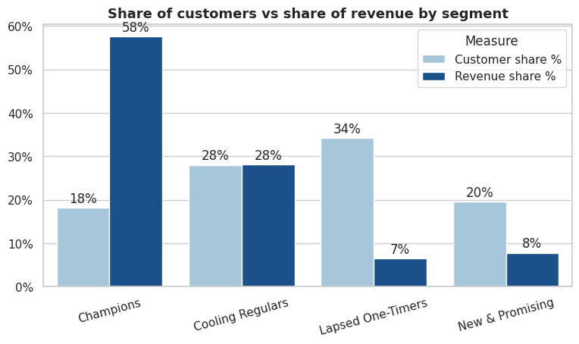
Share of customers compared with share of revenue for each segment. SkyRun_Retention_Analysis.ipynb
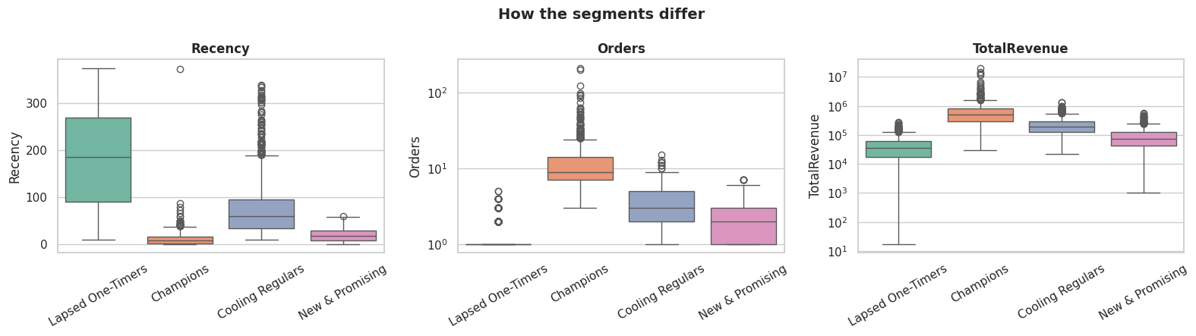
How the segments differ. Each box shows the middle half of the customers in a segment. Recency is days since the last order (lower is better); orders and spend are on a log scale. SkyRun_Retention_Analysis.ipynb

3. Most customers do not come back in the month after their first order
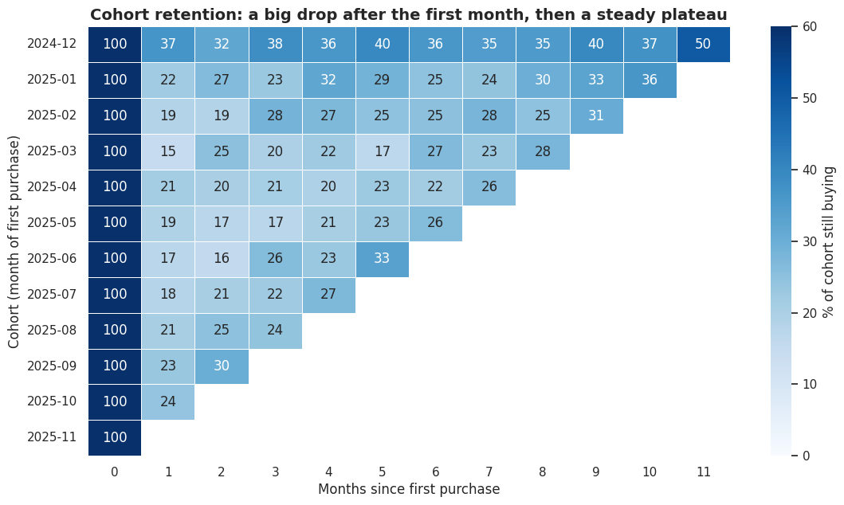
SkyRun_Retention_Analysis.ipynb · identified customers only, cancellations removed, Dec 2024 – 9 Dec 2025; December 2025 excluded (9 days only)
- On average, 20% of customers who joined in 2025 bought again in the month after joining. The lowest was March (15%) and the highest was October (24%).
- The December 2024 group (885 customers) looks the most loyal (32–50% buy again each month), but only because the data starts that month, so it includes existing customers. It is not a true new-customer group.
- Groups from January to August 2025 keep 15–36% of customers in any later month. Their highest values fall in September to November for every group; this is the autumn surge, not growing loyalty.
- The September and October 2025 groups started stronger (23–24% in month 1; 30% for September in month 2), which suggests autumn brought in better-quality customers.
- December 2025 covers only 9 days, so it is left out of the heatmap. It would show a false drop in the last column.

4. The second order is the critical moment
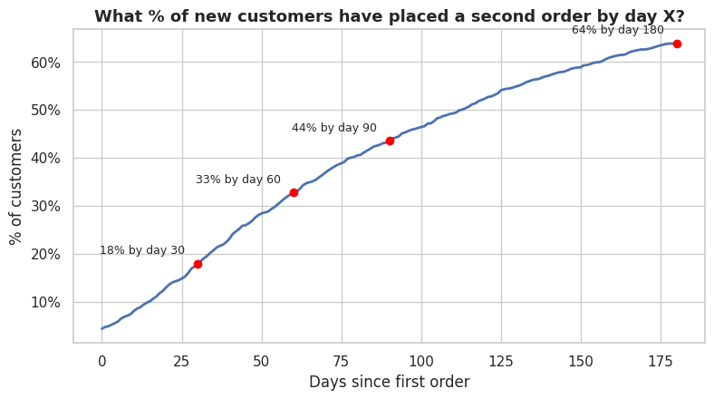
Based on 1,945 customers whose first order was between 1 Jan and 13 Jun 2025, so each had at least 180 days to return.
- 34% of customers never place a second order. Only 18% do so within 30 days, 33% within 60 days and 64% within 180 days. The typical second order comes 71 days after the first.
- Customers get stickier the more they buy: 66% go on to a second order, 71% of those go on to a third and 75% of those go on to a fourth.
- The more orders a customer has placed, the less likely they are to be lost: 55% of one-order customers, 31% with 2–3 orders, 13% with 4–6 orders and 2% with 7 or more.

Recommendations
The recommendations are ranked by revenue at stake. Owners and targets are suggestions to agree with the team. Test each action on a small group, and compare it with a similar group that does not receive it, before rolling it out.
# | Recommendation | Segment | Why | KPI | Owner | Target
1 | Assign a named account manager, early access and rewards | Champions (788) | 58% of revenue; each worth about 741K | Share of Champions lost | CRM / Account management | Keep below 1% (now 0.1%)
2 | Send a win-back message when a regular has been silent for 75–100 days | Cooling Regulars (1,216) | 28% of revenue; 77 days since last order; 23% already lost | Share lost; reactivation rate | CRM / Marketing | Lost share 23% → 15%
3 | Send a second-purchase offer 14–45 days after the first order | All new customers | 34% never reorder; only 18% reorder within 30 days | Second order within 60 days; next-month return rate | Marketing / CRM | 33% → 38%; 20% → 25%
4 | Use bundles and recommendations to reach a third order | New & Promising (848) | 71% of 2-order customers go on to a third | 2-order customers placing a third | Marketing / Merchandising | 71% → 75%+
5 | Plan stock, staffing and ad spend around Sep–Nov; aim for better-quality customers at the peak | All | 40% of 12-month revenue arrives in 3 months | Autumn next-month return rate; stock availability | Operations / Marketing | Return rate 24% or above
6 | Send low-cost automated reminders only; avoid heavy discounts | Lapsed One-Timers (1,487) | 34% of customers, 7% of revenue; 72% lost | Cost per reactivated customer | Marketing | Cost below one order's value
7 | Capture a customer ID on every order (account, phone or loyalty number) | All | 25% of rows have no CustomerID, so those buyers cannot be tracked | Rows with a CustomerID | Data / Engineering | 75% → 95%

Limitations and next steps

Limitations
- Missing customer IDs: 25% of transaction rows had no CustomerID and were left out. Revenue totals in this report cover identified customers only.
- Partial final month: December 2025 covers only 1–9 Dec. It is labelled as a partial month in the revenue chart and left out of the retention analysis.
- First month of data: the December 2024 group includes existing customers, so it is not a true new-customer group.
- Segment names: the names are labels based on average behaviour. The groups overlap at the edges (separation score 0.31), so review the names with the business.
- Clustering choices: K-Means is sensitive to extreme values, which taking logs first reduces. A two-group split scored higher statistically (0.41) but only separates active from lapsed customers, so four groups were used.
- Even spread: countries and categories are almost evenly distributed, so they give little segmentation signal. Country also changes within a single order, so it cannot describe a customer, and the countries shown differ from the US and UK markets in the project brief.
- Test-like data: retention does not fall after the first month as it usually does in real data, so small ups and downs should not be over-read. Twelve months of data cannot confirm the 18-month decline mentioned in the brief.
- No cost data: acquisition cost and profit per customer could not be calculated.

Next steps
- Share this report with the team and agree owners and targets for each recommendation.
- Run the first three actions as small trials with comparison groups.
- Re-run the notebook on live data and replace the figures in this report.
- Add marketing cost and margin data to calculate acquisition cost and customer lifetime value.
- Track the KPIs in the recommendations table every month.

