# Forest resources of the Baikal region: vegetation dynamics under anthropogenic use

*Anastasia K. Popova (1), Evgeny A. Cherkasin (1), Igor N. Vladimirov (2)*

(1) Matrosov Institute for System Dynamics and Control Theory SB RAS, Irkutsk, Russia

(2) V.B. Sochava Institute of Geography SB RAS, Irkutsk, Russia

## Abstract

We review the theoretical and applications-specific issues of modeling a temporal and spatial dynamics of forest ecosystems, based on the principles of investigating dynamical models. The model used takes into account various factors affecting the change in forest areas - fires, forest diseases, cutting, urban expansion, etc. Calculation of numerous scenarios for the use of forest resources makes it possible to see the consequences of various managerial decisions. The user can adjust the parameters of the main cutting volume, fires and tree planting. We present the results of a computer modeling and predictive mapping for the regional model under anthropogenic use of the forest resource dynamics.

## Introduction

Ecological forecasting and modeling are important tools in studying the dynamics of forest resources. A correct evaluation of the parameters of vegetation change makes it possible to build models that are closest to reality. Information systems which interact with forest management modeling systems and take into account anthropogenic use provide management decision making. Calculating effects of implementing various managerial decision helps to evaluate the development of forests, depending on the conditions of each scenario.

There are a number of papers devoted to the study of the influence of anthropogenic factors on the dynamics of forest resources. Mladenoff and Scheller used models to evaluate the complex effects of climate change, harvest, wind, species migration on the dynamics of regional forests in northern Wisconsin [1]. Abood, Lee et al investigated the contribution of logging and mining, palm oil harvesting on forest losses in Indonesia [2]. Popradit et al analyzed the effects of settlement expansion on the area and species diversity of tropical forest trees [4]. Musi et al studied the impact of agricultural development on forest land reduction on the example of Central Java [5]. Wu et al integrated land use change models based on CA-Markov and forest landscape model LANDIS-II to simulate dynamic of the forest landscape in response to the disturbances of land use change and harvest in the Taihe district, China [3].

This study is a continuation of the work done by authors [15-17]. We have created a software tool designed to automate decision support for the use of forest resources in the Irkutsk region of the Russian Federation. The developed program consists of a set of subsystems, including a geoinformation system (GIS) used to display spatially-distributed information, a mathematical modeling block and an interface with the function for forming various scenarios of forest dynamics. In the work, Model "Dynamics of stands" was used, which has been designed to calculate by age classes over vast areas, taking into account economic development of the territory.

In this work, an analysis of various scenarios for the quantitative assessment of the influence of a number of factors on the change of forest areas in the Irkutsk region has been carried out. The objectives of the study is to: 1) confirm the adequacy of chosen model by comparing the calculated scenarios of development of resources with real data; 2) modeling the dependence of the dynamics of forest resources on different types of anthropogenic factors; and 3) quantitative assessment of the impact of changes in anthropogenic factors on forest dynamics. The quantitative assessment is designed to make a regional strategy for the use of forest resources.

## Materials and Methods

### Study Area

This study was carried out in Irkutsk region of the Russian Federation. The region is located in the center of Eurasia, in Eastern Siberia at coordinates 51°18'– 64°15' N, 95°38 '– 119°10' E and occupies 774846 km2. Two thirds of the area is covered with forests. Pale conifers predominate - pine and larch. Also in the territory grow dark coniferous - spruce, fir and cedar - and deciduous trees - birch, aspen.

### Mathematical model

The model "Dynamics of stands" is based on the works of A.K. Cherkashin [12-14], taking into account the studies of Shifley, He [6], Shugart [7, 8], Wu [11], Horn [9], Mladenoff [10]. The dynamics is described by a system of differential equations. Land areas of different types are made on the modeled territory: non-forested, uncovered by forest, young, middle-aged, maturing, mature and over-mature. Non-forest area is an area where forests cannot grow. It includes ​​settlement, road, and deposit areas. The surface of Non-forested areas is not covered by trees temporarily. It’s an area after the fire, cutting, damage by insects and weather conditions. The dynamics of each section is described by formulas as follows (1):

(1)

where *aij* are the coefficients of transition from one category of land or age group to the next;

*SN* is the non-forest area;

*S0* is an area that is uncovered by forest;

*Si* is forest areas of different classes of age;

*unon i* defines annual increase in non-forest area at the expense of other categories of land;

*uncov i* defines increase in the area uncovered by forest;

*ucut i* defines the area of cutting, is subtracted only from the category of mature and over-mature forests, in other classes of age cutting is not carried out.

The annual decrease in the volume of forest resources is due to the impact of natural adverse factors and anthropogenic use. There are a number of permitted uses for forest resources of the Irkutsk region:

* cutting;
* agriculture;
* recreational activity;
* development of mineral deposits, work on geological study of mineral resources;
* construction and operation of linear objects;
* building and operation of reservoirs and other hydraulic structures;
* processing of wood and other forest resources.

Harvesting of wood is carried out in operational forests. It includes clear and selective cutting of mature and overmature plantations, clear and selective sanitary cutting, care, and other cutting. The [annual allowable cut](http://context.reverso.net/%D0%BF%D0%B5%D1%80%D0%B5%D0%B2%D0%BE%D0%B4/%D0%B0%D0%BD%D0%B3%D0%BB%D0%B8%D0%B9%D1%81%D0%BA%D0%B8%D0%B9-%D1%80%D1%83%D1%81%D1%81%D0%BA%D0%B8%D0%B9/annual+allowable+cut)  for forestry in the Irkutsk region is 71.5 million m³. At the same time, the actual volumes of cutting allow us to reach the estimates only by 40%.

The area of ​​forest areas used for cultural and recreational purposes is increasing for the development of tourism. Recreational activity is being carried on in the Baikal region with access to Lake Baikal, infrastructure and unique natural objects are being developed on its territory.

The exploitation areas of forests are involved in the mining and subsoil exploration, and a part of the reserve forests is transferred to operational ones. Construction and maintenance of hydraulic structures is carried out on the territory of that forestry, where modern wood processing enterprises are being created.

Therefore, the increase in non-forest area in the process of forest exploitation is as follows:

, (2)

where *kN* is the area of settlements per person, the remaining coefficients characterize the increase of forest population, *∆N*, agricultural area, *∆S ,* recreational zones, *∆R,* area of fields, *∆G*, construction of linear objects, *∆Bl, and* maintenance of hydraulic structures, *∆Bv*.

The transition of other categories of land to non-forest ones is done at random, depending on the needs of production. On this basis, the distribution of *unon* for the remaining categories of land is assumed to be proportional to the current area of each region:

(3)

Summation is made for all breeds and classes of age, including uncovered forest areas.

Annually forests are exposed to a set of adverse factors. The weakening and destruction of forest plantations in the Irkutsk region is affected by:

* fires;
* forest diseases;
* damage by insects;
* adverse weather conditions;
* other anthropogenic and non-pathogenic factors.

The fires (43.7%), forest diseases (25.2%) and insect damage (16.2%) are the most important factors for drying up and destruction of forest resources, so these factors should be taken into account in the model:

(4)

The distribution of *uncov* by categories of land considered to be similar to the previous one:

(5)

The pyrogenic factor is the main reason for the weakening of plantations and death of forests. The calculations take into account only the area of forest resources with the lost stability, not including all the lands passed by fires.

Damage by insects causes shrinking and weakening of trees, a decrease in growth, causing unsatisfactory condition of forest resources. The calculations also take into account only plantations with lost resistance were included, not including all disturbances.

### Software

The complex software system is implemented in the Java programming language. The calculation block loads the initial data for modeling from Microsoft Excel tables. They provide information on the forestry: the distribution of areas by land categories and classes of age, the volume of cutting, stocks, forest plantation areas, the number of people living, the values ​​of the parameters of anthropogenic use and natural factors. The indicator of the population increases every year by a certain amount of annual population growth defined in a model scanario. The values ​​of the parameters of anthropogenic use and natural factors for each forest area are considered constant throughout the simulation period.

After starting the program, the user sets the input values ​​– a forecasting interval and the step size. A numerical solution of the system of differential equations is performed by Runge-Kutta method of the fourth order. The combination of parameters – the volume of cutting, forest plantations and the impact of adverse conditions – is set as a percentage of the currently available values and forms a resource management scenario.

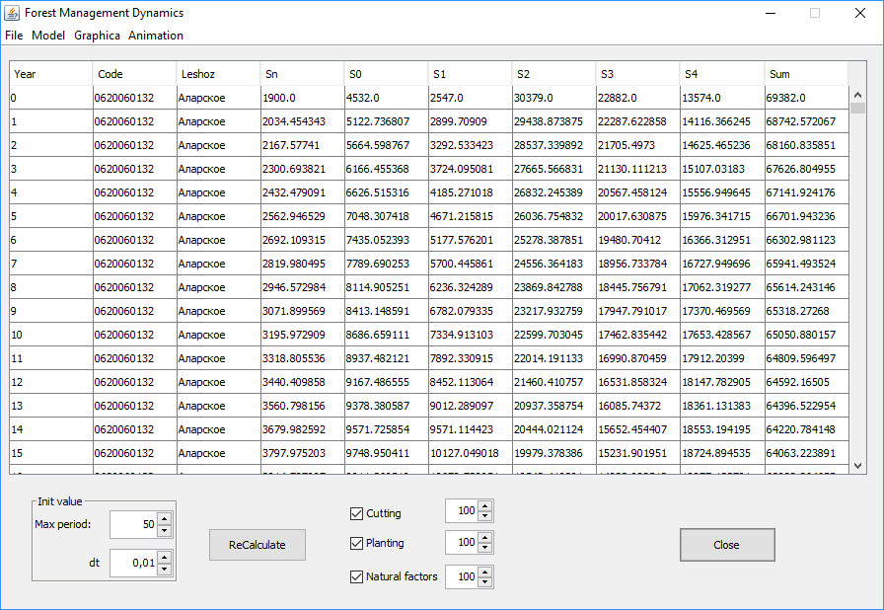

Figure 1. Interface of program

The output of the simulation is presented in a tabular form for the forest areas, years and age categories. The resulting tables are saved to a CSV file by user request. Freely distributed JFreeChart library is used for the graph construction. It displays curves of area changes for ​​each age category with a different color on the same figure. To obtain the totals, the indicators of the same type are preliminarily summed up for all the forest districts, giving the final value throughout the Irkutsk region.

The GIS subsystem builds maps based on SHP cartographic material using free OpenMap library. Each forest area is painted with a certain color, depending on the size of the selected parameter. In the resulting coloring, a lighter color corresponds to a smaller value of the parameter, a darker one to a larger value.

To create a map, the user selects the category of lands to display, the estimated data for this category is divided into five groups, and each forestry department is assigned the corresponding coloring value as a result. Relative values ​​are taken to determine ranges: the ratio of the difference in the current area of ​​the selected category of land and its initial value to the total area of ​​the forest area. The finished map is saved as a JPEG image by user request.

### Verification of the model

Verification of the adequacy of the model and the transition coefficients is done on the base of forestry input data of Irkutsk region for 1973. Input includes the distribution of forest areas by age categories, volumes of cuttings, fires and forest plantations on the territory of 53 forest districts. Computations for the model were conducted for a interval of 45 years. The final results of the simulation were compared with the available data on forest areas for 2017, obtained from the official «Forest Plan of the Irkutsk Region».

It was taken into account that in 2008 the Ust-Ordynsky Buryat Autonomous Area with the area of ​​22,138 thousand km2 was united with the Irkutsk region. Forest districts placed on its territory were not included in the final results for 2017. The total areas of different age categories for all forestry were calculated for comparison.

Figure 2. Chart of comparison of calculated and real data

As can be seen from Table 1, the dynamics of areas change of different categories according to real and calculated data is the same. Non-forest areas and covered with mature and over-mature forest plantations have slightly decreased; uncovered, the area of ​​young, middle-aged and maturing are increased. The difference between statistical and forecast data is due to the lack of accurate information on fires and the volume of all cutting over a period of 45 years. Some areas of Irkutsk region are difficult to access or inaccessible, hence, a regular forest pathological examination is difficult there.

Table 1. Comparison of real and calculated data

|  |  |  |  |  |
| --- | --- | --- | --- | --- |
| **Area type** | **Actual data, years** | | **Simulation** | **Error, %** |
| **1973-1985** | **2017** |
| Non-forested | 5108,223 | 4670,194 | 4401,66 | 5,75 |
| Uncovered | 3273,893 | 3032,455 | 3166,37 | 4,42 |
| Young | 12161,067 | 12847,546 | 12544,61 | 2,36 |
| Middle-aged | 12648,814 | 13411,571 | 13137,08 | 2,05 |
| Maturing | 5783,593 | 6170,173 | 6215,15 | 0,73 |
| Mature and overmature | 24444,429 | 24128,406 | 24089,60 | 0,16 |

In the last column of Table 1 is the calculated relative error of the forecating . The formula of the error is as follows:

,

where *Scalc*  is simulation data, *Strue* is actual data.

The relative error should not exceed 10% for the model to be considered valid. In "Dynamics of stands" the average error was 2.58%, therefore this model can be used for predictive simulation and assessment of the trends of the general dynamics of forest resources under influence of various management decisions.

## Results and discussion

Six different scenarios were сомзгеув to estimate the dynamics of the forest resources of Irkutsk region for 200 year interval. Forecasts were based on the data for 2017 by categories of land and age classes of forest resources of all 37 forestries in the territory of the Irkutsk region. Units of measure are total areas in thousand hectares in all forest districts.

Six scenarios are considered:

1) Current levels of cutting, tree planting and the influence of adverse factors.

2) Reducing the influence of adverse factors by 2 times.

3) Increase in the volume of tree planting by 2.5 times.

4) Decrease of cuttings by 2 times.

5) Increase of cuttings by 3 times.

6) Increase cuttings by 2.5 times, planting by 1.5 times.

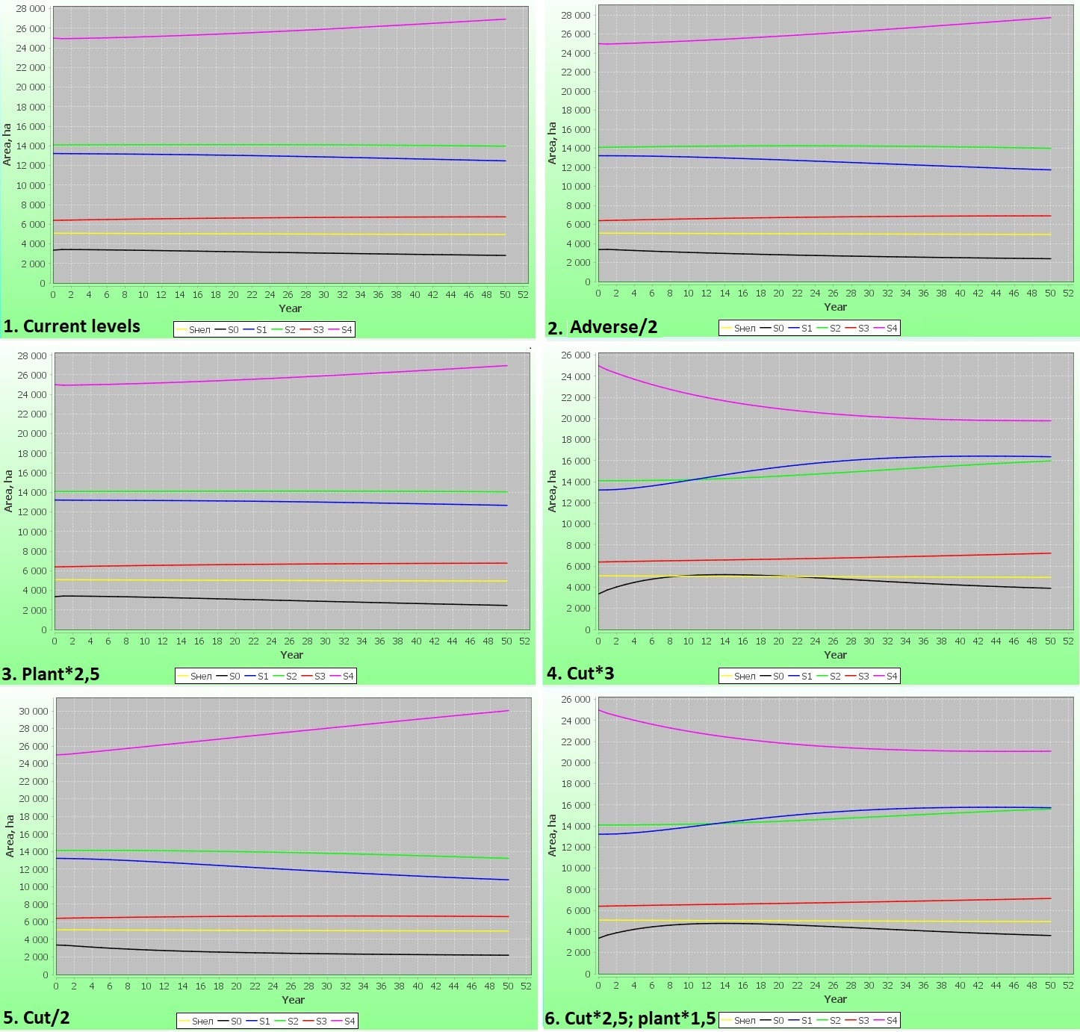

Figure 3. Six scenarios of dynamics of forest resources

The results show that at the current levels of natural and anthropogenic impact in the long run the areas of mature and over-mature forests grow confidently with a slight decrease in young growth. In the second scenario, we observe a sharp increase in mature and over-mature forests with a slower decline in young growth and uncovered by forest land. The dynamics of forests in the third scenario is similar to the first one.

In the fourth scenario, there is a remarkable decrease in the level of mature and over-mature forests during the first 50 years with an increase in the areas of younger age categories. No-covered аreas increase for 15 years, then gradually begin to decline. In the fifth scenario, sharp growth of mature and over-mature forests was noted with a slight decrease in younger age categories. In the latter scenario, stocks of mature and over-matured declines over the first 35 years, then remain at the same level.

The simulation results are shown on the map of the Irkutsk region, as a measure taken the difference between the forest area for all categories of age at the end and the beginning of the simulation interval. In Figure 4, colors 1-2 correspond to negative values ​​relative to the initial values, it is a decrease, color 3 is minor fluctuations, colors 4-5 is positive values, i.e. their area increases. It can be seen that forest areas located in the central part of the region are most affected by anthropogenic influence. In large forest areas in the north and east of the regionremain almost at the same level, regardless of the scenario of their use. It is due to their low transport accessibility,

Figure 4. Simulated land use maps generated under six scenarios

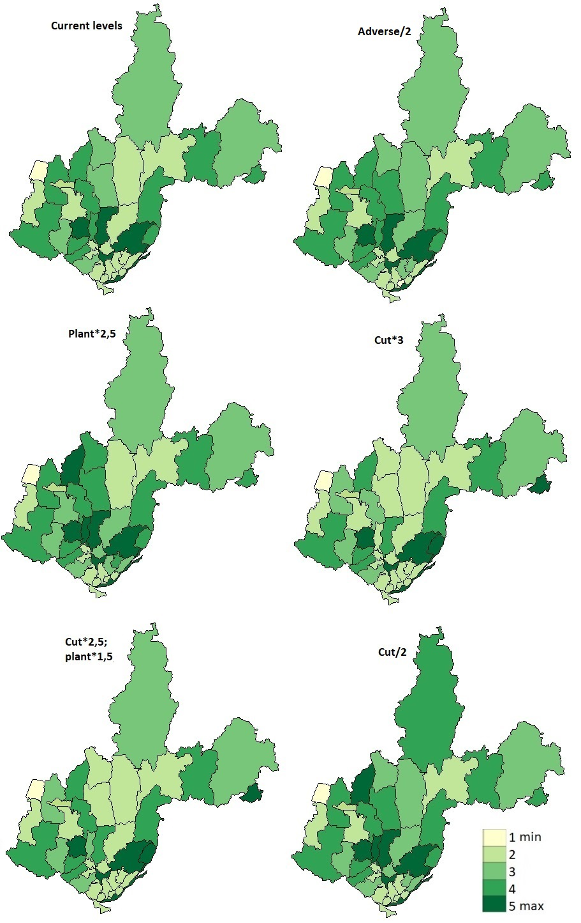

We make a consolidated quantitative assessment of the change in the total forest area in the scenario simulations. The results of the comparison are given in Table 2. If the influence of adverse factors is reduced by 2, the total area will increase by 0.4% (236 thousand hectares), as compared to the calculation at current levels of factors. With an increase in forest plantations in 2.5 times, an increase is noted of the total area by 0.5% (320 thousand ha).

Increasing the cutting by 3 times, results in a decreasing of the total area by 1.3% (780 thousand hectares), with the areas of mature and over-mature trees decreasing by 26.6%, while the young forests area is increased by 31.3%. If the volume of cuttings is reduced by 2 times, the total area will increase by 0.8% (501 thousand ha), while mature and over-mature area grows by 11.5%. In the latter scenario, with an increase in logging by 2.5 times (which corresponds to the full development of the estimated cutting area) with a simultaneous increase in forest plantations in 1.5 times, a decrease in total area by 0.9% (568 thousand hectares) is observed.

Table 2. Quantitative changes in areas in the computer simulations of defined scenarios with respect to the current level of factors

|  |  |  |  |  |  |  |  |  |  |  |  |  |
| --- | --- | --- | --- | --- | --- | --- | --- | --- | --- | --- | --- | --- |
| **№** | **Scenario** | **Young** | | **Middle-aged** | | **Maturing** | | **Mature and over-mature** | | **Total** | | |
| **Area** | **Ratio, %** | **Area** | **Ratio, %** | **Area** | **Ratio, %** | **Area** | **Ratio, %** | **Area** | **Diff** | **Ratio, %** |
| 1 | **Current** | 12467 |  | 13968 |  | 6755 |  | 26932 |  | 60122 |  |  |
| 2 | **Adverse/2** | 11733 | -5,9 | 13998 | 0,2 | 6900 | 2,2 | 27727 | 2,9 | 60358 | 236 | 0,4 |
| 3 | **Plant*2,5** | 12674 | 1,7 | 14054 | 0,6 | 6773 | 0,3 | 26940 | 0,02 | 60442 | 320 | 0,5 |
| 4 | **Cut*3** | 16367 | 31,3 | 15976 | 14,4 | 7225 | 6,9 | 19774 | -26,6 | 59342 | -780 | -1,3 |
| 5 | **Cut/2** | 10783 | -13,5 | 13217 | -5,4 | 6592 | -2,4 | 30031 | 11,5 | 60623 | 501 | 0,8 |
| 6 | **Cut*2,5; plant*1,5** | 15730 | 26,2 | 15608 | 11,7 | 7134 | 5,6 | 21083 | -21,7 | 59554 | -568 | -0,9 |

The graph in Figure 5 shows that the decrease in adverse factors (43.7% of them are fires) in Scenario 2 over the first 40 years will give a larger increase in the total area than the increase in forest plantations by 2.5 times in Scenario 3. Only after 40 years increase in plantings will begin to give a slightly larger increase in area. The sharp decrease in the area due to the increase in cuttings in 3 times in Scenario 4 is compensated by an increase in forest plantations by 1.5 times with an increase in cutting by 2.5 times in Scenario 6.

Figure 5. Changes in total forest area according to 6 scenarios for 50 years

The results of the simulation showed that an increase in the volume of cutting for the development of the estimated cutting area will lead to a significant reduction of forest areas. If, however, the increase in cuttings is supplemented by an increase in planting of trees and intensification of the fight against adverse factors, especially forest fires and tree diseases, then it will be much sooner to compensate for the reduction of forests.

## Conclusions

The developed software can simulate the dynamics of forest resources taking into account the influence of a complex of natural and anthropogenic factors. It also helps to make managerial decisions in the forestry sector, showing the direction of changing the area of ​​a category of land depending on the given scenario.

The results of calculations are presented to the user in the form of tables, graphs and maps. The final values ​​are displayed for each year from the given time interval for each category of land and the age class of the trees. One can analyze the results of modeling with whese tools.

The verification of used model "Dynamics of stands" was made before start of the simulations. The calculated data for a period of 45 years based on available data on the forests of Irkutsk region for 1973 were compared with the actual data for 2017. As a result, the accuracy of the model is 2.58% with an allowable relative error of 10%, therefore, "Dynamics of stands" can be used to assess the consequences of management decisions for the territories of the rank of forestry and the region.

When calculating forecast scenarios, a strategy is found that ensures a balance between the maximum volume of harvesting and the preservation of forest areas significant reduction: an increase in cutting by a 2.5 times will not lead to a sharp depletion of reserves with a simultaneous increase in forest plantations by a 1.5 times. In this case, the areas of mature and over-mature after a small decrease during the first 10 years will later be restored. Reduction of adverse factors in 2 times causes an increase in forest areas by 0.4%, comparable to an increase in plantings by 2.5 times - 0.5%.

However, not all possible natural and anthropogenic factors affecting the changes in the forest landscape are taken into account in scenario calculations. To obtain more accurate results, it is necessary to take into account other factors: climate, harvesting, urban planning. Also, the calculations are based on the assumption that the rates of transition from one category of land to another and the values ​​of the considered factors in the future will match with those currently available. Such assumptions reduce the accuracy of the results, but allow us to simplify the modeling process.

The combination of methods of mathematical modeling with the features of geographical mapping provides integration of information flows in forestry activities, visualization of information about the spatial and temporal state of forest resources. The results are to be used to support decision-making in the field of forest regional management, for achieving the economic development and the preservation of an environment comfortable for human beings.

**Acknowledgments**: This research was supported by…

## References

1. Scheller R.M., Mladenoff D.J. A spatially interactive simulation of climate change, harvesting, wind, and tree species migration and projected changes to forest composition and biomass in northern Wisconsin, USA. Glob. Chang. Biol. 2005, 11, 307–321.
2. Abood S.A., Lee J.S.H., Burivalova Z., Garcia-Ulloa J., Koh L.P. Relative contributions of the Logging, Fiber, Oil Palm, and mining industries to forest loss in Indonesia. Conserv. Lett. 2015, 8, 58–67.
3. Wu Z., Ge Q., Dai E. Modeling the relative contributions of land use change and harvest to forest landscape change in the Taihe County, China. Sustainability 2017, 9, 708.
4. Popradit A., Srisatit T., Kiratiprayoon S., Yoshimura J., Ishida A., etc. Anthropogenic effects on a tropical forest according to the distance from human settlements. Scientific Reports, 2015, 5, 14689.
5. Musi C., Anggoro S., Sunarsih. System dynamic modelling and simulation for cultivation of forest land: case study Perum Perhutani, Central Java, Indonesia. Journal of Ecological Engineering Volume 18, Issue 4, July 2017, pages 25–34.
6. Shifley S. R., He H. S., Lischke Y., Wang W. J., etc. The past and future of modeling forest dynamics: from growth and yield curves to forest landscape models. Landscape Ecol, 2017, 32:1307–1325.
7. Armstrong A., Fischer R., Shugart H., Huth A., Fatoyinbo L. Simulating forest dynamics of lowland rainforests in Eastern Madagascar. Forests 9(4):214, 2018.
8. Shugart H.H. A Theory of forest dynamics. The ecological implications of forest succession models. N.Y., Springer, 1984
9. Horn H.S. Some causes of variety in patterns of forest succession. Forest Succession: Concepts and Applications. N.Y., Springer-Verlag, 1991, 24–35.
10. Mladenoff D.J., He H.S. Design and behavior of LANDIS, an object-oriented model of forest landscape disturbance and succession. Advances in Spatial Modeling of Forest Landscape Change: Approaches and Applications. Cambridge University Press, 1999, 125–162.
11. Wu J., David J.L. A spatially explicit hierarchical approach to modeling complex ecological systems: theory and applications. Ecological Modelling, 153 (2002), 7–26.
12. Cherkashin A.K. Forecasting the spatial and temporal dynamics of forests of taiga landscape. Dynamics of Ecologo-Economic Systems. Novosibirsk, Nauka, 1981, 107-111.
13. Cherkashin A.K. The model for the dynamics of forest stands of a district forestry and its use in solving prediction problems. Planning and Forecasting of Natural-Economic Systems. Novosibirsk, Nauka, 1984, 69–81.
14. Cherkashin A.K. The expanding complex of particular models. Forest. Systemic Research Into a Region’s Nature – Economy Interaction. Irkutsk University Publisher, 1986, 71–77.
15. Popova A.K., Vladimirov I.N. Multilevel Modeling of the Forest Resource Dynamics // Mathematical Modelling of Natural Phenomena. 2009. Vol. 4, №5. pp. 72-88
16. Vladimirov I.N., Chudnenko A.K. Forecasting of the spatio-temporal dynamics of the forest resources of the Irkutsk region using GIS technologies. Sun. Earth, Water, and Energy. Transactions of the Siberian Division of APVN, issue 2. Novosibirsk, Nauka, 2005, 61–68.
17. Cherkashin Е.А., Badmatsyrenova S. B., Vladimirov I.N., Popova A.K., Davydov A. An optimal control module of sustainable natural resources consumption control synthesis for decision support systems // 37th International Convention on Information and Communication Technology, Electronics and Microelectronics (MIPRO), DOI: 10.1109/MIPRO.2014.6859733, 2014. pp. 1100-1105.