MERIDIAN TECHNOLOGIES · INVESTOR DAY · MARCH 11, 2026 · CONFIDENTIAL

Investor Day Positioning Memo
Catherine Park, President & CEO | March 11, 2026 | For distribution to board and IR team

EXECUTIVE SUMMARY
Meridian is declaring itself an agentic work platform — one where projects are how we started, agents are how enterprise work gets done in the next decade, and governance is the architecture that makes both safe for regulated industries. This is not a pivot away from our project management roots. It is a declaration that PM is the surface, the Helio-powered agent framework is the platform, and the enterprise compliance infrastructure we have spent four years building — FedRAMP, HIPAA, role-based access, full audit trails — is the moat that no competitor has yet replicated at our depth. The agentic work platform built specifically for regulated enterprises does not yet exist at scale. We intend to build it, and today we are telling you exactly how.

OUR POSITION
"Meridian is the agentic work platform enterprises trust for regulated work —
where governance isn't a feature, it's the architecture."

WHY THIS POSITION, WHY NOW
• The PM category is commoditising. Asana and Monday have both bundled AI into standard tiers. Smartsheet is guiding low-single-digit growth. The project management motion alone is not a growth engine in 2026. The defensible position is not "the best PM tool" — it is "the platform on which regulated enterprises safely run their agents."
• Our customers are already asking for it. 18 of 22 enterprise advisory board sessions in the last 90 days cited agent governance as urgent: auditability, role-based agent permissions, model selection, data residency. These are not requests for PM features. They are requests for an agent platform with enterprise controls. We are the only company in our competitive set that can credibly answer all four of those asks today.
• The Helio acquisition only pays a strategic return under this thesis. We paid $78M for a working agent framework and 28 engineers from leading AI labs. Under a PM-with-AI positioning, that is an expensive feature team. Under an agentic platform positioning, it is the technical foundation of everything we are building. The acquisition has already happened. The strategy has to match it.
• The competitive white space is genuinely unoccupied. Atlassian is the most committed agentic platform in our category — but they serve developer and IT organisations. Meridian serves general enterprise PM in financial services and life sciences. No competitor has FedRAMP Moderate, HIPAA, and regulated-industry vertical depth combined with a working agent framework. That intersection is ours to claim.

COMPETITIVE LANDSCAPE
The 2×2 matrix below plots all four direct competitors and Meridian on two dimensions: degree of agentic platform ambition (X) and pricing posture — bundled vs. premium/consumption (Y). The top-right quadrant — agentic platform with premium pricing — is the highest-upside position and is currently occupied only by Atlassian, which serves a different buyer (dev/IT). That is Meridian's destination.
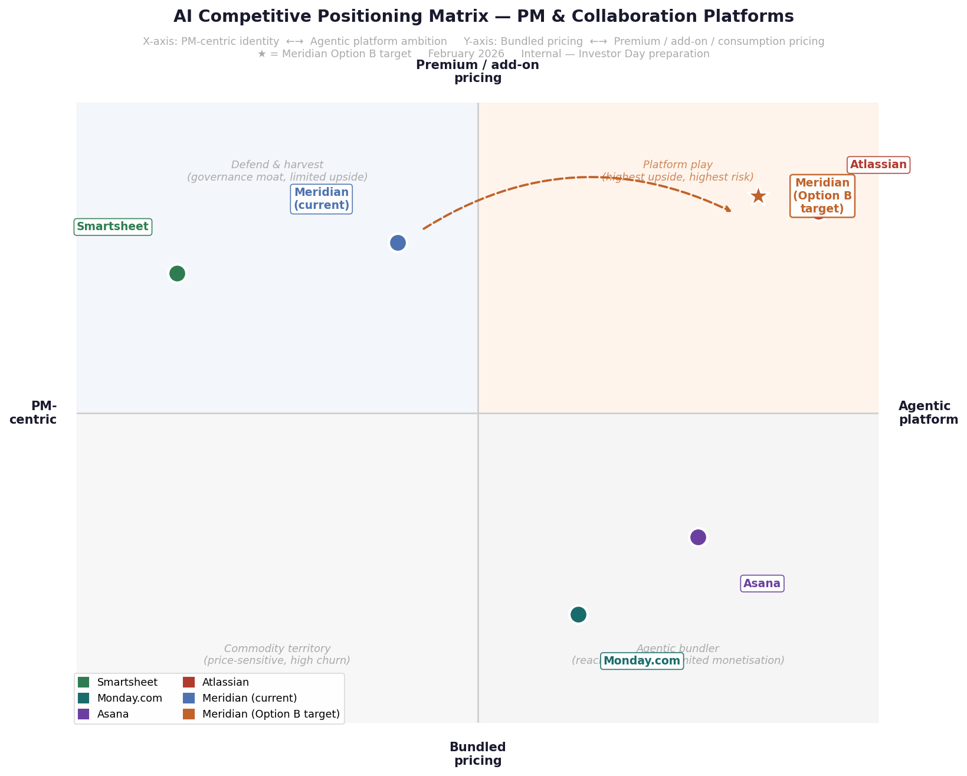
Exhibit 1: Competitive positioning matrix. Star = Meridian Option B target. Asana and Monday occupy the agentic-but-bundled quadrant. Smartsheet shares the current Meridian quadrant. No competitor combines agentic platform depth with regulated-industry governance at scale.

THREE RISKS WE ARE OWNING
• Credibility gap. We are declaring a platform identity ahead of full product delivery. AI Copilot closed 2025 at $3.5M ARR. The agent-builder ships Q2 2026. Consumption pricing rolls out H2 2026. We are mitigating this by anchoring today's declaration to specific, quarterly-trackable commitments (see below). The story must arrive with a scorecard, not just a vision.
• Mid-market air gap. Option B deprioritises the PM motion that currently funds the mid-market segment — 47% of our ARR at $194M, growing only 6% last year. If agentic revenue ramps slower than planned, we manage a declining core and an unproven platform simultaneously. We are addressing this by preserving the PM renewal motion and accelerating the resource management module (Q2 2026) as a mid-market retention lever.
• Model lab consolidation. If Anthropic, OpenAI, or Google builds the enterprise work management layer directly — or acquires a player to get there — Meridian's platform bet could be reduced to a thin wrapper. Our hedge is explicit model neutrality (no strategic lock-in to any single lab) and a governance moat that model labs are structurally slow to build: regulated certifications, enterprise audit infrastructure, and vertical compliance work take years, not months.

THREE COMMITMENTS TO INVESTORS
We are not asking investors to take this positioning on faith. We are setting three specific, public commitments we will report against every quarter.
Commitment | Metric | Target
AI revenue ramp | AI Copilot ARR exit rate, Q4 2026 | $25M+ (7× 2025 full-year)
Enterprise attach rate | Copilot attach on enterprise renewals | >60% by Q4 2026  (vs. 44% in Q4 2025)
Agent governance GA | Enterprise governance suite GA date | Q1 2026 — audit logs,  role-based agent perms,  model selection

Prepared for Meridian Technologies Investor Day, March 11, 2026. Sources: meridian_ai_strategy_options.md, meridian_recent_customer_feedback.md, meridian_financials_summary.csv, competitors_cached/. Positioning matrix: meridian_positioning_matrix.png.

