BOARD OF DIRECTORS · ANNUAL STRATEGIC REVIEW · CONFIDENTIAL

Meridian is financially stable and strategically at an inflection point —
the choices we make in 2026 will determine whether we lead the agentic era or follow it.
Catherine Park, President & CEO | Annual Board Strategic Review | May 2026

EXHIBIT 1 — THE CORE TENSION
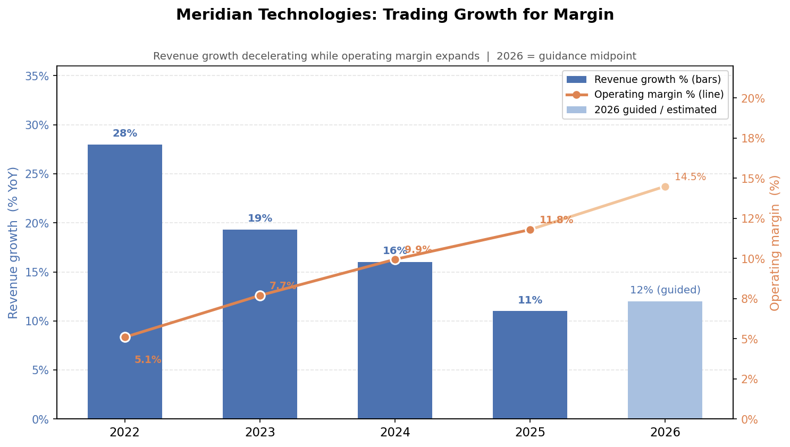
Revenue growth has decelerated from 28% (2022) to 11% (2025) while operating margin has expanded from 5% to 12%. This is not a bad quarter — it is a four-year structural trend. The 2026 guidance (12% growth / 14–15% margin) holds the same shape. The board must decide whether that shape reflects discipline or drift.

THREE ISSUES FOR THE BOARD
01 The AI bet is real — but the revenue is not yet.
AI Copilot reached GA in September 2025. End-of-year paying seats: 710. Full-year ARR contribution: $3.5M against a $413M base. The attach rate on Q4 enterprise renewals was 44%, ahead of our 40% target — that is genuine signal. The revenue is not. Meanwhile, Asana has bundled its AI agent into the standard tier. Monday is competing on price. ClearAI Work raised $120M at a $1B+ valuation and is taking SMB. Atlassian's agentic Jira will be in our enterprise deals more directly in 2026. The question is not whether to invest in AI — we are. The question is whether organic investment plus Helio is fast enough, and whether 10–14% guided growth reflects a trough before AI ramps or the new ceiling.
Key evidence:
- meridian_kpis_2024.csv: Magic number 1.20 (Q1 2024) → 0.92 (Q4 2025); CAC payback 18.2 → 22.4 months — sales efficiency deteriorating while we invest more.
- meridian_earnings_call_q4_2025.txt: Street modeled 15% growth for 2026; we guided 10–14%. The $30M SMB headwind has no AI offset this year.
- meridian_earnings_call_q2_2025.txt: "Model meaningful AI contribution starting in 2026, not 2025." That promise is now this year.
02 Mid-market is the quiet risk — and it is 47% of ARR.
SMB gets the attention because the collapse is dramatic ($105M → $52M ARR in three years). Mid-market is the underappreciated problem. At $194M ARR it is our largest segment, and net retention has compressed from 115% (2022) to 102% today. At 102% NRR, net expansion has nearly stopped. The trend line points toward net contraction. If mid-market NRR crosses below 100%, the majority of our business is shrinking. Competitors are accelerating this: Asana bundled AI into its standard tier in October, directly targeting mid-market customers who previously paid Meridian's add-on price. The resource management module — the top-3 customer advisory board request — was deferred twice and is now targeted Q2 2026.
Key evidence:
- meridian_kpis_2024.csv: Mid-market NRR 108% (Q1 2024) → 102% (Q4 2025); gross logo churn 9.1% → 10.2% over eight quarters.
- meridian_segments_overview.md: Mid-market grew only 6% ARR YoY in Q4 2025 — the largest segment is nearly standing still.
- meridian_product_roadmap_2025.md: Resource management module deferred from Q4 2025 to Q2 2026 for the second time.
03 The platform bet depends on talent we may not be able to keep.
The Investor Day commitment — positioning Meridian as an agentic work platform — is the right call. Executing it requires three things to go right simultaneously, each with visible fragility. First, Helio retention: the agent-builder roadmap belongs to 28 engineers whose retention equity vests over four years, with a cash compensation cliff in 2026. Twenty-six of twenty-eight are currently with us — one quarter in. Second, senior engineering pay: 27% of senior engineers flagged compensation in the October survey; the people team estimates 15–25 departures in 2026 without a Q1 refresh. Third, roadmap credibility: 31% of engineering survey respondents cited "roadmap thrash" as their top frustration. The organization does not yet believe the current direction is durable. The 2026 plan calls for 80 net new engineering hires; at 15% annual attrition, actual net adds are closer to 25.
Key evidence:
- meridian_employee_survey_2025.md: 31% of engineering cited roadmap thrash; 27% of senior engineers flagged pay. People team recommends compensation refresh in Q1 2026.
- meridian_product_roadmap_2025.md: "The agent-builder roadmap depends on Helio retention. If the team unwinds after their cash compensation cliff in 2026 — the roadmap is exposed."
- meridian_product_roadmap_2025.md: "At current attrition (~15% annual), net [engineering] adds are closer to 25" against a plan of 80.

MY ONE ASK OF THE BOARD TODAY
Authorize the Q1 2026 senior engineering compensation refresh and targeted Helio retention packages — before this meeting adjourns.
Issues 1 and 2 — AI revenue ramp and mid-market pressure — are strategic problems that will take 12–18 months to fully resolve. Issue 3 has a window that closes in weeks. The people team has recommended a Q1 2026 compensation action. Today is that moment. The cost is bounded (estimated $3–6M in salary and equity refresh for 15–25 senior ICs, plus targeted Helio cash retention). The cost of inaction — losing the engineering talent the entire platform bet depends on — is not bounded. I am asking the Compensation Committee to approve this today so we can move in the next ten business days. Everything else on the agenda — AI strategy, mid-market response, Investor Day positioning — depends on having the team to execute it.

This statement is intended as a 5-minute spoken opening. Full board materials distributed separately. Financials sourced from meridian_financials_2022_2025.csv and meridian_kpis_2024.csv. Survey data from meridian_employee_survey_2025.md. Chart: revenue growth vs. operating margin, 2022–2026.

