

Logicalis Managed SOC
SMU Monthly Report - February 2026








Logicalis GSOC
Monthly Report SMU – February 2026

11th February 2026
Presented by Logi c al i s Team

Contents
Executive Summary 3
1.1. Introduction 3
1.2. Incident Overview 3
1.3. Incident Severity 4
1.4. Incident Status 5
1.5. Closed Ticket 6
1.6. True Positive Incident details 6
1.7. Pending Incident Details 7
1.8. Top Alert Triggered on Microsoft Sentinel SIEM 9
1.9. MITRE ATT&CK Tactics 10
1.10. New Use Case Request / Fine Tune Rules 11
1.11. Microsoft Sentinel SIEM - Monthly Utilization 12
1.12. Log source coverage – Microsoft sentinel SIEM 13
1.13. Logicalis MSS SOC Dashboard 14
GSOC Recommendation Summary 16

Executive Summary

Introduction
Logicalis GSOC is excited and honored to present the monthly report for SMU, detailing key insights and data from our Security Intelligence Platform (Microsoft Sentinel SIEM). This report summarizes the cybersecurity activities and incidents recorded throughout February 2026, highlighting trends, threats, and our ongoing efforts to enhance SMU security posture.

Incident Overview
In February 2026, Logicalis GSOC escalated and reported a total of 248 incidents that were correlated by the Security Intelligence Platform (SMU Microsoft Sentinel SIEM). There were 2476 alerts generated in MS Sentinel SIEM; after triaging by GSOC a total of 248 potential incidents is escalated. Notably, all incidents have met the Service Level Agreement (SLA) requirements for response by Logicalis GSOC team.
- In February, 8 incidents were categorized as false positives. This indicates that all these 8 reported incidents were incorrectly flagged/Detected the authorized activity, significantly impacting the team's operational efficiency and response efforts.
- The ‘Threat Intelligence report’ (Microsoft: Critical GoAnywhere bug exploited in ransomware attacks, Yurei Ransomware, Microsoft Defender Vulnerabilities Allow Attackers to Bypass Authentication and Upload Malicious Files, Microsoft Restricts IE Mode Access in Edge After Zero-Day Attacks, F5 Breach Exposes Undisclosed BIG-IP Vulnerabilities and Source Code to Nation-State Threat Actor, ec) on new threats and zero-day attacks has been shared on a weekly and ad-hoc basis by Logicalis GSOC. This proactive sharing of intelligence helps the team stay informed and prepared to respond swiftly to emerging threats for SMU.
- Logicalis GSOC have confirmed that all the onboarded log sources are functioning optimally and successfully transmitting logs to the Microsoft sentinel SIEM. This consistent data flow is crucial for maintaining effective security monitoring and incident response.

Incident Severity
In February 2026, GSOC triaged and escalated a total of 248 incidents categorized by severity.
Below is a breakdown of the incidents reported:

    - Informational: 1 incident
    - Low Severity: 119 incidents
    - Medium Severity: 68 incidents
    - High Severity: 60 incidents
    - Critical Severity: 0 incidents

This month, 119 Low severity incidents were the most frequently observed, representing minor issues that typically do not require urgent action but should still be monitored for patterns or recurrence.

High: There were 60 high severity incidents, highlighting areas that required urgent attention to mitigate risks and prevent escalation. Medium severity incidents are second high triggered in February 68 incidents, indicating a rise in potential threats that warrant closer attention but do not pose an immediate risk to operations. These incidents may require investigation or remediation to prevent escalation

Critical: February 2026 experienced a stable operational environment with no critical incidents, reflecting effective risk management and proactive issue resolution. This marks a positive trend in maintaining system reliability and service continuity.

Informational:1 informational incident was recorded, suggesting that no significant concerns or urgent issues were raised under this category.

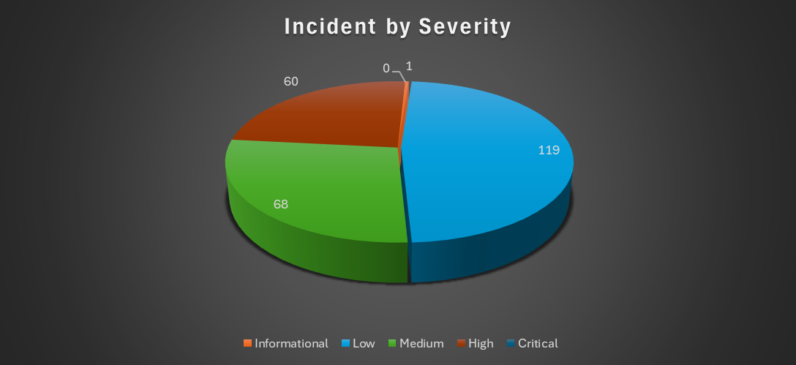

Incident Status
In February 2026, GSOC triaged and escalated to a total of 248 incidents, categorized by their status as follows:

- Pending: 17
- Closed: 230
- False Positive: 8
- Benign Positives: 222
- True Positive : 0

Analysis:
- Pending Incidents (17):
17 incidents remain pending and are currently under review. Timely follow-up is recommended to ensure closure within the defined SLA.

- Closed Incidents (230):
230 incidents were successfully closed during the month, reflecting effective incident handling and resolution processes by the GSOC team.

- False Positives (8):
8 incidents were identified as false positives. This highlights the need to further refine and optimize detection rules to reduce noise and improve operational efficiency. To support this, the Logicalis GSOC team requests the SMU team to notify us in advance of any authorized administrative or approved activities. Such proactive communication will allow us to whitelist expected actions and minimize unnecessary alerts in Microsoft Sentinel.

- Benign Positives (222):
222 incidents were categorized as benign positives, indicating that non-malicious but notable activities were detected and handled appropriately. This ensures system stability and operational continuity.

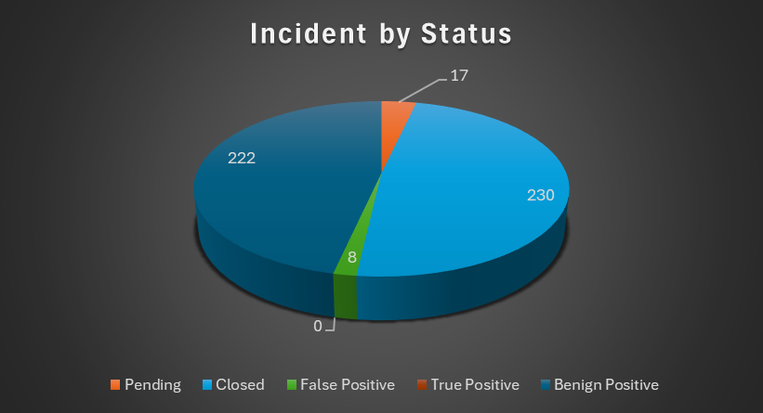

Closed Ticket

True Positive Incident details

In February 2026, no true positive security incidents were identified following the investigation and analysis conducted by the SOC team.

Pending Incident Details
There were 17 pending incidents recorded for the month of February 2026.

Incident ID | Incident | Priority | Date (MYT) | Status
SMU-5065 | SMU | SMU-5062 | HIGH | Leaked credentials involving one user | High | 28/2/2026 0:14 | Pending with Customer
SMU-5063 | SMU | SMU-5063 | Medium | TI Map IP Entity to SigninLogs | Low | 27/2/2026 22:41 | Pending with Customer
SMU-5057 | SMU | SMU-5057 | MEDIUM | [Logicalis] Account Elevated to New Role Observed | Medium | 27/2/2026 1:55 | Pending with Customer
SMU-5045 | SMU | SMU-5045 | MEDIUM | [Logicalis] Account Elevated to New Role Observed | Medium | 26/2/2026 0:11 | Pending with Customer
SMU-5040 | SMU | SMU-5040 | MEDIUM | MFA disabled for a user | Medium | 25/2/2026 11:40 | Pending with Customer
SMU-4980 | SMU | SMU-4980 | HIGH | Multi-stage incident involving Execution & Credential access on one endpoint | High | 17/2/2026 21:43 | Pending with Customer
SMU-4929 | SMU | SMU-4929 | Medium | [SMU]Anomalous login followed by Teams action | Medium | 11/2/2026 16:48 | Pending with Customer
SMU-4920 | SMU | SMU-4920 | High | NRT PIM Elevation Request Rejected | High | 10/2/2026 16:24 | Pending with Customer
SMU-4905 | SMU | SMU-4905 | MEDIUM | [Logicalis] Account Elevated to New Role Observed | Medium | 7/2/2026 23:24 | Pending with Customer
SMU-4898 | SMU | SMU-4898 | HIGH | Privileged Accounts - Sign in Failure Spikes | High | 7/2/2026 12:54 | Pending with Customer
SMU-4891 | SMU | SMU-4891 | MEDIUM | [SMU] Suspicious granting of permissions to an account | Medium | 6/2/2026 15:12 | Pending with Customer
SMU-4865 | SMU | SMU-4865 | HIGH | Initial access incident involving multiple users reported by multiple sources | High | 4/2/2026 11:40 | Pending with Customer
SMU-4864 | SMU | SMU-4864 | MEDIUM | [SMU-Custom] Trend Micro File Integrity Monitoring | Medium | 4/2/2026 10:54 | Pending with Customer
SMU-4863 | SMU | SMU-4863 | HIGH | Multi-stage incident involving Execution & Credential access on one endpoint | High | 4/2/2026 9:18 | Pending with Customer
SMU-4860 | SMU | SMU-4860 | [SMU] Conditional Access Policy Modified by New User by 90 days | Medium | 3/2/2026 19:24 | Pending with Customer
SMU-4848 | SMU | SMU-4848 | [SMU] Conditional Access Policy Modified by New User by 90 days | Low | 2/2/2026 19:24 | Pending with Customer
SMU-4844 | SMU | SMU-4844 | MEDIUM | [SMU-Custom] Trend Micro File Integrity Monitoring | Medium | 2/2/2026 10:41 | Pending with Customer

Top Alert Triggered on Microsoft Sentinel SIEM
A total of 1679 alerts were triggered in Microsoft Sentinel for SMU in February 2026. Logicalis GSOC triaged all alerts, took the necessary actions, and ensured all incidents were acknowledged and escalated within the SLA timeframe. Below are the top 10 incidents triggered in February 2026.

MITRE ATT&CK Tactics
In February 2026, alerts from Microsoft Sentinel triggered several MITRE ATT&CK tactics. This
report summarizes the identified tactics to provide insight into potential threats and areas for focus.

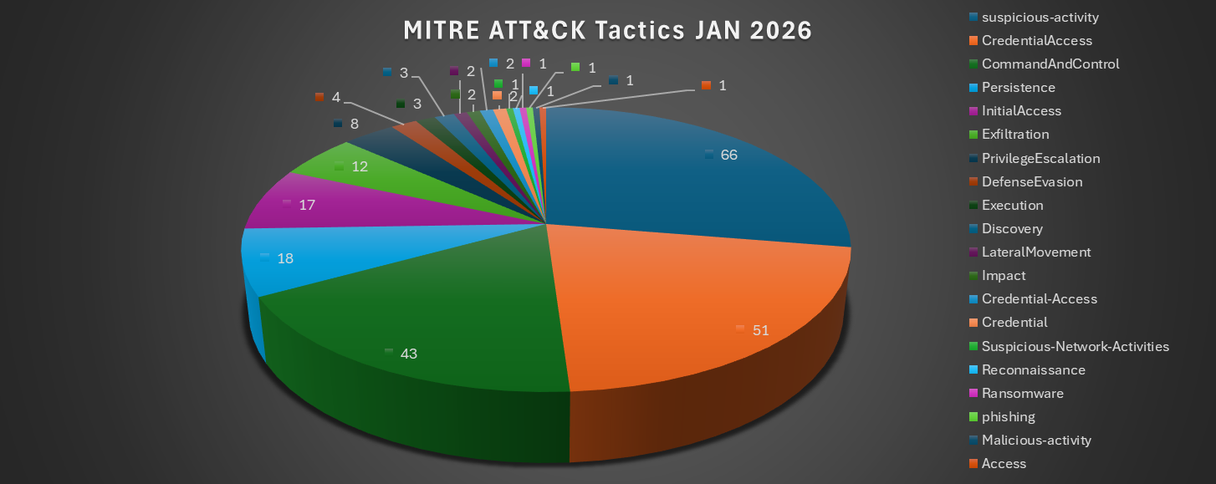

New Use Case Request / Fine Tune Rules
In February 2026, 1 fine tuning for detection rule was performed as per the discussion with SMU Team.

No | Fine tune | Action | Status
1 | GSOC has completed the rule fine-tuning. Please refer to the associated JIRA ticket for details. (Sentinel Fine-Tuning: SMU | SMU - 4968 | Detection Rule Fine-Tuning)  Rule Fine-Tuning Summary  - Rule Name: Detection Rule Fine-Tuning  - Fine-Tune: [SMU] TI map IP entity to Signin Logs:  - Exclude Failed attempt and only include Success attempt. | Fine-tune the known traffic/Activity. | Completed

Microsoft Sentinel SIEM - Monthly Utilization
In February 2026, Microsoft Sentinel's SIEM utilization for SMU reached 15.6 TB. To maintain system efficiency and cost-effectiveness, proactive measures are recommended to optimize data flow management. Additionally, Basic Logs’ ingestion increased from 7.8 GB in January 2026 to 15.6 GB. There is a slight increase in SIEM utilization compared to the previous month due to a increase in Basic logs of SMU (Firewall logs under Basic logs category).
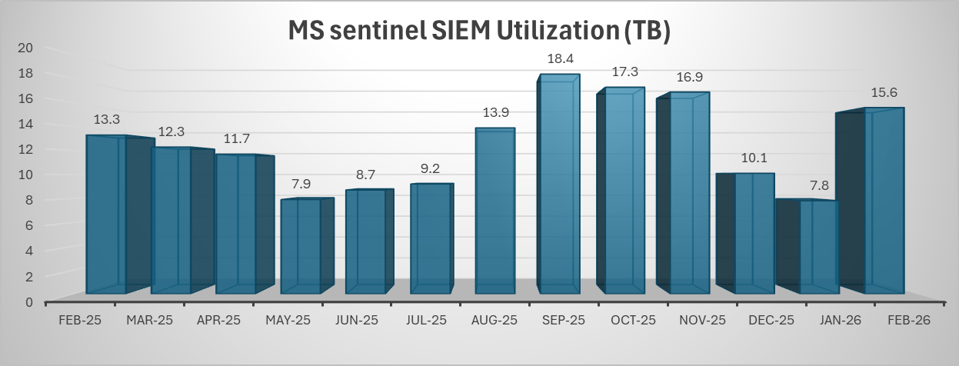

SMU Sentinel Basic Logs Utilisation:

Customer/Internal Entity Name | SMU Sentinel Utilisation
Month | Basic Logs (TB) | Analytics logs (Total utilisation) in TB | Analytics logs (daily average usage) in GB | Total (TB)
Feb-26 | 11.568 | 4.032 | 144 | 15.6

Log source coverage – Microsoft sentinel SIEM

Below is the Logicalis GSOC Monitoring Scope for SMU. Kindly do the verification and let us know if there is any modification required.

- Azure Activity
- Common Event Format (CEF) via Legacy Agent
- Dynamics365
- F5 Networks
- Microsoft 365 (formerly, Office 365)
- Microsoft Defender for Cloud Apps
- Microsoft Defender for Endpoint
- AWS
- Imperva
- TrendMicro
- Microsoft Defender for Identity
- Microsoft Defender for Office 365 (Preview)
- Microsoft Defender Threat Intelligence (Preview)
- Microsoft Defender XDR
- Microsoft Entra ID
- Microsoft Entra ID Protection
- Subscription-based Microsoft Defender for Cloud (Legacy)
- Microsoft Purview Information Protection (Preview)
- Syslog via AMA & Syslog via Legacy Agent
- Tenant-based Microsoft Defender for Cloud (Preview)
- Threat Intelligence Platforms - BEING DEPRECATED (Preview)
- Threat Intelligence Upload Indicators API (Preview)
- CyberArk Vault & Identify Threat Intelligence

Logicalis MSS SOC Dashboard

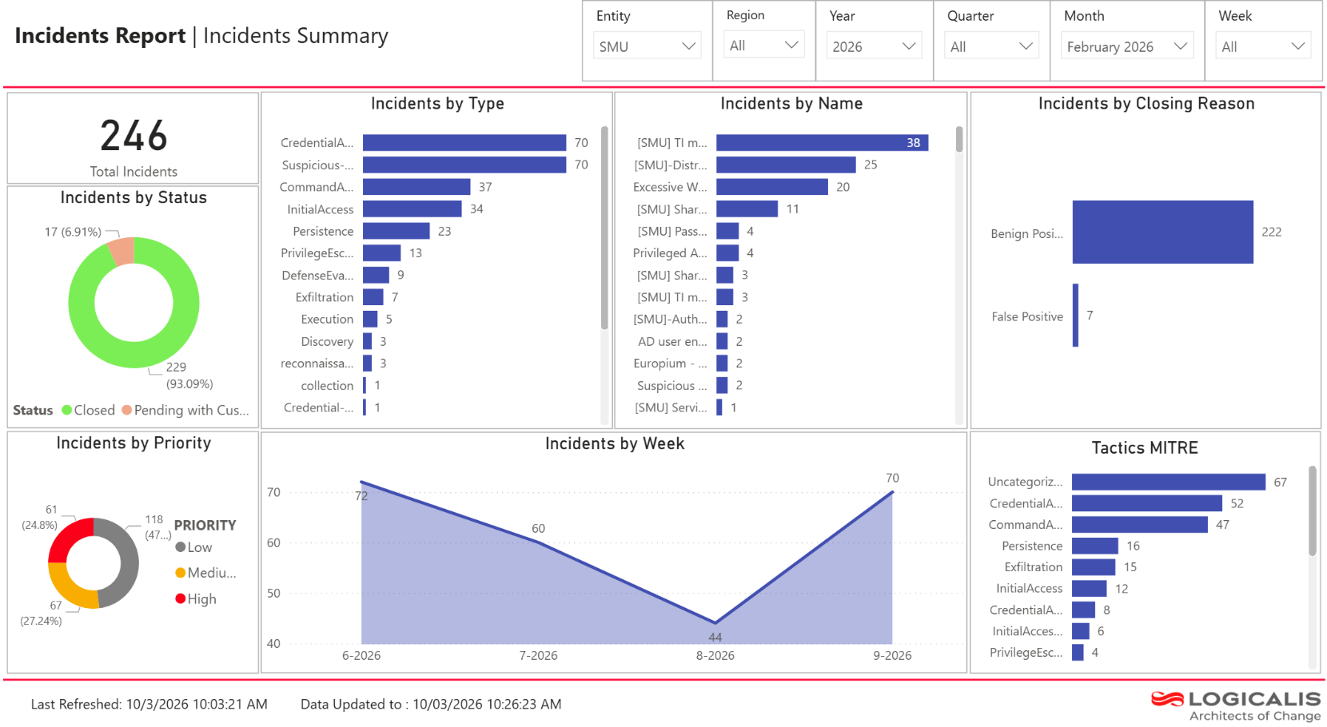

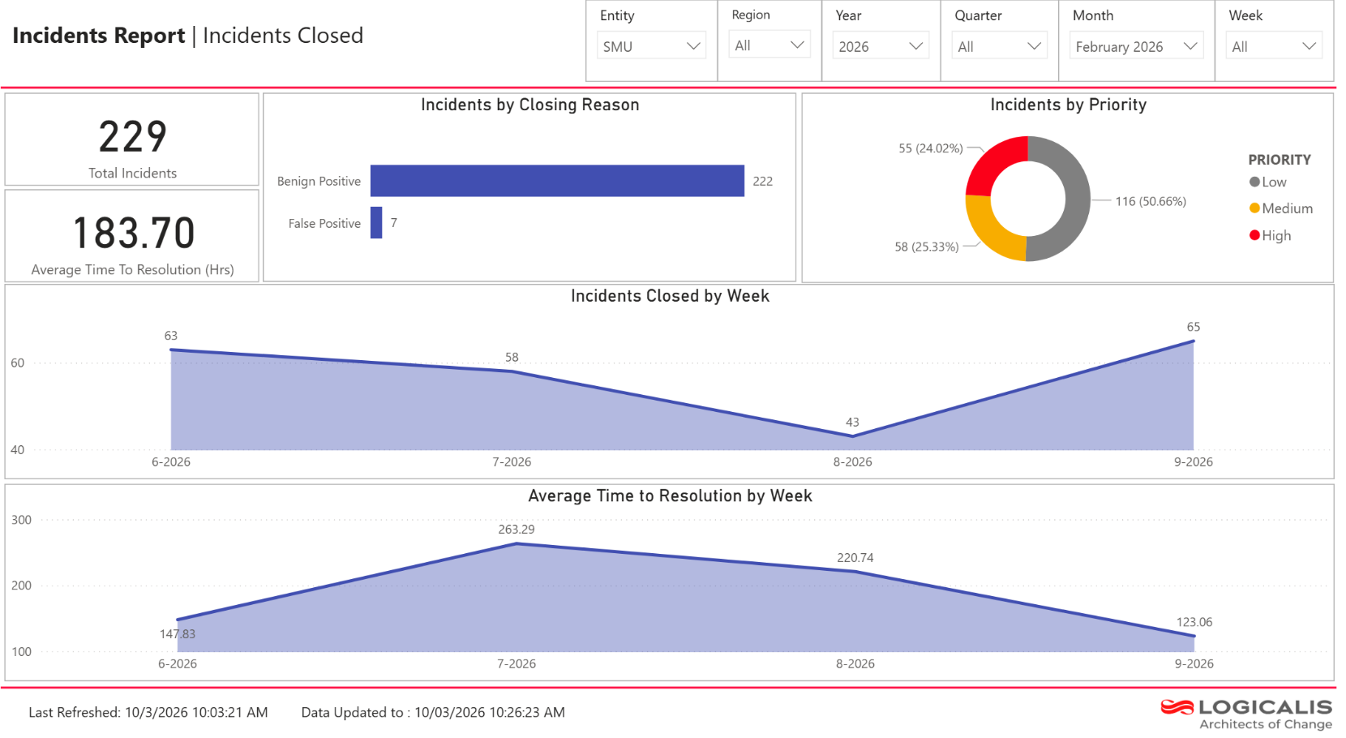
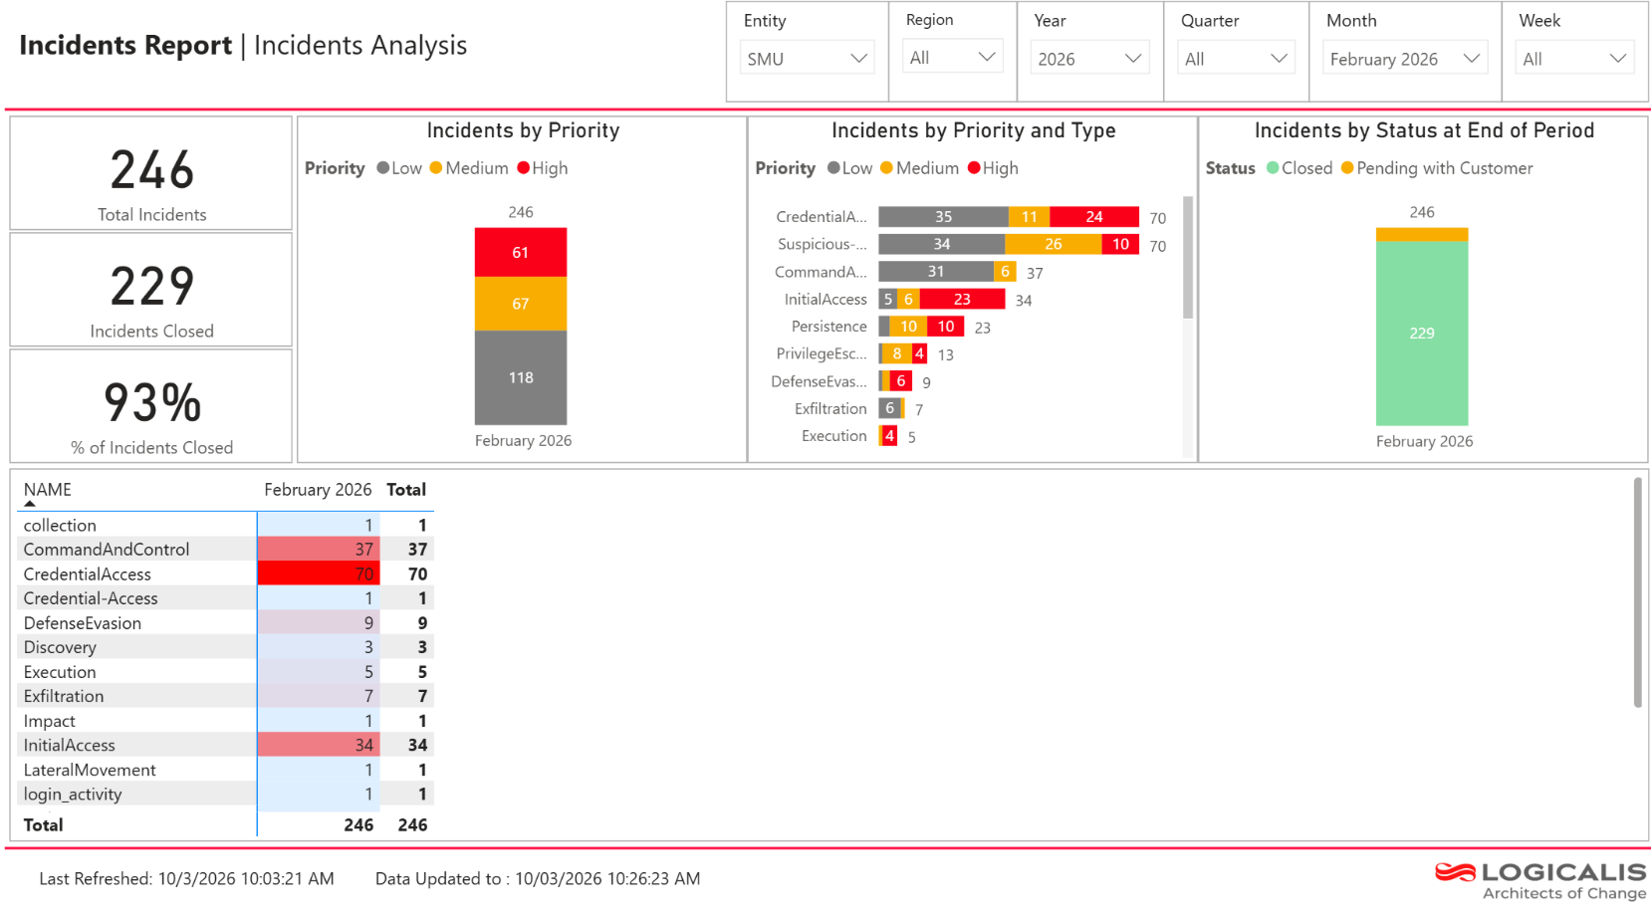

GSOC Recommendation Summary
The following table provides an overview of the summary made by GSOC, based on incidents observed and analyzed for the past month.

S. No | Recommendations | Action | Status
1 | Refer to the section of 1.4 Ticket Status to Resolve the tickets. It is recommended to actively review the pending incidents (if any) escalated by Logicalis GSOC. Collaborating to respond to these incidents promptly will ensure timely closure and mitigate potential risks. Regular follow-ups and prioritization of these incidents will enhance our incident management process and  improve overall security responsiveness. | GSOC Follow Up the Ticket Status and SMU team needs to check and respond | Open
2 | It is recommended to review the following documents regularly: Ad-hoc Threat Advisories, Zero-day Threat Advisories, Weekly Threat Advisories, Monthly Reports and Quarterly Reports.  Please ensure to thoroughly review these materials and address any queries or concerns that February arise. Engaging with these reports will help maintain situational awareness,  enhance our security posture, and ensure proactive measures are in place to counter emerging threats. | SMU team to review the respective reports and act on the recommendation, if applicable | Open
3 | Logicalis GSOC recommends onboarding any pending critical log sources (AV/EDR, IDS/IPS, Email Gateway, proxy, etc) as soon as possible. Ensuring comprehensive log coverage is essential for effective threat detection and incident response.  This enhancement will improve our visibility across the environment and strengthen our overall security posture.  Regularly assessing and integrating critical log sources will help maintain robust monitoring capabilities. | SMU team to notify Logicalis GSOC if any pending log sources to be onboarded to Microsoft sentinel  SIEM | Open
4 | It is recommended to review any assets or devices that have been decommissioned or newly added to Logicalis GSOC’s monitoring scope. This clarification will ensure that our monitoring capabilities are up-to-date and that no critical assets are overlooked. Regular assessments of the asset inventory will help maintain an effective security posture and  ensure appropriate oversight of all monitored devices. | SMU team to notify Logicalis GSOC, if any log sources to be decommissioned from SIEM | Open (On-  going)
5 | Refer to section 1.5 (Alert Triggered – Microsoft Sentinel) | GSOC is working closely with the team to fine-tune to reduce the number of alerts | Ongoing

Confidentiality Statement

The contents of this document are confidential and proprietary to Logicalis. This document is submitted on the condition that the customer does not disclose the information contained herein to any third party without the written consent of Logicalis. By receiving Logicalis submission of this document, the customer further agrees not to disclose the contents hereof internally other than to those of its agents, principals, representatives, consultants, or employees who need to know these contents for the purposes of the customer evaluation of the document.
The customer agrees to inform such persons of the confidential nature of the contents hereof and to obtain their agreement to preserve the confidentiality hereof to the same extent as the customer further agrees to treat the confidential information contained herein with at least the same level of care as it takes with respect to its own confidential information, but in no event with less than reasonable care.
© Logicalis 2026

All trademarks are acknowledged. All rights reserved.

