**June 2022 District News**

**from the Wartburg Project**

**Showers of Blessing**

I will make them and the area around my hill a blessing. I will send the rain showers, down in their season. They will be showers of blessing (Ezekiel 34:26).

Our basic suite of EHV products is now complete. For showers of blessings, read:

* the basic print Bible from Northwestern Publishing House;
* the print study Bible from Northwestern Publishing House;
* the Microsoft EHV Computer Study Bible from the Microsoft Store;
* the Logos version of the EHV Study Bible available from Faithlife;
* a condensed Bible, *the Story of God’s Love,* from NPH;
* a harmony of the Gospels, *The Life and Teachings of Jesus Christ,* from NPH;
* EHV versions of Luther’s Small Catechism from NPH and the ELS Bookstore.
* Other works available for free on the Wartburg Project website include a collection of Passion Histories and the lectionaries commonly used in WELS and the LCMS, including the readings for use with the new WELS hymnal.
* There are metric versions of the EHV available for our overseas users.

Spread the Word.

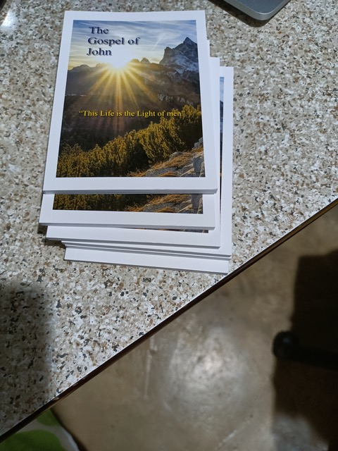

**Widening Circles**

*We have given permission or licenses for use of the EHV in many projects, small and large, and are always open to proposals.*

We recently granted a license to a missionary society in Hong Kong to print copies of the Gospels of John and Luke for free distribution for evangelism. John’s Gospel is in print and is being distributed in Hong Kong and the UK.

There is a Swedish version of our Passion History, and our catalog for composers is being used in Sweden as well as in the United States.

To our knowledge the *Concordia Commentary: Deuteronomy* by Adolph Harstad of Bethany Lutheran Theological Seminary is the first in-depth exegetical commentary to make extensive use of the EHV. A podcast dealing with this commentary is available at [podcasts.cph.org](http://podcasts.cph.org/) and in all the usual podcast platforms. Harstad is also the author of the *Concordia Commentary: Joshua* from the pre-EHV era.

Daniel Deutschlander’s popular commentary on Mark’s Gospel from Northwestern is, to our knowledge, the first commentary based on the EHV translation. We hope for many more.