Graph 1
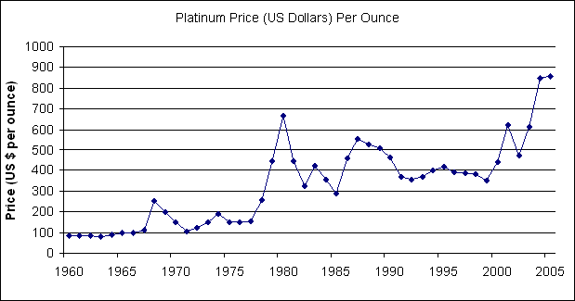

Platinum Prices
The line graph shows price of platinum per ounce in US dollars between 1960 and 2005. Overall, the price of this metal has increased significantly since the start of the period.
The biggest change was the substantial growth in total price of platinum. It rose from near 100 dollars per ounce in 1960 to more than 800 dollars in 2005. The second major peak was in about 1980. The cost remained stable after 1975 for 2-3 years, at around 150 dollars, but it jumped sharply to almost 700 dollars in 1981. In contrast, the price of platinum stayed at the same level at the beginning of the period. It stabilized for nearly 8 years, at 100 dollars per ounce from 1960 to 1967, but after that cost escalated considerably to about 250 dollars.
In conclusion, the price of platinum has changed substantially over the last half century.

Eugene Efimov, 592

