**HMI Modbus Panel manual**

This manual has been written by Jevgenijs Galaktionovs, a student assistant at AAU, Smart Lab.

If you have any questions or need some help with the Panel, contact me at [jgalak16@student.aau.dk](mailto:jgalak16@student.aau.dk)or[jga@reallyarobot.com](mailto:jga@reallyarobot.com).

**Introduction**

Here are some key points to clarify what HMI Modbus panel is and why would one use it:

* HMI Modbus panel is an add-on to Franka Panda Emika robots. It cannot be used without the robot.
* The panel is distributed and supported by PKJ Robotics.
* There are “onepager” and a user manual pdf files located in the same folder as this guide. User manual explains how to connect the panel to the robot and has all pin/button explanations. “Onepager” is useless...
* The panel consists of 3 parts: screen, PLC module, and I/O pin module called “MURR”.
* Designed to connect Franka robot with peripherals: sensors, knobs, cameras → whatever can be connected and can send digital HIGH/LOW.
* Can be used **without** any peripherals: The signals can be simulated either by pressing the buttons on the screen, or by activating them through Franka Desk web browser interface. (explained in “How to use it” part)
* Pin configuration must be uploaded into the HMI Modbus Panel to initialize the pins/buttons. Default config file is provided in this folder, file “HMI_Modbus Panel_v1.0”. More in “how to connect it”!

**How to connect it**

*Note: Steps how to connect the HMI Modbus Panel to the Franka Robot are described in “****HMI-Modbus Panel User Documentation_v1.pdf****” file in this folder. I am just giving some rephrasing here and some helping comments there.*

1. Franka robot and HMI panel must be on the same network. DO NOT connect Ethernet cable from the panel to the robot. Instead, connect the cable from HMI panel either to the same router where you franka controller box is connected , or to that controller box!

[connection image]

2. Power cable → power outlet. No tricks here. If power is present, the screen will light up and the GUI will appear.

3. Using default IP address on the panel did not work work me. So I changed IP according to the steps described in **HMI-Modbus Panel User Documentation_v1.pdf, page 9 “Getting Started”.***Note: pressing on those screen corners to get the settings menu out is tricky, but it works.*

My configuration:

[image]

4. When IP is configured (Step 3 above), a config file must be uploaded to the robot through Franka Desk browser interface. This is also described in **HMI-Modbus Panel User Documentation_v1.pdf, page 9 “Getting Started”.**

**IMPORTANT:** Before uploading the configuration, file “HMI_Modbus Panel_v1.0.json” In this folder, ensure that IP address on line 6 is the same as the one that was just set in Step 3.

[image same ip]

5. If you see “connection_up”: true,” in “Current Modbus TCP Values and Diagnostics” field, you are connected and good to start! If you see false → most likely IP addresses do not match. Redo steps 3-4 and try again.

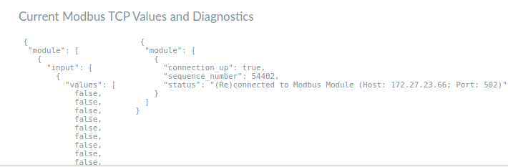

**How to use it**

*Note: This step is not described in user manual, which only provides the names for signals/buttons/pins in the panel.*

The main way of using the panel is to create a “Task” in Franka Desk web browser interface, using “Modbus” building blocks (“apps”). Example task “HMI_AAU_demo.task” in this folder contains an example demo that showcases what can be done with HMI Modbus Panel and Franka Robot, using Franka Desk.

To run “ HMI_AAU_demo” task, go to Frank Desk, login if needed, drag HMI_AAU_demo.task file and drop it into the task space

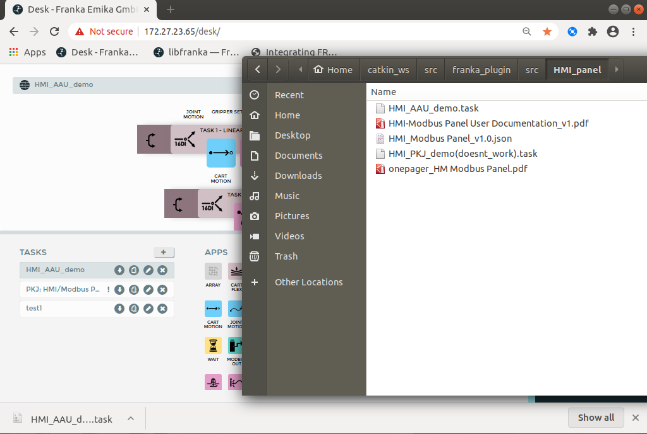

To run the program, ensure that:

* Robot brakes are released (robot is not in “yellow light” mode)
* Robot is in automatic mode (“blue light” mode) → black knob up.

Now press “Run the task” button in Franka Desk web interface. The way the task “HMI_AAU_demo” is configured is that it will wait for user to select one of the Tasks on the Panel screen, and pressing “Start”.

Example use case:

User presses “Run the task” in Franka Desk interface. Then user pressed “Task 1” on the HMI Panel. Finally, uses presses “Start” on the HMI Panel. **IMPORTAINT: robot will do a linear side motion towards you. Dont stay close!**

Further inspection and reverse-engineering of the demo program is left upon the reader! :)