Project Helena (alpha) help file

This help file has been created for version 130821-1 (with some updates for 150130-1 version), but it will do well for later versions.

Background
CRYSTAL is an optical supercomputer, however its logic and physical principles are different from that of modern computers. Instead of using one silicon processor core for a single calculation thread CRYSTAL uses a photon crystal for logical calculations with billions of simultaneous threads at a relatively low frequency. It is used at WMD laboratory for physical modeling of weapons and armor.
HELENA is a CRYSTAL generation and thread synchronization algorithm. It also handles GUI and most of other routines.
However, there is no use for this information in the game... yet.

The game
Project Helena is a turn-based RPG/Strategy game.
The goal of the game is to destroy all computer bots on a random generated map.

System requirements:
No less than 1.2 GHz recommended
64 Mb of free RAM
Screen resolution no less than 1024x768

Main menu
Main menu offers most of the game setup. Short menu help may be found by clicking on “Menu help” button.
In the main menu you can set the zoom level.
“Resume game button” resumes the game. If the game has not yet started or if the game is over the button is grayed out. The same thing is done by clicking “Menu” button.
“Generate new map” button will generate a new map with the specified parameters discussed below.
“Stop the game button” stops the game (destroys player bots) and shows the map. Your progress will be lost.
“Menu help” and “Game help” buttons show a short hint on menu options and game controls.
“Quit” button exits the game

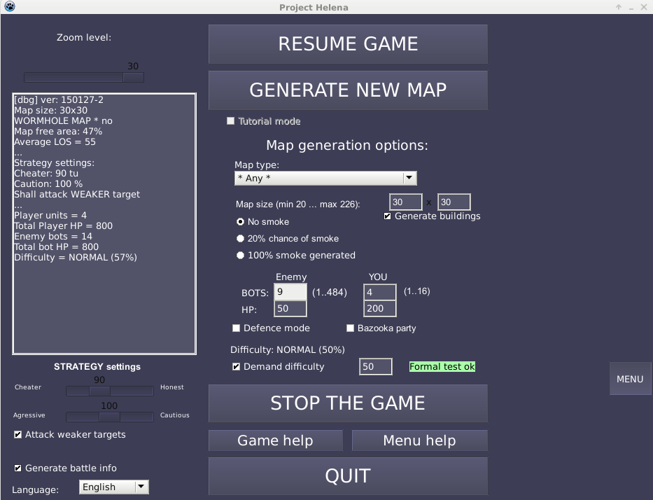
Fig.1. Game main menu (Linux version)

“Zoom level” slider sets the zoom level of the game from 20 to 50 tiles per screen and may not be greater than current map size.

Game controls
Game is mainly controlled by mouse.

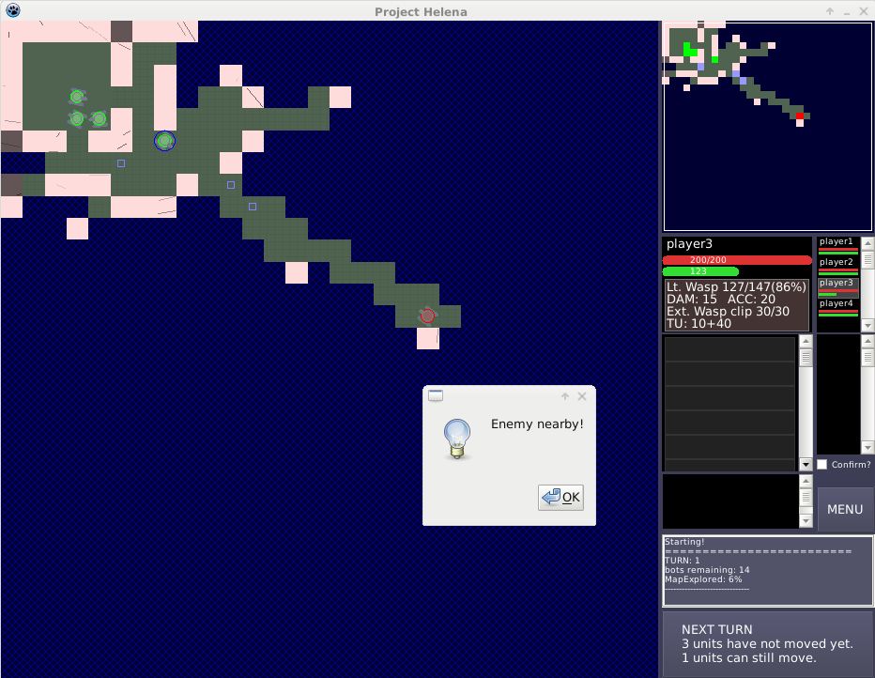
Fig.2. Game controls (Linux version)

Left click will select your bot or move it to a free space. You can also select your bot by left-clicking in the top-right list.
Right click will select and attack enemy. You can also select enemy bot without shooting at it by left-clicking in the middle-right list. If the bot is in the line of sight then the selection cross will be red, else it will be yellow. You can see enemies only in direct line of sight of your bots.
Middle click will center the map around the tile clicked; You can also move the map by left-clicking on the minimap in the ritght-top of the GUI.
Clicking “Next turn” button will start enemy turn and replentish your bots TUs. The game lasts until all bots of one of the sides are destroyed.
Confirm checkbox enables you to decide whether your bots take action (shot or move) immediately after click (quicker gameplay) or after second click (saves from errors).
Event log shows all events that happened this turn, ratio of the map explored and number of bots remaining. First turn after map generation event log shows map information and statistics.
Items operations
Left click at “List of items in the backpack” will select item and the next left-click will equip the item (change the weapon if weapon present or load ammo if only ammo clip is present). If an item is selected then clicking at a free space in the backpack will move it there.
Shift-left-click on item will drop it. Shift-left-click on empty space in the backpack will unload ammo clip from the primary weapon. Ctrl-left-click will remove ammo clip from the selected weapon without equipping it.
If there are items on the ground at place where the bot stands (the list is not empty) left click will select the item and another left-click will pick it up.
Right click at an equipped item, an item in the backpack or an item on the ground show its characteristics and description. For weapon with ammo charged some basic estimates are also made.

Bot properties
Each bot (your and computer's) has:
HP | Hit points. | When HPs reduce to 0 the bot is destroyed.
TU | Time units | TUs are spent for all actions. Each bot has equal amount of TUs (255). You cannot execute action if required amount of TUs is greater than remaining amount. The TUs reset back to max at the next turn.
 | Speed | At this time each bot's speed is equal to 30. This is the amount of TUs used for a horizontal or vertical step, diagonal steps will cost 1.41 times more. It will be possible to change this value by upgrades in later versions.
 | Primary weapon | The primary weapon is the weapon used for attacking enemy if the weapon has the ammo the bot has enough TUs to aim&shot.
 | Items | At this time only weapons and ammo items are implemented.
 | Backpack | Each bot can carry 12 items (including primary weapon).

Map types
The game offers several random map types. “ * Any * ” option will randomly pick one of these. You can also choose the map types manually.
Pay attention that map difficulty estimate is obsolete since new bots behavior algorithm in version 140829.
Map type | Kind | Description | Difficulty
* Any * | - | Randomly picks any of the below map types. | -
Random | Random | Represents a random set of walls and passages. The most simple map type. | Average
Random circles | Random | The same as “Random”, but generates several open areas in the map. Large open areas require careful attack formation. | Hard
Cocon | Random | The same as “Random”, but generates a large wall element at center. | Average
Block | Random | Similar to “Random” but generates large rooms instead of small blocks. Average shot distance is usually greater than for random maps, however several bottlenecks may be generated | Average
Circles | Random | Generates large circular areas. Large open areas require careful attack formation. | Hard
Anticircles | Random | Generates large areas between circular wall objects. Large open areas require careful attack formation. | Hard
Diamonds | Stamp | Generates diamond-like rooms. Lot's of place to hide, however long shooting ranges may be dangerous | Average
T-map | Stamp | Maze-like map resembling mines. Generates many deadens and long shooting ranges. Requires careful unit formation. | Easy
Linearsinus | Irregular | Generates map similar to caverns. Quiet easy map type due to large amount of bottlenecks. | Easy
Rectagonal | Random | Generates a lot of straight passages. Long shooting ranges require careful exploration. | Average
Rooms | Irregular | Generates a few straight passages connecting average-sized rooms. Rooms are usually areas of enemy bots concentrations with little place to retreat. | Average
Concentric | Regular | Generates a set of circular passages with a pillar inside. | Hard
Slant | Stamp | Stamp map type. Diagonal variation of “T-map”. | Average
Boxes | Irregular | Generates rectagonal passages. Generates a lot of long shooting ranges. | Hard
Concentric-full | Irregular | Variation of “Concentric” map. Smaller shooting ranges makes the map easier. | Average
Egg | Regular | Generates a circular shape structure varying short and narrow passages and long and wide ones which should be attacked with care. | Average
Net | Regular | Generates a set of interconnected regular passages. Long shooting ranges and little place to hide. | Easy
Plus | Stamp | Map resembling plus sign. Short shooting ranges and lots of turnarounds. | Easy
Small rooms | Stamp | Map with lots of small rooms. Short shooting ranges and lots of turnarounds. | Very easy
I-map | Stamp | Crooked map with small shot range. Very short shooting ranges and lots of turnarounds. | Very easy
Four map | Stamp | Crooked map with small shot range. Very short shooting ranges and lots of turnarounds. | Very easy
Five map | Stamp | Crooked map with long shooting ranges and narrow passages | Average
Dash | Stamp | Crooked map with long shooting ranges and narrow passages | Average
Rotor | Random | Many passages at different angles. Long diagonal shooting ranges. | Average
EggRe | Regular | Rectagonal variation of “Egg” with rooms, varying short and narrow passages and long and wide ones. | Average
Snowflake | Regular | A regular set of star-like passages. Sometimes may generate long shooting ranges. | Average
Areas | Irregular | A set of large interconnected open areas. Each area might contain a large number of enemy bots, but presence of a high amount of bottlenecks makes the map easier. | Average
Wormholes | Irregular | A set of wormhole-like passages. Average shooting ranges but wide passages. | Hard
“Random” map kind generates irregular random maps with no specific logic.
“Irregular” map kind generates an irregular set of passages with some regular logic.
“Regular” map kind is a map strongly affected by some general logic.
“Stamp” map kind is a map consisting of similar elements.
The difficulty for a specific map may be different from that of overall map type and depends on peculiarities of the generated map, amount and placement of bots. I.e. small amount of bots take advantage of small shooting ranges, while large amount of bots are more effective at long ranges and large open areas.

Map options
Map options are shown in fig.1.
The map is generated with specified map size. Large map sizes like 113x113 take a long time to generate and each enemy turn will take more time. Moreover, finding enemies at a huge map is quiet a boring experience. Therefore, usually, map size should not be set greater than 75x75.
There is an option to select whether smoke will be generated or not. Smoke reduces visible range. This may be either a strategic advantage or (more often) disadvantage depending on the situation.
In map generation options you can also set amount of enemy bots and each enemy bot hit points. The more enemies generated the more firepower they can accumulate making the game harder. The more hit points enemies have they become longer to destroy.
Usually hit points should not be set greater than 3000 due to AI limitations. In case HP is set to over 4000 all of the bots weapons sequentially become jammed and it is unable to attack anymore.
The same options are given for your bots.
“Defense mode” (something like survival mode) checkbox enables to launch all-out attack on your units making the game much harder. “Bazooka party” gives every bot a Falcon instead of Wasp.

Map diffictuly
Difficulty is also estimated for some “average” map type. I.e. game may be much harder at harder maps and much easier at easy maps. True difficulty level is calculated after map generation, which is thou not a true difficulty but a more correct estimate.
Difficulty is estimated based on two parameters comparison: total player and enemy HP and total player and enemy firepower. Enemy-to-player HP ratio shows how much more damage enemies can take. Enemy-to-player firepower ratio is estimated based on “average enemy bot density” and “average shooting area” around the map which presumes that player firepower is concentrated while computer's is not. This presumption is the source of difficulty estimation error because due to map peculiarities or random fluctuations enemy fire may be much more concentrated than expected, while careful use of bottlenecks together with some luck may drop enemy firepower almost to zero. Firepower is also calculated relative to some “average weak” weapon equipped and may be altered by use of different weapons.
Since version 130905-1 you can pre-set the map difficulty. The description of difficulty levels may be found in the table below.
(Obsolete since 140128 version, not enough statistics is available yet)
Values | Quality | Description
0% .. 75% | Easy | Quiet easy battle. Enemies will hardly attack you in groups, mostly scattered around the map. While being careful enough you will always win.
75% .. 150% | Normal | Harder, but not much harder. This time there are more enemies in the map and consequently they will appear in groups. However, in case you are careful enough you will always win.
150% .. 225% | Hard | More enemies. Sometimes you will be outnumbered. Depending on your luck and map peculiarities your chances to win are around 60%-70% with careful map exploration and good tactics.
225% .. 320% | Very hard | The map is swarming with enemy bots. Even the best mistake-free tactics will sometimes fail. Chances to win are around 30%-40%.
over 320% | Insane? | Only strong luck may provide victory in this case.
Please, pay attention, that difficulty in “defense” or “bazooka party” mode much more depends on the map peculiarities and the estimate may be inadequate.
Moreover, it should be noted that true difficulty may be significantly different due to map peculiarities, which cannot be included in formal difficulty estimate. E.g. a map with 50% difficulty may appear rather hard and 150% difficulty estimated map may appear quiet easy.
Graphically difficulty may be presented as below based on 37 battles. The plot shows percentage of HPs left after the battle versus difficulty level.

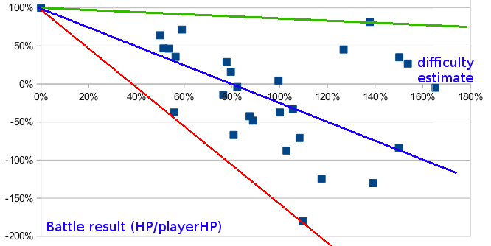
Fig. 3. Difficulty graph (based on 27 battles for new AI as of 150130 version).
Weapons & ammo
Weapons are used to shot ammo at enemy. The weapons have the following characteristics:
DAM | Damage | Damage is the amount of damage caused by the weapon in close-range shot.  The stat block shows sum of weapon and ammo DAM.
ACC | Accuracy | The damage reduces with distance to target. Higher the accuracy enables less damage reduction with distance. You cannot attack enemy too far away (further than current bot visible range; this is a bug)  The stat block shows sum of weapon and ammo ACC.
 | State | Weapons are lightly damaged by shooting and primary weaponry gets severely damaged by taking damage. If the bot is destroyed the primary weapon is additionally damaged and its ammo amount is reduced. If weapon state is less than 33% then damage made will be reduced until weapon jammed and unable to shoot.
 | Maxstate
 | TU | Shooting requires time to aim and to recharge (Tu=10+40 means 10TU to aim and 40 to recharge). Weapon is automatically recharged if ammo clip is not empty. Attacking enemy will force weapon to recharge (if it's not ready) and then aim. You can move while recharging.
 | Usable ammo | Each weapon can use specific ammo types. I.e. you can't use Falcon ammo for Wasp.
 | Explosion | Some ammo are explosive. This means that after direct impact damage explosion deals additional damage to this and nearby targets. In average explosion damage is about “Explosion” value divided by “Explosion area” value.
 | Smoke | Each explosion generates smoke in its explosion area.
 | Explosion area | The explosion power is concentrated on a specific area. If the explosion takes place at open areas the explosion strength is dissipated quickly. However explosions at narrow passages deal much more damage.  Explosions can push targets if strong enough.  Be careful. Explosion can damage your own bots and can burst from narrow passages to larger distances than expected. Explosions can also travel around the corners.

Wasp weapon class:
(This information may be a little obsolete as of 150130 version)
Lt. Wasp is a basic and average accurate weapon. Wasp is a modified version of light armor piercing cannon.
Hv. Wasp is a heavy modification of Lt. wasp. Less accurate but more powerful. Slower to recharge. It's the most powerful weapon in low-to-mid range.
Sniper Wasp is a very accurate modification of Lt. wasp. It's best for long-range shots.
 | Lt.Wasp | Hv.Wasp | Sniper Wasp
DAM | +0 | +5 | +0
ACC | +20 | +0 | +100
Aim time | 10 TUs | 10 TUs | 15 TUs
Recharge time | 40 TUs | 50 TUs | 40 TUs
Change clip | 50 TUs | 100 TUs | 100 TUs

Wasps can use the following ammo types:

Lt. wasp clip is a basic ammo type with it's modification as extended wasp clip with 30 instead of 20 ammo.
Hv. wasp clip is more heavy wasp ammo with lower clip capacity.
Acc. wasp clip is an accurate version of Lt. wasp clip. Dealing slightly more damage than a Lt. wasp clip it has much higher accuracy bonus.
 | Lt. wasp clip | Ext. wasp clip | Hv. wasp clip | Acc. wasp clip
DAM | +15 | +15 | +20 | +16
ACC | +0 | +0 | +0 | +80
Clip size | 20 | 30 | 10 | 12

There are also other Wasp class weapons and ammo, the detailed description may be found in-game.
Falcon weapon class:

St.Falcon is a standard heavy cannon. Slow recharge rate enables only one shot per turn, but it deals a lot of damage.
DAM | +0
ACC | +10
Aim time | 60 TUs
Recharge time | 150 TUs
Change clip | 200 TUs

Falcons can use the following ammo types:
 | St. Falcon clip | Expl. Falcon clip
DAM | +130 | +10
ACC | +0 | +0
Clip size | 7 | 7
Explosion | 30 | 999
Smoke | 10 | 50
Explosion area | 3 | 26

Standard Falcon clip is a regular powerful ammo dealing high amount of damage with weak explosion dealing 5-7 points of damage.
Explosion Falcon clip does not do much direct damage, but powerful explosion deals about 60 damage points to the target and over 30 damage to adjacent targets. When concentrated in small passages explosion can cause over 70 points of damage. Moreover high explosion area may cause explosion wave to travel over a dozen map squares if explosion takes place in a narrow passage.

