

CAVENDISH UNIVERSITY - ZAMBIA

ASSIGNMENT BRIEF AND FEEDBACK FORM

STUDENT No ……………….. 103-637

LECTURE …………………………MR. HENRY SINKALA

MODULE ………………….ADVANCED DATABASE DESING

MODULE CODE ………………….COM314

ASSUGNMENT No ………………. 1

DUE DATE…………………………10th April, 2024.

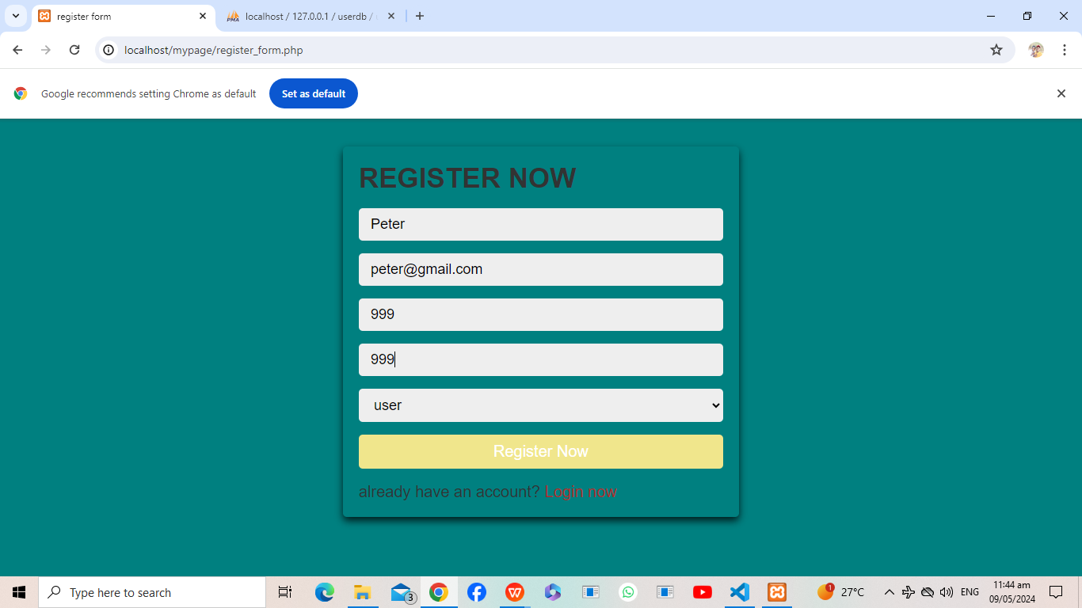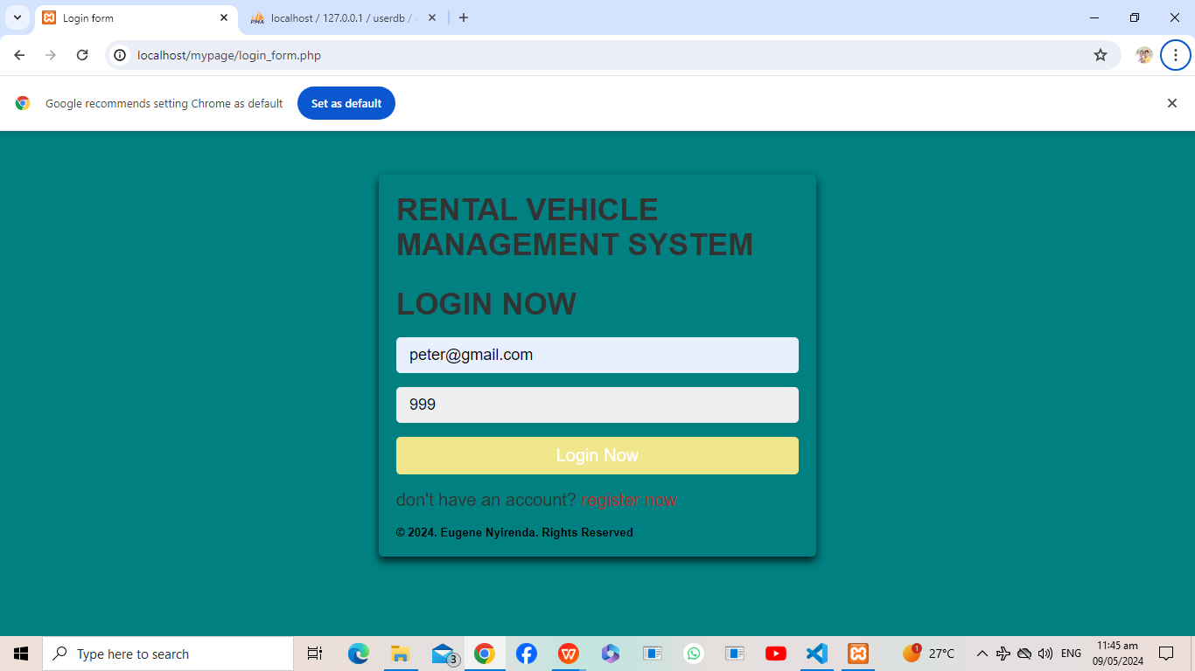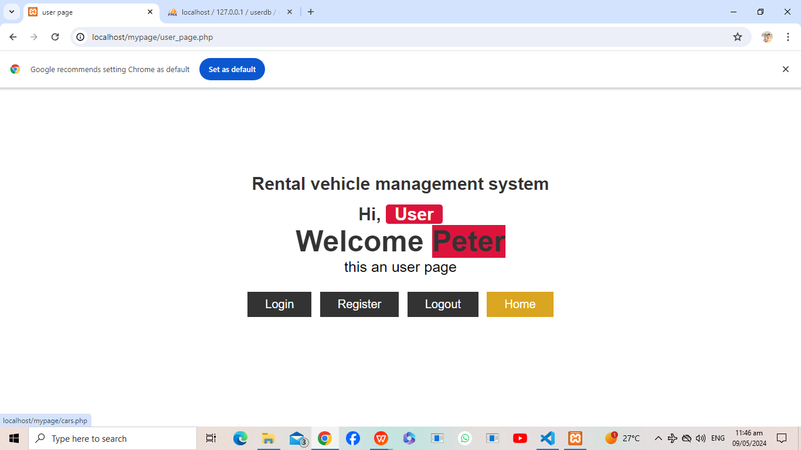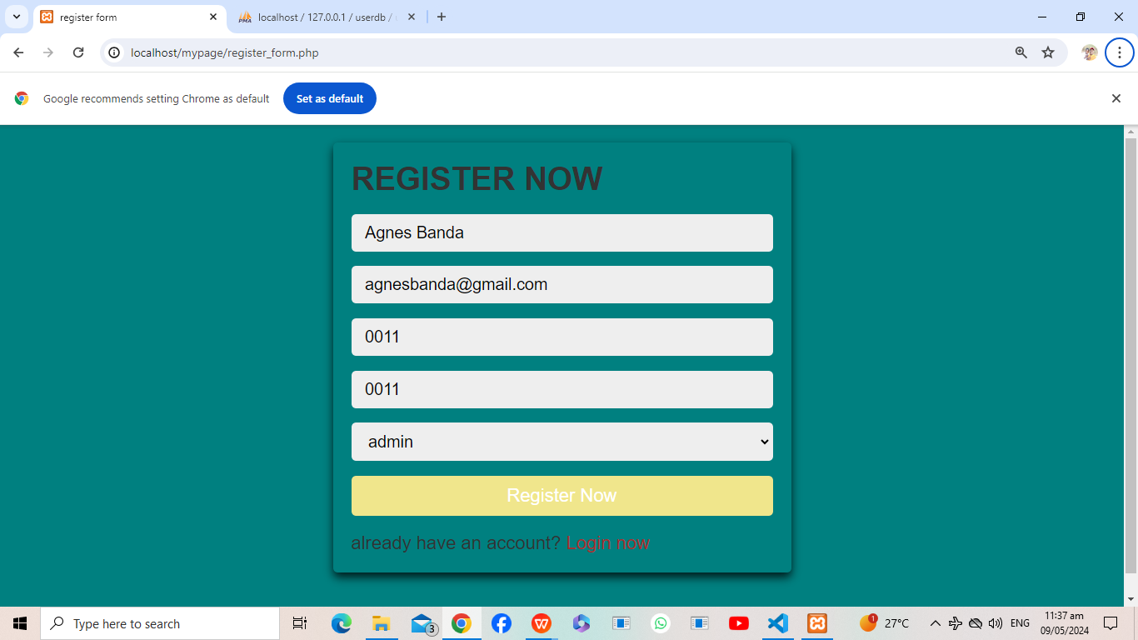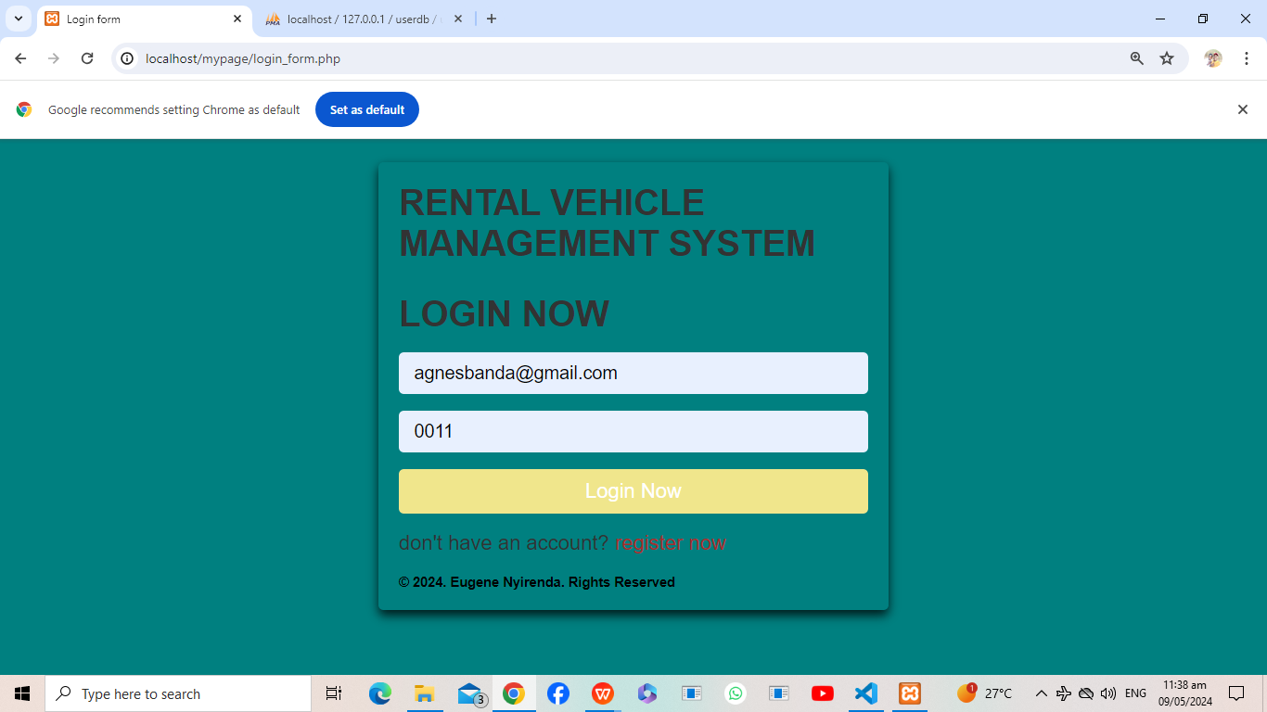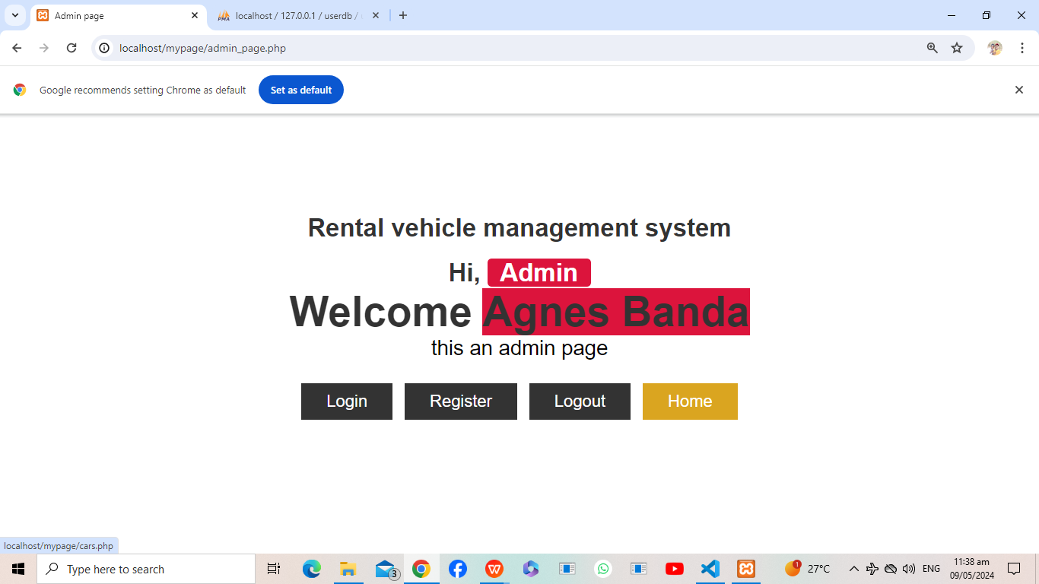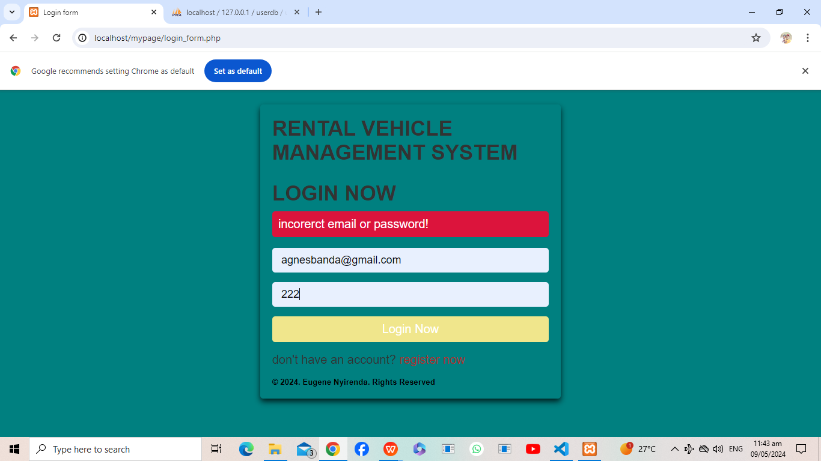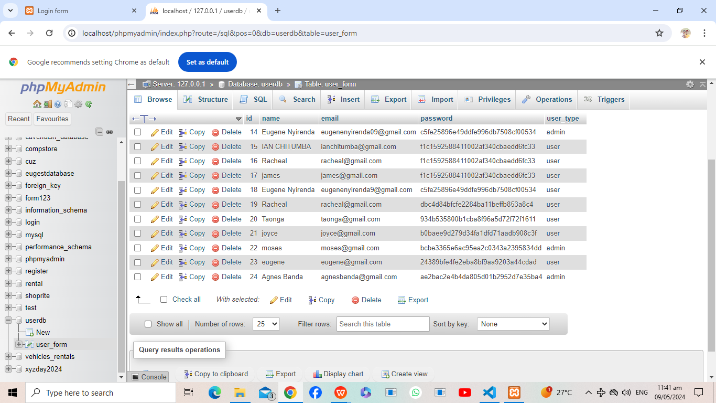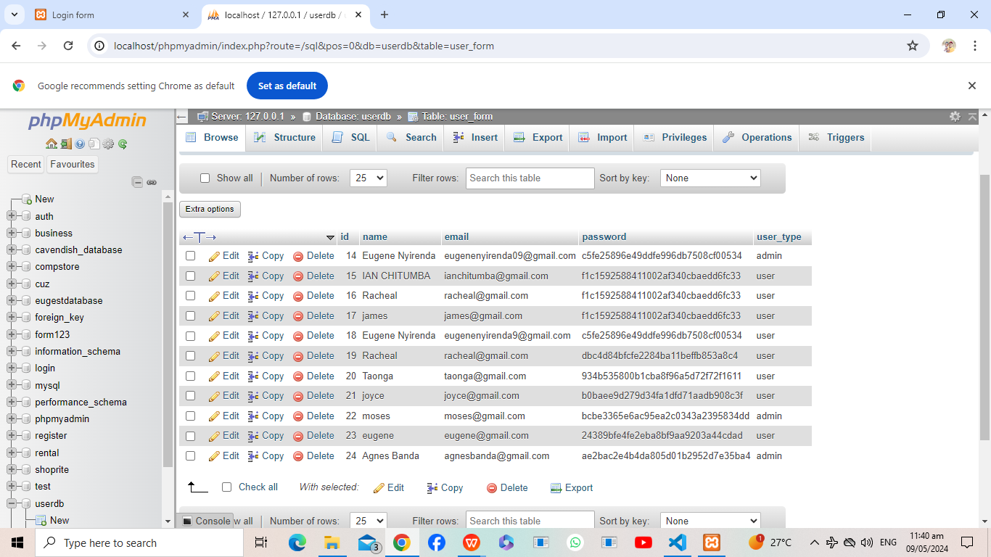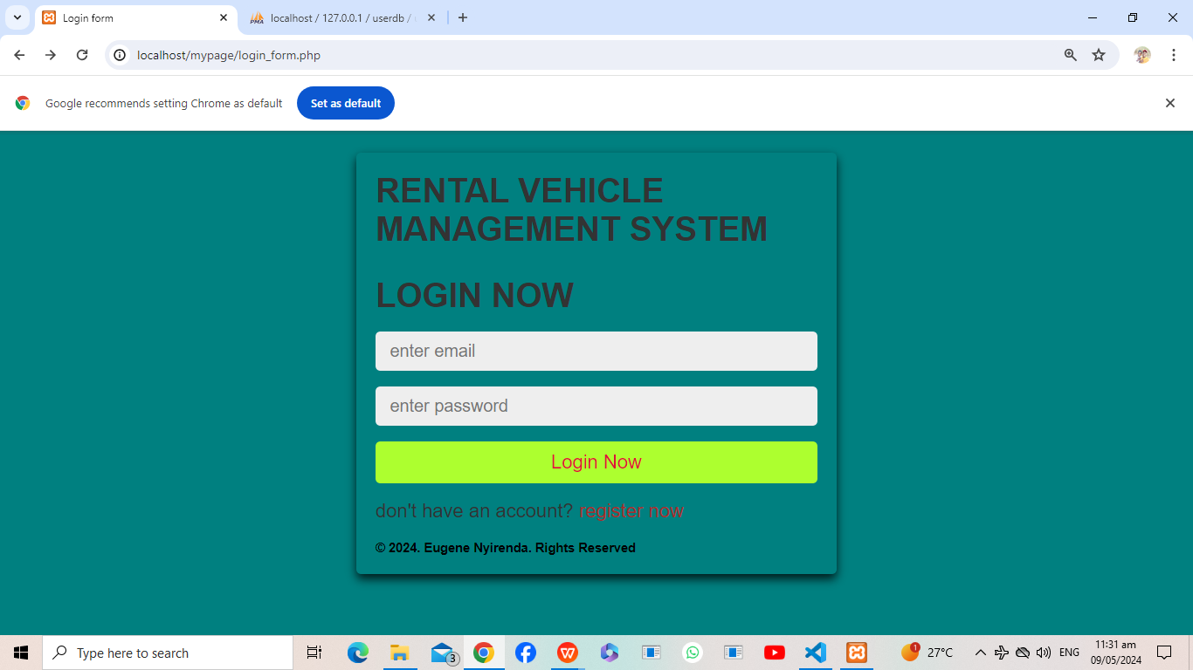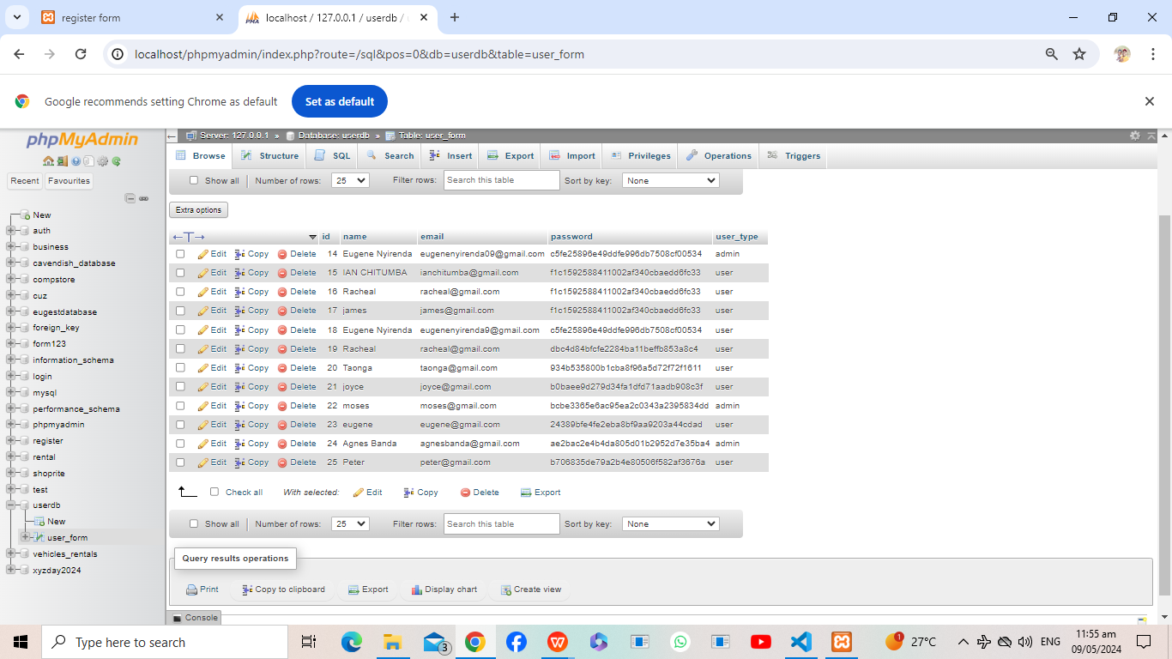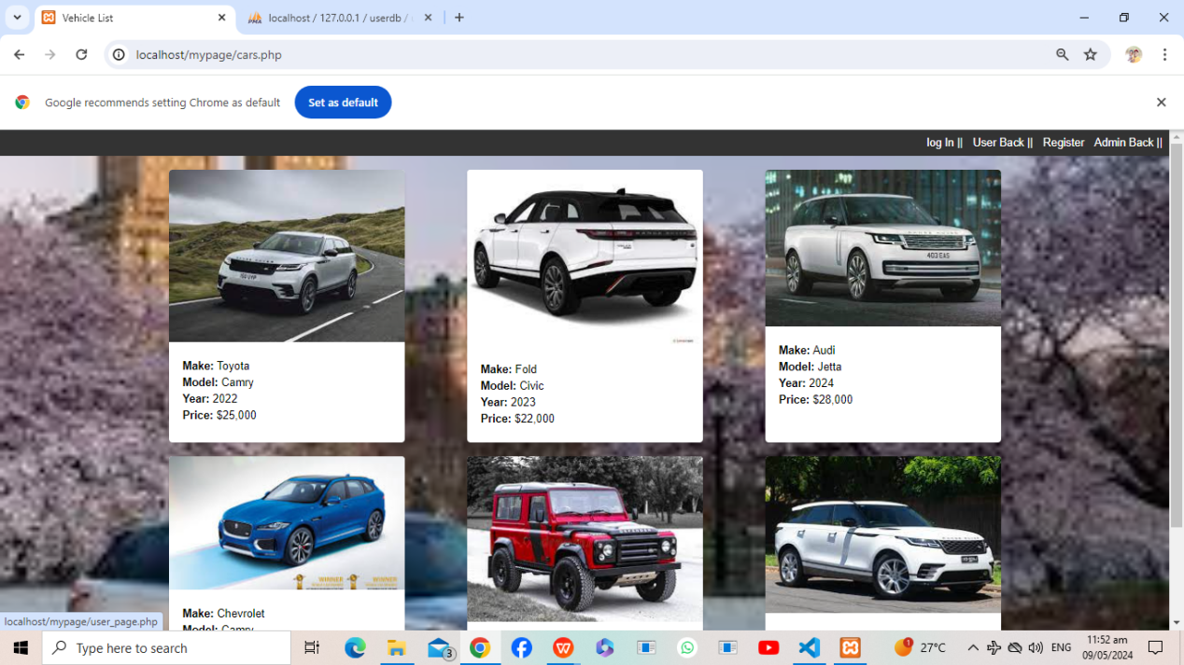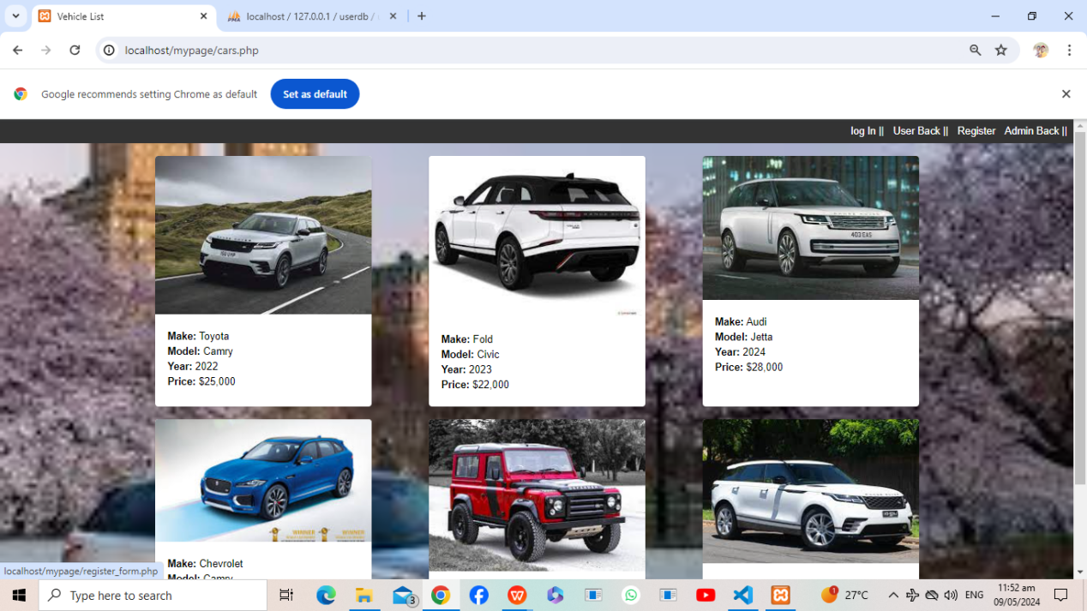

The system is developed to accept the valid values eg password and email has to match the registered one and the the login one else it will display invalid requirements.

The tools used are PhP, HTML, MySQL, little JAVASCRIPT.