Eugene Pavlyuk

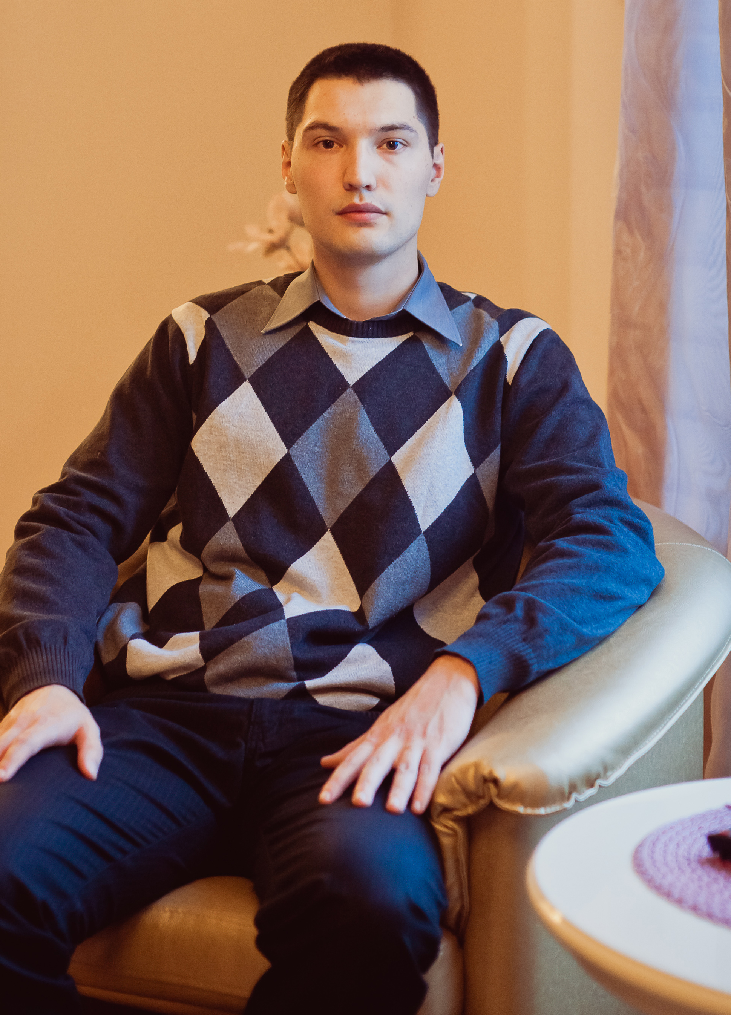
I’m a successful, hardworking, highly proficient IT professional with 4 years’ experience and a real passion for mobile application development. Having developed a series of commercially successful apps on iOS, I am seeking a new opportunity that will allow me to further expand on these skills. I am open to relocation.
I really love to read and write about development and technology in general.
I spend most of my time each day in Xcode on my MacBook Pro.
My iPhone is rarely more than 6 feet from me twenty four hours a day. I am an Apple Fan and living proof of the fact that “Once you go Mac, you never go back”. My idol and inspiration will always be Steve Jobs.

My future plans are:
• Learn English better to communicate with ease
• Move to some other country. I’m considering only English-speaking countries since I know only English
• Master Android development
• Master MacOS development
• Master Jailbreak development
• Master OpenGL ES, cocos2d and gavedev in general.

Date of Birth:
21th January 1988
.

Tongue:
Ukraine (Native), Russian (Native), English (Upper Intermediate)

Marital status:
Married, I have a child.

Skills
• iOS
• Objective-C
• XCode, SDK Frameworks
• OOP, patterns.
• svn, git, mercurial.
• Familiar with agile methodologies (Scrum).
• Jira.

Work History

2011 – present: Freelance/Objective-C. Mothermobile/Nerdpeople - Danish company.

2011 – 2010 Ciklum. Objective-C developer. Worked for a cool Dutch company, Layar by name. Took part in developing of the Augmented Reality Browser.

2010 – 2008
Soft-eXpansion Ukraine. C++ developer.

2009 - a few months worked for the gamedev company, MediaArt by name. C++/Playground developer.

Education

• 2005 – 2010 Donetsk National Technical University, Expert.

Driving Licence: B, C.

My address:
Ukraine, Donetsk.

My Contacts

• Email: eugene.pavlyuk(at)gmail.com
• ICQ: 478999935
• Skype: eugene.pavlyuk
• My blog: eugenepblog.wordpress.com
• Find me on facebook: http://www.facebook.com/eugene.pavlyuk.5
• Find me on vkontakte: http://vk.com/id9058611
• Find me on odnoklassniki: http://www.odnoklassniki.ru/profile/535015631393
• Find me on linkedin: http://www.linkedin.com/pub/eugene-pavlyuk/41/314/b50
• Find me on google plus: https://plus.google.com/u/0/112556871747964050086/about
• Follow me on twitter: https://twitter.com/eugene_pavlyuk

Mobile: +380957737798

