《数据结构》课程实践报告

|  |  |  |  |  |  |  |  |  |
| --- | --- | --- | --- | --- | --- | --- | --- | --- |
| 院、系 | 计算机学院 | | 年级专业 | 计算机类 | 姓名 |  | 学号 |  |
| 实验布置日期 | | 2019.11.14 | | 提交  日期 | 2019.12.27 | | 成绩 |  |

课程实践实验7：二叉树的实现

## 问题描述及要求

产生一个菜单驱动的演示程序，用以说明二叉树的使用。元素由单个键组成，键为单个字符。用户能演示的二叉树基本操作至少包括：构造二叉树，按先序、中序、后序、层序遍历这棵二叉树，求二叉树的深度、宽度，统计度为0，1，2的结点数等。

二叉树采用链式存储结构。

对二叉查找树做上述工作，且增加以下操作：插入、删除给定键的元素、查找目标键。

## 二、概要设计

**（1）对实验内容的理解和二次概括。**

**该实验需要使用模板类，设计一个二叉树的类，并且实现在图中添加节点，遍历以及计算高度，删除等算法的功能。**

**（2）给出系统的功能列表**

* **添加节点构建二叉树**
* **前序中序后序遍历**
* **输出高度，尺寸**
* **删除节点**

**（3）程序运行的界面设计**

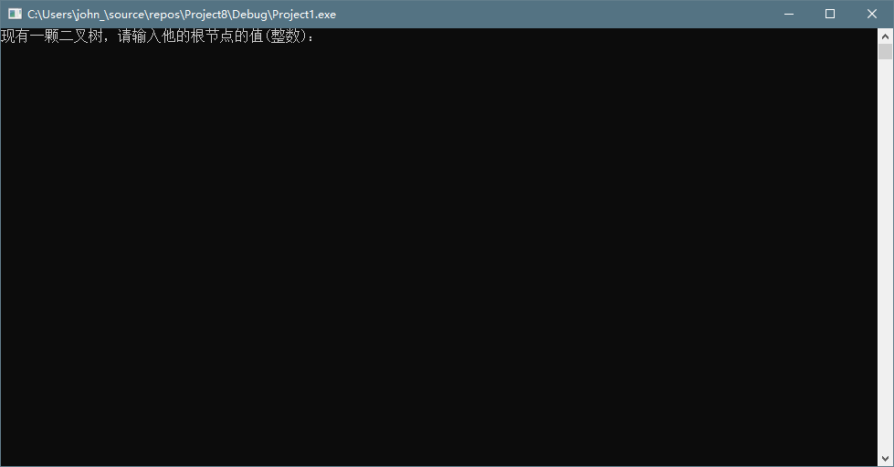

**（4）程序结构设计，包括：对已有程序的使用，自己将设计哪些程序文件，各部分关系描述。**

将设计一个二叉树类，利用链表和的结构存放节点和节点的左子树，右子树。利用递归算法简便写出遍历和添加删除结点的算法

## 三、详细设计

开始

按序生成二叉树

进行前序中序遍历

输入需要添加的节点

根据要求删除节点

终止

## 四、实验结果

紧扣题目要求设计提供相应的测试方法和结果。可以给出具体的测试用例，每个测试用例一般可列出：

* 测试输入：
* 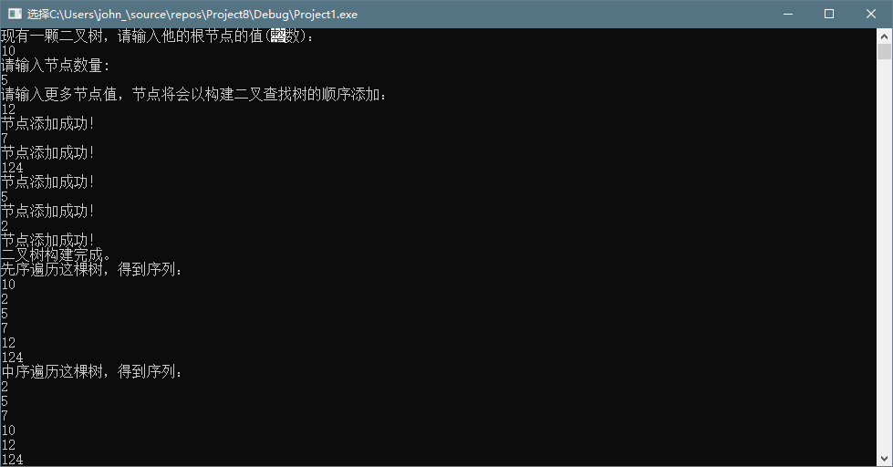
* 测试目的：检查程序是否正常运作
* 正确输出：
* 实际输出：
* 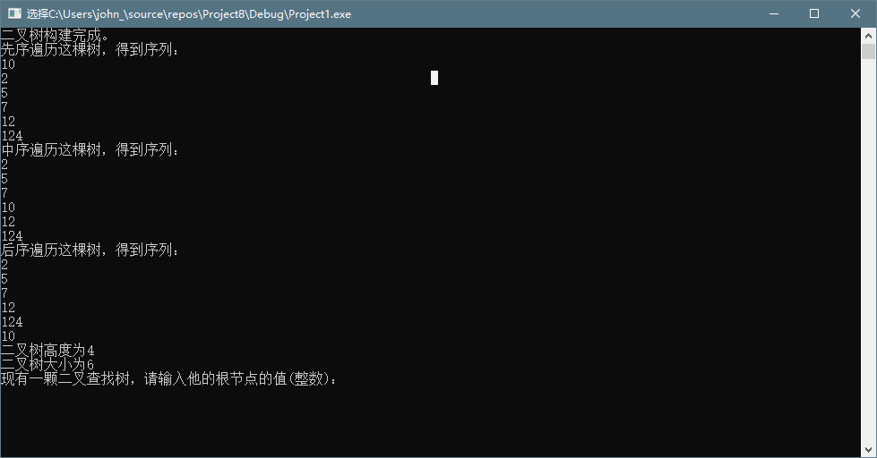
* 测试结论：通过

## 五、实验分析与探讨

测试结果的分析：结果较为正常。

**实验设计、实现过程中遇到的问题：当新建指针没有指定其left和right指针所指的是NULL时，系统有可能会认为其指针指向0xCDCDCDCD，从而引发错误。**

## 六、小结

本次实验完成了二叉树的构建，以及遍历，添加，删除的基本功能。主要掌握了二叉树结构的定义，和基本功能的递归算法实现。

## 附录：源代码

#include <iostream>

using namespace std;

template <class Entry>

struct Binary_node

{

public:

// data members:

Entry data;

Binary_node<Entry> *left;

Binary_node<Entry> *right;

// constructors:

Binary_node();

Binary_node(const Entry &x)

{

data = x;

left = NULL;

right = NULL;

}

};

enum Error_code

{

success, fail, not_present, duplicate_error

};

template<class Entry>

void print(Entry data)

{

cout << data << endl;

}

template <class Entry>

class Binary_tree

{

protected:

// Add auxiliary function prototypes here.

Binary_node<Entry> *root;

public:

Binary_tree();

Error_code insert(const Entry &new_data);

Error_code search_and_insert(Binary_node<Entry> * &sub_root, const Entry &new_data);

bool empty() const;

void preorder(void(*visit)(Entry &));

void recursive_preorder(Binary_node<Entry> *sub_root, void(*visit)(Entry &));

void inorder(void(*visit)(Entry &));

void recursive_inorder(Binary_node<Entry> *sub_root, void(*visit)(Entry &));

void postorder(void(*visit)(Entry &));

void recursive_postorder(Binary_node<Entry> *sub_root, void(*visit)(Entry &));

int size() const;

int recursive_size(Binary_node<Entry> *sub_root) const;

void clear();

void recursive_clear(Binary_node<Entry> * &sub_root);

void deleteleaf();

void recursive_deleteleaf(Binary_node<Entry>* &sub_root);

int height() const;

int recursive_height(Binary_node<Entry> *sub_root) const;

Binary_node<Entry> *recursive_copy(Binary_node<Entry> *sub_root);

Binary_tree(const Binary_tree<Entry> &original);

Binary_tree & operator = (const Binary_tree<Entry> &original);

void set_root(Entry x)

{

root = new Binary_node<Entry>(x);

}

};

template <class Entry>

Error_code Binary_tree<Entry> ::insert(const Entry &new_data)

{

return search_and_insert(root, new_data);

}

template <class Entry>

Error_code Binary_tree<Entry> ::search_and_insert(Binary_node<Entry> * &sub_root, const Entry &new_data)

{

if (sub_root == NULL)

{

sub_root = new Binary_node<Entry>(new_data);

return success;

}

else if (new_data < sub_root->data)

return search_and_insert(sub_root->left, new_data);

else if (new_data > sub_root->data)

return search_and_insert(sub_root->right, new_data);

else return duplicate_error;

}

template <class Entry>

int Binary_tree<Entry>::size() const

{

return recursive_size(root);

}

template <class Entry>

int Binary_tree<Entry> ::recursive_size(Binary_node<Entry> *sub_root) const

/* Post: The number of entries in the subtree rooted at sub_root is returned. */

{

if (sub_root == NULL) return 0;

return 1 + recursive_size(sub_root->left) + recursive_size(sub_root->right);

}

template <class Entry>

int Binary_tree<Entry>::height() const

{

return recursive_height(root);

}

template <class Entry>

int Binary_tree<Entry> ::recursive_height(Binary_node<Entry> *sub_root) const

/* Post: The height of the subtree rooted at sub_root is returned. */

{

if (sub_root == NULL) return 0;

int l = recursive_height(sub_root->left);

int r = recursive_height(sub_root->right);

if (l > r) return 1 + l;

else return 1 + r;

}

template <class Entry>

Binary_tree<Entry> ::Binary_tree()

/* Post: An empty binary tree has been created. */

{

root = nullptr;

}

template <class Entry>

bool Binary_tree<Entry> ::empty() const

/* Post: A result of true is returned if the binary tree is empty. Otherwise, false is returned. */

{

return root == NULL;

}

template <class Entry>

void Binary_tree<Entry> ::clear()

{

recursive_clear(root);

}

template <class Entry>

void Binary_tree<Entry>::recursive_clear(Binary_node<Entry> * &sub_root)

{

if (sub_root != NULL)

{

recursive_clear(sub_root->left);

recursive_clear(sub_root->right);

delete sub_root;

sub_root = NULL;

}

}

template <class Entry>

void Binary_tree<Entry> ::preorder(void(*visit)(Entry &))

/* Post: The tree has been been traversed in inorder sequence.

Uses: The function recursive_inorder */

{

recursive_preorder(root, visit);

}

template <class Entry>

void Binary_tree<Entry> ::recursive_preorder(Binary_node<Entry> *sub_root, void(*visit)(Entry &))

{

if (sub_root != NULL)

{

(*visit)(sub_root->data);

recursive_inorder(sub_root->left, visit);

recursive_inorder(sub_root->right, visit);

}

}

template <class Entry>

void Binary_tree<Entry> ::inorder(void(*visit)(Entry &))

/* Post: The tree has been been traversed in inorder sequence.

Uses: The function recursive_inorder */

{

recursive_inorder(root, visit);

}

template <class Entry>

void Binary_tree<Entry> ::recursive_inorder(Binary_node<Entry> *sub_root, void(*visit)(Entry &))

{

if (sub_root != NULL)

{

recursive_inorder(sub_root->left, visit);

(*visit)(sub_root->data);

recursive_inorder(sub_root->right, visit);

}

}

template <class Entry>

void Binary_tree<Entry> ::postorder(void(*visit)(Entry &))

/* Post: The tree has been been traversed in inorder sequence.

Uses: The function recursive_inorder */

{

recursive_postorder(root, visit);

}

template <class Entry>

void Binary_tree<Entry> ::recursive_postorder(Binary_node<Entry> *sub_root, void(*visit)(Entry &))

{

if (sub_root != NULL)

{

recursive_inorder(sub_root->left, visit);

recursive_inorder(sub_root->right, visit);

(*visit)(sub_root->data);

}

}

template <class Entry>

Binary_tree<Entry>::Binary_tree(const Binary_tree<Entry> &original)

{

root = recursive_copy(original.root);

}

template <class Entry>

Binary_node<Entry> *Binary_tree<Entry> ::recursive_copy(Binary_node<Entry> *sub_root)

/* Post: The subtree rooted at sub_root is copied, and a pointer to the root of the new copy is returned. */

{

if (sub_root == NULL) return NULL;

Binary_node<Entry> *temp = new Binary_node<Entry>(sub_root->data);

temp->left = recursive_copy(sub_root->left);

temp->right = recursive_copy(sub_root->right);

return temp;

}

template <class Entry>

void Binary_tree<Entry>::recursive_deleteleaf(Binary_node<Entry>* &sub_root)

{

if (sub_root == NULL)

return;

if (sub_root->left == NULL && sub_root->right == NULL)

{

delete sub_root; sub_root = NULL; return;

}

recursive_deleteleaf(sub_root->left);

recursive_deleteleaf(sub_root->right);

}

template <class Entry>

void Binary_tree<Entry>::deleteleaf()

{

recursive_deleteleaf(root);

}

template <class Record>

class Search_tree : public Binary_tree<Record> {

public:

int size() const;

int recursive_size(Binary_node<Record> *sub_root) const;

Error_code insert(const Record &new_data);

Error_code remove(const Record &old_data);

Error_code tree_search(Record &target) const;

Binary_node<Record>* search_for_node(Binary_node<Record>* sub_root, const Record &target) const;

Error_code search_and_insert(Binary_node<Record> * &sub_root, const Record &new_data);

Error_code search_and_destroy(Binary_node<Record>* &sub_root, const Record &target);

Error_code remove_root(Binary_node<Record> * &sub_root);

private:

// Add auxiliary function prototypes here.

Binary_node<Record> *root;

};

template <class Record>

int Search_tree<Record>::size() const

{

return recursive_size(root);

}

template <class Record>

int Search_tree<Record> ::recursive_size(Binary_node<Record> *sub_root) const

/* Post: The number of entries in the subtree rooted at sub_root is returned. */

{

if (sub_root == NULL) return 0;

return 1 + recursive_size(sub_root->left) + recursive_size(sub_root->right);

}

template <class Record>

Binary_node<Record> *Search_tree<Record> ::search_for_node(Binary_node<Record>* sub_root, const Record &target) const

{

if (sub_root == NULL || sub_root->data == target)

return sub_root;

else if (sub_root->data < target)

return search_for_node(sub_root->right, target);

else return search_for_node(sub_root->left, target);

}

template <class Record>

Error_code Search_tree<Record> ::tree_search(Record &target) const

{

Error_code result = success;

Binary_node<Record> *found = search_for_node(root, target);

if (found == NULL)

result = not_present;

else

target = found->data;

return result;

}

template <class Record>

Error_code Search_tree<Record> ::insert(const Record &new_data)

{

return search_and_insert(root, new_data);

}

template <class Record>

Error_code Search_tree<Record> ::search_and_insert(Binary_node<Record> * &sub_root, const Record &new_data)

{

if (sub_root == NULL)

{

sub_root = new Binary_node<Record>(new_data);

return success;

}

else if (new_data < sub_root->data)

return search_and_insert(sub_root->left, new_data);

else if (new_data > sub_root->data)

return search_and_insert(sub_root->right, new_data);

else return duplicate_error;

}

template <class Record>

Error_code Search_tree<Record> ::remove(const Record &target)

/* Post: If a Record with a key matching(符合） that of target belongs to the Search_tree a code of success is returned and the co. rresponding node is removed from the tree. Otherwise, a code of not_present is returned.

Uses: Function search_and_destroy */

{

return search_and_destroy(root, target);

}

template <class Record>

Error_code Search_tree<Record> ::search_and_destroy(Binary_node<Record>* &sub_root, const Record &target)

{

if (sub_root == NULL || sub_root->data == target)

return remove_root(sub_root);

else if (target < sub_root->data)

return search_and_destroy(sub_root->left, target);

else

return search_and_destroy(sub_root->right, target);

}

template <class Record>

Error_code Search_tree<Record> ::remove_root(Binary_node<Record> * &sub_root)

{

if (sub_root == NULL) return not_present;

Binary_node<Record> *to_delete = sub_root;

// Remember node to delete at end.

if (sub_root->right == NULL) sub_root = sub_root->left;

else if (sub_root->left == NULL) sub_root = sub_root->right;

else { // Neither subtree is empty.

to_delete = sub_root->left;

// Move left to find predecessor(前驱）.

Binary_node<Record> *parent = sub_root; // parent of to_delete

while (to_delete->right != NULL)

{ // to delete is not the predecessor.

parent = to_delete;

to_delete = to_delete->right;

}

sub_root->data = to_delete->data; // Move from to_delete to root.

if (parent == sub_root) sub_root->left = to_delete->left;

else parent->right = to_delete->left;

}

delete to_delete; //Remove to_delete from tree.

return success;

}

int main()

{

Binary_tree<int> bt;

int root_value,n,node_value;

cout << "现有一颗二叉树，请输入他的根节点的值(整数)："<<endl;

cin >> root_value;

bt.set_root(root_value);

cout << "请输入节点数量:"<<endl;

cin >> n;

cout << "请输入更多节点值，节点将会以构建二叉查找树的顺序添加："<<endl;

for (int i = 0; i < n; i++)

{

cin >> node_value;

int result;

result=bt.insert(node_value);

if (result == 0) cout << "节点添加成功！" << endl;

}

cout << "二叉树构建完成。" << endl;

cout << "先序遍历这棵树，得到序列：" << endl;

bt.preorder(print);

cout << "中序遍历这棵树，得到序列：" << endl;

bt.inorder(print);

cout << "后序遍历这棵树，得到序列：" << endl;

bt.postorder(print);

cout << "二叉树高度为" << bt.height() << endl;

cout << "二叉树大小为" << bt.size() << endl;

Search_tree<int> st;

int root_value2, n2, node_value2;

cout << "现有一颗二叉查找树，请输入他的根节点的值(整数)：" << endl;

cin >> root_value2;

st.set_root(root_value2);

cout << "请输入需要添加的节点数量:" << endl;

cin >> n;

cout << "请输入更多节点值，构建二叉查找树：" << endl;

for (int i = 0; i < n; i++)

{

cin >> node_value2;

int result;

result = st.insert(node_value2);

if (result == 0) cout << "节点添加成功！" << endl;

else cout << "节点删除失败！";

}

cout << "请输入需要删除的节点数量:" << endl;

cin >> n;

cout << "请输入需要删除的节点值：" << endl;

for (int i = 0; i < n; i++)

{

cin >> node_value2;

int result;

result = st.remove(node_value2);

if (result == 0) cout << "节点删除成功！" << endl;

else cout << "节点删除失败！" << endl;

}

system("pause");

}