**TWO-DIMENSIONAL MATERIALS IN SUSTAINABLE TECHNOLOGY**

Veera Juntunen1, Prof. Matti Alatalo2

1 Department of Physics, University of Oulu, Finland

2 Department of Theoretical Physics, University of Oulu, Finland

veera.emilia.juntunen@gmail.com

***Aim***: spoken presentation

For first, I would like to tell you, that I haven’t finished my Bachelor’s thesis yet. This is my topic for the thesis and I will finish it by the beginning of this summer. I am so enthusiastic about the subject, that I would love to present my conclusions at the International Conference of Physics Students.

We are living in the turning point of technology. First two-dimensional material was found in 2004, and since then this research field has grown enormously. Two-dimensional materials are one atom thick layers which can be easily removed from layered materials. Layered materials are classified by extended crystalline planar structures held together by in-plane covalent bonds and out-of-plane van der Waals forces.

Material’s properties change as their size approaches nanoscale. Thus, many of known 2D materials have interesting properties, for example graphene is an extremely good conductor, many times stronger than steel, as flexible as rubber and transparent.

Now we are able to build new types of quantum heterostructures by stacking dissimilar 2D layers. We can choose those properties what we want to have and adjusting the angle between two atomic lattices can result in structures with different properties. [1]

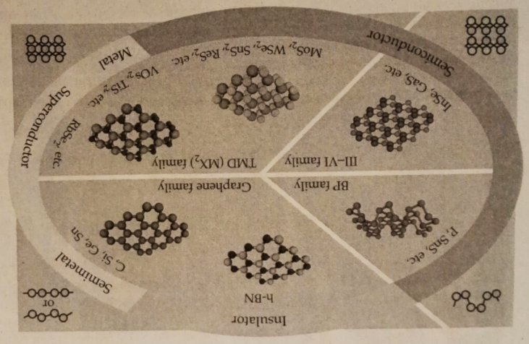

Fig. 1. Collection of sorted 2D materials.

2D materials span the full range of electronic properties [Fig. 1.], and we have the possibility to build various electronic devices with high performance and low power consumption. Theoretical analysis has shown that the skin effect is diminished in multilayered graphene, and semiconducting TMDs have many desirable properties for low-power devices. [1]

It’s possible to create new and more sustainable technology with 2D materials. They seem to be a promising building blocks for solar cells, energy storage and new-age technology. In my BC thesis I will resolve physics behind two-dimensional materials and what are the possibilities to use them in sustainable technology.

[1] P. Ajayan, P. Kim, K. Banerjee., Two-dimensional van der Waals materials, Physics Today, **69**(8), 39-44 (2016).