**Plasmonic excitations in Au induced atomic wires on vicinal Si(hhk)**

Zamin Mamiyev, Timo Lichtenstein, Christoph Tegenkamp, and Herbert Pfnür

Institute of Solid State Physics, Leibniz University Hannover, D-30167 Hannover, Germany

[mamiyev@fkp.uni-hannover.de](mailto:mamiyev@fkp.uni-hannover.de)

***Aim***: spoken presentation

Metal-induced atomic wires obtained by self-organization on regularly stepped Si surfaces have attracted great interest because of their potential to study exotic quantum phenomena in one-dimensional (1D) physics, such as charge density-waves, non-Fermi liquid behavior as well as plasmonic excitations. They may also serve as a basis for nanoscale devices. Depending on the misorientation against high symmetry directions, regular arrays of straight steps and narrow terraces of well-defined width are generated, while the geometry of steps and metal concentration allow the formation of a single or double atomic chain per terrace. The collective electronic behavior undergoes a dramatic change when the geometry is restricted to quasi-1D and electrons in such systems are strongly correlated. Thus, these wires on vicinal (insulating) surfaces are a perfect playground to study quasi-1D physics and their crossover to 2D.

Here we illustrate the variability of these systems by a study plasmonic excitations in Au wires on Si(553) and (557) surfaces, which are prototype systems for this class just mentioned. SPA-LEED (spot profile analysis-low energy electron diffraction) was used to control the long-range order of these surfaces. Then plasmonic excitations were investigated via EELS (electron energy loss spectroscopy) with an instrument that provides both high energy and momentum resolution. All measurements were carried out at room temperature under UHV conditions. In the case of Si(553), 0.48 monolayers (ML) of Au (high coverage wires) form a double strand on each terrace with an inter-wire distance of 14.8 Å and modify the step edges into honeycomb-like chains. Moreover, at the lower coverage of 0.19 ML only every second terrace is covered with a double gold chain, allowing to study effects of inter-chain coupling. Interestingly, the same concentration (0.18 ML) of Au on Si(557) leads to spontaneous formation of only single atomic chains on each terrace with 19.2 Å inter-wire distance and additional Si adatom rows decorate the step edges. These rows make this surface highly reactive to additional adsorbates. Fig.1 shows the energy dispersion curve determined from the peak positions of the losses in the EELS spectra. Dispersion is only seen along the wires, as expected for a quasi-1D system, and the losses approach zero at small kǁ,the typical feature of low dimensional plasmons. However, the dispersion curves turn out to be sensitive not only to the local electron density but also to further structural elements such as terrace width and terrace separation. They also deviate significantly from a nearly free electron gas more free-electron-like. This 2D crossover in 1D atomic wires is beyond a nearly-free-electron gas behavior. Thus, plasmon dispersion contains information about both the occupied and unoccupied band structure, which again is coupled to structural motifs. During my talk, I will give more insight into effects of every structural building block on plasmon dispersions.

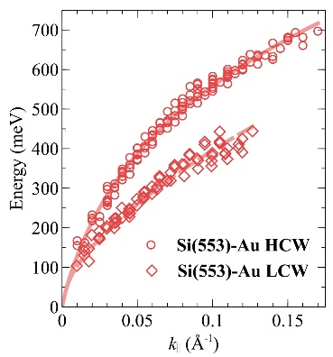 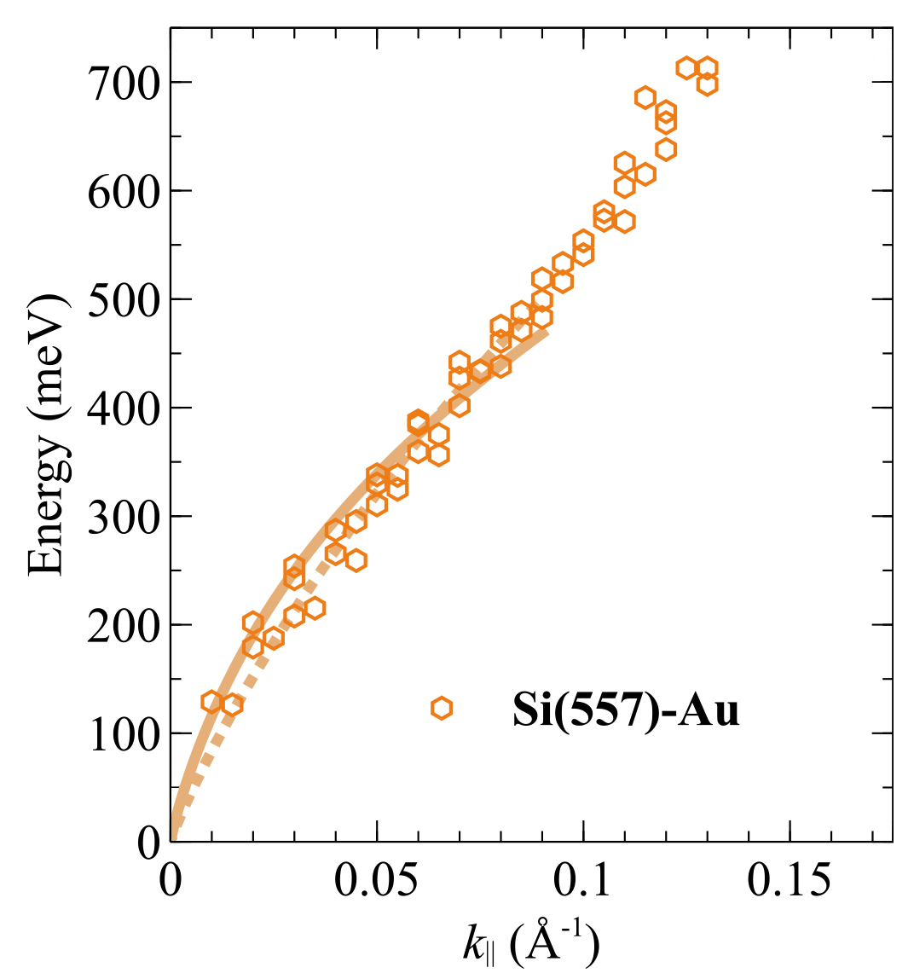

Fig. 1. Plasmon energy dispersions for Si(553)-Au and Si(557)-Au.