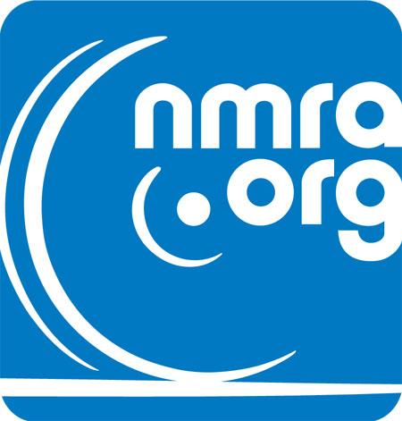

NMRA National Convention 2027

National Model Railroad Association

**Date**

August 10–15, 2027

**Location**

[Tacoma Convention Center](https://www.tacomaconventioncenter.org/), Tacoma, Washington

**Theme**

Expand Your Horizon

## Welcome!

Join us for the NMRA National Convention 2027! Experience a week of model railroading excitement, keynotes, operating sessions, panel discussions, tutorials, clinics, layout and prototype tours, contests, modular layouts and camaraderie with fellow enthusiasts from around the world. Whether you're a seasoned modeler or just starting out, there's something for everyone.

## Subscribe to Our Newsletter

Stay updated! Enter your email to receive news and updates: Subscribe

## Schedule

**August 10-13 National Convention**

**August 14-15** [**National Train Show**](https://www.nmra.org/national-train-show)

Stay tuned for the full schedule of events, clinics, and tours. Details coming soon!

## Destination

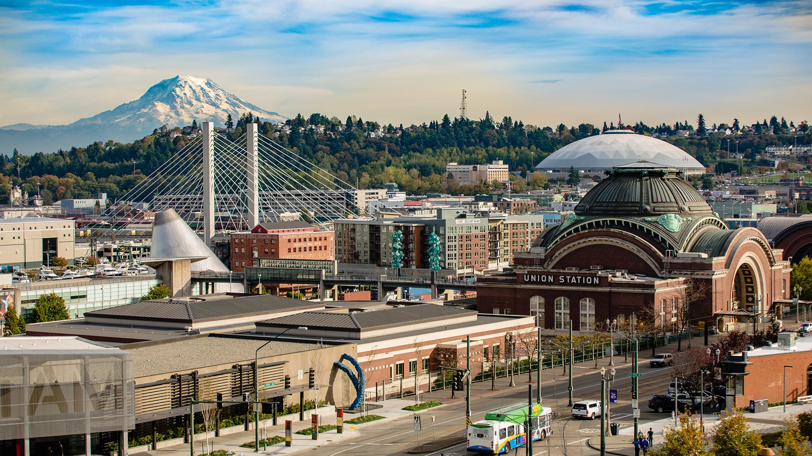

Welcome to the stunning Puget Sound Region! Centered in Tacoma, Washington, our convention puts you at the heart of the Pacific Northwest's most scenic and historic maritime area. From the snow-capped peak of [Mount Rainier](https://www.nps.gov/mora/index.htm) to the bustling ports and waterways of Puget Sound, this region offers a unique blend of natural beauty, rich railroad heritage, and maritime history.

Railroad Heritage

The Puget Sound region played a [pivotal role in railroad history](https://www.jobcarrmuseum.org/blog/the-railroad-comes-to-commencement-bay), with major railroads connecting its ports to the rest of the continent. Today, you can explore this legacy at the [Washington State History Museum's](https://www.washingtonhistory.org/) model railroad exhibit, Tacoma's restored [Union Station](https://www.unionstationrotunda.org/), the [Northwest Railway Museum](https://www.trainmuseum.org/), and scenic railroads like the [Mount Rainier Railroad](https://mtrainierrailroad.com/). Watch active freight yards and see how rail and [maritime commerce](https://www.nwseaportalliance.com/) still shape the region.

Regional Attractions

The Puget Sound region offers endless exploration opportunities. Visit the [Museum of Glass](https://www.museumofglass.org/) in Tacoma, take a [ferry ride](https://wsdot.wa.gov/travel/washington-state-ferries) on the Puget Sound, explore Seattle's [Pike Place Market](https://www.pikeplacemarket.org/), or venture to [Olympic National Park's](https://www.nps.gov/olym/index.htm) rainforests. The region's [air](https://www.boeing.com/history) and nautical heritage is showcased in museums in [Seattle](https://www.museumofflight.org/), [Tacoma](https://www.fosswaterwayseaport.org/), and [Bremerton](https://pugetsoundnavymuseum.org/) including the [Navy Underwater Museum](https://navalunderseamuseum.org/), while [Mount Rainier National Park](https://www.nps.gov/mora/index.htm) provides spectacular hiking and scenic drives.

Getting Around

Tacoma sits at the heart of the Puget Sound region, just 30 minutes from [Seattle-Tacoma International Airport](https://www.portseattle.org/sea-tac). Amtrak serves the region with [Cascades](https://www.amtrak.com/cascades-train) (Vancouver, BC to Eugene, OR), [Coast Starlight](https://www.amtrak.com/coast-starlight-train) (Seattle to Los Angeles) and [Empire Builder](https://www.amtrak.com/empire-builder-train) (Seattle/Portland to Chicago). The historic [Tacoma Station](https://www.amtrak.com/stations/tac) connects with [light rail](https://www.visitpiercecounty.com/plan/transportation/link-light-rail/) to the convention center's downtown location with easy access to restaurants, hotels, and waterfront attractions.

Extend Your Stay: Alaska Cruises

Consider extending your Pacific Northwest adventure with an Alaska cruise! The [Port of Seattle](https://www.portseattle.org/maritime/cruise) serves as a major departure point for Alaska cruises during the summer season. Several cruise lines including [Princess](https://www.princess.com/en-us/cruise-destinations/alaska-cruises), [Holland America](https://www.hollandamerica.com/en/us/find-a-cruise?destinationIds:(A)), [Norwegian](https://www.ncl.com/cruise-destinations/alaska-cruises), and [Royal Caribbean](https://www.royalcaribbean.com/alaska-cruises) offer 7-14 day voyages to Alaska's Inside Passage, featuring glaciers, wildlife, and scenic ports. Many cruises depart both before and after the convention, making it a perfect add-on to your trip.

## Royal Caribbean Ovation Cruise Ship in AlaskaRegistration

Registration will open soon. Check back for updates and early bird specials!

## Contact

For questions or more information, email us at [conv2027@nmra.org](mailto:conv2027@nmra.org).

Organizers



[**4D**](https://4dpnr.org)

4th Division



[**PNR**](https://pnr.nmra.org)

Pacific Northwest Region

© 2027 NMRA. All rights reserved.