**Supplementary Materials for: Immigrant Mortality Advantage in the United States**

**during the First Year of the COVID 19 Pandemic**

Supplementary Table 1a: Death Counts and Person-Years by Period, Nativity, Race, and Ethnicity (Males 25+)

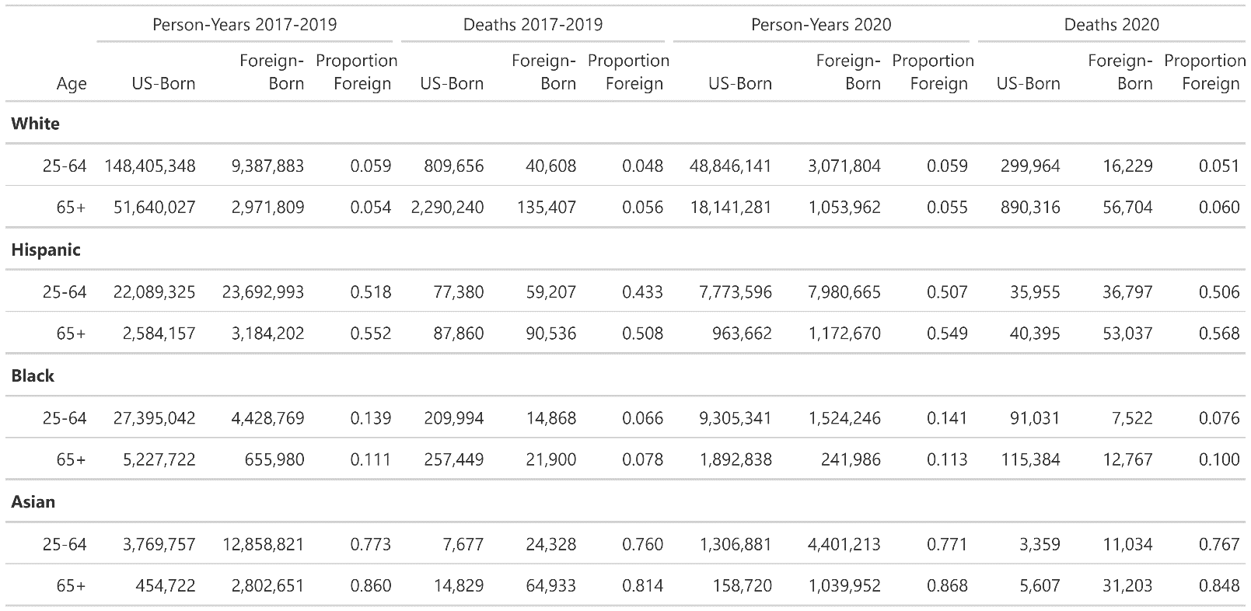

Supplementary Table 1b: Death Counts and Person-Years by Period, Nativity, Race, and Ethnicity (Females 25+)

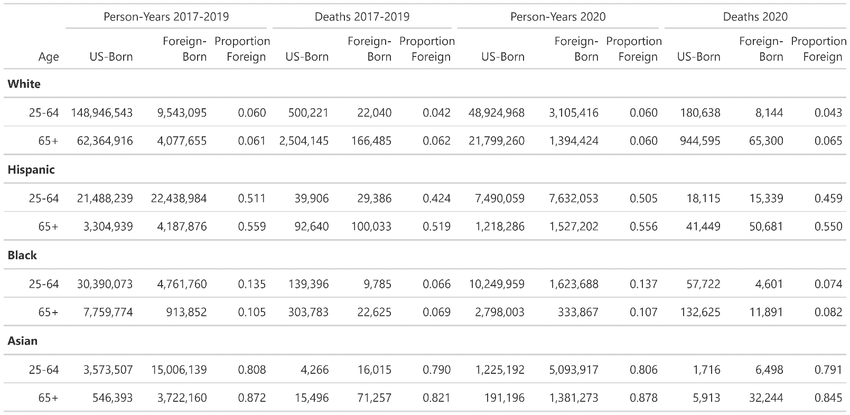

Supplementary Table 2: Cause of Death Classification

Supplementary Table 3a: Age-Standardized Death Rates per 100,000 for Men by Period, Age Group, Race/Ethnicity and Nativity (all-cause, all-cause excluding Covid-19, and Covid-19 death rates)

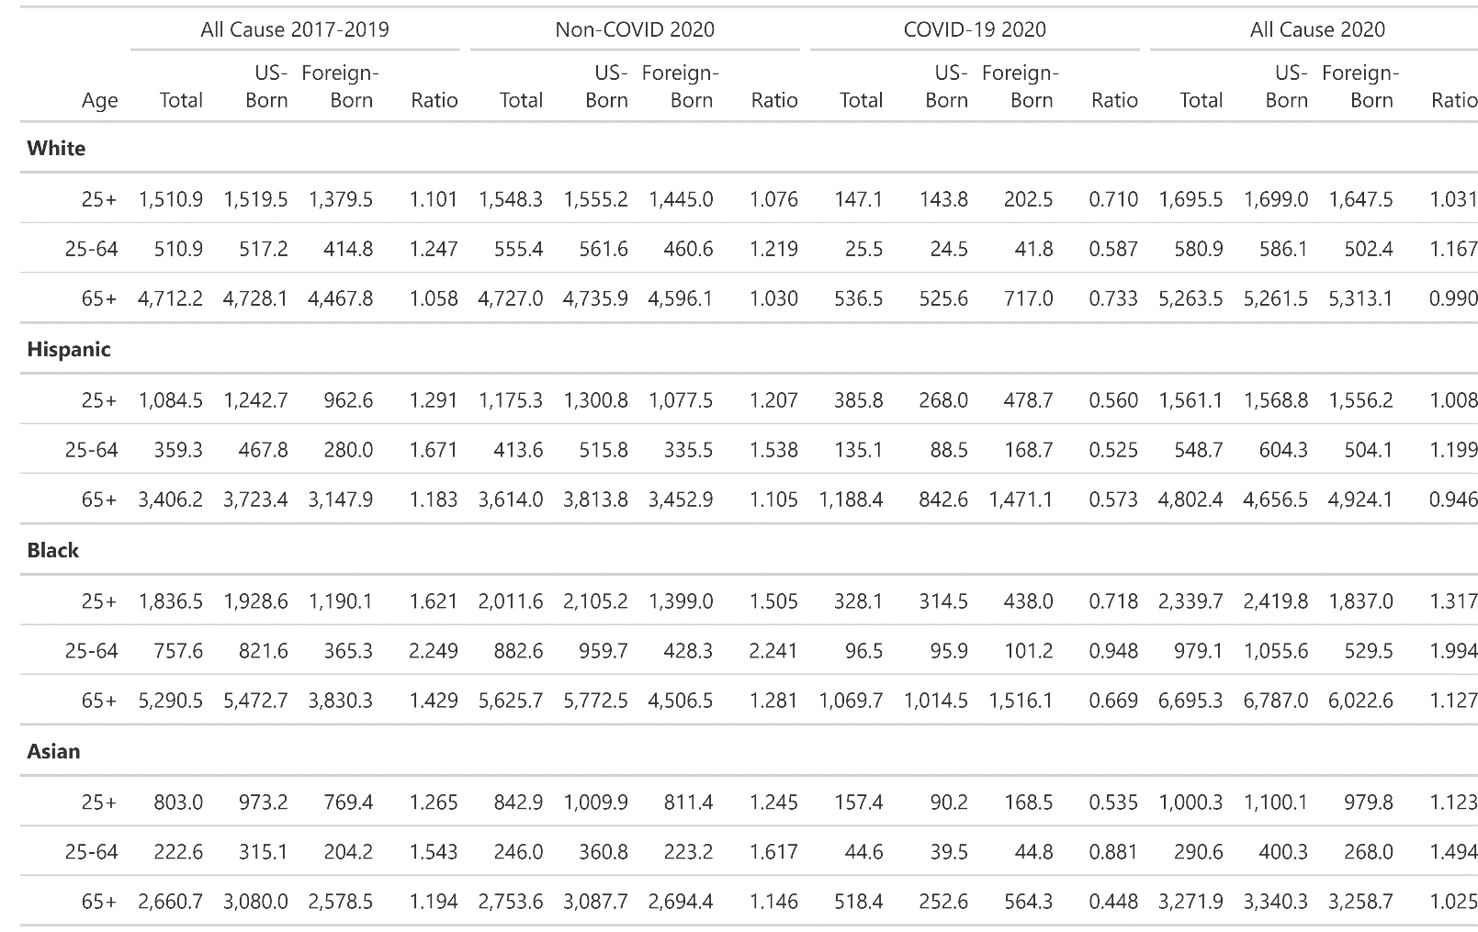

*Notes: Ratios are US-Born mortality (numerator) over Foreign-Born mortality (denominator). A ratio close to one implies equal ASDR between US-born and foreign-born individuals. Values higher than one indicate higher mortality for the US-born, and values smaller than one indicate higher mortality for the foreign-born.*

Supplementary Table 3b: Age-Standardized Death Rates per 100,000 for Women by Period, Age, Race/Ethnicity and Nativity (all-cause, all-cause excluding Covid-19, and Covid-19 death rates)

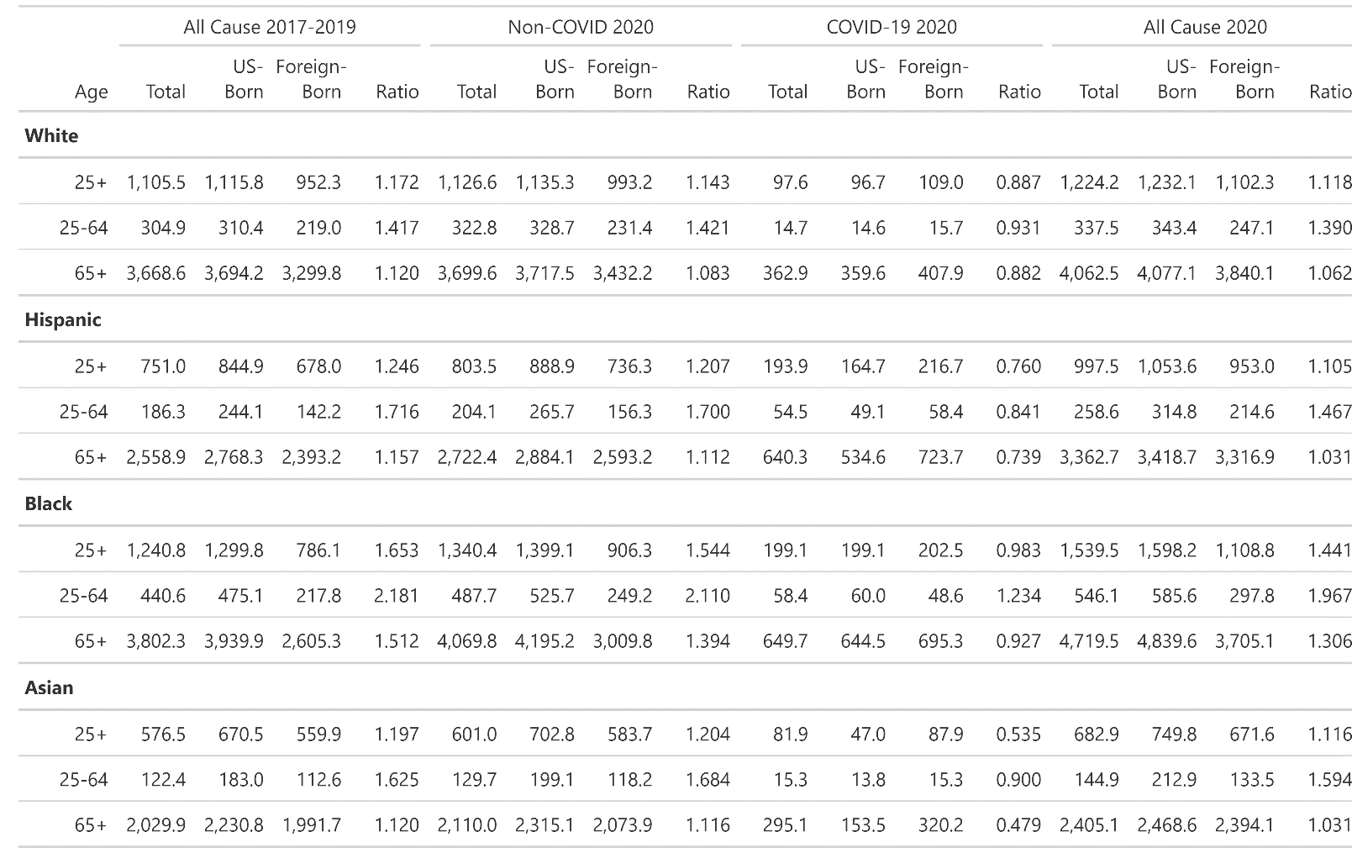

*Notes: Ratios are US-Born mortality (numerator) over Foreign-Born mortality (denominator). A ratio close to one implies equal ASDR between US-born and foreign-born individuals. Values higher than one indicate higher mortality for the US-born, and values smaller than one indicate higher mortality for the foreign-born.*

Supplementary Table 4: Ratio of Age-Standardized Death Rates by Race/Ethnicity, Period, Nativity, and Sex (Reference Non-Hispanic White Population)

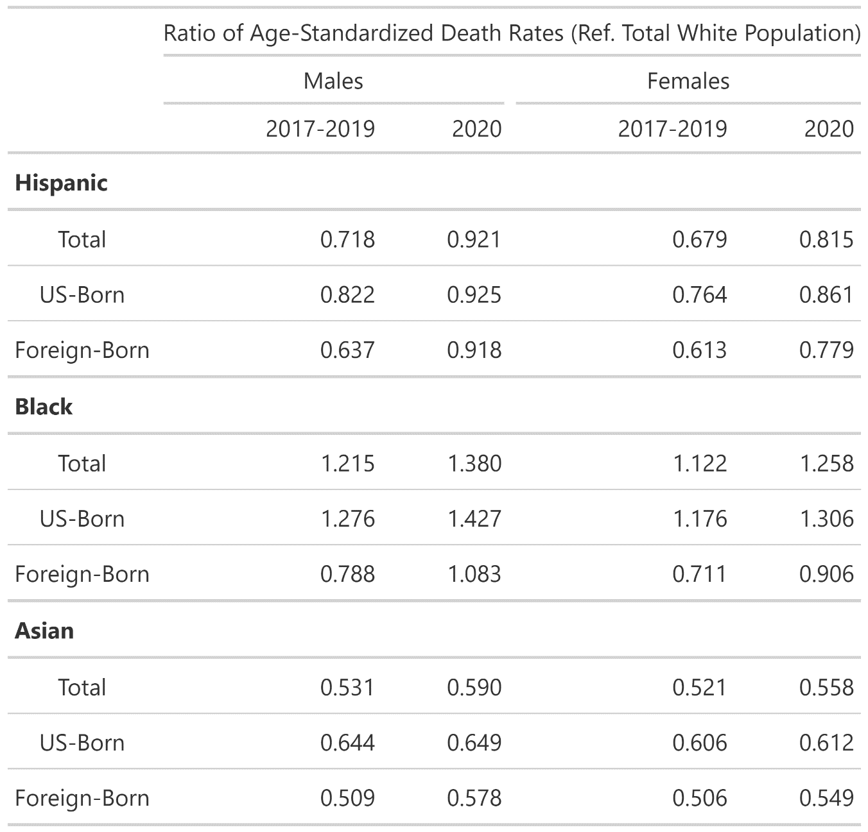

Supplementary Table 5a: Age-standardized Death Rates per 100,000 by Cause of Death, Males 25+

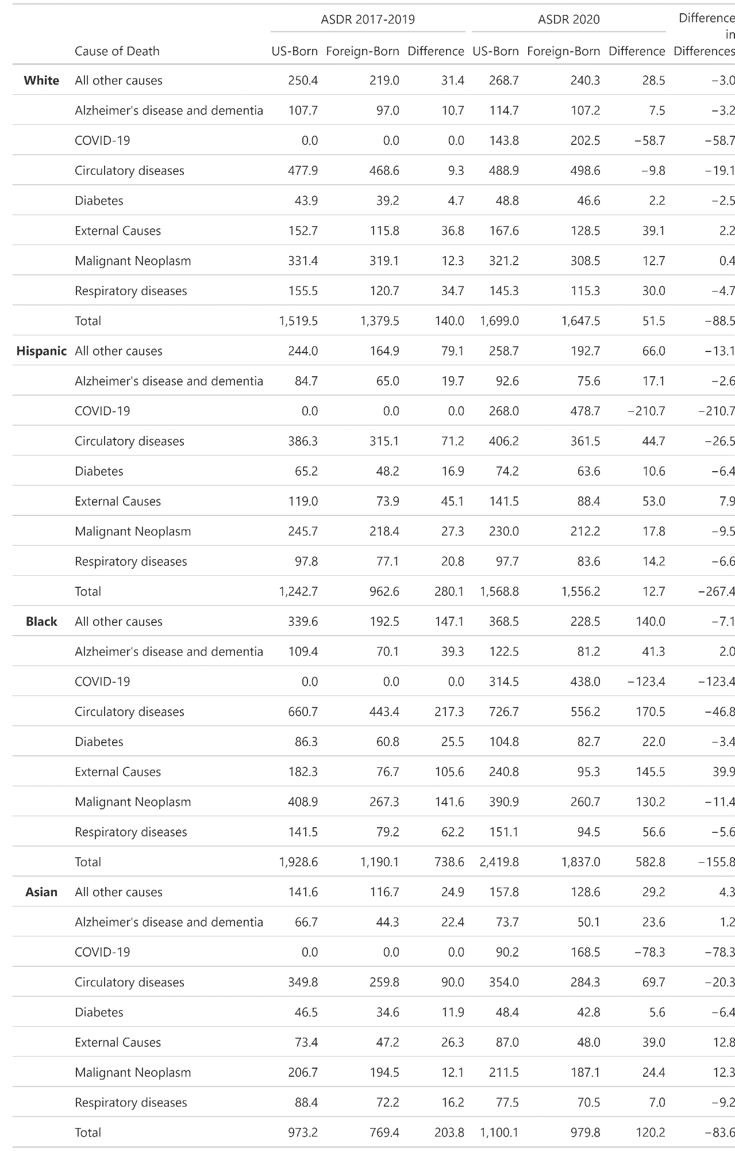

*Notes: The “Difference” column refers to differences in cause-specific ASDR between US-Born and Foreign-Born populations. The “Difference in Differences” column computes the difference between the US-Born to Foreign-Born difference in 2017-2019 and the difference in 2020. A negative value in either of the “Difference” columns indicates that mortality is lower among the Foreign Born. Negative values in the “Difference in Differences” column indicates that the mortality advantage of the Foreign-Born population decreased in 2020 relative to 2017-2019.*

Supplementary Table 5b: Age-standardized Crude Death Rates per 100,000 by Cause of Death, Females 25+

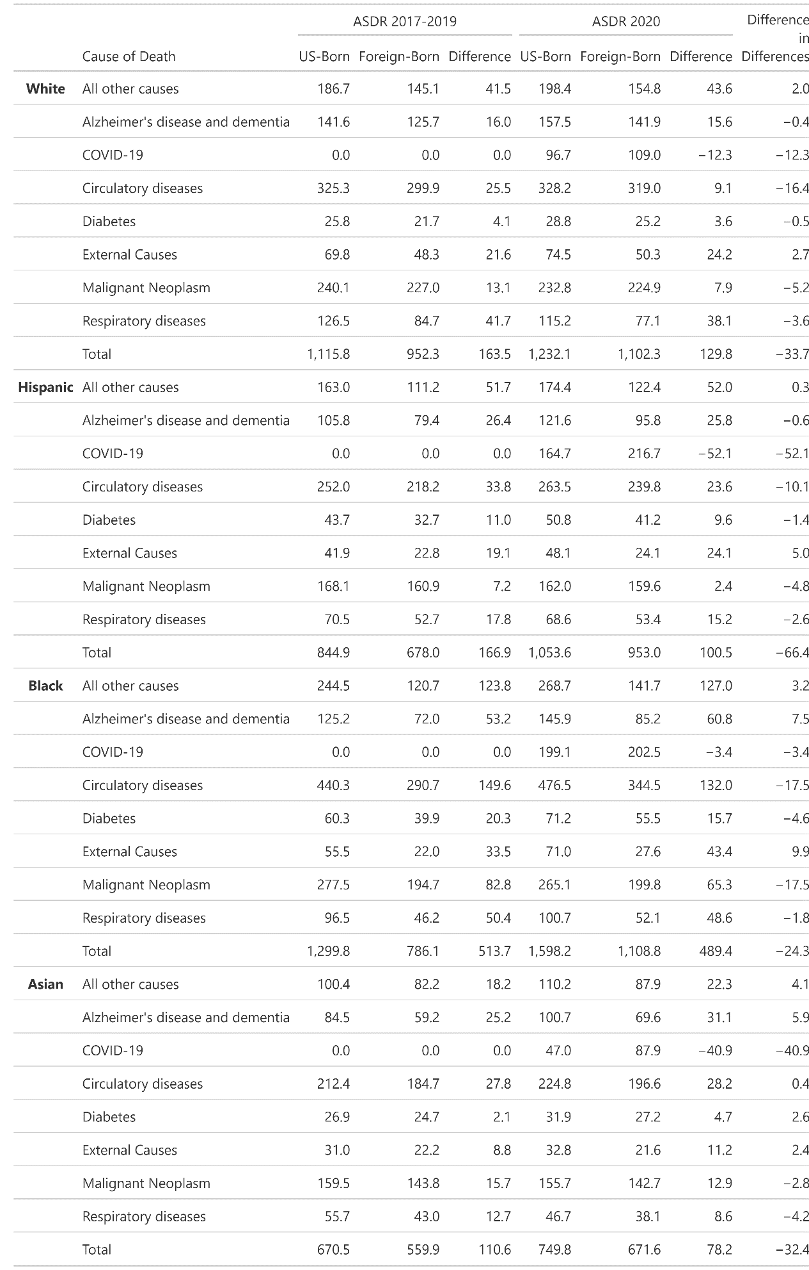

*Notes: The “Difference” column refers to differences in cause-specific ASCDR between US-Born and Foreign-Born populations. The “Difference in Differences” column computes the difference between the US-Born to Foreign-Born difference in 2017-2019 and the difference in 2020. A negative value in either of the “Difference” columns indicates that mortality is lower among the Foreign Born. Negative values in the “Difference in Differences” column indicates that the mortality advantage of the Foreign-Born population decreased in 2020 relative to 2017-2019.*