A General-Purpose Algorithm for Life Table Construction

Introduction
The most widely used textbooks for demographic methods (Keyfitz and Caswell 2005; Preston, Heuveline, and Guillot 2001; Wachter 2014) introduce life tables separately from mortality modeling, and, in covering life table construction, treat age-specific mortality rates as given. The problem of how to estimate mortality rates, parametrically or non-parametrically, is covered in additional chapters (Preston et al. 2001), ignored altogether (Keyfitz and Caswell 2005; Wachter 2014), or confined to more specialized books on statistical demography or mortality modeling (Alho and Spencer 2005; Macdonald, Richards, and Currie 2018). The related issue of smoothing or graduating estimated mortality rates to improve the representation of underlying mortality conditions is also dealt with separately if at all, giving the impression that mortality modeling, smoothing, or graduation, and life table construction are separate processes.
There is no such thing as the best algorithm for life table construction. Even the existence of a reasonably simple universal algorithm seems debatable. What we are left with is a general-purpose algorithm which will provide satisfactory estimates most of the time, with no promise of providing the best, or even reasonable estimates all of the time. Such an algorithm is the focus of the present paper.
However, modern life table construction, whether by national statistical agencies or other institutions, regularly involves both mortality modeling and mortality smoothing or graduation. For example, in constructing life tables for the total population, the National Center for Health Statistics (NCHS) in the United States fits logistic models (Himes, Preston, and Condran 1994; Perks 1932; Thatcher, Kannisto, and Vaupel 1998) in the age range 85-99 and uses the predicted rates to replace observed rates for ages 85-120 (Arias, Xu, and Kochanek 2025). The Human Mortality Database (HMD) uses a similar procedure but fits the logistic model to ages 80 and above and replaces the observed rates with the predicted ones above age 95 and for any age between 80 and 95 with fewer than 100 deaths (Wilmoth et al. 2025). The Australian Government Actuary and Statistics Canada use a different approach in which mortality rates or probabilities of death for the entire age range are smoothed using B-splines with manually placed knots. Both agencies complement B-spline smoothing with old-age extrapolation. The Australian Government Actuary uses a Makeham model (Makeham 1860) to extrapolate the smoothed rates above age 90 for males and 96 for females (Australian Government Actuary 2024). Statistics Canada fits a logistic model and uses to replace observed rates above age 95 before using B-spline smoothing (Statistics Canada 2023).
These examples illustrate two important points. First, modern life table construction is rarely disjointed from statistical modeling, even when using high-quality full population data. Second, different statistical agencies and institutions employ different methods, and there is no common standard to process raw mortality rates into life tables. A third related point is that despite the use of statistical methods, and despite their use being motivated by the stochasticity of mortality, uncertainty intervals for life table quantities are rarely reported. For example, none of the sources above quantifies the uncertainty due to the stochasticity of mortality (i.e. the same underlying rates can generate different death counts), the uncertainty in the model parameters (i.e. what we quantify with standard errors on model coefficients), or the uncertainty coming from the choice of a specific modeling approach (i.e. how would have the results changed if a different model had been used or the same model had been fit on a different age range?).
A potential rebuttal to the last two points is that with national data for large populations the choice of modeling approach is largely irrelevant because stochastic variation is minimal at most ages and a range of sensible models will provide essentially equivalent estimate, with very little uncertainty. For example, life expectancy at birth for Canada in 2019 was estimated as 82.22 years by Statistics Canada and as 82.25 years by the Human Mortality Database. Some would also argue that when estimates are constructed from population data, sampling theory does not apply. However, one counter argument is that uncertainty comes from the stochasticity of the data so that we can still think of having sampled one specific realization of the data generating process and ask what other values the observed death counts could have taken. Both arguments are somewhat convincing in cases in which models are hardly needed, and raw mortality rates would provide essentially the same estimates as the modeled ones. However, when the same methods are applied subnationally, for example in the United States to construct state-specific estimates (Arias, Xu, Tejada-Vera, et al. 2025) or in Canada (Statistics Canada 2023) to construct province-specific estimates, or estimates are stratified by race and ethnicity, for example in the NCHS national life tables (Arias, Xu, and Kochanek 2025), raw mortality rates can be fairly unstable, the modeling approach can have a stronger influence on the estimates, and model-based uncertainty can be substantial.
We do not wish to make universal recommendations for the best method to construct life tables across multiple populations. In fact, we believe any such recommendation would prove suboptimal in the real world because, for example, flexible models that work well when abundant data can drive the estimation, may fail in surprising ways when faced with scarce or low-quality data. At the same time, we want to provide a general approach that can deal with a reasonable range of populations and allow researchers and analysts to integrate mortality modeling, smoothing, and uncertainty quantification in their life tables. What we propose is an extension of existing methods integrating relational models, dating back to the work of William Brass (Brass 1971), with modern spline-based methods for additional flexibility.

Methods

Setup and a Note on Age as a Continuous Variable
We start by recognizing that mortality rates are not an observed quantity, only death counts are, and thus mortality models are more naturally expressed as models for death counts rather than models for rates. Among potential distributions for processes in which we wish to model the rate (rather than the probability) with which an event occurs, the Negative-Binomial distribution stands out, at least in a frequentist framework, as a more flexible alternative to the Poisson distribution, since it relaxes the assumption of equal mean and variance (thus allows for overdispersion). Denoting the observed death counts for the age-group $\left[x,x+n\right)$ with ${}_{n}^{}{D_{x}^{}}$ we then write:
$$\begin{aligned}{}_{n}^{}{D_{x}^{}}∼NegativeBinomial\left({}_{n}^{}{λ_{x}^{}},θ\right) \#\left(1\right)\end{aligned}$$
In a generalized linear framework, we would then write:
$$\log\left({}_{n}^{}{λ_{x}^{}}\right)=\log\left(μ_{a^{*}}\right)+\log\left({}_{n}^{}{E_{x}^{}}\right)$$
$$\begin{aligned}\log\left(μ_{a}\right)=Xϕ\#\left(2\right)\end{aligned}$$
Where ${}_{n}^{}{E_{x}^{}}$ are the person-years of exposure for ages $\left[x,x+n\right)$. Notice that we wrote $μ_{a}$ for the mean of the Negative-Binomial distribution rather than ${}_{n}^{}{M_{x}^{}}$. We did so because we wish to model instantaneous mortality rates, rather than rates referring to a specific age range. Why? Because modeling mortality as a continuous process over age allows us more flexibility in what we can predict from the model. For example, we could start from age-specific death counts in five-year intervals and predict age-specific mortality rates in single-year intervals (or any arbitrary interval). Our ability to relate $μ_{a}$ to ${}_{n}^{}{D_{x}^{}}$ relies on the assumption that $μ_{x}$ is continuous in the range $\left[x,x+n\right)$, and on assumptions about the distribution of person-years within the same age range and the change in $μ_{x}$ over the age interval. To see why, it is helpful to write ${}_{n}^{}{D_{x}^{}}$, ${}_{n}^{}{E_{x}^{}}$, and the corresponding rate ${}_{n}^{}{M_{x}^{}}$as integrals over some continuous age measure:
$$\begin{aligned}{}_{n}^{}{E_{x}^{}}=\int_{x}^{x+n}{E_{a}}da \#\left(3\right)\end{aligned}$$
$$\begin{aligned}{}_{n}^{}{D_{x}^{}=}\int_{x}^{x+n}{μ_{a}⋅E_{a}}da \#\left(4\right)\end{aligned}$$
$$\begin{aligned}{}_{n}^{}{M_{x}^{}=\frac{{}_{n}^{}{D_{x}^{}}}{{}_{n}^{}{E_{x}^{}}}=}\frac{\int_{x}^{x+n}{μ_{a}⋅E_{a}}da }{\int_{x}^{x+n}{E_{a}}da} \#\left(5\right)\end{aligned}$$
Where in Equation (4) $μ_{a}$ is the instantaneous mortality rate. Equation (4) also tells us that ${}_{n\left(x\right)}^{}{D_{x}^{}}$ is a weighted average of age-specific mortality rates, with weights proportional to the number of person-years lived by people with exact age $a$. Assuming that $μ_{a}$ is continuous, the Mean Value Theorem guarantees that there exists some value $a^{*}∈\left[x,x+n\right)$ such that ${}_{n}^{}{M_{x}^{}}=μ_{a^{*}}$. In other words, in addition to being a weighted average of mortality rates in the age interval $\left[x,x+n\right)$, ${}_{n}^{}{M_{x}^{}}$also equals the instantaneous mortality rate at a specific age. What age? It depends on the age distribution of the person-years of exposure with the age interval, which will be influenced by fertility, mortality, and possibly migration patterns of the population we are studying, and on the curvature of the instantaneous mortality rate. The younger the age distribution, the lower $a$ will be but the steeper the mortality rate (with a positive slope), the higher $a^{*}$ will be. However, when the age intervals are relatively narrow and mortality is relatively flat, a good approximation is:
$${}_{n}^{}{M_{x}^{}≈}μ_{(x+n)/2}$$
The narrower the interval the better the approximation. If we have access to more information on the distribution of the exposures, we could also improve the approximation by selecting a better $a^{*}$. A better approximation will be needed for the first age interval, in which $a^{*}$ will be closer to 0.1, and the open-ended interval, for example 110+, in which it will be close to 111.5. In any case, knowing that there exists some age $a^{*}$ for which ${}_{n}^{}{M_{x}^{}}=μ_{a^{*}}$ and thus${}_{n}^{}{D_{x}^{}}=μ_{a^{*}}⋅{}_{n}^{}{E_{x}^{}}$is what allows us to write Equation (2), and thus to relate a death count for an age range to the mortality rate for an exact age.

A Review of (Selected) Method for Mortality Smoothing
Back to equation (2), representing a general log-linear model for mortality we wrote:
$$\begin{aligned}\log\left(μ_{a}\right)=Xϕ \#\left(2\right)\end{aligned}$$
The simplest model with age-varying mortality is:
$$\begin{aligned}\log\left(μ_{a}\right)=β_{0}+β_{1}⋅a \#\left(6\right)\end{aligned}$$
Which corresponds to Gompertz’s formulation (Gompertz 1825) of a long-linear relationship between age and mortality. Gompertz’s model remains a surprisingly good approximation for mortality in middle and late adulthood (approximately ages 30 to 85) but is too rigid to model mortality at younger and older ages. A popular alternative, with the same number of parameters, is a relational model in which a fixed standard is used as a covariate, and we would write:
$$\begin{aligned}\log\left(μ_{a}\right)=β_{0}+β_{1}⋅log⁡(μ_{a}^{STD})\#\left(7\right)\end{aligned}$$
This is close in spirit to a Brass relational logit model (Brass 1971), but formulated directly for the log of the rates rather than for the logit of the probability of death. The advantage of this model over Gompertz’s is that it can model mortality across the entire age range, however, it has the same rigidity and can only fit well mortality rates that have a shape close to that of the standard. The standard itself is thus crucial to having good fit but also allows the analyst to build in some desirable features, for example the absence of age-heaping and a slowdown in mortality increases at the oldest ages (e.g. by applying a logistic model to an existing life table and predicting mortality).
The next natural question is whether we can relax the relational model to preserve the ability to model mortality in the entire age range while also being able to capture systematic deviations from the standard schedule. The TOPALS relational model (de Beer 2012) was introduced precisely for this purpose and uses linear splines to model ratios of probabilities of death under the observed mortality rates and the standard schedule. Subsequent refinements (Gonzaga and Schmertmann 2016) express the deviations as additive difference between the observed and standard log mortality rates and replace linear splines with penalized B-splines (Currie and Durban 2002; Eilers and Marx 1996). In a sense, the TOPALS relational approach combines Brass-type relational models with mortality modeling based on P-splines (Currie, Durban, and Eilers 2004), ensuring improved performance with sparse data. We can write the Gonzaga and Schmertmann (2016) version of TOPALS as:
$$\begin{aligned}\log\left(μ_{a}\right)=β_{0}+β_{1}⋅\log\left(μ_{a}^{STD}\right)+s(a)\#\left(8\right)\end{aligned}$$
Where $s(a)$ represents the smooth deviations of the observed log rates from the standard schedule. An advantage of this formulation, though this also applies to the original TOPALS, is that the standard schedule has little influence on the resulting estimates unless the input data is extremely noisy, in which case the model “defaults” to the standard schedule, only adjusting for the slope of mortality increase over age and its level (Gonzaga and Schmertmann 2016). The formulation of Gonzaga and Schmertmann (2016) requires the specification of the number and location of knots for the splines. However, with the introduction of P-splines (Eilers and Marx 1996), this step becomes unnecessary and the only choice users must make is how many degrees of freedom $k$ the smooth term should have prior to penalization. P-splines for mortality modeling are popular in actuarial applications (Currie et al. 2004; Macdonald et al. 2018). An alternative to P-splines is the thin-plate regression spline (Wood 2003), an optimal low-rank basis that is particularly suited for multidimensional smoothing. While the standard roughness penalties for both P-splines and thin-plate splines leave a linear null space unpenalized, later advancements introduced an additional penalty specifically targeting this null space (Marra and Wood 2011). This modification enables data-driven variable selection, allowing any smooth term to be shrunk strictly to zero and eliminated from the model when it is uninformative. This is a particularly useful feature when combining a relational and spline-based model because it allows a simpler relational-only model if the data suggests it is adequate to fit the data.

The Generalized Additive Relational Model
Starting with the key idea of TOPALS of combining a relational model with a flexible term to account for systematic deviations from the standard schedule, and integrating a more modern approach to the estimation of smooth terms by relying on penalized thin-plate splines, we arrive at the following model:
$${}_{n}^{}{D_{x}^{}}∼NegativeBinomial\left({}_{n}^{}{λ_{x}^{}},θ\right)$$
$$\log\left({}_{n}^{}{λ_{x}^{}}\right)=\log\left(μ_{a}\right)+\log\left({}_{n}^{}{E_{x}^{}}\right)$$
$$\begin{aligned}\log\left(μ_{a}\right)=β_{0}+β_{1}⋅\log\left(μ_{a}^{STD}\right)+s(a)\#\left(9\right)\end{aligned}$$
$$s\left(a\right)=\sum_{j=1}^{k-1}{γ_{j}b_{j}(a)}$$
Where $b_{j}(a)$ are the thin plate spline basis functions and $γ_{j}$ are the corresponding coefficients. This model can be fit by maximizing a penalized log-likelihood. Let $l(β,γ,θ)$ be the unpenalized log-likelihood of the Negative Binomial model. The parameter estimates are then obtained by maximizing:
$$l_{p}=l\left(β,γ,θ\right)-\frac{1}{2}λγ^{T}Sγ$$
Where $S$ is the penalty matrix. We call this model the generalized additive relational model, in reference to its combination of a relational approach with the generalized additive models machinery. We wish to clarify that nothing in this model is new, and it is essentially an improved version of the TOPALS approach as revised by Gonzaga and Schmertmann. Still, we hope to convince readers that framing this model is terms of modern GAM machinery (Wood 2023) makes estimation much simpler and more accessible to a wider audience that can follow the basic idea behind the model but not the technical implementation details of previous estimation approaches.

The Estimation Workflow
The last step we are left with is to define a workflow for how to go from the raw data (counts and exposures) to a life table. Because a standard schedule is involved, we also need to discuss how to derive a suitable schedule, but we will postpone this problem for the next section. As we mentioned above, we want to fit the model:
$${}_{n}^{}{D_{x}^{}}∼NegativeBinomial\left({}_{n}^{}{λ_{x}^{}},θ\right)$$
$$\log\left({}_{n}^{}{λ_{x}^{}}\right)=\log\left(μ_{a}\right)+\log\left({}_{n}^{}{E_{x}^{}}\right)$$
$$\begin{aligned}\log\left(μ_{a}\right)=β_{0}+β_{1}⋅\log\left(μ_{a}^{STD}\right)+s(a)\#\left(9\right)\end{aligned}$$
$$s\left(a\right)=\sum_{j=1}^{k-1}{γ_{j}b_{j}(a)}$$
To do so, we need a dataset with one row for each age interval with columns for the estimated age at which the mortality rate for the age interval matches the instantaneous mortality rate (this is the age $a^{*}$ at which $μ_{a^{*}}={}_{n}^{}{M_{x}^{}}$), the death count, the exposure, and the log mortality rate from the standard schedule. From this dataset, and using, for example, the mgcv package in R (Wood 2023), we can fit the model in Equation 9. We will need to choose a suitable number of degrees of freedom $k$, for which we recommend 10. A lower number might be preferred if the data is very irregular, but we have found 10 to be a good compromise between overconstraining the penalized smooth term and avoiding overfitting with sparse data. It is important to note that we can exclude certain ages when fitting the model if, for example, we believe that the corresponding data is unreliable. We will see an example in the application section below. Having fit the model, we can re-express it in purely linear form as:
$$\log\left(μ_{a}\right)=Xϕ$$
Where $ϕ$ combines all the coefficients, both $β$s and $γ$s, and $X$ all the covariates, both the standard schedule $\log\left(μ_{a}^{STD}\right)$ and the thin plate basis functions $b_{j}(a)$. When the model is fit using mgcv, the vector of coefficients $ϕ$ will have an approximately multivariate Normal posterior distribution (we say posterior because mathematically, the penalization procedure is analogous to placing a multivariate Normal prior on the coefficients for the splines, which leads to a multivariate Normal posterior). We can thus write:
$$\begin{aligned}ϕ∼MVN\left(\hat{ϕ},\hat{V_{p}}\right) \#\left(11\right)\end{aligned}$$
Because the coefficients are the only source of uncertainty for the log rates, this is all we need to simulate from the distribution of the log rates, and these log rates are all we need to obtain simulation of the mortality rates and any quantity that is a function of these rates, including every cell in a typical life table. At this point it is important to highlight two valuable features of our approach so far. First, the granularity of our estimates is only constrained by the granularity of the standard schedule, not by input data. If the schedule is obtained from single-year data, then we can simulate single-year data, even if we use abridged data as input. This is a very desirable property because it means we can achieve mortality smoothing and abridged-to-single conversion in a single step. It also greatly simplifies life table construction since the assumptions we need to make about the average age at death in each interval ${}_{n}^{}{a_{x}^{}}$, are less consequential in a single-year table. Second, once we fit the model, we can use it to extrapolate mortality at older ages, once again being constrained only by the age range of the standard schedule rather than by the age range of the input data. If we select a standard schedule which extends to age 110, which is the standard, for example, in the Human Mortality Database, we can use our model to extrapolate the input data to age 110. This is another great property of this approach since it means we can perform mortality smoothing and mortality extrapolation in a single step, all while propagating uncertainty.
Two caveats are in order at this point. First, in Equation 11 above we are effectively conditioning on a specific value for the variance-covariance matrix. The variance-covariance matrix is itself estimated, thus plugging-in the point estimate $\hat{V_{p}}$ leads us to underestimate the uncertainty in the model coefficients. This inconsistency could be solved with a fully Bayesian approach but that goes beyond the scope of the current paper. Second, notice that we simulate the underlying mortality rates, whose distribution reflects model-based uncertainty, rather than also simulating the expected death counts and the corresponding rates by simulating draws from the Negative Binomial distribution. We do so because we are interested in capturing the uncertainty in the mean expected rates, not the uncertainty in the expected rates, which would be larger. This is the relevant level because life table quantities are themselves means of an underlying distribution. The choice of focusing on uncertainty in the underlying rather than observed rates has the consequence that the resulting intervals might not have the nominal coverage when compared with the observed rates, because the latter also reflect the additional variation resulting from the many-to-one relationship between the underlying mortality rates and the observed death counts.
Equipped with a set of simulated single-year mortality rates (say 1,000 simulations), we can apply basic life table machinery to construct one life table for each vector of simulated rates. For the first of such vectors $M_{x}^{1}$, and using $l_{0}=1$ as the radix, we would construct the standard life table columns with the following equations:
$$q_{x}^{1}=\frac{M_{x}^{1}}{1+\left(1-a_{x}\right)*M_{x}^{1}} for x<100 and q_{110}^{1}=1$$
$$p_{x}^{1}=1-q_{x}^{1}$$
$$l_{x}^{1}=\prod_{a<x}{p_{a}^{1}}$$
$$d_{x}^{1}=l_{x+1}^{1}-l_{x}^{1}$$
$$L_{x}^{1}=l_{x+1}^{1}+d_{x}^{1}⋅a_{x}$$
$$e_{x}^{1}=T_{x}^{1}=\sum_{a≤x}{L_{x}^{1}}$$
For the first age interval, we can use the formulas provided by Andreev and Kingkade to estimate appropriate values of $a_{0}$ from the data itself (Andreev and Kingkade 2015) or borrow it from another life table. For the open-ended age interval we can use $a_{110}=1/M_{110}^{1}$, since the proportion of survivors to such an extreme age will be negligible, making this assumption largely inconsequential for life expectancy at most ages. We would then repeat this procedure for each of the 1,000 simulated vectors, thus obtaining a full sample for each cell in the life table. Depending on the main goal for which the life table was constructed, we could then report, for example, the 2.5th, 10th, 25th, 50th, 75th, 90th, and 97.5th percentiles for life expectancy at birth, along with the mean of the distribution. This approach to uncertainty quantification is a model-based version of the Monte-Carlo approach recommended by Hendi (Hendi 2023), but relaxes the distributional assumptions by estimating distributional parameters from the data itself. This step would conclude the workflow.

Constructing a Standard Schedule
We outlined above how we can go from a set of death counts and exposures, possibly abridged, to a single-year life table extending to age 110, and including uncertainty intervals for each of its cells. The only remaining step is how to construct a suitable standard schedule. This is a simpler task than it might appear at first because the only role that the standard plays is to stabilize the estimates and to provide an indication of what the age pattern of mortality should be in the absence of information from the input data. Given these considerations, our recommendation is to use smoothed rates from the Human Mortality Database, with a preference for the country in which the analysis is being conducted if included (e.g. U.S. life tables to construct U.S. state-level life tables). When more suitable data is available, but, for example, does not extend to age 110, we recommend first running the workflow above to obtain a smoothed and extrapolated version of the desired standard, using data from the HMD as the standard for the smoothing procedure, and then using the resulting estimates as the new standard in subsequent analyses. One advantage of relying on HMD rates is that they are already pre-processed so, for example, the age pattern at the oldest age will follow a plausible mortality deceleration without mortality declines. An alternative would thus be to preprocess the preferred non-HMD standard according to the HMD protocol (Wilmoth et al. 2025), and then use it as the standard in subsequent analyses.

Application
We test our proposed approach with two scenarios. First, we use as input abridged death counts and exposures for the United States total population in 2019 from the HMD. Second, we construct “problematic” data with no reported death at ages 0 to 15, an implausible mortality hump at ages 25 to 35, and flat old-age mortality above age 70, with 90 and above as the open-ended age interval. This is a rather extreme case of low-quality data, but we wanted to see how the model performs in such a scenario. In both cases we use single-year rates from the five-year 2015-2019 U.S. life table from the HMD as the standard schedule.

Scenario 1: Baseline Performance on High-Quality Data
In the first scenario, we apply the generalized additive relational model to abridged U.S. 2019 data. The objective is to verify that the model correctly recovers the single-year mortality schedule without introducing bias, and to demonstrate the baseline level of uncertainty for a large national population. We draw 500 simulations from the posterior of the mortality rates ($M_{x}$) to construct 95%, 80%, and 50% uncertainty (credible) intervals.
As shown in Figure 1, the point estimates (model mean) track the real single-year rates with high accuracy across the entire age range. Because the U.S. total population provides very large exposures, the uncertainty is negligible, resulting in tight intervals around the log-mortality rates. Table 1 and the corresponding Figures 2 and 3 show that the model translates abridged data into an accurate single-year life table which closely matches the actual single-year table from the HMD both in terms of survival function ($l_{x}$) and remaining life expectancy ($e_{x}$). For example, the modeled life expectancy at birth matches the empirical abridged and single-year calculations nearly perfectly (79.00 vis-à-vis 79.04), with a tightly bound 95% credible interval (78.86, 79.22).

Scenario 2: Additional Testing with Low-Quality Data
A robust mortality model should perform well even when data is missing, sparse, or shows some anomalies. In our second scenario, the raw rates are heavily distorted by low exposures leading to zero death counts below age 15, and simulated anomalies, including age-heaping/implausible adult mortality hump in the 25-35 range and an unrealistically flat age profile above age 70. To handle the anomalies, which an analyst would detect by looking at the raw data, we drop the counts for ages 0 to 5 and above age 80 during the fitting process. The model naturally handles missingness because the intercept and the coefficient on the standard schedule are estimated on the entire age-range and because the penalized splines in the absence of data will essentially drive the prediction towards the standard schedule.
Figure 4 shows how the model performs with low-quality data. The model relies on the standard schedule to estimate mortality for ages corresponding to the data points. This is a reasonable behavior which, for example, could not be replicated with a pure P-spline model, which has no notion that mortality should decline between age zero and age eight or nine before rising again. Notice the behavior of the uncertainty intervals: in areas with sufficient, albeit noisy, data (e.g., ages 40-60), the intervals narrow around the empirical trend. In areas with missing data (e.g., ages 80+), the intervals widen.
Despite the substantial volatility in the underlying rates, the integration over the age range required to build the life table smooths out some of this noise. Table 2 and the survival and remaining life expectancy plots in Figures 5 and 6 show that the model generates a coherent, monotonically decreasing survival curve and a logically consistent life expectancy trajectory. The 95% uncertainty intervals for $e_{0}$ are significantly wider, 66.28 [63.57, 68.83], compared with the first scenario (reflecting the smaller exposures and more variable data), indicating lower precision of the points estimates, but still providing an accurate summary of the data.

References
Alho, Juha M., and Bruce D. Spencer. 2005. Statistical Demography and Forecasting. Springer Series in Statistics. New York: Springer-Verlag.
Andreev, Evgeny M., and W. Ward Kingkade. 2015. “Average Age at Death in Infancy and Infant Mortality Level: Reconsidering the Coale-Demeny Formulas at Current Levels of Low Mortality.” Demographic Research 33:363–90. doi:10.4054/DemRes.2015.33.13.
Arias, Elizabeth, Jiaquan Xu, and Kenneth Kochanek. 2025. “United States Life Tables, 2023.” National Vital Statistics Reports 74(6):1–63.
Arias, Elizabeth, Jiaquan Xu, Betzaida Tejada-Vera, and Bastian Brigham. 2025. “U.S. State Life Tables, 2022.” National Vital Statistics Reports 74(12).
Australian Government Actuary. 2024. Australian Life Tables 2020-22.
de Beer, Joop. 2012. “Smoothing and Projecting Age-Specific Probabilities of Death by TOPALS.” Demographic Research 27:543–92.
Brass, William. 1971. “On the Scale of Mortality.” Pp. vii–167 in Biological aspects of demography. Barnes and Noble.
Currie, I. D., and M. Durban. 2002. “Flexible Smoothing with P-Splines: A Unified Approach.” Statistical Modelling 2(4):333–49. doi:10.1191/1471082x02st039ob.
Currie, Iain D., Maria Durban, and Paul HC Eilers. 2004. “Smoothing and Forecasting Mortality Rates.” Statistical Modelling 4(4):279–98. doi:10.1191/1471082X04st080oa.
Eilers, Paul H. C., and Brian D. Marx. 1996. “Flexible Smoothing with B-Splines and Penalties.” Statistical Science 11(2):89–121. doi:10.1214/ss/1038425655.
Gompertz, Benjamin. 1825. “On the Nature of the Function Expressive of the Law of Human Mortality, and on a New Mode of Determining the Value of Life Contingencies.” Philosophical Transactions of the Royal Society of London 115:513–83.
Gonzaga, Marcos Roberto, and Carl Paul Schmertmann. 2016. “Estimating Age- and Sex-Specific Mortality Rates for Small Areas with TOPALS Regression: An Application to Brazil in 2010.” Revista Brasileira de Estudos de População 33:629–52. doi:https://doi.org/10.20947/S0102-30982016c0009.
Hendi, Arun. 2023. “Estimation of Confidence Intervals for Decompositions and Other Complex Demographic Estimators.” Demographic Research 49:83–108. doi:10.4054/DemRes.2023.49.5.
Himes, Christine L., Samuel H. Preston, and Gretchen A. Condran. 1994. “A Relational Model of Mortality at Older Ages in Low Mortality Countries.” Population Studies 48(2):269–91. doi:10.1080/0032472031000147796.
Keyfitz, Nathan, and Hal Caswell. 2005. Applied Mathematical Demography. Statistics for Biology and Health. New York: Springer-Verlag.
Macdonald, Angus S., Stephen J. Richards, and Iain D. Currie. 2018. Modelling Mortality with Actuarial Applications. International Series on Actuarial Science. Cambridge: Cambridge University Press.
Makeham, William Matthew. 1860. “On the Law of Mortality and the Construction of Annuity Tables.” Journal of the Institute of Actuaries 8(6):301–10. doi:10.1017/S204616580000126X.
Marra, Giampiero, and Simon N. Wood. 2011. “Practical Variable Selection for Generalized Additive Models.” Computational Statistics & Data Analysis 55(7):2372–87. doi:10.1016/j.csda.2011.02.004.
Perks, Wilfred. 1932. “On Some Experiments in the Graduation of Mortality Statistics.” Journal of the Institute of Actuaries 63(1):12–57. doi:10.1017/S0020268100046680.
Preston, Samuel H., Patrick Heuveline, and Michel Guillot. 2001. Demography: Measuring and Modeling Population Processes. Oxford ; Blackwell Publishers,.
Statistics Canada. 2023. “Methods for Constructing Life Tables for Canada, Provinces and Territories.”
Thatcher, Roger, Väinö Kannisto, and James W. Vaupel. 1998. Odense Monographs on Population Aging 5: The Force of Mortality at Ages 80 to 120.
Wachter, Kenneth W. 2014. Essential Demographic Methods. Harvard University Press.
Wilmoth, John R., Evgeny M. Andreev, Dmitri A. Jdanov, Dana A. Glei, and Tim Riffe. 2025. “Methods Protocol for the Human Mortality Database.”
Wood, Simon. 2023. “Mgcv: Mixed GAM Computation Vehicle with Automatic Smoothness Estimation.”
Wood, Simon N. 2003. “Thin Plate Regression Splines.” Journal of the Royal Statistical Society Series B: Statistical Methodology 65(1):95–114. doi:10.1111/1467-9868.00374.

Figure 1: Observed and Modeled Age-Specific Mortality Rates from Scenario 1.
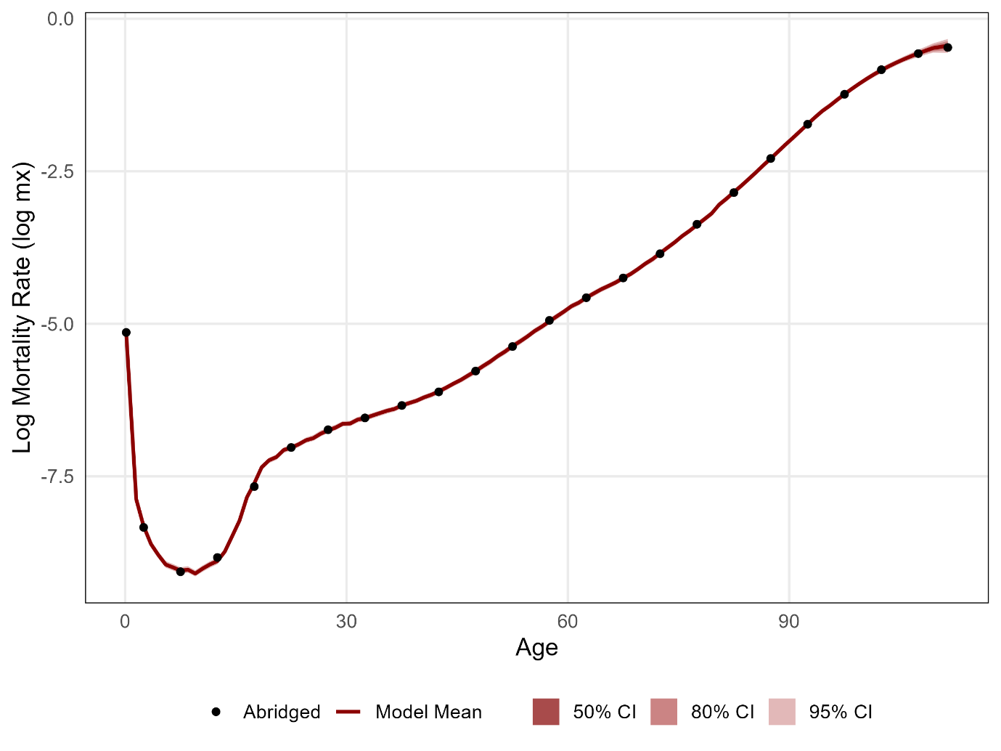

Figure 2: Survival Function under the Observed Abridged, Observed Single-Year, and Modeled Mortality Rates from Scenario 1.
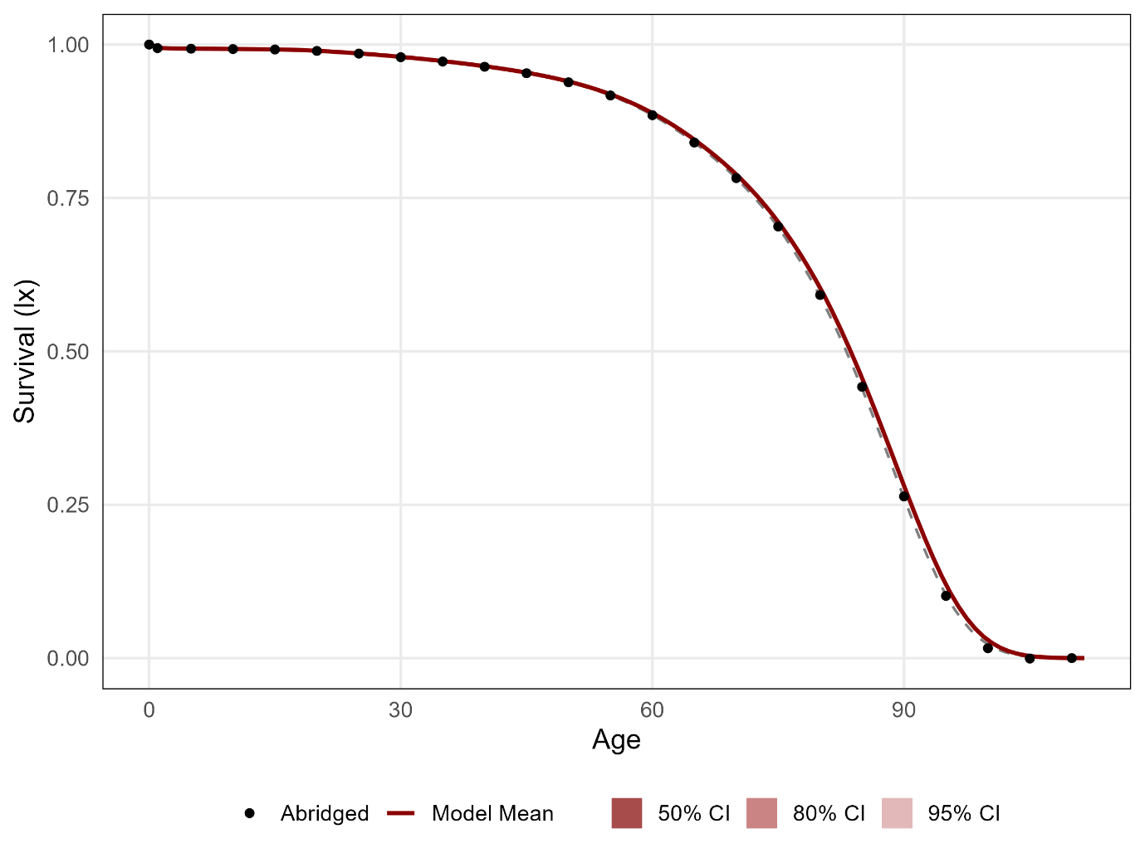

Figure 3: Remaining Life Expectancy under the Observed Abridged, Observed Single-Year, and Modeled Mortality Rates from Scenario 1.
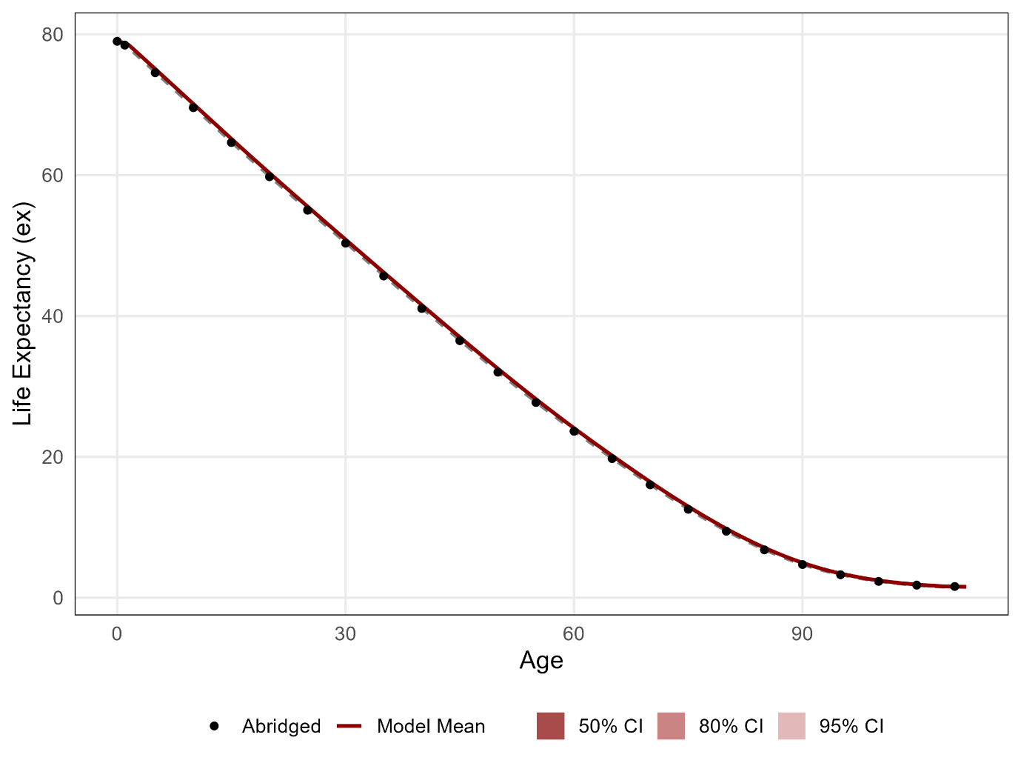

Figure 4: Observed and Modeled Age-Specific Mortality Rates from Scenario 2.
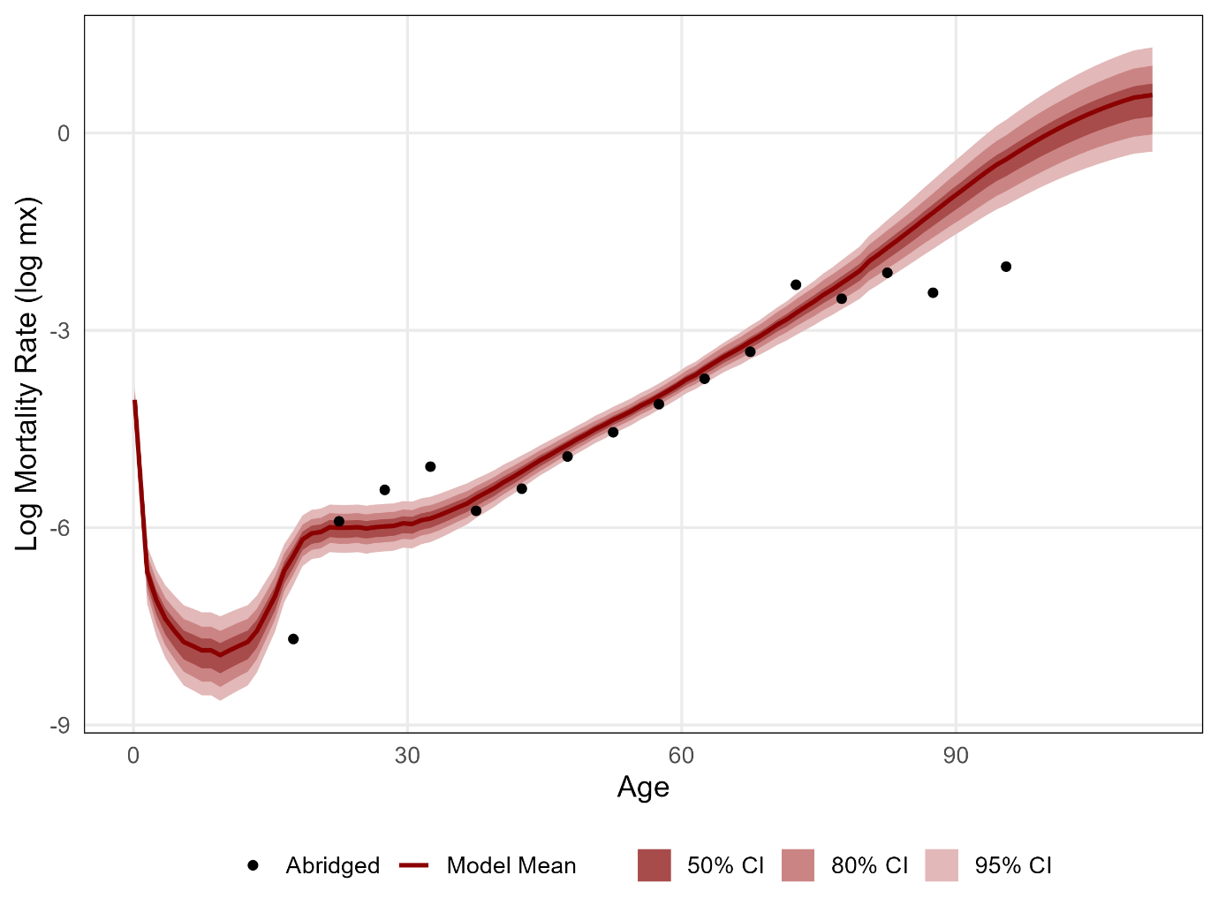

Figure 5: Survival Function under the Observed Abridged and Modeled Mortality Rates from Scenario 2.
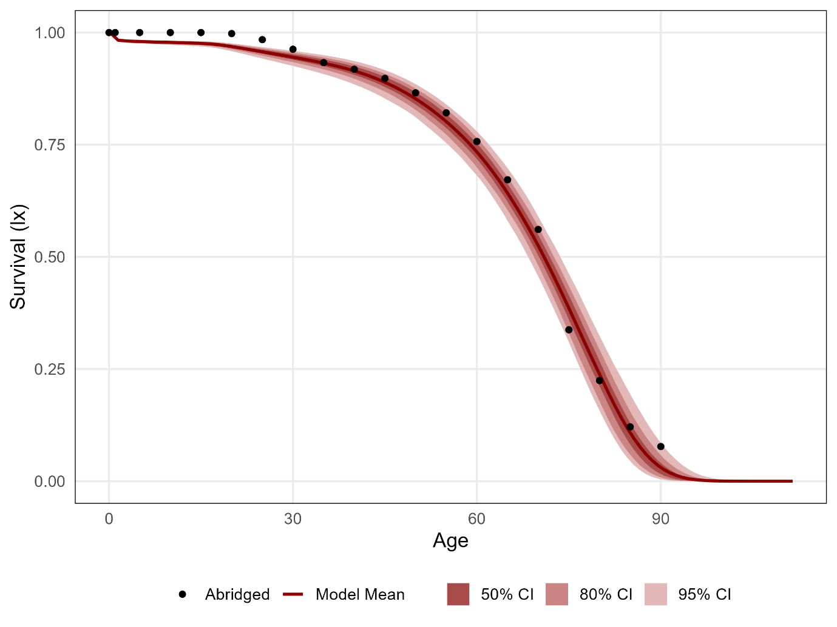

Figure 6: Remaining Life Expectancy under the Observed Abridge and Modeled Mortality Rates from Scenario 2.
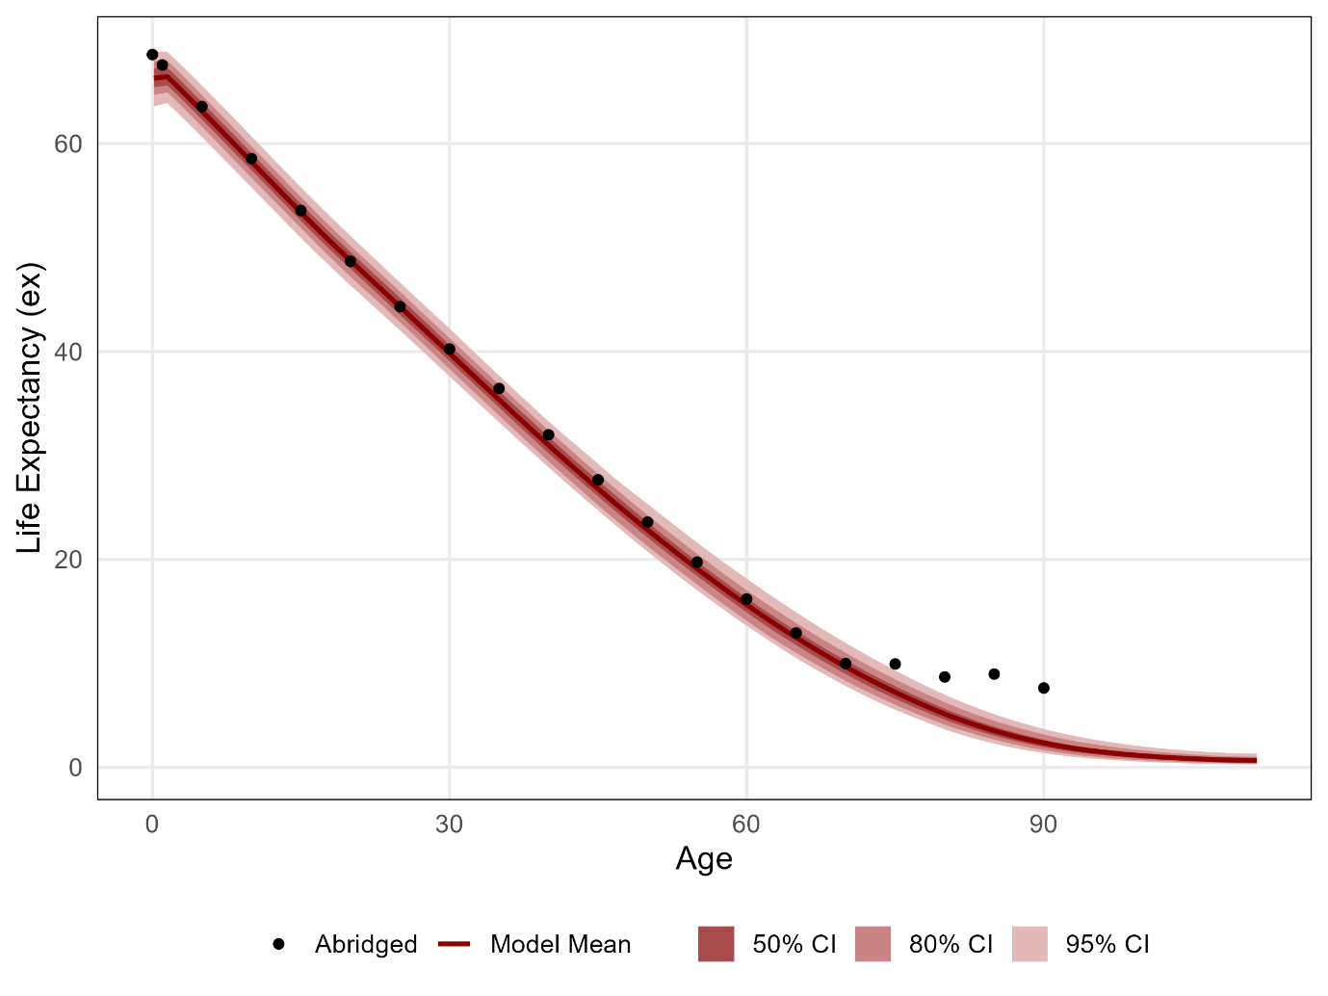

Table 1: Proportion Surviving and Remaining Life Expectancy at Selected Ages under the Observed Abridged, Observed Single-Year, and Modeled Mortality Rates, Scenario 1.
 | Survivors (%) |  |  | Life Expectancy ($e_{x}$)
Age | Abridged | Single-Year | Modeled [95% CI] | Abridged | Single-Year | Modeled [95% CI]
0 | 100.0 | 100.0 | 100.0 [100.0, 100.0] | 79.00 | 79.00 | 79.04 [78.86, 79.22]
10 | 99.3 | 99.3 | 99.3 [99.2, 99.3] | 69.58 | 69.58 | 69.62 [69.44, 69.80]
20 | 99.0 | 99.0 | 98.9 [98.9, 99.0] | 59.77 | 59.77 | 59.82 [59.64, 60.01]
40 | 96.4 | 96.4 | 96.4 [96.3, 96.5] | 41.07 | 41.07 | 41.11 [40.94, 41.28]
60 | 88.5 | 88.5 | 88.5 [88.2, 88.7] | 23.64 | 23.62 | 23.69 [23.53, 23.84]
80 | 59.2 | 58.9 | 59.1 [58.4, 59.7] | 9.45 | 9.43 | 9.50 [9.35, 9.65]
90 | 26.4 | 26.1 | 26.3 [25.5, 27.1] | 4.72 | 4.68 | 4.79 [4.67, 4.91]

Table 2: Proportion Surviving and Remaining Life Expectancy at Selected Ages under the Observed Abridged and Modeled Mortality Rates, Scenario 2.
 | Survivors (%) |  | Life Expectancy ($e_{x}$)
Age | Abridged (Problematic) | Modeled [95% CI] | Abridged (Problematic) | Modeled [95% CI]
0 | 100.0 | 100.0 [100.0, 100.0] | 68.56 | 66.28 [63.57, 68.83]
10 | 100.0 | 97.8 [97.2, 98.2] | 58.56 | 57.76 [55.29, 60.20]
20 | 99.8 | 96.8 [95.7, 97.5] | 48.67 | 48.30 [45.93, 50.67]
40 | 91.8 | 91.2 [88.2, 93.5] | 31.99 | 30.56 [28.44, 32.85]
60 | 75.7 | 72.6 [67.3, 77.3] | 16.19 | 15.30 [13.30, 17.81]
80 | 22.4 | 22.4 [14.4, 31.0] | 8.69 | 4.94 [3.49, 6.77]
90 | 7.7 | 2.6 [0.3, 7.6] | 7.62 | 2.25 [1.30, 3.57]

