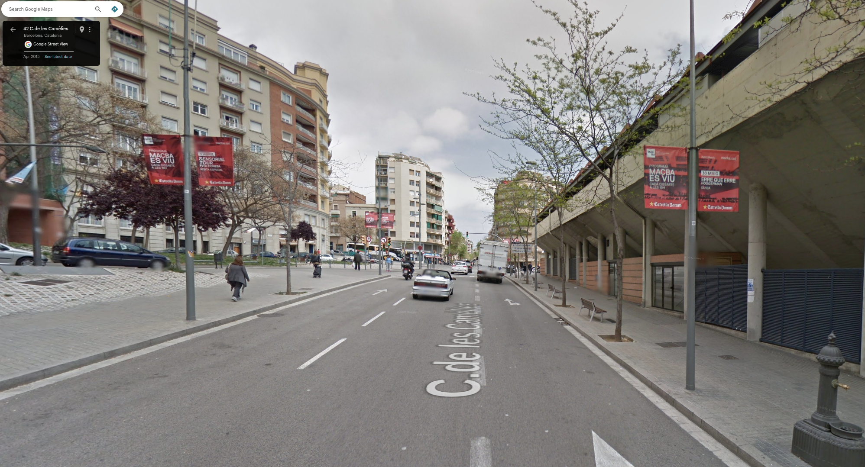  (a) | 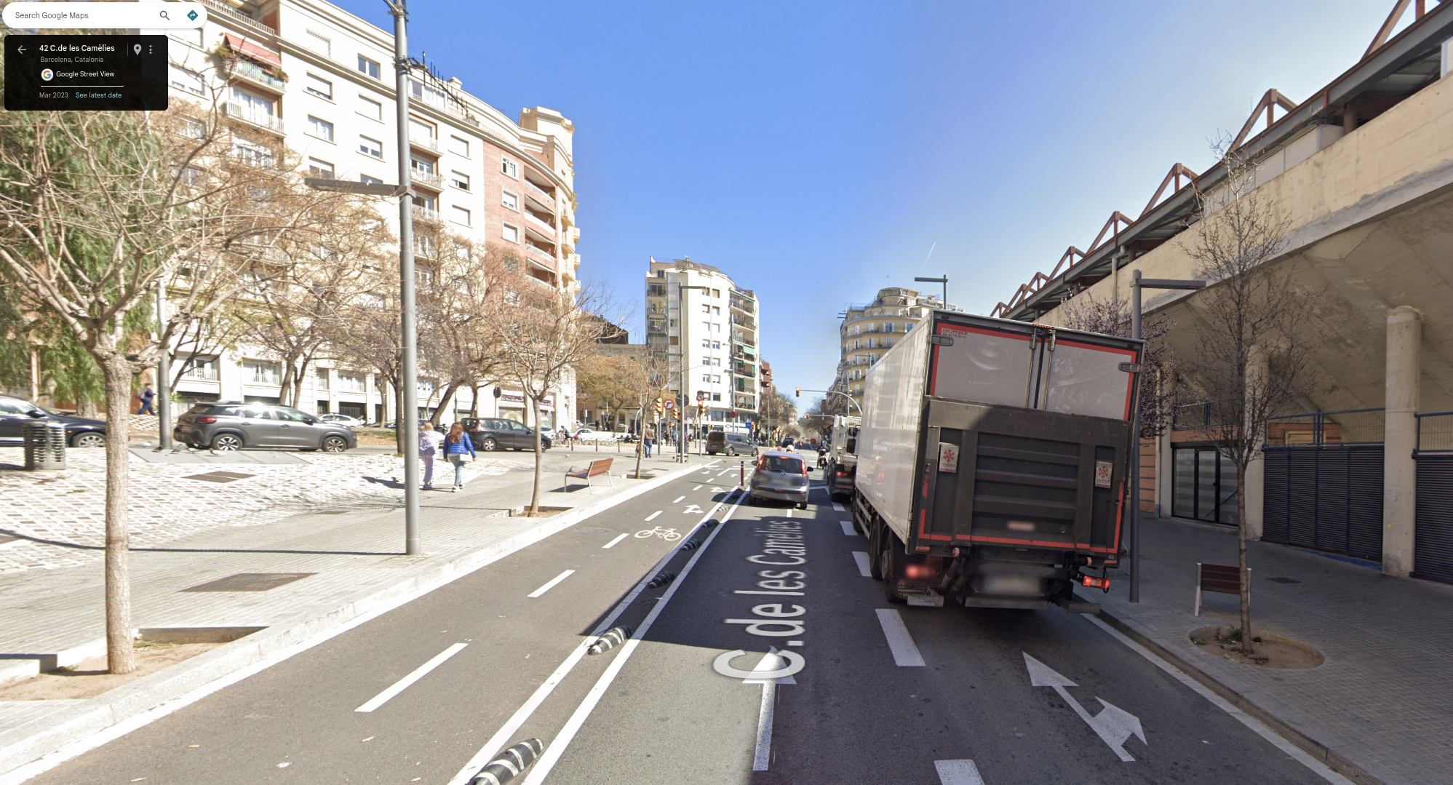  (b)
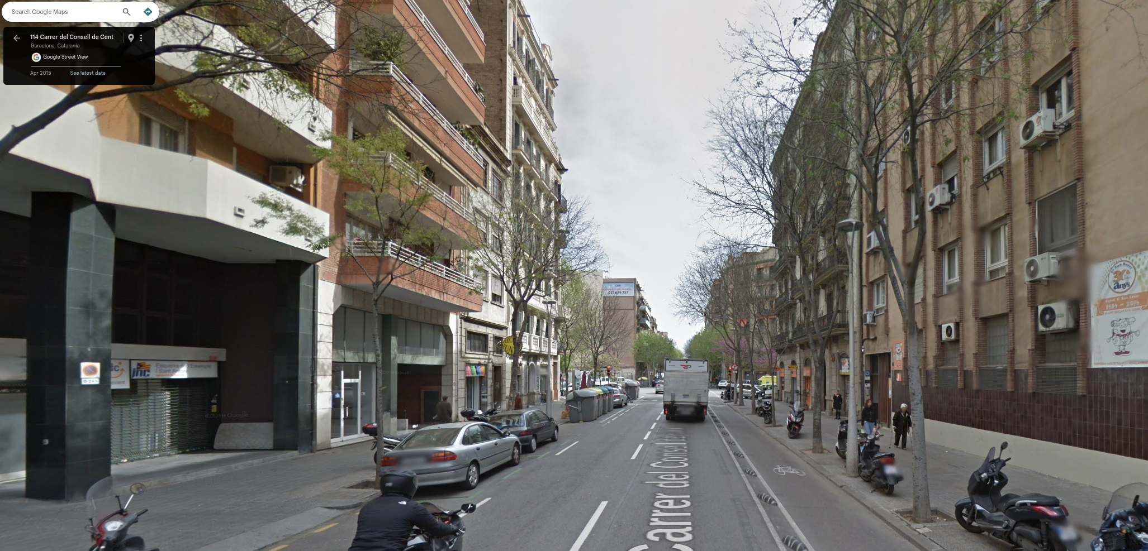  (c) | 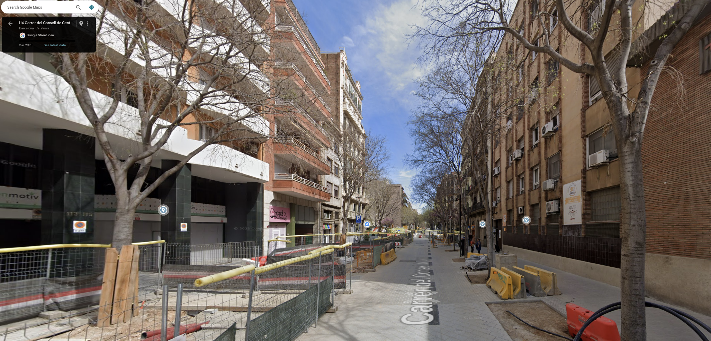  (d)

Figure 2. Examples of OSM-detected cycling-infrastructure change validated through Google Street View (2015–2023). (a–b) Addition: new protected cycle lane on C.de les Camèlies. (c–d) Removal: former protected lane converted into a traffic-calmed civic street on Consell de Cent.

