Wearable Heart Rate Rhythm Predicts Depression and Cardiometabolic Illness in Adolescence
Supplementary Materials
Table of Contents
Section 1. Fitbit Protocol, Processing, and Quality Checks
Section 2. Cosinor Model Specification and Parameter Distributions
Section 3. Multi-Component (24 + 12-Hour) Cosinor Sensitivity Analysis
Section 4. Full Comorbidity Analysis
Section 5. Behavioral Sensitivity Analyses (Activity and Sleep Adjustment)

Section 1. Fitbit Protocol, Processing, and Quality Checks
Fitbit minute-level heart rate (HR), step, and sleep streams from the ABCD Novel Technologies sub-study at Wave 2 were processed through a five-stage pipeline. (1) Non-wear identification combined HR and step criteria (Kiss et al., 2024; Wing et al., 2022): a run of ≥30 consecutive minutes with zero HR and zero steps was flagged as non-wear. (2) Artifact flagging removed minutes with HR < 40 bpm, HR > 200 bpm, or ≥11 consecutive identical readings. (3) A valid wear day required ≥600 minutes of non-zero HR AND non-zero HR coverage in all four 6-hour quadrants (00:00–06:00, 06:00–12:00, 12:00–18:00, 18:00–24:00). (4) Participant-level retention required ≥3 valid wear days AND a wear-period density ≥0.50 (valid days divided by calendar span from first to last valid day; Damme et al., 2024). (5) A single-component cosinor mixed-effects model was fit per participant at Wave 2; participants whose model converged contributed to subsequent analyses. Convergent validity was supported by a moderate-to-strong correlation between the cosinor mesor and the concurrent cuff-measured resting heart rate (r = 0.59, N = 3,392; both measured at the Wave-2 in-person visit).

Table S1.1
Inclusion/Exclusion Flow from Wave-2 Enrollment to the Analytic Cosinor Cohort
Step | N retained | N dropped | % retained | Definition
Enrolled in Wave-2 Novel Technologies sub-study | 8093 | nan | 100.0 | All participants with any Wave-2 Fitbit session in the cohort manifest.
Met ≥3 valid wear days (4-of-4 quadrant rule) | 7230 | 863.0 | 89.3 | ≥3 days with ≥600 non-zero HR minutes AND HR coverage in all four 6-h quadrants.
Met wear-period density ≥ 0.50 | 6388 | 842.0 | 78.9 | Valid days / calendar span from first to last valid day ≥ 0.50 (Damme et al., 2024).
Cosinor model converged → analytic cohort | 7230 | -842.0 | 89.3 | Per-participant mixed-effects single-component cosinor fit converged.
Note. Percentages are relative to the Wave-2 enrolled cohort.

Table S1.2
Fitbit Wear Summary Statistics by Analytic Group
Group | N | Median valid wear days | Mean valid wear hrs/day (SD) | Wear-period density M (SD) | Per-participant cosinor R² M (SD)
Healthy controls (cross-condition) | 2004 | 20 | 13.55 (9.00) | 0.82 (0.30) | 0.82 (0.11)
Incident depression | 463 | 19 | 12.53 (9.04) | 0.82 (0.29) | 0.82 (0.10)
Incident obesity | 457 | 19 | 12.42 (9.01) | 0.78 (0.32) | 0.82 (0.12)
Incident hypertension | 270 | 18 | 11.40 (8.88) | 0.78 (0.30) | 0.81 (0.13)
Note. Healthy controls = participants below the clinical threshold for depression, obesity, and hypertension at every observed wave from Waves 1–4, with confirmed below-threshold follow-up CBCL, BMI, and blood-pressure data at Wave 3 or Wave 4 (N = 2,004). Incident-case groups defined as first onset at Wave 3 or Wave 4. SD = standard deviation; R² = coefficient of determination from the single-component cosinor mixed-effects model.

Table S1.3
Convergent Validity of the Cosinor Mesor Against Cuff-Measured Resting Heart Rate at Wave 2
Wave | N | Pearson r | 95% CI | p
Wave 2 (predictor wave) *** | 3392 | 0.59 | [0.57, 0.61] | < .001
Note. Pearson correlation between Wave-2 cosinor mesor and the cuff-measured resting heart rate from the same in-person visit. CI = confidence interval. * p < .05, ** p < .01, *** p < .001.

Figure S1.1
Distribution of Valid Wear Days Per Participant.
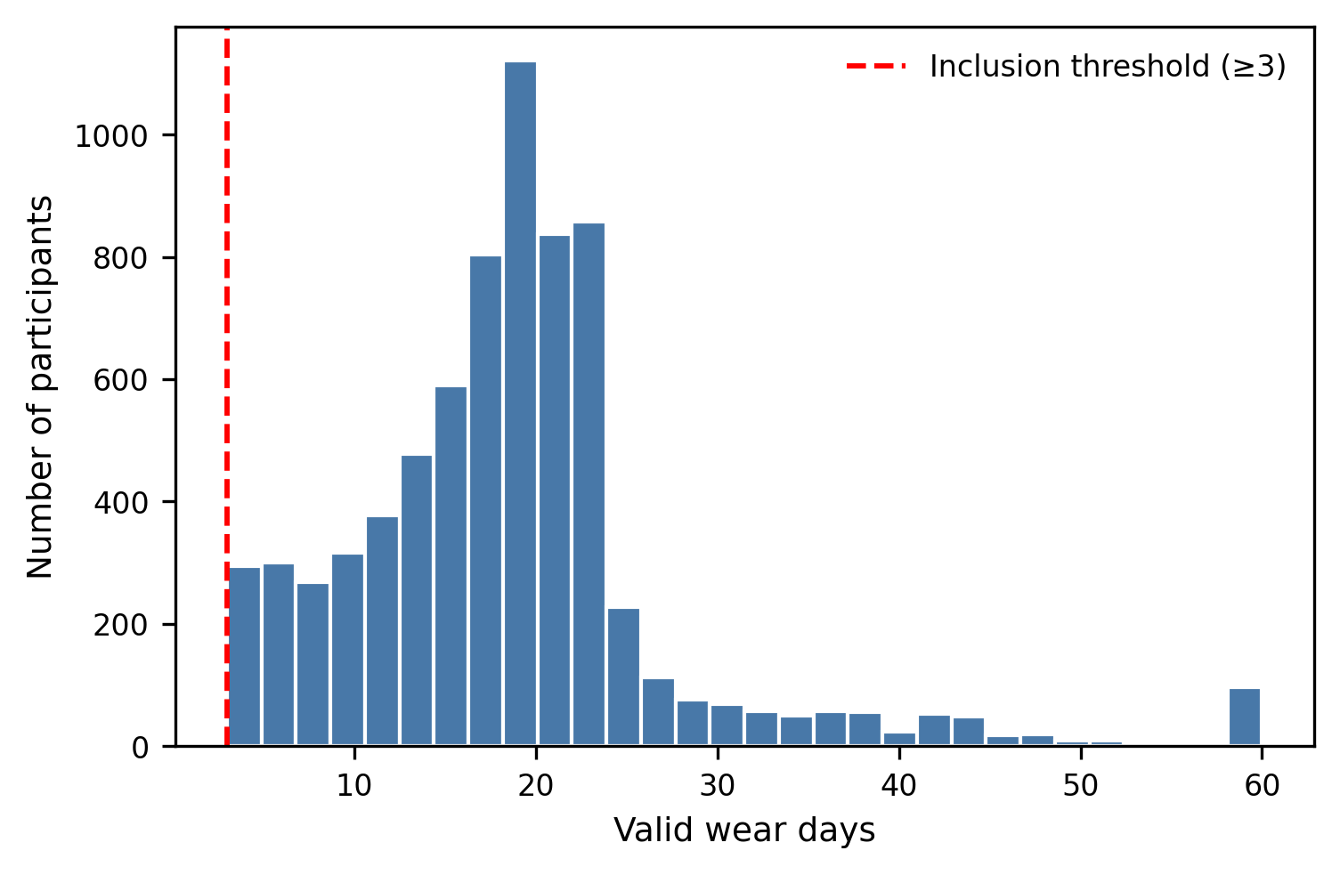
Note. Distribution among the 7,230 participants in the QC-pass cohort. The dashed red line marks the ≥3-day inclusion threshold.

Figure S1.2
Distribution of Wear-Period Density.
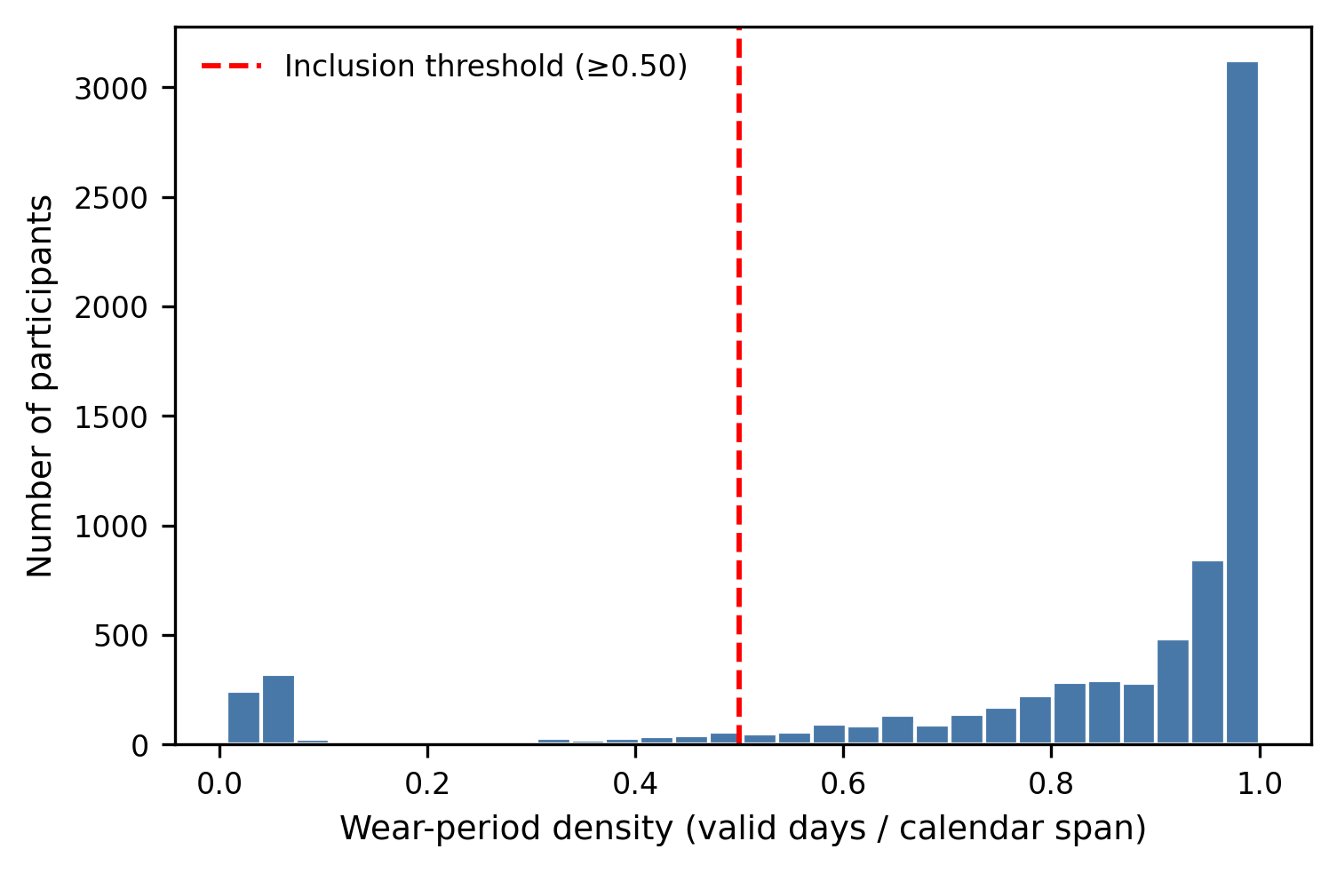
Note. Density = valid days / calendar span. Distribution among the 7,230 participants in the QC-pass cohort. The dashed red line marks the ≥0.50 inclusion threshold.

Figure S1.3
Cosinor Mesor Versus Cuff-Measured Resting Heart Rate at Wave 2.
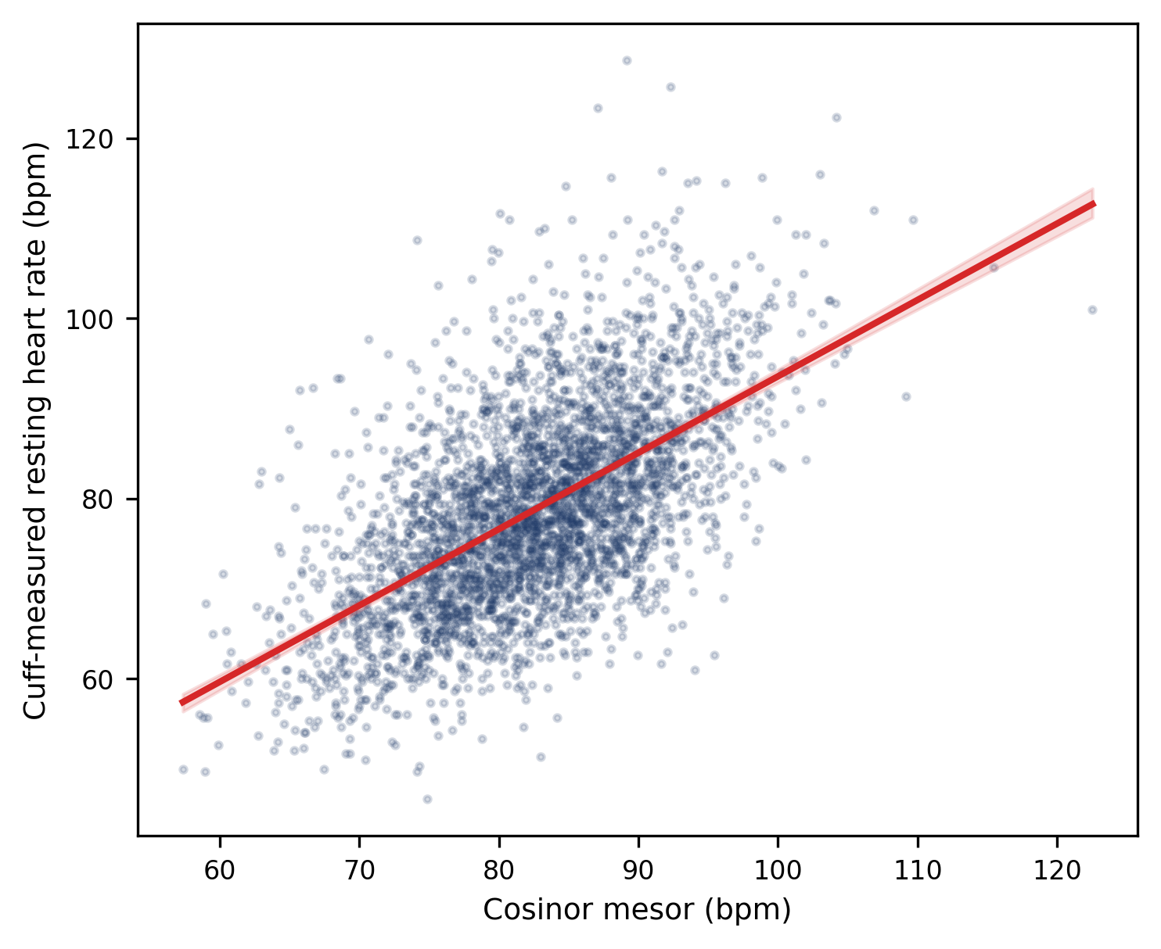
Note. N = 3,392; r = 0.59, p < .001. Red line shows the OLS regression with bootstrap 95% confidence band.

Section 2. Cosinor Model Specification and Parameter Distributions
The single component cosinor model expresses each minute's heart rate as $HR\left(t\right)=M+A·cos\left(2π\left(t-φ\right)/24\right)+ε$, where t is clock hour, M is the mesor (rhythm-adjusted mean), A is the amplitude (peak-to-mesor distance), and φ is the acrophase (clock hour of peak). Equivalently, the model was fit with cosine and sine bases $cos(2πt/24)$ and $sin(2πt/24))$ as fixed effects, with per-participant random slopes on both bases (no random intercept, which would be absorbed by the mesor). Models were fit with lme4 in R 4.5.2. Per-participant best linear unbiased predictors (BLUPs) for mesor, amplitude, and acrophase were extracted from the fitted mixed model. Acrophase was derived from the BLUP cosine (b₁) and sine (b₂) coefficients as atan2(b₂, b₁) · 24/(2π), then wrapped to [0, 24) so values represent clock hour of peak.
For within-person analyses, the same single-component cosinor was re-fit separately to each participant's HR data for each valid wear day. A day counted as a valid daily fit if its R² ≥ .30, and a participant was retained for within-person analyses if they had ≥7 valid daily fits. The median per-day R² was 0.85, and the median number of usable days per participant was 16. Participants whose typical-day cosinor failed to converge were excluded from all analyses.
CBCL T-scores are already age- and sex-normed; nonetheless models adjusted for chronological age and sex as fixed effects, because the cosinor parameters themselves vary systematically with age and sex (e.g., the developmental phase delay in adolescent acrophase). The adjustment is on the predictor side, not the outcome side.

Table S2.1
Per-Participant Cosinor R² Distribution in the QC-Pass Cohort
N | M (SD) | Median | IQR | % > .50 | % > .70 | % > .85
7230 | 0.82 (0.11) | 0.85 | [0.78, 0.89] | 97.8 | 89.0 | 47.8
Note. Single-component cosinor mixed-effects model fit at Wave 2. M = mean; SD = standard deviation; IQR = interquartile range.
Table S2.2
Between-Person Rhythm Parameter Distributions in the QC-Pass Cohort
Parameter | Unit | M | SD | Median | IQR | Min | Max
Mesor | bpm | 82.37 | 7.68 | 82.6 | [77.25, 87.63] | 57.32 | 122.52
Amplitude | bpm | 12.18 | 3.01 | 12.13 | [10.16, 14.09] | 0.87 | 24.79
Acrophase | clock hour | 14.96 | 1.26 | 14.78 | [14.14, 15.59] | 0.22 | 22.84
Note. Best linear unbiased predictors (BLUPs) extracted from the Wave-2 single-component cosinor mixed-effects model. M = mean; SD = standard deviation; IQR = interquartile range; bpm = beats per minute.

Table S2.3
Within-Person Rhythm SD Distributions in the Within-Person Sub-Cohort
Parameter | Unit | N | M | SD | Median | IQR
SD of daily mesor | bpm | 6283 | 4.09 | 1.37 | 3.86 | [3.17, 4.76]
SD of daily amplitude | bpm | 6283 | 3.68 | 1.03 | 3.57 | [2.97, 4.25]
SD of daily acrophase | hr | 6283 | 1.43 | 0.58 | 1.31 | [1.04, 1.65]
Note. Restricted to participants with ≥7 valid daily fits (N = 6,283). SD = standard deviation; IQR = interquartile range; bpm = beats per minute.

Figure S2.1
Example Participant Illustrating the Cosinor Decomposition.
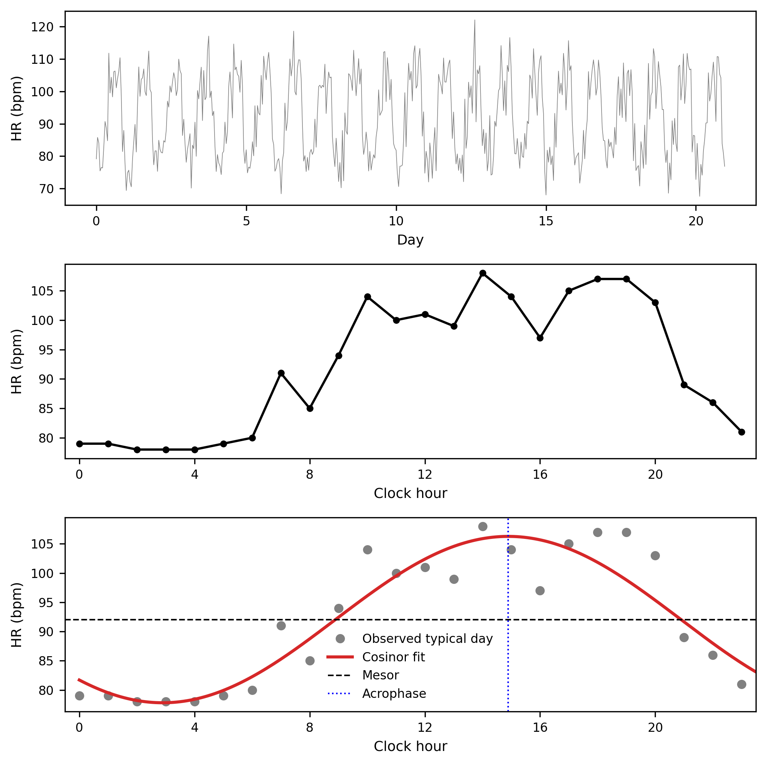
Note. Participant sub-01AJ15N9 (R² = 0.86). Top panel: minute-level HR over 21 days. Middle panel: typical-day profile (mean HR by clock hour). Bottom panel: fitted 24-hour cosinor curve overlaid on the typical-day profile, with mesor (horizontal dashed line) and acrophase (vertical dotted line) indicated.

Figure S2.2
Distribution of Per-Participant Cosinor R² in the QC-Pass Cohort.
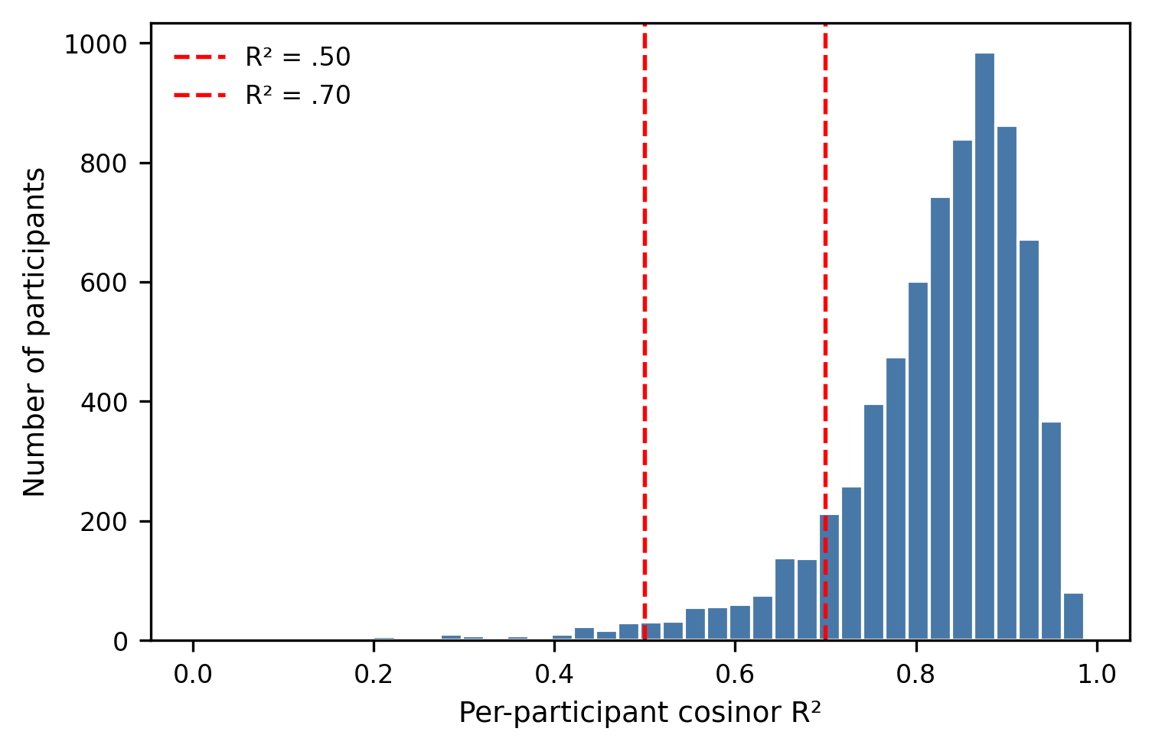Note. Dashed red lines mark R² = .50 and R² = .70.

Section 3. Multi-Component (24 + 12-Hour) Cosinor Sensitivity Analysis
Prior work in pediatric and adolescent samples has shown that the 24-hour rhythm predominates while ultradian (12-hour, 8-hour) components contribute smaller variance (Hadtstein et al., 2004; Sigrist et al., 2023). To confirm that primary findings are not an artifact of the single-component specification, we re-fit each participant's typical-day profile with a joint 24+12-hour cosinor model and re-ran the primary onset regressions using the resulting 24-hour mesor, amplitude, and acrophase parameters. Median 24-hour R² = 0.85; median 24+12-hour R² = 0.91. Primary findings hold under the joint specification, with effect sizes for mesor and acrophase essentially unchanged across all three outcomes.

Table S3.1
Variance Decomposition: 24-Hour Versus 24+12-Hour Cosinor R²
Component | Mean R² (SD) | Median R² | N
24-hour only | 0.823 (0.109) | 0.847 | 7188
24 + 12-hour joint | 0.891 (0.079) | 0.911 | 7188
Added variance from 12-hour | 0.068 (0.059) | 0.053 | 7188
Note. Per-participant R² for the typical-day fit. The 12-hour component contributes a small additional fraction of variance beyond the 24-hour rhythm. SD = standard deviation.

Table S3.2
Between-Person Primary Results: 24-Hour-Only Versus 24+12-Hour Cosinor Parameters
Outcome | Parameter | OR (24-hr only) | OR (24+12-hr) | p (24-hr) | p (24+12-hr)
Depression * | Mesor | 1.13 [1.02, 1.25] | 1.13 [1.02, 1.25] | 0.016 | 0.016
Depression | Amplitude | 1.02 [0.93, 1.12] | 1.02 [0.93, 1.12] | 0.719 | 0.719
Depression | Acrophase | 0.95 [0.87, 1.04] | 0.95 [0.87, 1.04] | 0.279 | 0.279
Obesity *** | Mesor | 1.28 [1.16, 1.42] | 1.28 [1.16, 1.42] | < .001 | < .001
Obesity | Amplitude | 0.91 [0.82, 1.00] | 0.91 [0.82, 1.00] | 0.058 | 0.058
Obesity * | Acrophase | 1.13 [1.03, 1.25] | 1.13 [1.03, 1.25] | 0.011 | 0.011
Hypertension *** | Mesor | 1.31 [1.14, 1.51] | 1.31 [1.14, 1.51] | < .001 | < .001
Hypertension | Amplitude | 0.94 [0.83, 1.07] | 0.94 [0.83, 1.07] | 0.357 | 0.357
Hypertension * | Acrophase | 1.16 [1.02, 1.32] | 1.16 [1.02, 1.32] | 0.024 | 0.024
Note. Odds ratios per 1 SD of the standardized cosinor parameter, from logistic regression with age and sex as fixed effects and family-clustered standard errors. Bold p-values indicate p < .05. OR = odds ratio; CI = confidence interval. * p < .05, ** p < .01, *** p < .001.

Table S3.3
Within-Person SDs: Primary 24-Hour Daily-Cosinor Results
Outcome | Parameter | OR (per SD) | 95% CI | p
Depression * | SD daily mesor | 1.12 | [1.02, 1.23] | 0.014
Depression | SD daily amplitude | 1.04 | [0.94, 1.14] | 0.468
Depression ** | SD daily acrophase | 1.15 | [1.05, 1.25] | 0.002
Depression | SD daily mesor | nan | [nan, nan] | —
Depression | SD daily amplitude | nan | [nan, nan] | —
Depression | SD daily acrophase | nan | [nan, nan] | —
Obesity *** | SD daily mesor | 1.17 | [1.07, 1.28] | < .001
Obesity * | SD daily amplitude | 1.12 | [1.02, 1.24] | 0.017
Obesity *** | SD daily acrophase | 1.16 | [1.06, 1.26] | < .001
Obesity | SD daily mesor | nan | [nan, nan] | —
Obesity | SD daily amplitude | nan | [nan, nan] | —
Obesity | SD daily acrophase | nan | [nan, nan] | —
Hypertension | SD daily mesor | 1.08 | [0.94, 1.24] | 0.287
Hypertension | SD daily amplitude | 1.04 | [0.92, 1.18] | 0.517
Hypertension | SD daily acrophase | 1.09 | [0.97, 1.22] | 0.136
Hypertension | SD daily mesor | nan | [nan, nan] | —
Hypertension | SD daily amplitude | nan | [nan, nan] | —
Hypertension | SD daily acrophase | nan | [nan, nan] | —
Note. 24+12-hour daily fits are not stable at single-day resolution due to limited intra-day minute coverage. SD = standard deviation; OR = odds ratio; CI = confidence interval. * p < .05, ** p < .01, *** p < .001.

Figure S3.1
Example Participant: 24-Hour Versus 24+12-Hour Cosinor Fit.
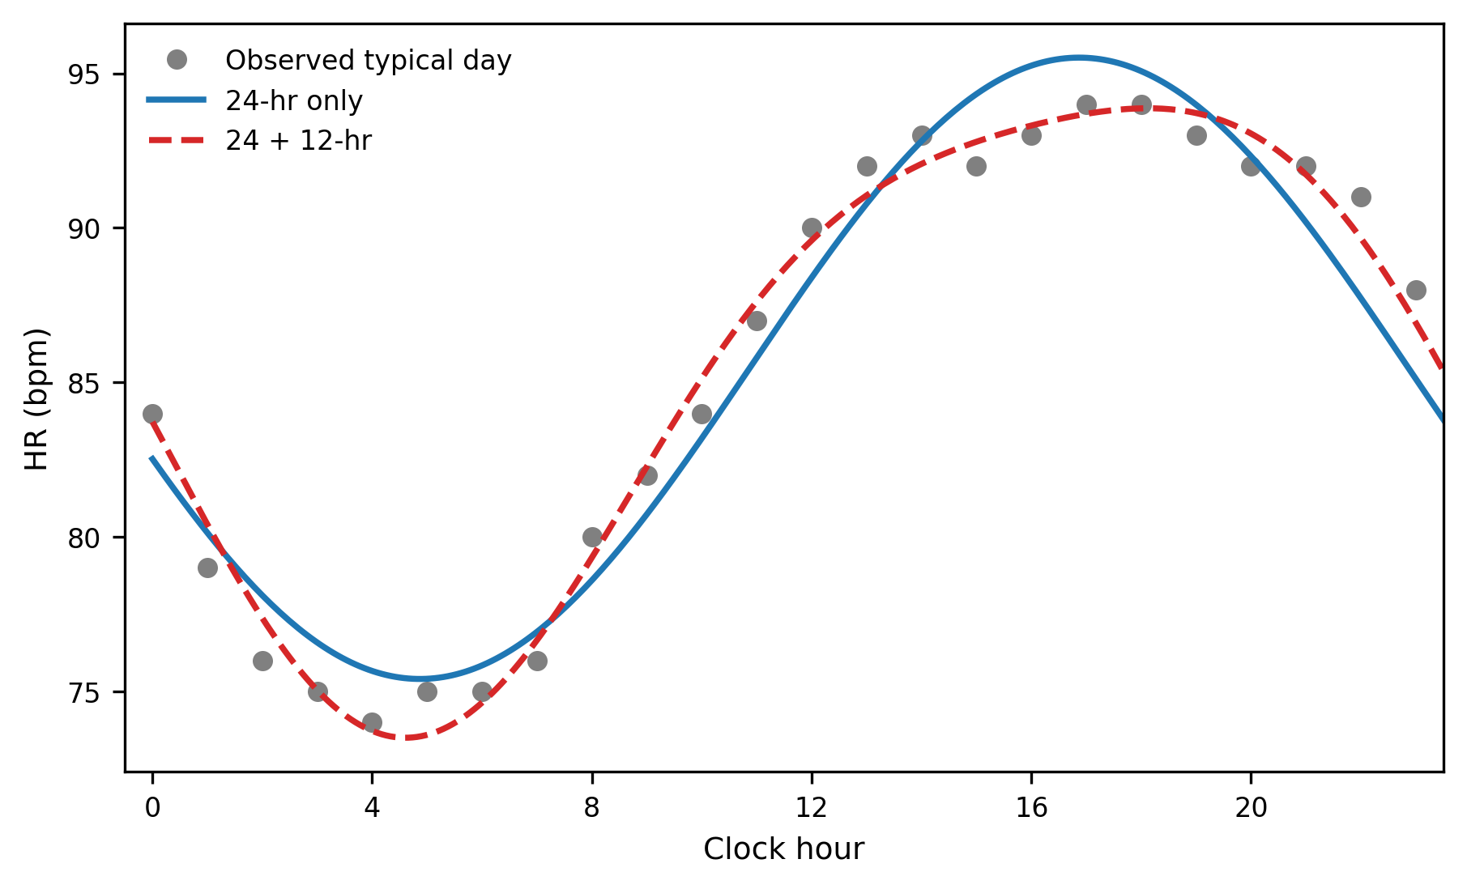Note. Gray circles: observed typical-day HR. Blue solid: 24-hour cosinor fit. Red dashed: 24+12-hour joint cosinor fit.

Figure S3.2
Distribution of the 12-Hour-to-24-Hour Amplitude Ratio.
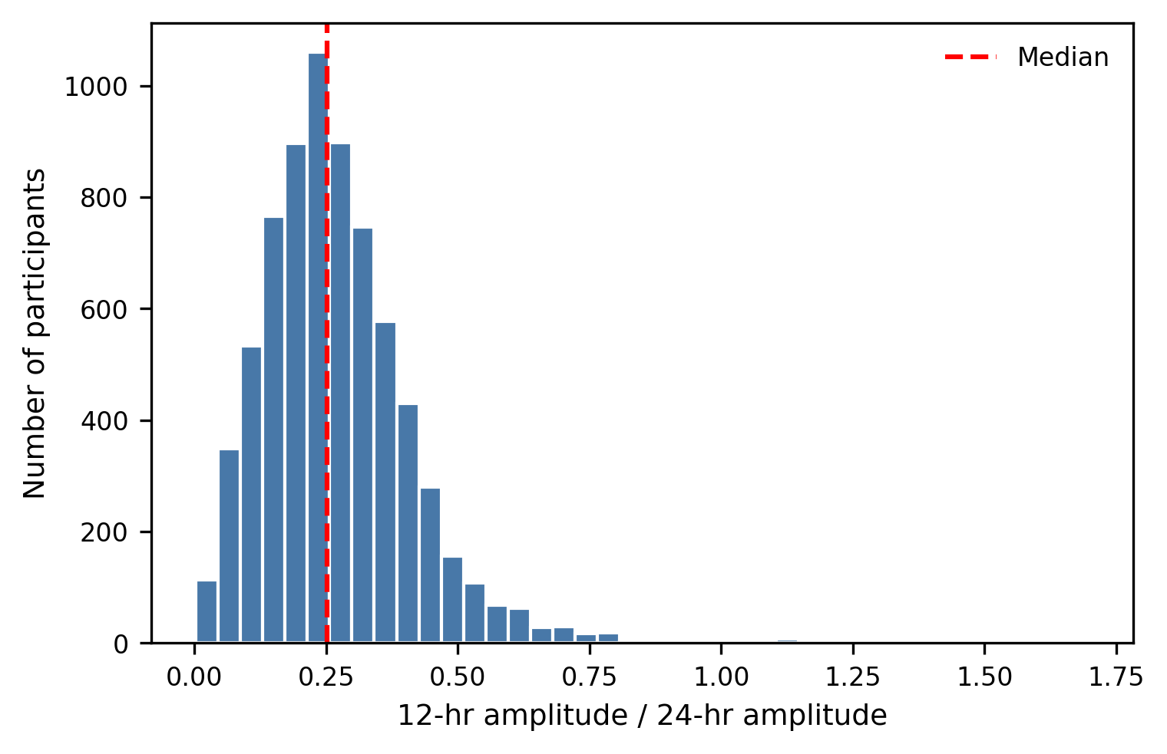
Note. Across the 7,230 participants in the QC-pass cohort. Median ratio = 0.25. The red dashed vertical line is the median ratio.

Section 4. Full Comorbidity Analysis
To probe whether wearable HR rhythm features predict cross-condition onset, we defined for each pair of conditions an index condition (positive at Wave 1 OR Wave 2) and a predicted condition (negative at Wave 1 AND Wave 2, with first onset at Wave 3 or Wave 4). Hypertension as index condition was not estimable in the present sample: blood pressure was not assessed at Wave 1, and the resulting at-risk cohort yielded fewer than 20 incident cases of each target condition (see Table S4.1). Hypertension as predicted condition from depression or from obesity was tested and was null. As a sensitivity analysis, all estimable cross-condition cells were re-run restricted to adolescents whose index condition first appeared at Wave 1, ensuring that cosinor measurement post-dated index onset. Estimable cells were depression to obesity and obesity to depression. Significant findings (depression to obesity mesor OR = 1.41; obesity to depression SD daily mesor OR = 1.28) held in the Wave-1-restricted sensitivity analysis.

Table S4.1
Sample Sizes and Estimability for All Six Cross-Condition Cells
Index condition | Predicted condition | N at-risk | N incident | Estimable
Depression | Obesity | 386 | 71 | Yes
Depression | Hypertension | 311 | 46 | Yes
Obesity | Depression | 1553 | 174 | Yes
Obesity | Hypertension | 999 | 182 | Yes
Hypertension | Depression | 51 | 7 | No
Hypertension | Obesity | 36 | 8 | No
Note. A cell is considered estimable if it yields ≥20 incident cases. Hypertension as index condition is not estimable because blood pressure was not assessed at Wave 1.

Table S4.2
Cross-Condition Prediction: Depression (Index) to Obesity (Predicted Onset)
Parameter | N at-risk | N incident | OR (per SD) | 95% CI | p
Between-person mesor * | 386 | 71 | 1.41 | [1.07, 1.86] | 0.015
Between-person amplitude | 386 | 71 | 1.11 | [0.87, 1.41] | 0.413
Between-person acrophase | 386 | 71 | 1.03 | [0.81, 1.32] | 0.79
SD daily mesor | 338 | 62 | 1.27 | [0.98, 1.65] | 0.076
SD daily amplitude | 338 | 62 | 1.2 | [0.93, 1.54] | 0.156
SD daily acrophase | 338 | 62 | 0.8 | [0.62, 1.02] | 0.077
Note. At-risk cohort: adolescents with established depression by Wave 2 (positive at Wave 1 or Wave 2) and obesity-negative at Wave 2. Outcome: incident obesity at Wave 3 or Wave 4. Predictors are per-1-SD-standardized within the at-risk cohort. Bold p-values indicate p < .05. OR = odds ratio; CI = confidence interval; SD = standard deviation. * p < .05, ** p < .01, *** p < .001.

Table S4.3
Cross-Condition Prediction: Obesity (Index) to Depression (Predicted Onset)
Parameter | N at-risk | N incident | OR (per SD) | 95% CI | p
Between-person mesor | 1553 | 174 | 0.96 | [0.81, 1.14] | 0.646
Between-person amplitude | 1553 | 174 | 1.04 | [0.89, 1.21] | 0.631
Between-person acrophase | 1553 | 174 | 0.9 | [0.79, 1.03] | 0.125
SD daily mesor ** | 1303 | 154 | 1.28 | [1.10, 1.48] | 0.001
SD daily amplitude | 1303 | 154 | 1.14 | [0.97, 1.34] | 0.121
SD daily acrophase | 1303 | 154 | 1.09 | [0.94, 1.27] | 0.248
Note. At-risk cohort: adolescents with established obesity by Wave 2 (positive at Wave 1 or Wave 2) and depression-negative at Wave 2. Bold p-values indicate p < .05. OR = odds ratio; CI = confidence interval; SD = standard deviation. * p < .05, ** p < .01, *** p < .001.

Section 5. Behavioral Sensitivity Analyses (Activity and Sleep Adjustment)
For each primary outcome (depression, obesity, hypertension) we fit four nested logistic regression models with HR cosinor predictors (mesor, amplitude, acrophase): M1 — HR only; M2 — HR plus activity covariates (steps, METs); M3 — HR plus sleep covariates (sleep period, wake after sleep onset); M4 — HR plus all behavioral covariates. For the within-person family of analyses (within-person rhythm SDs as predictors), we adjusted with scale-matched within-person SDs of the same behavioral signals (SD of daily steps, daily METs, daily sleep period). All predictors were per-SD z-scored within each analytic sample; all models included age and sex fixed effects and family-clustered SEs on ABCD family ID.

Table S5.1
Between-Person Nested Models for Incident Depression
Parameter | M1 OR (95% CI) | M1 (p) | M2 OR (95% CI) | M2 (p) | M3 (OR 95% CI) | M3 (p) | M4 (OR 95% CI) | M4 (p)
HR mesor ** | 1.21 [1.07, 1.37] | 0.003 | 1.19 [1.05, 1.35] | 0.006 | 1.19 [1.05, 1.36] | 0.007 | 1.18 [1.04, 1.34] | 0.013
HR amplitude | 0.96 [0.85, 1.08] | 0.469 | 1.02 [0.88, 1.17] | 0.827 | 0.97 [0.86, 1.10] | 0.669 | 1.04 [0.90, 1.19] | 0.627
HR acrophase | 0.97 [0.87, 1.09] | 0.631 | 0.95 [0.85, 1.07] | 0.423 | 0.97 [0.87, 1.09] | 0.636 | 0.95 [0.85, 1.07] | 0.419
Note. M1 = HR only; M2 = HR + activity covariates (steps, METs); M3 = HR + sleep covariates (sleep period, wake after sleep onset); M4 = HR + all behavioral covariates. All predictors are per-1-SD z-scored within the analytic frame. Models include age and sex fixed effects and family-clustered standard errors on ABCD family ID. Bold p-values indicate p < .05. OR = odds ratio; CI = confidence interval. * p < .05, ** p < .01, *** p < .001.

Table S5.2
Between-Person Nested Models for Incident Obesity
Parameter | M1 (OR 95% CI) | M1 (p) | M2 (OR 95% CI) | M2 (p) | M3 (OR 95% CI) | M3 (p) | M4 (OR 95% CI) | M4 (p)
HR mesor *** | 1.26 [1.12, 1.41] | < .001 | 1.28 [1.14, 1.45] | < .001 | 1.25 [1.11, 1.40] | < .001 | 1.26 [1.12, 1.43] | < .001
HR amplitude *** | 0.85 [0.75, 0.96] | 0.010 | 0.71 [0.61, 0.82] | < .001 | 0.85 [0.75, 0.97] | 0.013 | 0.71 [0.61, 0.83] | < .001
HR acrophase * | 1.16 [1.03, 1.31] | 0.015 | 1.16 [1.02, 1.31] | 0.023 | 1.15 [1.02, 1.30] | 0.020 | 1.15 [1.01, 1.30] | 0.032
Note. M1 = HR only; M2 = HR + activity covariates (steps, METs); M3 = HR + sleep covariates (sleep period, wake after sleep onset); M4 = HR + all behavioral covariates. All predictors are per-1-SD z-scored within the analytic frame. Models include age and sex fixed effects and family-clustered standard errors on ABCD family ID. Bold p-values indicate p < .05. OR = odds ratio; CI = confidence interval. * p < .05, ** p < .01, *** p < .001.

Table S5.3
Between-Person Nested Models for Incident Hypertension
Parameter | M1 (OR 95% CI) | M1 (p) | M2: (OR 95% CI) | M2 (p) | M3 (OR 95% CI) | M3 (p) | M4 (OR 95% CI) | M4 (p)
HR mesor ** | 1.28 [1.07, 1.53] | 0.006 | 1.22 [1.02, 1.46] | 0.034 | 1.22 [1.02, 1.46] | 0.026 | 1.17 [0.97, 1.40] | 0.1
HR amplitude | 0.86 [0.72, 1.04] | 0.121 | 0.82 [0.67, 1.01] | 0.06 | 0.90 [0.75, 1.08] | 0.271 | 0.86 [0.70, 1.06] | 0.168
HR acrophase | 1.13 [0.95, 1.34] | 0.17 | 1.10 [0.93, 1.30] | 0.263 | 1.11 [0.94, 1.31] | 0.22 | 1.09 [0.92, 1.28] | 0.307
Note. M1 = HR only; M2 = HR + activity covariates (steps, METs); M3 = HR + sleep covariates (sleep period, wake after sleep onset); M4 = HR + all behavioral covariates. All predictors are per-1-SD z-scored within the analytic frame. Models include age and sex fixed effects and family-clustered standard errors on ABCD family ID. Bold p-values indicate p < .05. OR = odds ratio; CI = confidence interval. * p < .05, ** p < .01, *** p < .001.

Table S5.4
Within-Person Rhythm SDs for Incident Depression: Unadjusted Versus Scale-Matched Behavior-Adjusted
Parameter | Unadjusted OR (95% CI) | Unadjusted p | Adjusted OR (95% CI) | Adjusted p | N | N cases
SD daily mesor | 1.09 [0.98, 1.22] | 0.127 | 1.07 [0.96, 1.20] | 0.227 | 2752 | 299
SD daily amplitude | 1.01 [0.90, 1.14] | 0.814 | 1.00 [0.88, 1.14] | 0.993 | 2752 | 299
SD daily acrophase | 1.07 [0.97, 1.19] | 0.192 | 1.03 [0.93, 1.16] | 0.54 | 2752 | 299
Note. Within-person rhythm SDs entered as per-1-SD-standardized predictors. Adjusted models add scale-matched SDs of daily steps, daily METs, and daily sleep period. Bold p-values indicate p < .05. OR = odds ratio; CI = confidence interval; SD = standard deviation.

Table S5.5
Within-Person Rhythm SDs for Incident Obesity: Unadjusted Versus Scale-Matched Behavior-Adjusted
Parameter | Unadjusted OR (95% CI) | Unadjusted p | Adjusted OR (95% CI) | Adjusted p | N | N cases
SD daily mesor ** | 1.19 [1.07, 1.32] | 0.001 | 1.17 [1.04, 1.31] | 0.009 | 2623 | 292
SD daily amplitude * | 1.14 [1.01, 1.28] | 0.029 | 1.13 [1.00, 1.29] | 0.057 | 2623 | 292
SD daily acrophase * | 1.14 [1.03, 1.27] | 0.014 | 1.08 [0.97, 1.21] | 0.162 | 2623 | 292
Note. Within-person rhythm SDs entered as per-1-SD-standardized predictors. Adjusted models add scale-matched SDs of daily steps, daily METs, and daily sleep period. Bold p-values indicate p < .05. OR = odds ratio; CI = confidence interval; SD = standard deviation. * p < .05, ** p < .01, *** p < .001.

Table S5.6
Within-Person Rhythm SDs for Incident Hypertension: Unadjusted Versus Scale-Matched Behavior-Adjusted
Parameter | Unadjusted OR (95% CI) | Unadjusted p | Adjusted OR (95% CI) | Adjusted p | N | N cases
SD daily mesor | 1.12 [0.94, 1.33] | 0.208 | 1.05 [0.88, 1.27] | 0.576 | 1685 | 154
SD daily amplitude | 1.01 [0.85, 1.19] | 0.939 | 0.95 [0.78, 1.15] | 0.576 | 1685 | 154
SD daily acrophase | 1.10 [0.95, 1.27] | 0.208 | 1.00 [0.85, 1.18] | 0.984 | 1685 | 154
Note. Within-person rhythm SDs entered as per-1-SD-standardized predictors. Adjusted models add scale-matched SDs of daily steps, daily METs, and daily sleep period. Bold p-values indicate p < .05. OR = odds ratio; CI = confidence interval; SD = standard deviation.

Table S5.7
Model Comparison Statistics for Nested Between-Person Models
Outcome | Comparison | ΔAUC | LRT χ² | df | p (LRT)
Depression | M2: HR + activity vs M1: HR only | 0.018 | 5.61 | 2 | 0.060
Depression | M3: HR + sleep vs M1: HR only | 0.006 | 2.2 | 2 | 0.333
Depression | M4: HR + activity + sleep vs M1: HR only | 0.023 | 7.98 | 4 | 0.092
Obesity *** | M2: HR + activity vs M1: HR only | 0.063 | 51.29 | 2 | < .001
Obesity | M3: HR + sleep vs M1: HR only | -0.001 | 1.16 | 2 | 0.560
Obesity *** | M4: HR + activity + sleep vs M1: HR only | 0.063 | 52.93 | 4 | < .001
Hypertension *** | M2: HR + activity vs M1: HR only | 0.028 | 17.14 | 2 | < .001
Hypertension * | M3: HR + sleep vs M1: HR only | 0.014 | 6.41 | 2 | 0.041
Hypertension *** | M4: HR + activity + sleep vs M1: HR only | 0.04 | 23.37 | 4 | < .001
Note. ΔAUC = change in area under the ROC curve relative to M1. LRT = likelihood ratio test against M1. Bold p-values indicate p < .05. * p < .05, ** p < .01, *** p < .001.
Figure S5.1
HR Rhythm Parameters Across Nested Behavioral Adjustments.
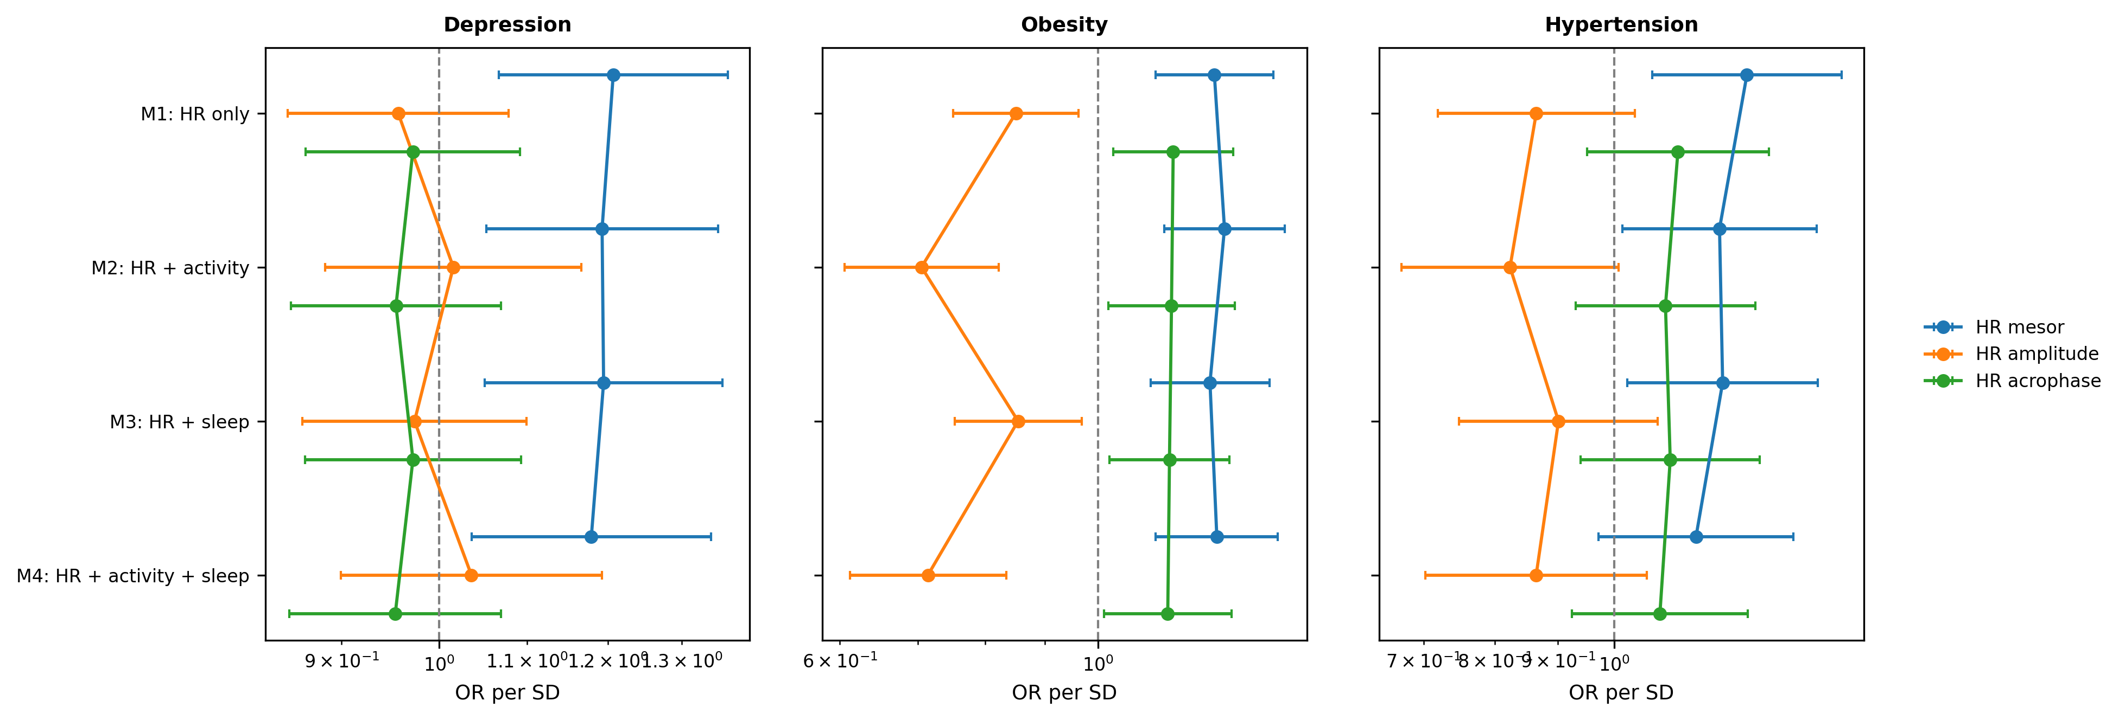Note. Each panel shows one outcome (depression, obesity, hypertension). Markers and connecting lines show how the OR for each HR parameter (mesor, amplitude, acrophase) shifts across the four nested model specifications. Vertical dashed line at OR = 1. x-axis on log scale.
Figure S5.2
Within-Person Rhythm SDs: Unadjusted Versus Behavior-Adjusted Odds Ratios.
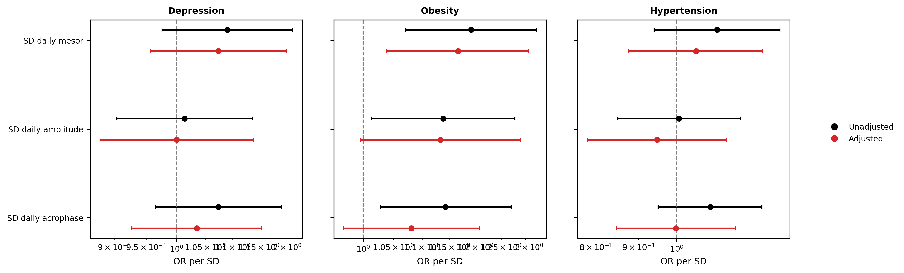Note. Black markers: unadjusted models. Red markers: models adjusted for scale-matched within-person behavioral SDs. Vertical dashed line at OR = 1. x-axis on log scale.

