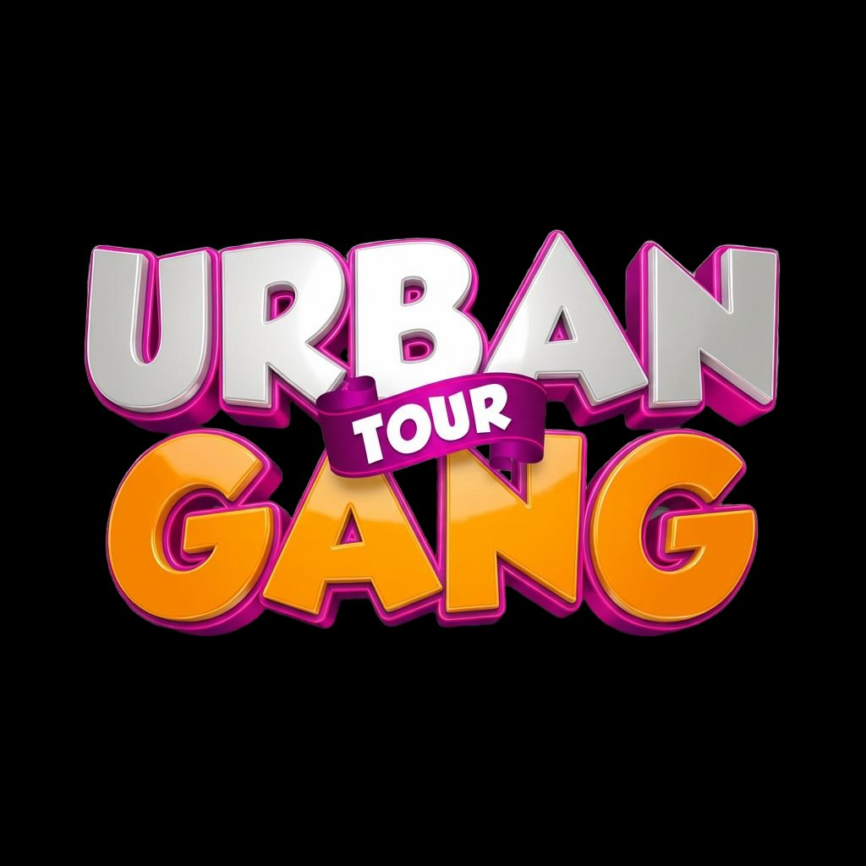

URBAN GANG TOUR
From Potential to Purpose

PARTNER CATALOGUE
Your Brand. Their Future. One Movement.

euginemicah@gmail.com
2026 | Countrywide Programme

THE CHALLENGE EVERY BRAND FACES
Kenya has 10,000+ secondary schools, hundreds of universities and colleges, and millions of young people making daily decisions about the brands they trust, the products they buy, and the companies they want to work for. Traditional advertising reaches them on screens they scroll past. UGT puts your brand in the room with them — on a stage they’re cheering for, in a tent they’re visiting, on a certificate they’re holding, and in content they’re sharing.
This is not a one-off event. This is a long-term, countrywide movement that extends beyond schools into universities, concerts, festivals, church missions, and community events. When you partner with UGT, your brand grows with us.

THE NUMBERS
PPP TV National Viewership | Up to 8 million viewers
Urban News Daily Reach | 400,000 to millions (variable daily)
Students Per School Event | Hundreds to thousands per visit
Content Output Per Event | 1 full TV episode + 8–12 social clips + photography gallery
Social Platforms | Instagram, TikTok, YouTube Shorts, Facebook, X
Team Deployed Per Event | 30+ professionals including hosts, DJs, dancers, camera crew
Scope | Countrywide — schools, universities, colleges, concerts, festivals, church events
Schools Booked (Term 2, 2026) | 3 confirmed and growing
Follow-Up Reach | 2 winners per school on PPP TV + Urban Gang Clubs established in every school

HOW TO PARTNER WITH US
We don’t have a rigid one-size-fits-all package. We believe the best partnerships are co-created. Here are the ways your brand can join the movement:

1. Segment Sponsorship
Own a specific segment of every event. Your brand becomes synonymous with that category across every school, every city, every event nationwide. Options include any talent category (Rap, Dance, Poetry, Gospel, Drama, Choir, Comedy, Maths & Logic), the Modelling Showcase, Urban Pods, Teacher Appreciation, Tree Planting, or any custom segment.
Your Brand Gets: Stage mentions by hosts, branded category intro, your logo on category certificates and awards, TV and social media credits, logo on backdrop, on-camera brand moment during your segment

2. Awards & Prize Sponsorship
Supply the gift hampers, certificates, trophies, sashes, crowns, or unique prizes. Your brand is physically in the hands of every winner and visible in every award photo and video broadcast on PPP TV.
Your Brand Gets: Logo on certificates, branded gift hampers with your products, on-stage mention, TV and social coverage of winners holding your branded prizes

3. Booth & Activation
Set up a branded booth or activation zone. Sample products, run contests, offer information, or engage directly with thousands of students face-to-face.
Your Brand Gets: Dedicated tent/booth space, branded signage, direct student engagement, on-camera mention, social media feature

4. Branding & Visibility
Your logo across UGT’s physical and digital assets: stage backdrop, teardrops, banners, printed programmes, certificates, social media posts, TV broadcast credits, and Urban News mentions.

5. Vendor Partnership
Sell your products directly to students and event attendees. Snacks, beverages, stationery, accessories, clothing — UGT events give you a captive audience. Destiny Life Church also brings vendors, creating a vibrant vendor ecosystem.

6. PR Package
We build custom PR campaigns for our partners. TV mentions and adverts on PPP TV, dedicated social media posts, branded content, event reels featuring your brand, and a structured campaign that pushes your visibility far beyond the event.

7. Unique Element Creation
Create something entirely new and own it: a branded award category, a student challenge, a digital literacy station, a career expo booth, a VIP experience, or anything creative that aligns with UGT’s mission. We co-design it with you.

8. Musician / Artist Facilitation
Sponsor one of our two guest musicians. Your brand introduces the headline act and is associated with the biggest musical moment of the day.

9. University / College Partnership
Provide career guidance, scholarship info, campus tours, or student recruitment at UGT events. Direct access to high school students at the point of career decision-making.

THE FULL ASSET MENU
Every partner gets a custom mix from this menu, tailored to your goals:
On Stage | MC mentions, branded intros, award presentations, artist introductions, crowd shout-outs
On the Backdrop | Logo on main stage backdrop (T-shaped, 36–42 boards)
On Teardrops & Banners | Branded teardrop flags and banners across venue
On Certificates & Awards | Your logo on every cert and hamper in your category
In the Tent / Booth | Branded booth, activation zone, or vending space
On TV | PPP TV broadcast credits, Urban News mentions, ad slots
On Social Media | Instagram, TikTok, YouTube Shorts — tagged, featured, amplified
In the Pods | Branded 30-min mentorship breakout with students
In the Programme | Logo on printed event programme for every attendee
At the Photobooth | Branded Urban Gang Moments prints (KES 20/pic, every student’s keepsake)
In the Follow-Up | Brand presence in Urban Gang Clubs, church conference day, PPP TV winner features

WHO IS ALREADY ON BOARD
Destiny Life Church | Co-production: stage, sound, PAR can lights, crew, speaker, counselling, Tribez, Lit Gen, transport, musicians, vendors
PPP TV Kenya | National broadcaster (up to 8M viewers). Home of Urban News
The Experience Hub | 30+ person team: hype sets, DJs, 5 dancers, crowd activation
The Green Movement | Tree planting at every school (led by Tai)

THIS IS LONG-TERM. THIS IS COUNTRYWIDE.
UGT is not a one-off activation. We visit schools term after term. We establish Urban Gang Clubs that keep your brand visible year-round. We follow up with winners on national TV. We are expanding into universities, mega concerts, and community events. Your partnership with UGT compounds over time.
We are not asking for a cheque. We are asking you to join a movement. Support can come as products, services, expertise, facilitation, branded activations, PR packages, booths, or creative collaborations. We sit down with you and design something that works for both of us.

NEXT STEPS
Step 1: Reach out to us at euginemicah@gmail.com expressing your interest
Step 2: We sit down and explore how your brand fits into the UGT experience
Step 3: We co-create a partnership tailored to your brand and goals
Step 4: We execute together — at events, on TV, across social media, and beyond

Let’s build something that matters. From Potential to Purpose.

Contact: euginemicah@gmail.com
Broadcast: Urban News on PPP TV Kenya

