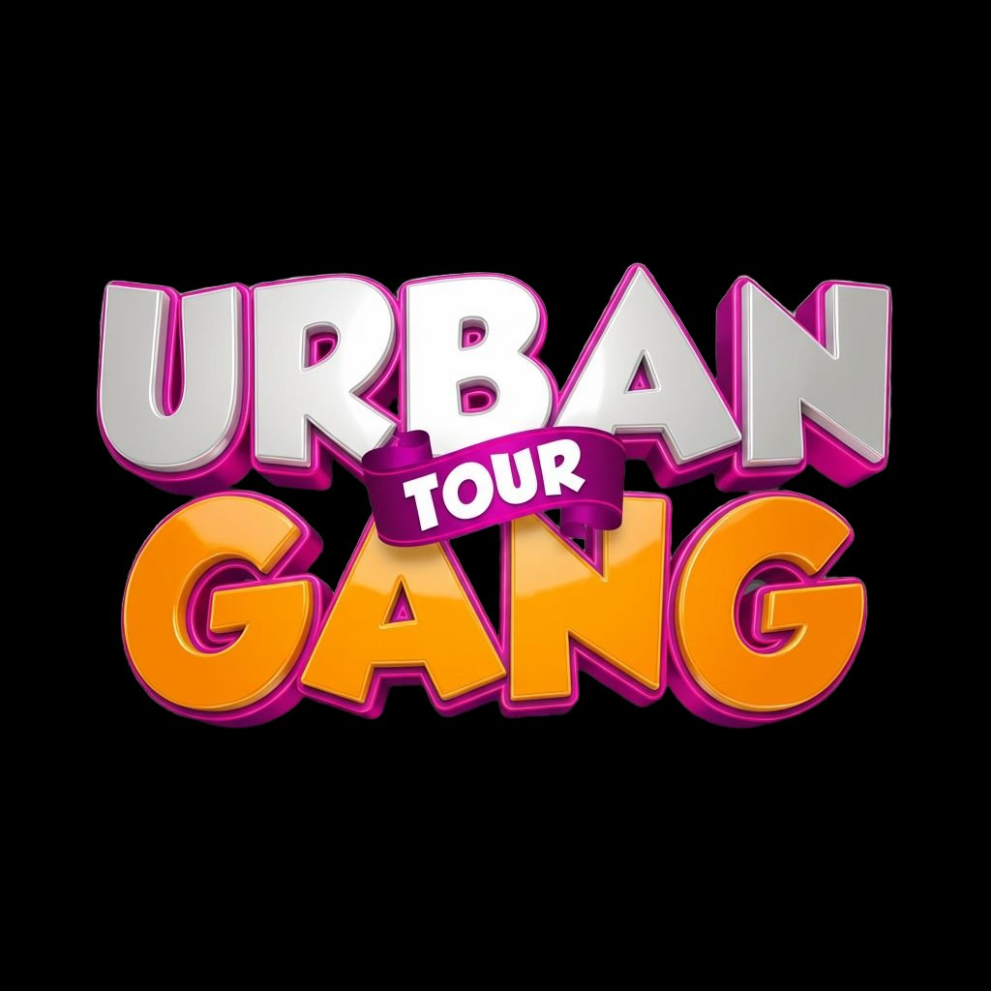

URBAN GANG TOUR
From Potential to Purpose

SOCIAL MEDIA
REBRAND KIT

Instagram • Facebook • TikTok • WhatsApp

April 2026

ASSET CHECKLIST
Your rebrand kit includes these files (attached separately):

Profile Pictures | profile_instagram_1080.png, profile_facebook_640.png, profile_whatsapp_500.png, profile_tiktok_400.png, profile_square_1080.png
Facebook Cover | facebook_cover_1640x624.png
Instagram Story Banner | instagram_story_brand_1080x1920.png
Instagram Highlights (x9) | highlight_talent, highlight_pods, highlight_models, highlight_hype, highlight_awards, highlight_bts, highlight_merch, highlight_church, highlight_schools
WhatsApp Status | whatsapp_status_1080x1920.png
TikTok Header | tiktok_header_1080x1080.png

INSTAGRAM

Profile Setup
Username | @urbangangtour
Display Name | Urban Gang Tour 🎤
Profile Picture | Use profile_instagram_1080.png (circular crop with magenta border)
Category | Entertainment / Event / Media
Contact Email | euginemicah@gmail.com
Action Button | Email (euginemicah@gmail.com)

Instagram Bio
Copy and paste this exactly:

🎯 From Potential to Purpose
🎶 Kenya’s #1 High School Talent Tour
📺 Urban News on @ppptv_kenya
🎭 Talent • Mentorship • Awards • Concerts
🇺🇦 Countrywide — Schools • Universities • Festivals
📩 euginemicah@gmail.com
⬇️ Next stop loading...

Instagram Highlight Covers
9 branded highlight covers included. Set them up as:
TALENT: All talent competition clips (rap, dance, poetry, gospel, choir, drama, comedy)
PODS: Urban Pod mentorship session clips
MODELS: Modelling showcase runway clips
HYPE: Experience Hub hype set clips and crowd moments
AWARDS: Award ceremony moments and winner features
BTS: Behind-the-scenes content from events
MERCH: Urban Gang Merch, Snacks, and Moments photobooth content
CHURCH: Destiny Life Church sessions, Tribez, gospel moments
SCHOOLS: School-by-school archive (add school name in stories)

Instagram Hashtag Strategy
Primary hashtags (use on every post):
#UrbanGangTour #FromPotentialToPurpose #UGT2026 #UrbanNews #PPPTV

Category-specific hashtags (rotate based on content):
#KenyanTalent #HighSchoolTalent #KenyanYouth #TalentSearch #GenZKenya
#KenyanRap #KenyanDance #KenyanPoetry #SpokenWordKenya #KenyanGospel
#MentoringYouth #YouthEmpowerment #KenyanSchools #EducationKenya
#ModellingKenya #FashionKenya #CosplayKenya #RunwayKenya

Location hashtags (add the school’s area):
#Nairobi #Kiambu #Ruiru #Syokimau #AthiRiver #KenyanHighSchools

FACEBOOK

Page Setup
Page Name | Urban Gang Tour
Username | @urbangangtour
Profile Picture | Use profile_facebook_640.png
Cover Photo | Use facebook_cover_1640x624.png
Category | Entertainment Website / Event / Youth Organization
Contact Email | euginemicah@gmail.com

Facebook About Section
Short Description (under 155 characters):
Kenya’s #1 high school talent search, mentorship & awards tour. From Potential to Purpose. Urban News on PPP TV.

Long Description:
Urban Gang Tour (UGT) is Kenya’s largest high school talent search, mentorship, and awards concert programme. We go directly into schools, universities, and institutions nationwide to discover talent, nurture dreams, and give young people a reason to believe.

Our motto: From Potential to Purpose.

What we do: Talent competitions (rap, dance, poetry, gospel, drama, comedy, modelling), Urban Pod mentorship sessions, tree planting, teacher appreciation, and awards concerts — all broadcast on PPP TV Kenya through our show Urban News.

Our team deploys 30+ professionals to every event — hosts, DJs, dancers, camera crew, and our strategic partner Destiny Life Church.

We are countrywide. We are long-term. We are From Potential to Purpose.

Contact: euginemicah@gmail.com

Facebook Page Info Fields
Website: https://github.com/eugineous/urban-gang-tour- (update when website launches)
Email: euginemicah@gmail.com
Founded: 2025
Mission: To discover, nurture, and celebrate the talent and potential of every young person in Kenya — From Potential to Purpose

TIKTOK

Profile Setup
Username | @urbangangtour
Display Name | Urban Gang Tour 🎤🔥
Profile Picture | Use profile_tiktok_400.png
Category | Entertainment

TikTok Bio
Copy and paste this exactly (TikTok limit: 80 characters):
Kenya’s #1 Talent Tour 🎤 From Potential to Purpose 🔥 PPP TV

If you get more characters (business account):
Kenya’s #1 High School Talent Tour 🎤
From Potential to Purpose 🔥
Urban News on PPP TV 📺
euginemicah@gmail.com

TikTok Content Strategy
Primary Content: Reels from events — rap battles, dance-offs, hype sets, crowd reactions, modelling walks, comedy acts, awards moments
Behind-the-Scenes: Setup at 5 AM, crew briefings, sound checks, backstage moments
Host Content: Eugine and Lucy doing school walkthroughs, food reviews at canteen, interviewing students
Challenge Content: Create UGT-specific challenges (e.g., #UGTDanceChallenge, #FromPotentialToPurpose)
Educational: Quick clips from Urban Pods (financial tips, digital literacy, mental health moments)

TikTok Hashtags
#UrbanGangTour #UGT #FromPotentialToPurpose #KenyanTalent #PPPTV
#KenyanTikTok #KenyanHighSchool #TalentKenya #fyp #foryou #viral

WHATSAPP

Profile Setup
Profile Picture | Use profile_whatsapp_500.png
Display Name | Urban Gang Tour

WhatsApp About Text
Option 1 (short — 139 chars max):
Urban Gang Tour 🎤 From Potential to Purpose | Kenya’s #1 Talent Tour | PPP TV | euginemicah@gmail.com

Option 2 (shorter):
🎤 Urban Gang Tour | From Potential to Purpose | PPP TV Kenya

WhatsApp Business Catalogue (If Using WhatsApp Business)
Service 1: School Event Booking — Book UGT for your school’s talent day
Service 2: Partnership Enquiry — Become a UGT partner or sponsor
Service 3: Media & Press — Request coverage or content collaboration
Service 4: Urban Gang Merch — Official merchandise orders

WhatsApp Status Strategy
Use the whatsapp_status_1080x1920.png as your first status after the rebrand. Then maintain regular status updates:
Pre-Event (1 week before): "Next stop: [School Name]! 🔥 Are you ready?"
Event Day: Live updates from setup, pods, performances, awards
Post-Event: Highlights reel, winner announcements, thank-you to school
Weekly: Throwback clips, team moments, motivational quotes from the motto

BRAND RULES FOR ALL PLATFORMS

Voice & Tone
Always: Bold, energetic, Gen Z-friendly, purposeful, warm, confident
Never: Corporate, stiff, overly formal, preachy, condescending
Speak like: A big brother/sister who made it and came back to show the way
Motto integration: Work “From Potential to Purpose” into captions naturally — don’t force it every time

Visual Rules
Primary Colours: #C7238E (Magenta) and #F5A623 (Orange) — always present
Background: Dark (#1A1A1A) preferred. Never use white backgrounds for primary brand content
Logo: Always use the official 3D logo. Never stretch, recolour, or crop it
Text on Images: White text on dark backgrounds. Magenta or orange for accents. Never use more than 3 text colours per image
Consistency: Same profile picture across ALL four platforms. Same display name. Same bio structure

Posting Schedule (Recommended)
Instagram | 3–5x per week (reels, carousels, stories daily during events)
Facebook | 2–3x per week (event announcements, photo galleries, TV episode shares)
TikTok | 4–7x per week (short clips, challenges, trending audio)
WhatsApp Status | Daily during events, 2–3x per week otherwise

Content Team
Rania Martin: Primary content creator. Reels, TikToks, Instagram stories. Assisted by Nyarangi
Eugine Micah: Social media co-manager. Caption writing, strategy, posters
Lucy Ogunde: Social media co-manager. Community engagement, responses
George Morgan + Lallez: Photography and long-form video for Facebook and YouTube

URBAN GANG TOUR | From Potential to Purpose | 2026
euginemicah@gmail.com

