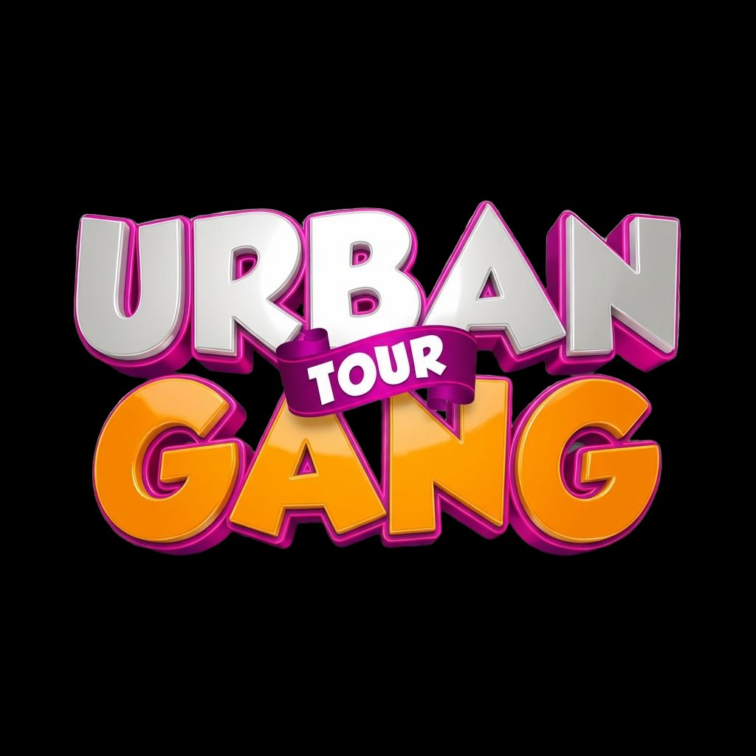

URBAN GANG TOUR
From Potential to Purpose

SPONSOR CATALOGUE
Invest in Kenya’s Youth. Amplify Your Brand. Leave a Legacy.

euginemicah@gmail.com
2026 | Countrywide Programme

WHAT IF YOUR BRAND COULD DO THIS?
Imagine thousands of students chanting your brand name from a stage. Imagine your logo on a certificate that a 16-year-old frames and hangs on their wall. Imagine your product in the hands of every winner, captured on camera and broadcast to 8 million viewers on national television. Imagine a club in every school in Kenya carrying your brand alongside ours, year after year.
That’s not a dream. That’s what Urban Gang Tour delivers — event after event, school after school, nationwide.

WHO YOUR BRAND REACHES
Primary Audience | High school students aged 13–18 (hundreds to thousands per event)
Secondary Audience | Teachers, school staff, parents, and community members at events
TV Audience | Up to 8 million PPP TV viewers nationally
Digital Audience | 400K– millions daily via Urban News + social media content engine
Content Per Event | 1 full TV episode (25–30 min) + 8–12 social clips + photography
Post-Event Reach | 2 winners on PPP TV per school + Urban Gang Clubs in every school
Growth Trajectory | 3 schools this term → expanding to universities, concerts, festivals countrywide

WHY UGT, NOT ANOTHER EVENT
You’re In the Room: Not buying eyeballs on a screen. You’re on the stage, in the tent, in the student’s hands. Direct, physical, memorable
National TV: Every event becomes a PPP TV episode. Your brand is on television, not just at the event
Content Machine: 8–12 clips per event, distributed across every platform Gen Z actually uses
Trusted Voices: Our hosts, DJs, and performers are trusted by the youth community. Association with UGT is association with credibility
Year-Round Presence: Urban Gang Clubs keep your brand visible in schools between visits. The church conference day extends your reach further
Compound Effect: This is long-term. Every school, every term, your brand compounds. You’re not renting attention — you’re building equity

SPONSORSHIP TIERS
Support comes in many forms: products, branded activations, PR packages, segment ownership, musician facilitation, booths, vendor setups, or creative collaboration. These tiers guide the conversation — everything is negotiable and tailored to your brand.

⭐ PRESENTING PARTNER ⭐
Scope | Naming rights: “Urban Gang Tour presented by [Your Brand]” across all events nationally
Stage | Primary logo on backdrop, all teardrops, banners, printed programmes
TV | Opening + closing credits on every PPP TV episode. Dedicated Urban News ad slots
Social | Featured in every post, reel, story. Dedicated brand spotlight content
Segments | First right of refusal on any event segment, pod topic, or award category
Booth | Premium activation space at every event. Priority vendor positioning
Follow-Up | Brand presence in Urban Gang Clubs, church conference day, PPP TV winner features
Duration | Annual minimum. Full countrywide coverage

🏆 IMPACT PARTNER
Scope | Major brand presence across all events
Stage | Logo on backdrop, select teardrops, and all certificates
TV | Brand mention in every PPP TV episode. Rotating ad slots
Social | Featured in event recaps and 3–4 dedicated reels per event
Segments | Own 2–3 event segments or award categories
Booth | Branded booth at every event
Duration | Termly or annual

💡 CATEGORY PARTNER
Scope | Strong presence at select events or across one specific segment
Stage | Logo on event banners. Mentions during your sponsored segment
TV | Brand mention during your segment on PPP TV
Social | Tagged in event posts. 2+ dedicated reels
Segments | Own 1 event segment or award category
Booth | Booth space at select events
Duration | Per event or termly

🌱 COMMUNITY PARTNER
Scope | Support specific mission elements of UGT
How | Products for hampers, snacks for UG Snacks, trees for planting, certificates, merchandise, materials, or in-kind services
Recognition | On-stage thank-you, logo on relevant materials, social media mention
Ideal For | Brands that want to support youth development with focused, tangible contributions
Duration | Per event or ongoing

THE FULL ASSET MENU
Every sponsor gets a custom selection from this menu:
On Stage | MC mentions, branded intros, award presentations, artist introductions, crowd shout-outs by hosts
On the Backdrop | Logo on T-shaped stage backdrop (36–42 boards)
Teardrops & Banners | Branded flags and banners across venue
Certificates & Awards | Your logo on certificates and hampers in your category
Booth / Activation | Branded tent, vending space, or activation zone
On PPP TV | Broadcast credits, Urban News mentions, ad slots (up to 8M viewers)
Social Media | Instagram, TikTok, YouTube Shorts, Facebook, X — tagged and amplified
Urban Pods | Branded 30-min mentorship session with students
Event Programme | Logo on printed programme for all attendees
Urban Gang Moments | Your logo on photobooth prints (students take home a branded keepsake)
Urban Gang Clubs | Brand presence in school clubs established after each visit
Church Conference Day | Visibility at follow-up event for winners from all toured schools
PPP TV Winner Feature | 2 winners per school on Urban News — your brand in the broadcast

STRATEGIC PARTNERS ALREADY ON BOARD
Destiny Life Church | Co-production: stage, sound, PAR can lights, crew, speaker, counselling, Tribez, Lit Gen, musicians, vendors
PPP TV Kenya | National broadcaster (up to 8M viewers). Urban News
The Experience Hub | 30+ person team: hype, DJs, 5 dancers, crowd activation
The Green Movement | Tree planting at every school (led by Tai)

WHAT HAPPENS AFTER THE EVENT
Your sponsorship doesn’t expire when the stage comes down:
Week 1: 2 category winners featured on PPP TV Urban News — your brand in the broadcast
Week 2: Urban Gang Club established in school with student leadership — your brand stays in the school
Weeks 3–4: Church conference day at Destiny Life Church grounds for winners from all toured schools — your brand at the milestone event
Ongoing: Clubs maintain your brand visibility year-round. Repeat visits. Alumni network growing. Countrywide expansion

WE WANT TO HEAR FROM YOU
This document is a conversation starter, not a contract. Everything is flexible. We want to sit down with you, understand your goals, and co-create something that amplifies your brand while making a real difference in the lives of Kenya’s young people.

Email: euginemicah@gmail.com
Broadcast: Urban News on PPP TV Kenya
Creative Director: Eugine Micah

This is long-term. This is countrywide. This is bigger than a school event.

From Potential to Purpose.

